Massachusetts HIV Epidemiologic Profile: Data as of 7/1/2024
Population Report: Older Individuals
Accessible MS Word Version, optimized for screen reader use
Please note that while the content of this report is the same as the pdf version, the format and pagination have been modified significantly to optimize use with screen readers to ensure access for blind or visually impaired audiences.
Suggested citation:
Massachusetts Department of Public Health, Bureau of Infectious Disease and Laboratory Sciences. Massachusetts HIV Epidemiologic Profile: Data as of 7/1/2024, Population Report: Older Individuals, https://www.mass.gov/lists/hivaids-epidemiologic-profiles Published June 2025. Accessed [date].
Bureau of Infectious Disease and Laboratory Sciences
Massachusetts Department of Public Health
Jamaica Plain Campus/State Public Health Laboratory
305 South Street
Jamaica Plain, MA 02130
Questions about this report
Tel: (617) 983-6560
To reach the Reporting and Partner Services Line
Tel: (617) 983-6999
To speak to the on-call epidemiologist
Tel: (617) 983-6800
Questions about infectious disease reporting
Tel: (617) 983-6801
HIV Data Dashboard
https://www.mass.gov/info-details/hiv-data-dashboard
Requests for additional data
https://www.mass.gov/lists/infectious-disease-data-reports-and-requests
Slide sets for HIV Epidemiologic Profile Reports
https://www.mass.gov/lists/hivaids-epidemiologic-profiles

OLDER INDIVIDUALS LIVING WITH HIV INFECTION
The number of older persons living with HIV infection in Massachusetts is increasing both because effective HIV medicines help people living with HIV lead longer, healthier lives and because HIV continues to be newly diagnosed in older individuals every year. For the purposes of this fact sheet, “older individuals” is defined as those who are aged 60+ years.
There are several distinct areas of concern regarding aging and HIV. First, older persons living with HIV may experience health challenges that tend to present later in life, such as low bone density, high cholesterol, and high blood pressure, and therefore may take substantially more medications, in addition to HIV treatments, than younger people. Second, HIV disease may affect the biology of aging, possibly resulting in earlier manifestations of clinical syndromes generally associated with more advanced age. Third, reduced mucosal and immunologic defenses (e.g., postmenopausal atrophic vaginitis) and changes in risk related-behaviors (e.g., decreased condom use because of lower concerns about pregnancy or more high-risk sexual activity with increased use of erectile dysfunction drugs) in older adults may lead to increased risk of acquisition and transmission of HIV. Finally, HIV screening among older adults remains low because they are generally perceived by health care providers to be at low risk of acquiring HIV. However, data indicate that older individuals are at risk for HIV acquisition, and testing and other prevention interventions are indicated for older adults.
OLDER INDIVIDUALS AT A GLANCE
N = 107, 7% of 1,435 new HIV diagnoses from 2021–2023 were among persons aged 60+ years
N = 8,726, 36% of 24,119 persons living with HIV infection in MA as of 12/31/2023 were persons aged 60+ years

FIGURE 1. Percentage distribution of persons living with HIV infection by age, Massachusetts 2014–2023
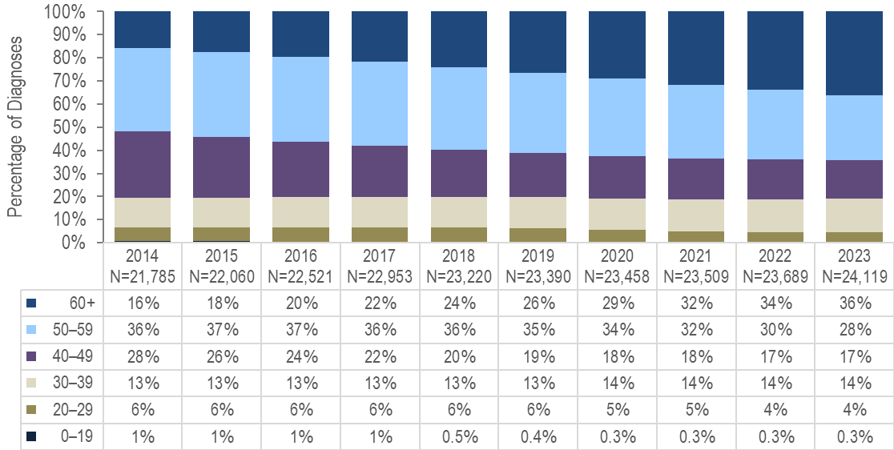
- From 2014 to 2023, the proportion of persons living with HIV infection (PLWH) who were aged 60+ years increased from 16% to 36% and who were aged 50+ years from 52% to 64%.
FIGURE 2. Persons living with HIV infection by expanded older age categories, Massachusetts 2023 (N=24,119)
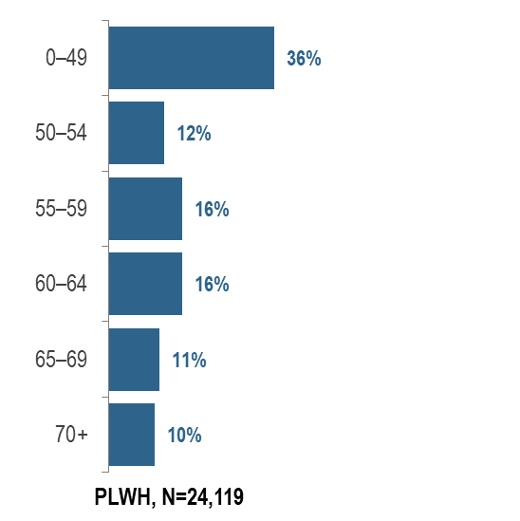
- In 2023, 20% (N=4,891) of PLWH were aged 65 years or older, the age of eligibility for Medicare for individuals without a disability.
YEARS SINCE HIV INFECTION DIAGNOSIS AMONG PLWH 60+ YEARS OLD
FIGURE 3. Number of years since HIV infection diagnosis among individuals aged 60+ years living with HIV infection, Massachusetts 2023 (N=8,726)
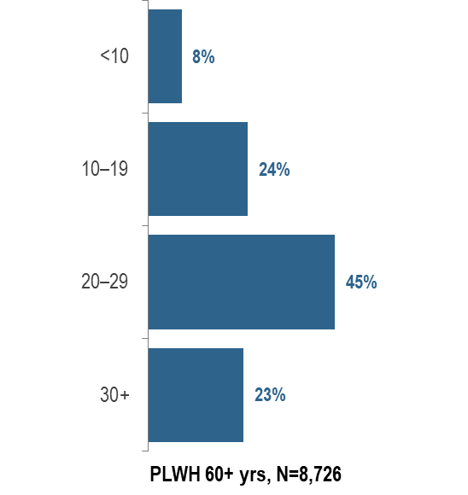
KEY FINDING
- In 2023, the majority (68%) of PLWH aged 60 years and older were diagnosed with HIV infection at least 20 years ago. The average number of years since HIV infection diagnosis among PLWH aged 60 years and older was 22.8 years.
FIGURE 4: People aged 60+ years and living with HIV infection compared to people aged under 60 years by selected characteristics, Massachusetts, 2023
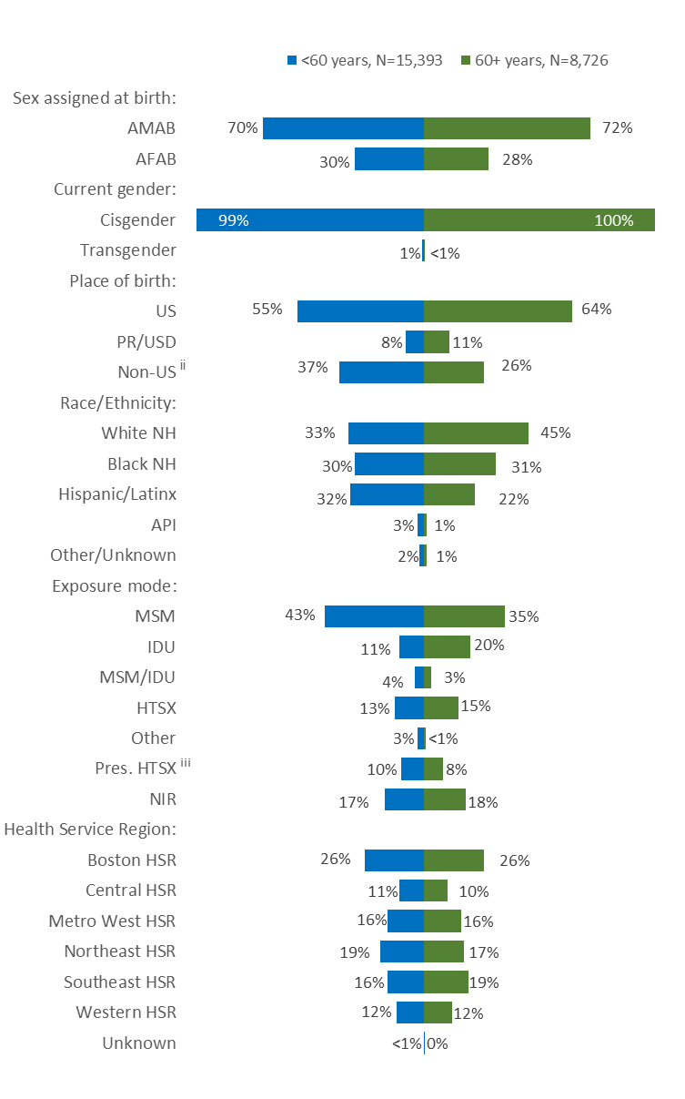
Figure 4 Notes:
^{ii} PR/USD = Puerto Rico/US Dependencies, 98% persons living with HIV infection on 12/31/2023 who were born in PR/USD were born in Puerto Rico
^{iii} Pres. HTSX=presumed heterosexual exposure, includes individuals assigned female at birth with a negative history of injection drug use who report having sex with an individual that identifies as male of unknown HIV status and risk
AMAB = assigned male at birth; AFAB = assigned female at birth; NH = non-Hispanic; API = Asian/Pacific Islander; MSM=male-to-male sex; IDU=injection drug use; HTSX=heterosexual sex; Pres. HTSX=presumed heterosexual exposure, includes individuals assigned female at birth with a negative history of injection drug use who report having sex with an individual that identifies as male of unknown HIV status and risk; NIR=no identified risk
In 2023, the distributions of people living with HIV infection by place of birth, race/ethnicity, and exposure mode varied by age:
- A larger proportion of individuals aged 60+ years (64%) than those aged under 60 years (55%) was born in the US.
- A larger proportion of individuals aged 60+ years (45%) than those aged under 60 years (33%) was White (non-Hispanic), and a smaller proportion was Hispanic/Latinx (22% vs. 32%).
- A larger proportion of individuals aged 60+ years (20%) than those aged under 60 years (11%) had injection drug use exposure mode and a smaller proportion had MSM exposure mode (35% vs. 43%). However, MSM was still the most frequently reported exposure mode for both age groups. The proportion with no identified risk (NIR) was similar for both age groups. Individuals aged 60+ years with NIR were predominantly assigned male at birth (81%), non-US born (51%), and Black (non-Hispanic) (51%).
- The distributions of people living with HIV infection by sex assigned at birth, current gender identity and health service region of current residence were similar for both age groups in 2023.
TRANSGENDER INDIVIDUALS LIVING WITH HIV INFECTION
- Ninety-five percent (N=121/128) of persons living with HIV infection on 12/31/2023 and reported to be transgender were aged under 60 years and 5% (N=7/128) were aged 60+ years.
HIV CARE CONTINUUM
FIGURE 5. Viral load status among persons living with HIV infection by age (<60 years vs. 60+ years) Massachusetts, 2023
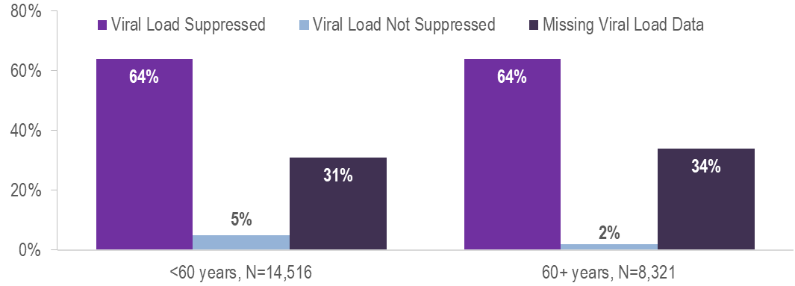
Among 8,321 persons living with HIV infection (PLWH) aged 60+ years in Massachusetts at the end of 2023 (and diagnosed through 2022), 64% were virally suppressed, 2% were not virally suppressed, and 34% did not have a viral load test in 2023. This compares to 14,516 PLWH aged under 60 years, among whom 64% were virally suppressed, 5% were not virally suppressed and 31% did not have a viral load test in 2023.
FIGURE 6. Stages of HIV care among persons living with HIV infection by age (<60 years vs. 60+ years) Massachusetts, 2023
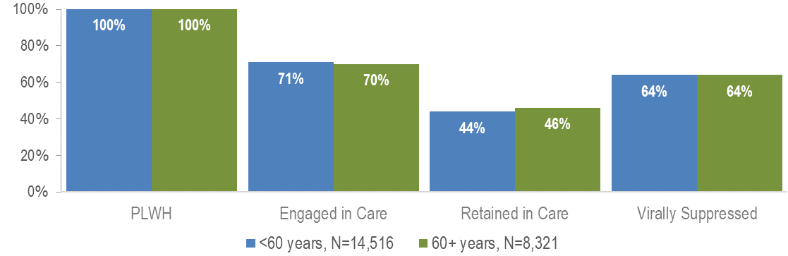
Proportions of care engagement and retention were similar among individuals aged 60+ years and those aged under 60 years in 2023 (70% vs. 71% and 46% vs. 44%, respectively). Please note that the total number of PLWH used to calculate these proportions includes all individuals who have ever been reported with HIV infection in Massachusetts with no evidence of death or having moved out of the state or country. Routine quality assurance efforts are ongoing and the number of PLWH used for this and other care continuum analyses may be updated based on these efforts.

OLDER MSM LIVING WITH HIV INFECTION
FIGURE 7. Persons aged 60+ years living with HIV infection by exposure mode, Massachusetts 2023 (N=8,726)
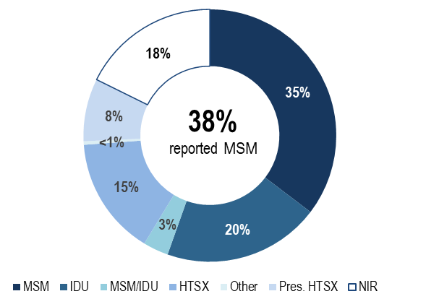
- Individuals with MSM exposure mode accounted for the largest proportion of PLWH aged 60+ years. In 2023, 35% of PLWH aged 60+ years were reported with an exposure mode of MSM and an additional 3% were reported with an exposure mode of MSM/IDU. This compares to 43% and 4% respectively for individuals aged under 60 years.
- Twenty percent of persons aged 60+ years were reported with an exposure mode of IDU and an additional 3% were reported with an exposure mode MSM/IDU. This compares to 11% and 4%, respectively, for individuals aged under 60 years.
FIGURE 8. PLWH aged 60+ years with MSM or MSM/IDU exposure mode (N=3,374) compared to PLWH aged 60+ years with other exposure modes (N=5,352) by selected demographics, Massachusetts 2023
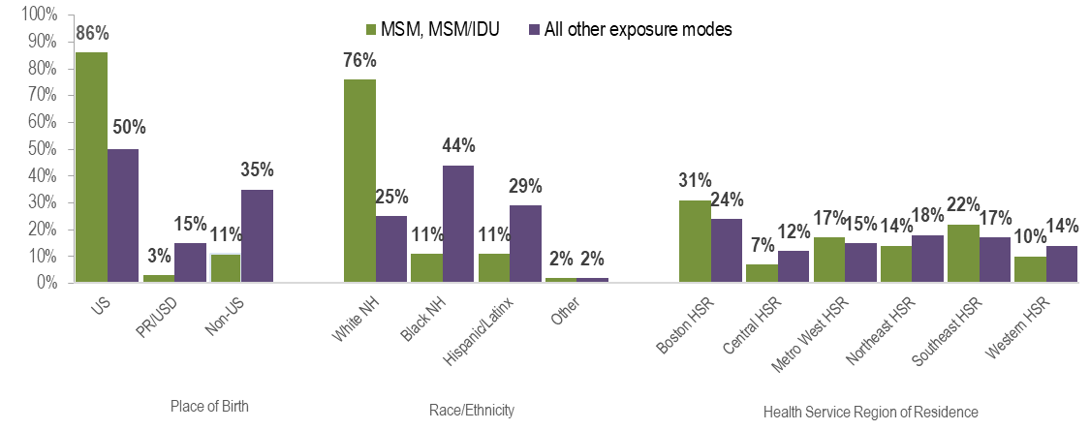
- In 2023, a larger proportion of older PLWH with MSM exposure modes:
  - was born in the United States, as compared to older PLWH with other exposure modes (86% vs. 50%);
  - was White (non-Hispanic), as compared to older PLWH with other exposure modes (76% vs. 25%); and
  - was living in the Boston or Southeast Health Service Regions, as compared to older PLWH with other exposure modes (31% and 22%, respectively vs. 24% and 17%, respectively).
HIV CARE CONTINUUM
FIGURE 9. Stages of HIV care among MSM (including MSM/IDU) aged 60+ years living with HIV infection, Massachusetts 2023 (N=3,257)
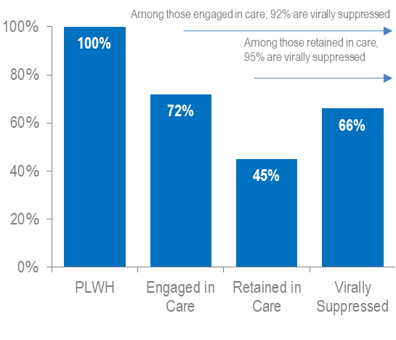
FIGURE 10. Viral load status MSM (including MSM/IDU) aged 60+ years living with HIV infection, Massachusetts 2023 (N=3,257)
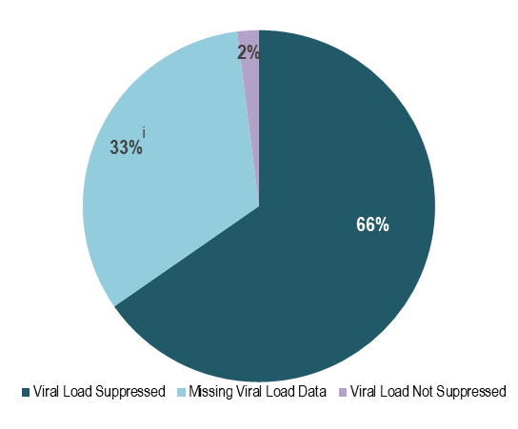
^{i} Figure 10 Note: Missing viral load data includes individuals who had not had a lab reported in the past year
In Massachusetts, among 3,257 PLWH aged 60+ years in 2023 (and diagnosed through 2022) with MSM exposure modes, 66% were virally suppressed, 2% were not virally suppressed, and 33% did not have a viral load test in 2023. Among those older PLWH with MSM exposure modes who were engaged in care (N=2,338) and retained in care (N=1,471), rates of viral suppression were higher at 92% and 95%, respectively. Engagement in care and viral suppression proportions were slightly higher among older PLWH with MSM exposure modes (72% and 66%, respectively) as compared to older PLWH with all other exposure modes (69% and 64%, respectively, data not shown). In 2023, engagement in care and viral suppression among older PLWH with MSM exposure modes differed by place of birth, race/ethnicity, and health service region of residence. Both were lowest among MSM born outside the US and those of Hispanic/Latinx ethnicity. Engagement in care and viral suppression rates were higher in the Western HSR compared to other HSRs.
FIGURE 11. Engagement in care among MSM (including MSM/IDU) aged 60+ years living with HIV infection by place of birth, race/ethnicity, and Health Service Region of residence, Massachusetts 2023, (N=3,257)
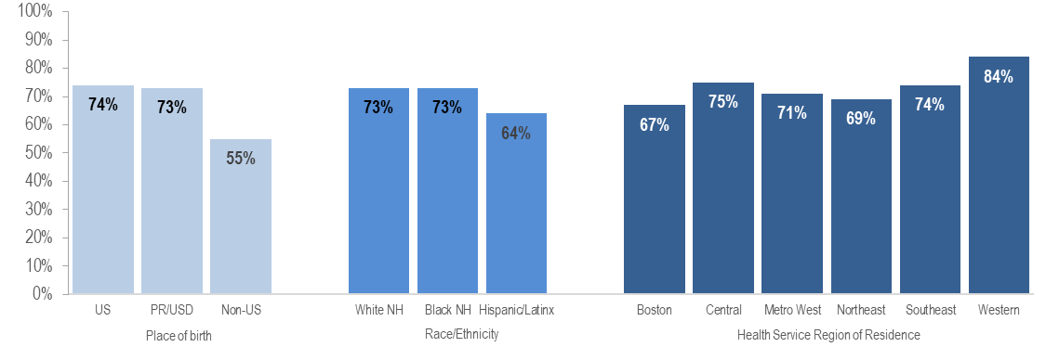
- Only 55% (N=196/354) of non-US born older MSM living with HIV infection were engaged in care, compared to 74% (N=2,072/2,807) of older US born MSM and 73% (N=70/96) of older MSM born in Puerto Rico/US Dependencies.
FIGURE 12. Viral suppression among MSM (including MSM/IDU) aged 60+ years living with HIV infection by place of birth, race/ethnicity, and Health Service Region of residence, Massachusetts 2023, (N=3,257)
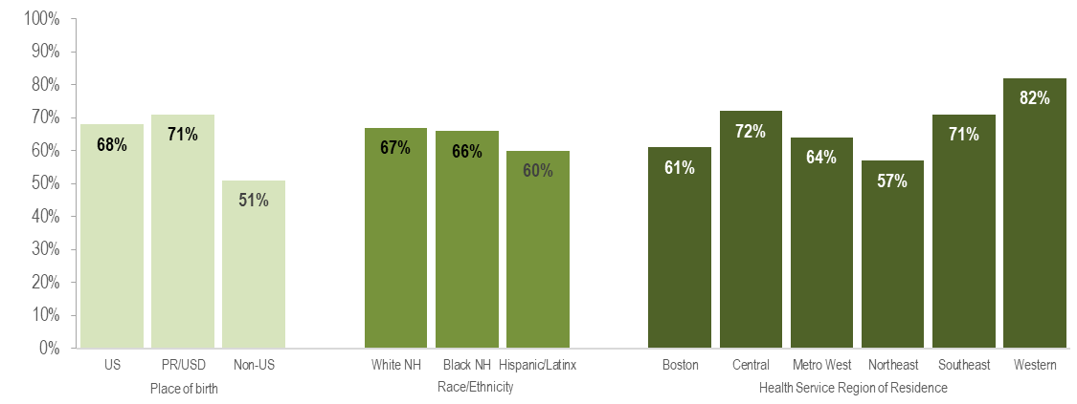
- Only 51% (N=181/354) of non-US born older MSM living with HIV infection were virally suppressed, compared to 68% (N=1,896/2,807) of older US born MSM and 71% (N=68/96) of older MSM born in Puerto Rico/US Dependencies. However, it is important to note that a much greater proportion of older non-US born MSM living with HIV infection were missing viral load information (47%) compared to those born in the US (31%) or Puerto Rico/US dependencies (29%) and that the proportion known to be not virally suppressed was similar for all groups (2% for US born and Non-US born and 0% for those born in Puerto Rico/US Dependencies). This difference may highlight limited access to clinical documentation and/or less access to viral load testing in the country of origin for non-US born individuals, particularly those who have recently arrived.

OLDER INDIVIDUALS DIAGNOSED WITH HIV INFECTION
AGE AT DIAGNOSIS
FIGURE 13. Individuals diagnosed with HIV infection by age at diagnosis, Massachusetts 2014 – 2023
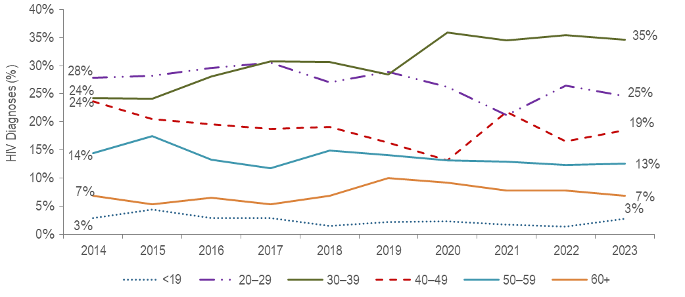
- From 2014 to 2023, the proportion of HIV infection diagnoses among 30–39 year-olds increased from 24% to 35%, while it decreased from 28% to 25% among 20–29 year-olds and from 24% to 19% among 40–49 year-olds.
- During the same time period, the percentage of HIV infection diagnoses among individuals aged 50–59 years and individuals aged 60+ years remained relatively stable.
- The average age at HIV infection diagnosis from 2014 to 2023 ranged from 36.9 years (2017) to 39.1 years (2021). Among individuals 60 years of age and older the average age at diagnosis ranged from 64.4 years (2020 and 2021) to 66.5 years (2022) (data not shown).
INDIVIDUALS DIAGNOSED WITH HIV INFECTION BY AGE (<60 VS 60+ YEARS)
SEX ASSIGNED AT BIRTH
FIGURE 14. Percentage of individuals diagnosed with HIV infection by age at diagnosis (<60 years [N=1,328] vs. 60+ years [N=107]) and sex assigned at birth, Massachusetts 2021 – 2023
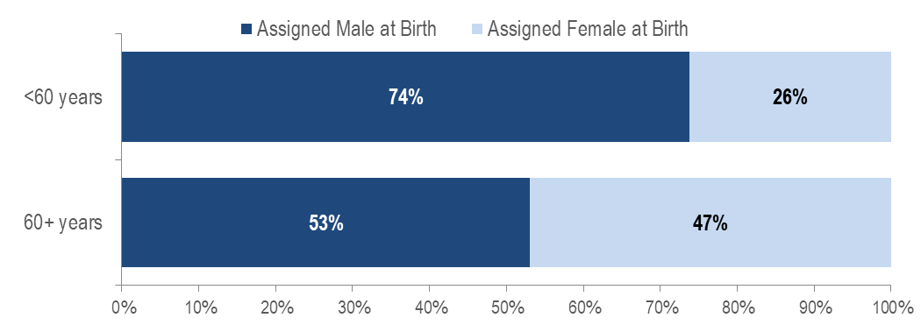KEY FINDING
- A larger proportion of individuals recently diagnosed with HIV infection aged 60+ years (47%) than those aged under 60 years (26%) was assigned female at birth. Individuals AFAB recently diagnosed with HIV infection aged 60+ years (N=50) were predominantly born outside the US (60%), Black (non-Hispanic) (64%), and had an exposure mode of presumed heterosexual sex (60%).
TRANSGENDER INDIVIDUALS AND AGE AT DIAGNOSIS
- All (N=18) individuals diagnosed with HIV infection from 2021 to 2023 and reported to be transgender were aged under 60 years.
PLACE OF BIRTH
When reviewing the following data presentations on people diagnosed with HIV infection aged 60+ years, please note that the ascertainment of accurate initial diagnosis date/age is often more difficult for individuals born outside the United States than those born in the United States or Puerto Rico. This is due to limited access to clinical documentation and/or less access to testing in the patient’s country of origin. Differences between younger (<60) and older (60+) individuals diagnosed with HIV infection displayed in this report may be an artifact of this data quality discrepancy rather than actual age at diagnosis.
FIGURE 15. Percentage of individuals diagnosed with HIV infection by age at diagnosis (<60 years [N=1,328] vs. 60+ years [N=107]) and place of birth, Massachusetts 2021 – 2023
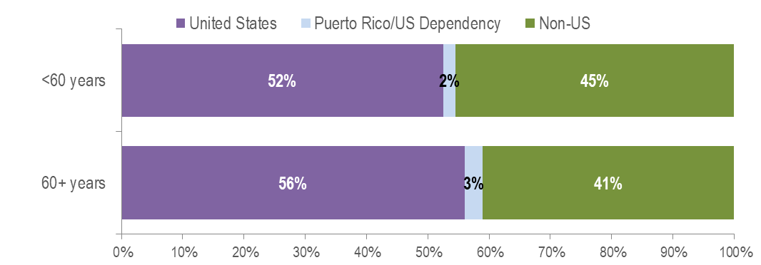
KEY FINDING
- Forty-one percent of individuals aged 60+ years recently diagnosed with HIV infection were born outside the United States, compared to 45% of individuals aged under 60 years. Among individuals aged 60+ years recently diagnosed with HIV infection and born outside the United States, 32% were assigned male at birth (AMAB) and 68% were assigned female at birth (AFAB).
RACE/ETHNICITY
FIGURE 16. Percentage of individuals diagnosed with HIV infection by age at diagnosis (<60 years [N=1,328] vs. 60+ years [N=107]) and race/ethnicity, Massachusetts 2021 – 2023
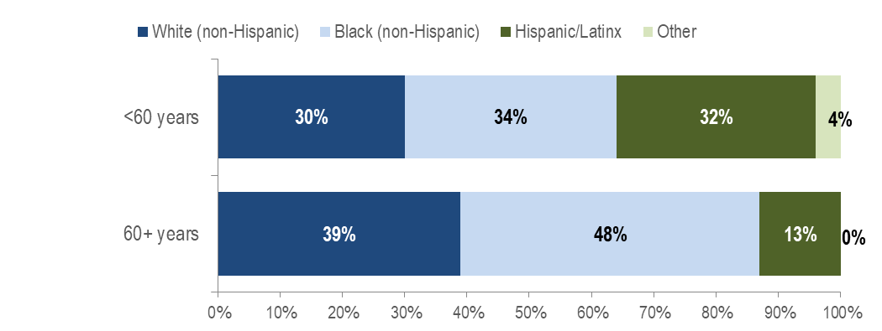

KEY FINDING
- Forty-eight percent of individuals aged 60+ years recently diagnosed with HIV infection were Black (non-Hispanic), compared to 34% of individuals aged under 60 years.
EXPOSURE MODE
FIGURE 17. Percentage of individuals diagnosed with HIV infection by age at diagnosis (<60 years [N=1,328] vs. 60+ years [N=107]) and exposure mode, Massachusetts 2021 – 2023
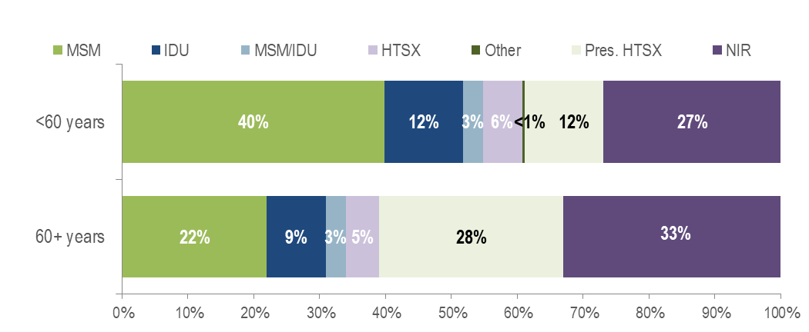
KEY FINDING
- Thirty-three percent (N=35/107) of individuals recently diagnosed with HIV infection at age 60+ years did not have exposure mode information reported that met CDC-defined categories, compared to 27% among individuals diagnosed under age 60 years. This highlights challenges in assigning primary exposure modes for the older adult population. Individuals aged 60+ years recently diagnosed without reported exposure mode information consisted predominantly of individuals AMAB (66%), individuals born outside the US (54%), and individuals of Black (non-Hispanic) (74%) race.
EXPOSURE MODE BY SEX ASSIGNED AT BIRTH
FIGURE 18. Percentage of individuals diagnosed with HIV infection at 60+ years (N=107) by sex assigned at birth and exposure mode, Massachusetts 2021 – 2023
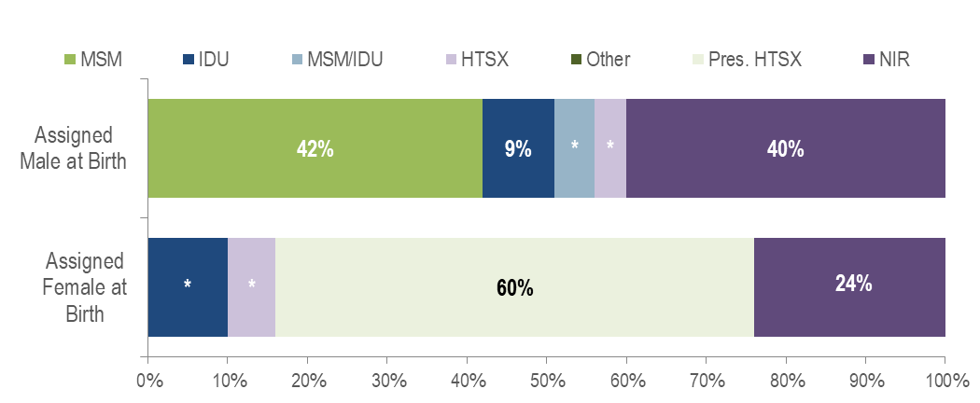Figure 18 note:* Values less than five are suppressed for populations less than 50,000 or for populations of unknown size. Percentages do not add up to 100% due to suppressed values.
- Forty percent (N=23/57) of individuals AMAB recently diagnosed with HIV infection at age 60+ years did not have exposure mode information reported that met CDC-defined categories, compared to 24% (N=12/50) among individuals AFAB diagnosed at age 60+ years. Among individuals AMAB aged 60+ years recently diagnosed with HIV infection without exposure mode information, 52% were born outside the US. Comparatively, among individuals AFAB aged 60+ years recently diagnosed with HIV infection without exposure mode information, 58% were born outside the US.
AREA OF RESIDENCE
FIGURE 19. Percentage of individuals diagnosed with HIV infection by age at diagnosis (<60 years [N=1,328] vs. 60+ years [N=107]) and by Health Service Region (HSR) of residence, Massachusetts 2021 – 2023
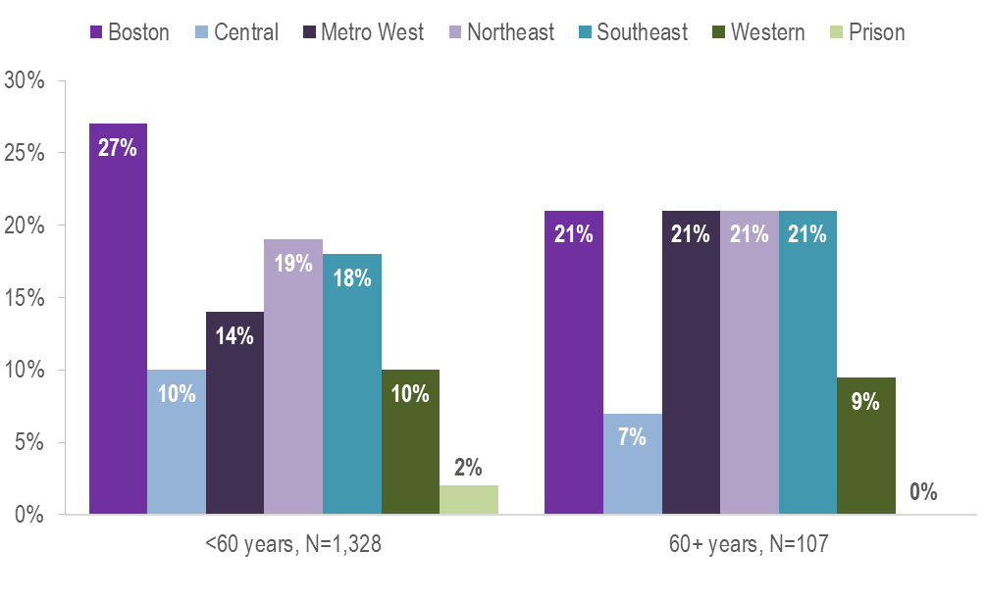
- A larger proportion of individuals recently diagnosed with HIV infection aged 60+ years (21%) than those aged under 60 years (14%) were living in the Metrowest HSR and a smaller proportion were living in the Boston HSR (21% vs. 27%).

HIV Surveillance Data Source: MDPH Bureau of Infectious Disease and Laboratory Sciences, data are current as of 7/1/2024 and may be subject to change.

Providers may use this number to report individuals newly diagnosed with a notifiable sexually transmitted infection, including HIV, or request partner services. Partner services is a free and confidential service for individuals recently diagnosed with a priority infection. The client-centered program offers counseling, linkage to other health and social services, anonymous notification of partners who were exposed and assistance with getting testing and treatment. For more information, see: https://www.mass.gov/service-details/partner-services-program-information-for-healthcare-providers)
Panel on Antiretroviral Guidelines for Adults and Adolescents. Guidelines for the Use of Antiretroviral Agents in Adults and Adolescents with HIV. Department of Health and Human Services. 2019. Available at https://clinicalinfo.hiv.gov/en/guidelines/hiv-clinical-guidelines-adult-and-adolescent-arv/hiv-and-older-person Accessed (2/3/2023) [HIV and the Older Person]
Please consider the impact of the COVID-19 pandemic on infectious disease screening, treatment, and surveillance in the interpretation of data from 2020 to 2023.
Please consider the impact of the COVID-19 pandemic on infectious disease screening, treatment, and surveillance in the interpretation of data from 2020 to 2023.
Please consider the impact of the COVID-19 pandemic on infectious disease screening, treatment, and surveillance in the interpretation of data from 2020 to 2023.
Please consider the impact of the COVID-19 pandemic on infectious disease screening, treatment, and surveillance in the interpretation of data from 2020 to 2023.
HIV care continuum among persons living with HIV infection (PLWH) in Massachusetts: “PLWH” refers to individuals diagnosed through 2022, alive through 12/31/2023, and living in Massachusetts based on last known address. “Engaged in Care” is defined as having ≥1 VL or CD4 test result in 2023. “Retained in Care” is defined as having ≥2 VL or CD4 test results at least 3 months apart in 2023. “Virally Suppressed” is defined as having a VL <200 copies/mL for the most recent VL test drawn in 2023.
Please consider the impact of the COVID-19 pandemic on infectious disease screening, treatment, and surveillance in the interpretation of data from 2020 to 2023.
Routine quality assurance and follow up are conducted to update mortality status and the current residence of PLWH.
Please consider the impact of the COVID-19 pandemic on infectious disease screening, treatment, and surveillance in the interpretation of data from 2020 to 2023.
Please consider the impact of the COVID-19 pandemic on infectious disease screening, treatment, and surveillance in the interpretation of data from 2020 to 2023.
Includes MSM and MSM/IDU exposure modes
HIV care continuum among persons living with HIV infection (PLWH) in Massachusetts: “PLWH” refers to individuals diagnosed through 2022, alive through 12/31/2023, and living in Massachusetts based on last known address. “Engaged in Care” is defined as having ≥1 VL or CD4 test result in 2023. “Retained in Care” is defined as having ≥2 VL or CD4 test results at least 3 months apart in 2023. “Virally Suppressed” is defined as having a VL <200 copies/mL for the most recent VL test drawn in 2023.
Please consider the impact of the COVID-19 pandemic on infectious disease screening, treatment, and surveillance in the interpretation of data from 2020 to 2023.
Includes MSM and MSM/IDU exposure modes
Please consider the impact of the COVID-19 pandemic on infectious disease screening, treatment, and surveillance in the interpretation of data from 2020 to 2023.
Please consider the impact of the COVID-19 pandemic on infectious disease screening, treatment, and surveillance in the interpretation of data from 2020 to 2023.
Please consider the impact of the COVID-19 pandemic on infectious disease screening, treatment, and surveillance in the interpretation of data from 2020 to 2023.
Please consider the impact of the COVID-19 pandemic on infectious disease screening, treatment, and surveillance in the interpretation of data from 2020 to 2023.
Please consider the impact of the COVID-19 pandemic on infectious disease screening, treatment, and surveillance in the interpretation of data from 2020 to 2023.
Please consider the impact of the COVID-19 pandemic on infectious disease screening, treatment, and surveillance in the interpretation of data from 2020 to 2023.
Please consider the impact of the COVID-19 pandemic on infectious disease screening, treatment, and surveillance in the interpretation of data from 2020 to 2023.

