# The Commonwealth of Massachusetts

Executive Office of Health and Human Services Department of Public Health

250 Washington Street, Boston, MA 02108-4619

## On-Site Unhealthy Heat Management Plan for Correctional Facilities

|  |
| --- |
| **Facility Name:** |
| **Address:** |
| **Environmental Health and Safety Officer (EHSO) Name:** |

This On-Site Unhealthy Heat Management Plan will help prepare for and manage unhealthy heat events, document your facility’s mitigation efforts, and monitor your progress during an unhealthy heat wave. Every site or facility is different, and plans are meant to be modified to fit your site’s needs.

Parts of the template are meant to have multiple pages for equipment catalogues and housing unit surveys. Other parts of this on-site management plan, like the temperature logs and mitigation efforts, should be partially completed during the planning stages and then, during each extreme heat event, the monitoring information is completed. Facilities should keep completed forms together to document the steps taken to address extreme heat and health concerns. These completed forms can be used to evaluate and prioritize longer-term upgrades and plans for the next season. Staff preferences for paper forms or electronic fillable forms will vary as will the building designs and infrastructure. There is no one-size fits all approach, and correctional facilities should customize plans and templates to fit their needs.

**Keep all completed templates together and provide them to the Division of Environmental Health Regulations and Standards (EHRS) staff during inspections, surveys, and audits to show the steps your facility has taken to address extreme heat and health concerns.**

How to use this template:

Section One: Plan and Prepare (Winter and Spring)

1. Maintain and track servicing for mechanical ventilation systems for each housing unit
2. Maintain and track accessibility and functionality of non-HVAC cooling options - AC’s, fans, windows
   * Inventory of operational windows, fans and AC’s
   * Repair/replace as needed
3. Survey and assess risk based on housing unit and area specific results for existing ventilation and cooling capacity
4. Identify site-specific most vulnerable individuals during an unhealthy extreme heat event
5. Identify and plan for site-specific short-term mitigation efforts to implement during unhealthy heat waves
6. Select, purchase, catalogue, and calibrate air testing equipment
7. Order other items or equipment if identified as part of the short-term mitigation strategies (canopies, umbrellas, misters, coolers/cambros, water bottles, cooling towels)

Section Two: Track efforts during unhealthy heat waves

1. Track unhealthy heat alerts
2. Implement and track mitigation efforts (behavioral and engineering) during an extreme heat event
3. Implement and track relocation mitigation efforts during an extreme heat event
4. Monitor and track cooling efforts for vulnerable individuals at greatest risk for heat related illness
5. Monitor the indoor air temperature and relative humidity for each housing unit

Planning, Preparing, Identifying, and Monitoring Site Specific Risk:

1. Does your facility have formal policies and procedures in place to mitigate the effects of extreme heat?
   * YES ☐NO
2. Does your facility have air testing equipment capable of testing air temperature and relative humidity?
   * YES ☐NO
3. Are there any housing units that have partial or complete air conditioning? If so, document them on the Mitigation Efforts documentation page.
   * YES ☐NO
4. When was the last ventilation survey from the MA Division of Resource Management:
5. What was the result of that survey? Is the ventilation system at your facility working in accordance with the manufacturer’s specifications?

## Planning: Air Testing Equipment

1. Complete the boxes below. Use one box for each piece of air testing equipment used to measure the air temperature and relative humidity at your facility. If you only have one piece of equipment, complete one box.
2. The following are examples of low cost and user-friendly options for air testing equipment that are under $100 and have limited calibration requirements. These are possible options and not an exhaustive list of products available. The MA Department of Public Health does not endorse any specific equipment or company:
   1. [EXTECH Temperature Humidity Meter](https://www.grainger.com/product/3LYW6)
   2. [Sper Scientific – 800127, Pen Style](https://www.grainger.com/product/3LYW6) [Thermo-Hygrometer with Wet Bulb and Dew Point](https://sperdirect.com/products/pen-type-thermo-hygrometer)
   3. [Mastercool 52230](https://www.tequipment.net/Mastercool/52230/Hygrometers/?Source=googleshopping&gad_source=1&gclid=EAIaIQobChMIkeiFooDChgMVj0r_AR2ClgCgEAQYASABEgLJYPD_BwE)
3. Make additional copies if needed.

|  |  |
| --- | --- |
| **Air Testing Equipment** | |
| **Date of Purchase:** |  |
| **Manufacturer:** |  |
| **Model:** |  |
| **Type of Equipment:** |  |
| **Manufacturer Calibration Specifications:** |  |

|  |  |
| --- | --- |
| **Air Testing Equipment** | |
| **Date of Purchase:** |  |
| **Manufacturer:** |  |
| **Model:** |  |
| **Type of Equipment:** |  |
| **Manufacturer Calibration Specifications:** |  |

|  |  |
| --- | --- |
| **Air Testing Equipment** | |
| **Date of Purchase:** |  |
| **Manufacturer:** |  |
| **Model:** |  |
| **Type of Equipment:** |  |
| **Manufacturer Calibration Specifications:** |  |

## Planning: Calibration Log

1. Complete the boxes below. Use one box to document when each piece of air testing equipment used to measure the air temperature and relative humidity at your facility is calibrated, in accordance with manufacturer’s specifications. If you only have one piece of equipment, complete one box.
2. The cost of required air testing calibration equipment is separate and is usually available for less than $50.
3. Make additional copies if needed.

|  |  |
| --- | --- |
| **Calibration Information** | |
| **Equipment:** |  |
| **Date of Calibration:** |  |
| **Name of Person Conducting**  **Calibration:** |  |

|  |  |
| --- | --- |
| **Calibration Information** | |
| **Equipment:** |  |
| **Date of Calibration:** |  |
| **Name of Person Conducting**  **Calibration:** |  |

|  |  |
| --- | --- |
| **Calibration Information** | |
| **Equipment:** |  |
| **Date of Calibration:** |  |
| **Name of Person Conducting**  **Calibration:** |  |

|  |  |
| --- | --- |
| **Calibration Information** | |
| **Equipment:** |  |
| **Date of Calibration:** |  |
| **Name of Person Conducting**  **Calibration:** |  |

|  |  |
| --- | --- |
| **Calibration Information** | |
| **Equipment:** |  |
| **Date of Calibration:** |  |
| **Name of Person Conducting**  **Calibration:** |  |

## Planning: Ventilation

1. Complete (at least) one page for **each** housing unit.
2. Make additional copies if needed.

**Housing Unit:**

**(ex: Pod #, Block #, Unit #, Dorm #)**

Describe the primary ventilation system design within this housing unit (**check all that apply**):

* + Mechanical ☐Openable windows ☐Transoms ☐ Wall Mounted Fans ☐Ceiling Fans ☐Other

Include design specifications and details:

|  |  |
| --- | --- |
| **Mechanical Ventilation Maintenance and Service** | |
| **Date of Last Service:** |  |
| **Description of Service Provided:**  **(changed filters, changed belts, etc…)** |  |
| **Results from Service:** |  |
| **Description of Follow-Up:**  **(if necessary)** |  |
| **Name of Company or Internal**  **Facility Staff Performing Service:** |  |
| **Address:** |  |
| **Contact Person:** |  |
| **Phone Number:** |  |

|  |  |  |
| --- | --- | --- |
| **Location and Number of Additional Fans** | | |
| **Type of fan (wall, ceiling, industrial, window, standing)** | **Describe the location (floor, tier, wall)** | **Number of fans** |
|  |  |  |
|  |  |  |
|  |  |  |
|  |  |  |

|  |  |  |  |
| --- | --- | --- | --- |
| **Are Personal Fans supplied to indigent inmates?**  **YES or NO** | **Can windows open in the cells? YES or NO** | **Are transoms open? YES, NO, N/A** | **Is the Housing Unit Air Conditioned?**  **YES or NO** |
| **Yes**  **No** | **Yes**  **No** | **Yes**  **No** | **Yes**  **No** |

## Planning and Monitoring: Cooler Indoor and Outdoor Areas Identified for Temporary Relocation

1. Complete the top part of these boxes to identify each designated area(s) within the facility that may be used to temporarily house vulnerable incarcerated individuals during extreme heat events as part of your planning.
2. Document the capacity (number of individuals) that can be safely and securely housed in that area.
3. Document the benefit of the area that makes this space cooler (level of the building, air conditioning, additional fans, etc.)
4. Identify any specific requirements needed to use the space (moving tables/chairs, increased oversight, etc.)
5. Monitor and track the relocated individuals during each heat event (green section). Each area identified has spaces for 4

separate extreme heat events, if more than 4 extreme heat events occur this form will need to be copied.

|  |  |  |  |
| --- | --- | --- | --- |
| Area | Capacity | Benefit of the Area | Requirements to Use the  Space |
|  | |  |  |
|  |  |
| To be completed if the area is used during a heat event Date:  Number of Individuals: | | To be completed if the area is used during a heat event Date:  Number of Individuals: | |
| To be completed if the area is used during a heat event Date:  Number of Individuals: | | To be completed if the area is used during a heat event Date:  Number of Individuals: | |

|  |  |  |  |
| --- | --- | --- | --- |
| Area | Capacity | Benefit of the Area | Requirements to Utilize the Space |
|  | |  |  |
|  |  |
| To be completed if the area is used during a heat event Date:  Number of Individuals: | | To be completed if the area is used during a heat event Date:  Number of Individuals: | |
| To be completed if the area is used during a heat event Date:  Number of Individuals: | | To be completed if the area is used during a heat event Date:  Number of Individuals: | |

|  |  |  |  |
| --- | --- | --- | --- |
| Area | Capacity | Benefit of the Area | Requirements to Utilize the Space |
|  | |  |  |
|  |  |
| To be completed if the area is used during a heat event Date:  Number of Individuals: | | To be completed if the area is used during a heat event Date:  Number of Individuals: | |
| To be completed if the area is used during a heat event Date:  Number of Individuals: | | To be completed if the area is used during a heat event Date:  Number of Individuals: | |

## Planning and Monitoring: Vulnerable Individuals

1. The facility staff should work with the Health Services Unit (HSU) to identify and designate an area(s) suitable for safely housing the most vulnerable population during extreme heat conditions. HSU should complete, maintain and store the following template which includes personal medical information to help identify high-risk incarcerated individuals prior to extreme heat events. This template should be used to identify and document high-risk incarcerated individuals who have been temporarily relocated to mitigate the effects of extreme heat.
2. Monitor and track each relocated individual(s) during separate extreme heat events. Each identified individual has spaces for 4 extreme heat events, if more than 4 extreme heat events occur, or more than 3 individuals are involved, this form will need to be copied.

|  |  |  |
| --- | --- | --- |
| Individual Identified as High Risk for Extreme Heat Concerns  Name: | Pre-existing Condition/High Risk Category (indicate all that apply)   * Age 65 or older * Asthma * Allergy/Sensitivity * Diabetes * Obesity * Disability/Impaired mobility * Heart, Lung, Liver or Kidney Disease * Pregnancy * Prescription Drug Concerns * Other | Temporary Relocation Area Date:  Area:  Date: Area:  Date: Area:  Date: Area: |
| Individual Identified as High Risk for Extreme Heat Concerns  Name: | Pre-existing Condition/High Risk Category (indicate all that apply)   * Age 65 or older * Asthma * Allergy/Sensitivity * Diabetes * Obesity * Disability/Impaired mobility * Heart, Lung, Liver or Kidney Disease * Pregnancy * Prescription Drug Concerns * Other | Temporary Relocation Area Date:  Area:  Date: Area:  Date: Area:  Date: Area: |
| Individual Identified as High Risk for Extreme Heat Concerns  Name: | Pre-existing Condition/High Risk Category (indicate all that apply)   * Age 65 or older * Asthma * Allergy/Sensitivity * Diabetes * Obesity * Disability/Impaired mobility * Heart, Lung, Liver or Kidney Disease * Pregnancy * Prescription Drug Concerns * Other | Temporary Relocation Area Date:  Area:  Date: Area:  Date: Area:  Date: Area: |

## Monitoring: Indoor Air Temperature Results

1. Complete one page for **each** housing unit.
2. Measure and document the indoor air temperature and relative humidity for each housing unit.
3. The EHRS recommends testing at least three times a day in different places within each housing unit.
4. Make additional copies if needed.

|  |  |
| --- | --- |
| **Housing Unit:**  **(ex: Pod # Block #, Unit #, Dorm #)** |  |
| **Name of Person Conducting Air**  **Testing:** |  |
| **Equipment Used:** |  |
| **Outside Temperature: Outside Relative Humidity: Time of Day:** | |

|  |  |  |  |  |
| --- | --- | --- | --- | --- |
| **Temperature Testing Log** | | | | |
| **Date** | **Time of Day** | **Testing Location**  **(ex: 1st floor common area, 2nd tier cell #)** | **Temperature** | **Relative Humidity** |
|  |  |  |  |  |
|  |  |  |  |  |
|  |  |  |  |  |
|  |  |  |  |  |
|  |  |  |  |  |
|  |  |  |  |  |
|  |  |  |  |  |
|  |  |  |  |  |
|  |  |  |  |  |
|  |  |  |  |  |
|  |  |  |  |  |
|  |  |  |  |  |
|  |  |  |  |  |
|  |  |  |  |  |
|  |  |  |  |  |
|  |  |  |  |  |

Comments:

## Monitoring: Mitigation Efforts During Unhealthy Heat

1. Use the chart below to document additional mitigation efforts put in place within multiple housing units.
2. In the first column identify the housing unit and in each subsequent column indicate Yes or No in the box to reflect whether each category is applicable or not to that housing unit.
3. 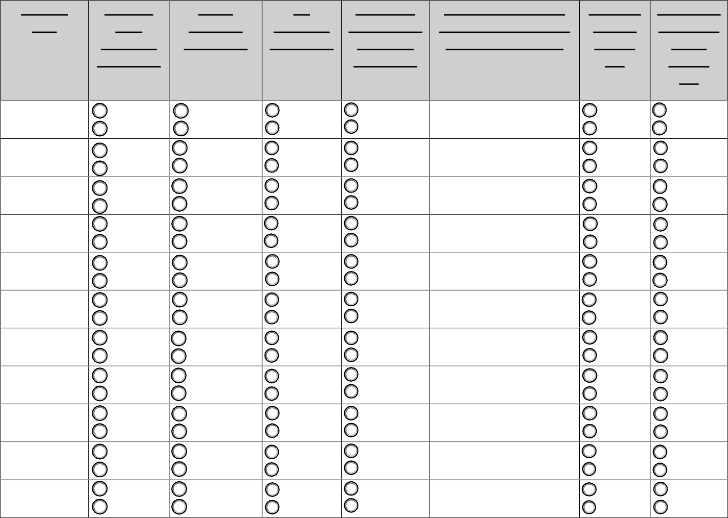Make additional copies if needed.

|  |  |  |  |  |  |  |  |
| --- | --- | --- | --- | --- | --- | --- | --- |
| **Housing Unit** | **Personal Fans Supplied?**  **YES or NO** | **Water supplied? YES or NO** | **Ice Supplied? YES or NO** | **Additional Shower Time available?**  **YES or NO** | **If the answer is Yes to additional shower time, indicate times below:** | **Windows Tinted? YES or NO** | **Alternative Recreation Time?**  **YES or**  **NO** |

|  |  |  |  |  |  |
| --- | --- | --- | --- | --- | --- |
| Yes | Yes | Yes | Yes | Yes | Yes |
| No | No | No | No | No | No |
| Yes | Yes | Yes | Yes | Yes | Yes |
| No | No | No | No | No | No |
| Yes | Yes | Yes | Yes | Yes | Yes |
| No | No | No | No | No | No |
| Yes | Yes | Yes | Yes | Yes | Yes |
| No | No | No | No | No | No |
| Yes | Yes | Yes | Yes | Yes | Yes |
| No | No | No | No | No | No |
| Yes | Yes | Yes | Yes | Yes | Yes |
| No | No | No | No | No | No |
| Yes | Yes | Yes | Yes | Yes | Yes |
| No | No | No | No | No | No |
| Yes | Yes | Yes | Yes | Yes | Yes |
| No | No | No | No | No | No |
| Yes | Yes | Yes | Yes | Yes | Yes |
| No | No | No | No | No | No |
| Yes | Yes | Yes | Yes | Yes | Yes |
| No | No | No | No | No | No |
| Yes | Yes | Yes | Yes | Yes | Yes |
| No | No | No | No | No | No |

Does the facility offer outdoor shaded areas? Please indicate where:

What additional control measures beyond those noted above are in place to help individuals seek relief from the extreme heat:

**Unhealthy Heat Forecast**

The [Unhealthy Heat Forecast](https://www.mass.gov/info-details/massachusetts-unhealthy-heat-forecast) is a Massachusetts-specific tool developed by BCEH to help communities prepare for dangerous heat. It monitors temperature trends across the state and provides a 7-day forecast that signals when a heat wave is expected and alerts should be activated using the Unhealthy Heat Threshold.

**Unhealthy Heat Threshold**

When BCEH compared heat waves over several prior summers, our data show that when the temperature rises to 85°F or more for three days in a row, there is a significant increase in emergency room visits and heat-related illnesses. This Unhealthy Heat Threshold (85°F for 3 or more days) predictably identifies significant health impacts.

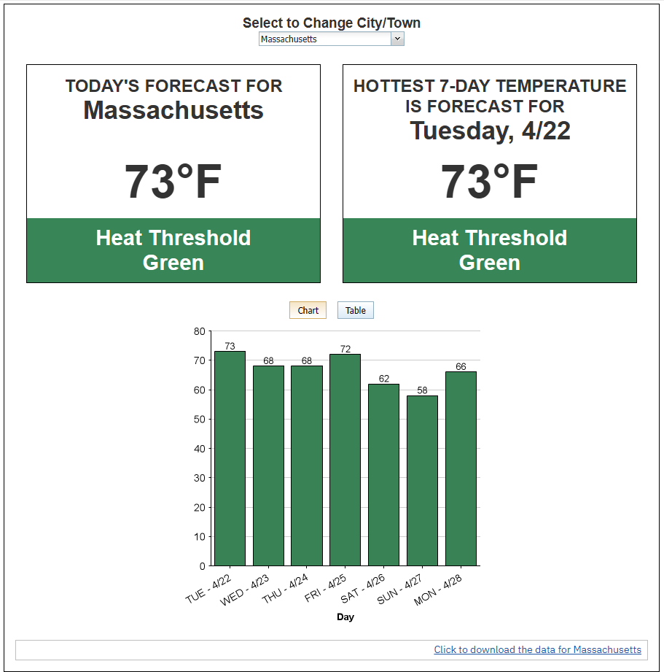



The EHRS will use this tool and will send out extreme heat alerts to facilities based on predicted weather. The EHRS recommends that at least once a week, your facility log into the dashboard to check the forecast and prepare for the days and week ahead. Save a copy of the weekly forecast dashboard to document your forecasting efforts.

|  |  |  |
| --- | --- | --- |
| Review  Date | Weekly Dates  **2025** | Copy attached |
|  | 6/22–6/28 |  |
|  | 6/29 – 7/5 |  |
|  | 7/6 – 7/12 |  |
|  | 7/13 – 7/19 |  |
|  | 7/20 – 7/26 |  |
|  | 7/27 – 8/2 |  |
|  | 8/3 – 8/9 |  |
|  | 8/10 – 8/16 |  |
|  | 8/17 – 8/23 |  |
|  | 8/24 – 8/30 |  |

|  |  |  |
| --- | --- | --- |
| Review  Date | Weekly Dates  **2025** | Copy attached |
|  | 8/31 – 9/6 |  |
|  | 9/7 – 9/13 |  |
|  | 9/14 – 9/20 |  |
|  | 9/21 – 9/27 |  |
|  | 9/28 – 10/4 |  |
|  | 10/5 – 10/11 |  |
|  | 10/12 – 10/18 |  |
|  | 10/19 – 10/25 |  |
|  | 10/26 – 11/1 |  |

# Monitoring Mitigation Strategies and Indoor Air Temperatures

## Unhealthy Heat Events Year:

**Alert received on by**

Mitigation Efforts Implemented

❑

Details:

❑

## Alert received on by

Mitigation Efforts Implemented

❑

Details:

❑

## Alert received on by

Mitigation Efforts Implemented

❑

Details:

❑