Are you or a family member in One Care?
Commonwealth Care Alliance (CCA) or Tufts Health Unify?
Are you thinking about joining?
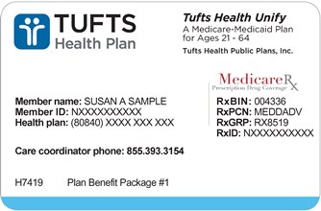
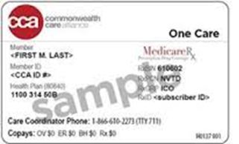

Join us for a statewide discussion about One Care
Share your thoughts about One Care with MassHealth and fellow One Care members
Sponsored by the One Care Implementation Council

WHEN: December 14 from 10:00 am-12 noon

HOW: Register for the Dec 14th Town Hall for Zoom:
https://bit.ly/RegisterICTownHall
or
Join the meeting by phone: 1-646-876-9923
(Meeting ID: 940 3359 4823 and Password: 373067)

For questions, contact the My Ombudsman program at 855-781-9898, VideoPhone: 339-224-6831, or via email at: info@myombudsman.org.

Closed captioning, American Sign Language (ASL) interpreters and Spanish translators will be available.
For any other reasonable accommodation and translator requests contact
margaret.carey@umassmed.edu

Facilitated by Community Catalyst

