INDOOR AIR QUALITY ASSESSMENT

One Grafton Common
Suite 14
Grafton, Massachusetts



Prepared by:
Massachusetts Department of Public Health
Bureau of Environmental Health
Indoor Air Quality Program
February 2014

Background/Introduction
At the request of Mr. Brian Gallant, Health Agent for the Grafton Board of Health (GBOH), the Massachusetts Department of Public Health (MDPH), Bureau of Environmental Health (BEH) provided assistance and consultation regarding indoor air quality (IAQ) concerns at Suite 14 of One Grafton Common, Grafton, Massachusetts. On October 17, 2013, Cory Holmes, Environmental Analyst/Inspector for BEH’s Indoor Air Quality (IAQ) Program conducted an IAQ assessment. The request was prompted by concerns of respiratory irritation, airborne particulate exposure and general IAQ conditions.
One Grafton Common is a red brick/slate-roofed town-owned/operated building that was built in the mid 1800’s. The town of Grafton leases space within the building to non-profit groups and private businesses. It is listed on both the state and federal historic building registers. Suite 14 is a private office space situated on the first floor of the building housing a recruitment/staffing business. Windows are currently unopenable.

Methods
Air tests for carbon monoxide, carbon dioxide, temperature and relative humidity were conducted with the TSI, Q-Trak, IAQ Monitor, Model 7565. Air tests for airborne particle matter with a diameter less than 2.5 micrometers were taken with the TSI, DUSTTRAK™ Aerosol Monitor, Model 8520. BEH/IAQ staff also performed visual inspection of building materials for water damage and/or microbial growth. Test results are listed in Table 1.

Results
Suite 14 has an employee population of 3-5 and can be visited by several individuals daily. Tests were taken during normal operations and results appear in Table 1.

Discussion

Ventilation
It can be seen from Table 1 that carbon dioxide levels were above 800 parts per million (ppm) in two of six areas surveyed the day of assessment, indicating less than optimal air exchange in some areas. The heating, ventilation and air conditioning (HVAC) system consists of air-handling units (AHUs) located in the basement (Picture 1). Conditioned air is distributed via air diffusers installed in the floor (Picture 2) and ducted back to the AHUs via return vents.
It is important to note, however, that the AHUs did not appear to introduce fresh air and are limited to heating/cooling and circulating air. Therefore, the only means of introducing fresh, outside air would be via openable windows. The building was originally designed to have openable windows for natural ventilation; however the windows have reportedly been painted shut for decades.
The HVAC system is controlled by digital thermostats (Picture 3). Airflow is controlled using a fan switch that has two settings, on and auto. When the fan is set to on, the system provides a continuous source of air circulation and filtration. The automatic setting on the thermostat activates the HVAC system at a preset temperature. Once the preset temperature is reached, the HVAC system is deactivated. Therefore, no mechanical ventilation is provided until the thermostat re-activates the system. The MDPH recommends that digital thermostats be set to the fan “on” setting to provide continuous air circulation.
Minimum design ventilation rates are mandated by the Massachusetts State Building Code (MSBC). Until 2011, the minimum ventilation rate in Massachusetts was higher for both occupied office spaces and general classrooms, with similar requirements for other occupied spaces (BOCA, 1993). The current version of the MSBC, promulgated in 2011 by the State Board of Building Regulations and Standards (SBBRS), adopted the 2009 International Mechanical Code (IMC) to set minimum ventilation rates. Please note that the MSBC is a minimum standard that is not health-based. At lower rates of cubic feet per minute (cfm) per occupant of fresh air, carbon dioxide levels would be expected to rise significantly. A ventilation rate of 20 cfm per occupant of fresh air provides optimal air exchange resulting in carbon dioxide levels at or below 800 ppm in the indoor environment in each area measured. MDPH recommends that carbon dioxide levels be maintained at 800 ppm or below. This is because most environmental and occupational health scientists involved with research on IAQ and health effects have documented significant increases in indoor air quality complaints and/or health effects when carbon dioxide levels rise above the MDPH guidelines of 800 ppm for schools, office buildings and other occupied spaces (Sundell, J. et al., 2011). The ventilation must be on at all times that the room is occupied. Providing adequate fresh air ventilation with open windows and maintaining the temperature in the comfort range during the cold weather season is impractical. Mechanical ventilation is usually required to provide adequate fresh air ventilation.
Carbon dioxide is not a problem in and of itself. It is used as an indicator of the adequacy of the fresh air ventilation. As carbon dioxide levels rise, it indicates that the ventilating system is malfunctioning or the design occupancy of the room is being exceeded. When this happens, a buildup of common indoor air pollutants can occur, leading to discomfort or health complaints. The Occupational Safety and Health Administration (OSHA) standard for carbon dioxide is 5,000 parts per million parts of air (ppm). Workers may be exposed to this level for 40 hours/week, based on a time-weighted average (OSHA, 1997).
The MDPH uses a guideline of 800 ppm for publicly occupied buildings. A guideline of 600 ppm or less is preferred in schools due to the fact that the majority of occupants are young and considered to be a more sensitive population in the evaluation of environmental health status. Inadequate ventilation and/or elevated temperatures are major causes of complaints such as respiratory, eye, nose and throat irritation, lethargy and headaches. For more information concerning carbon dioxide, consult Appendix A.
Temperature readings during the assessment ranged from 71ºF to 72ºF, which were within the MDPH recommended comfort guidelines. The MDPH recommends that indoor air temperatures be maintained in a range of 70ºF to 78ºF in order to provide for the comfort of building occupants. In many cases concerning indoor air quality, fluctuations of temperature in occupied spaces are typically experienced, even in a building with an adequate fresh air supply.
The relative humidity at the time of assessment ranged from 45 to 51 percent, which was within the MDPH recommended comfort range. The MDPH recommends a comfort range of 40 to 60 percent for indoor air relative humidity. Relative humidity levels in the building would be expected to drop during the winter months due to heating. The sensation of dryness and irritation is common in a low relative humidity environment. Low relative humidity is a very common problem during the heating season in the northeast part of the United States.

Microbial/Moisture Concerns
In order for building materials to support mold growth, a source of water exposure is necessary. No current water damage, visible mold growth or associated odors were observed/detected in Suite 14 at the time of the assessment.
BEH/IAQ staff examined the outside perimeter of the building to identify breaches in the building envelope and/or other conditions that could provide a source of water penetration. A number of exterior sources for moisture infiltration were identified:
- Clinging plants, trees and shrubbery were observed growing on/in close proximity to the foundation and building exterior (Pictures 4 and 5). Plants in close proximity to the building envelope can cause water damage to brickwork and mortar. Water can eventually penetrate the brick providing for subsequent freezing and thawing during the winter. This freezing/thawing action can weaken bricks and mortar, resulting in damage;
- Missing/damaged mortar and brick (Pictures 6 through 8);
- Damaged wooden windows (Picture 9);
- Open holes/breaches in the building’s exterior (Pictures 10 and 11);
- Missing/damaged window caulking and joint sealant (Pictures 12 and 13). Please note, window and other sealants in buildings of this age may be composed of regulated materials [(e.g., asbestos, polychlorinated biphenyls (PCBs)]. For information regarding PCBs, please consult MDPH guidance (Appendix B).
These conditions can undermine the integrity of the building envelope and provide a means of water entry by capillary action into the building through exterior walls, foundation concrete and masonry (Lstiburek & Brennan, 2001). In addition, these breaches in exterior areas can provide a means of drafts and pest entry into the building.

Other IAQ Evaluations
Indoor air quality can be negatively influenced by the presence of respiratory irritants, such as products of combustion. The process of combustion produces a number of pollutants. Common combustion emissions include carbon monoxide, carbon dioxide, water vapor, and smoke (fine airborne particle material). Of these materials, exposure to carbon monoxide and particulate matter with a diameter of 2.5 micrometers (μm) or less (PM2.5) can produce immediate, acute health effects upon exposure. To determine whether combustion products were present in the indoor environment, BEH/IAQ staff obtained measurements for carbon monoxide and PM2.5.

Carbon Monoxide
Carbon monoxide is a by-product of incomplete combustion of organic matter (e.g., gasoline, wood and tobacco). Exposure to carbon monoxide can produce immediate and acute health effects. Several air quality standards have been established to address carbon monoxide and prevent symptoms from exposure to these substances. The MDPH established a corrective action level concerning carbon monoxide in ice skating rinks that use fossil-fueled ice resurfacing equipment. If an operator of an indoor ice rink measures a carbon monoxide level over 30 ppm, taken 20 minutes after resurfacing within a rink, that operator must take actions to reduce carbon monoxide levels (MDPH, 1997).
The American Society of Heating Refrigeration and Air-Conditioning Engineers (ASHRAE) has adopted the National Ambient Air Quality Standards (NAAQS) as one set of criteria for assessing indoor air quality and monitoring of fresh air introduced by HVAC systems (ASHRAE, 1989). The NAAQS are standards established by the US EPA to protect the public health from six criteria pollutants, including carbon monoxide and particulate matter (US EPA, 2006). As recommended by ASHRAE, pollutant levels of fresh air introduced to a building should not exceed the NAAQS levels (ASHRAE, 1989). The NAAQS were adopted by reference in the Building Officials & Code Administrators (BOCA) National Mechanical Code of 1993 (BOCA, 1993), which is now an HVAC standard included in the Massachusetts State Building Code (SBBRS, 2011). According to the NAAQS, carbon monoxide levels in outdoor air should not exceed 9 ppm in an eight-hour average (US EPA, 2006).
Carbon monoxide should not be present in a typical, indoor environment. If it is present, indoor carbon monoxide levels should be less than or equal to outdoor levels. Outdoor carbon monoxide concentrations were non-detect (ND) at the time of assessment (Table 1). No measurable levels of carbon monoxide were detected inside the building during the assessment (Table 1).

Particulate Matter
The US EPA has established NAAQS limits for exposure to particulate matter. Particulate matter includes airborne solids that can be irritating to the eyes, nose and throat. The NAAQS originally established exposure limits to PM with a diameter of 10 μm or less (PM10). In 1997, US EPA established a more protective standard for fine airborne particulate matter with a diameter of 2.5 μm or less (PM2.5). The NAAQS has subsequently been revised, and PM2.5 levels were reduced. This more stringent PM2.5 standard requires outdoor air particle levels be maintained below 35 μg/m³ over a 24-hour average (US EPA, 2006). Although both the ASHRAE standard and BOCA Code adopted the PM10 standard for evaluating air quality, MDPH uses the more protective PM2.5 standard for evaluating airborne PM concentrations in the indoor environment.
As mentioned previously, occupants had concerns regarding airborne particulate/debris that may be distributed by the forced air HVAC system. To help reduce airborne particulates/debris the town has hired a an HVAC vendor to install pleated filters in AHUs (Picture 14), which were clean and appeared to have been recently changed at the time of assessment. In addition, a secondary filter medium has been installed at the site of air diffusers (Picture 2). Outdoor PM2.5 concentrations the day of the assessment were measured at 12 μg/m³. PM2.5 levels measured inside the building ranged from 1 to 3 μg/m³ (Table 1). Both indoor and outdoor PM2.5 levels were below the NAAQS PM2.5 level of 35 μg/m³.
Frequently, indoor air levels of particulates (including PM2.5) can be at higher levels than those measured outdoors. A number of mechanical devices and/or activities that occur indoors can generate particulate matter during normal operations. Sources of indoor airborne particulates may include but are not limited to particles generated during the operation of fan belts in the HVAC system, use of stoves and/or microwave ovens in kitchen areas; use of photocopiers, fax machines and computer printing devices; operation of an ordinary vacuum cleaner and heavy foot traffic indoors.

Other Conditions
No local exhaust vents were identified in restrooms examined; in addition, windows in restrooms were unopenable. Exhaust ventilation is essential in restrooms to remove excess moisture and to prevent odors from penetrating into adjacent areas, particularly if windows cannot be opened.

Conclusions/Recommendations
In view of the findings at the time of the visit, the following recommendations are made to improve indoor air quality:
- Restore windows to working order as they were originally designed.
- Consult with HVAC engineering firm to determine if AHUs are equipped with the capabilities to introduce fresh air or if they can be retrofitted to introduce fresh air and exhaust stale air.
- Operate the HVAC system continuously in the fan “on” mode during periods of occupancy to maximize air circulation and filtration.
- For buildings in New England, periods of low relative humidity during the winter are often unavoidable. Therefore, scrupulous cleaning practices should be adopted to minimize common indoor air contaminants whose irritant effects can be enhanced when the relative humidity is low. To control dusts, a high efficiency particulate arrestance (HEPA) filter equipped vacuum cleaner in conjunction with wet wiping of all surfaces is recommended. Drinking water during the day can help ease some symptoms associated with a dry environment (throat and sinus irritations).
- Repoint exterior brick/masonry to prevent further damage/water penetration.
- Replace water-damaged/rotted wooden window frames/sills.
- Remove clinging plants and trim plant growth to at least three to five feet away from exterior of building.
- Seal breaches/holes in building envelope to prevent drafts, access by pests/rodents, and water penetration/damage to building materials.
- Address deteriorated window/joint sealant in accordance with EPA regulations/MDPH guidance.
- Restore openable windows and/or install exhaust ventilation in restrooms to remove odors and moisture. Ensure exhausts are ducted to the outside of the building.
- Refer to resource manuals and other related indoor air quality documents for further building-wide evaluations and advice on maintaining public buildings. Copies of these materials are located on the MDPH’s website: http://mass.gov/dph/iaq.

References
ASHRAE. 1989. Ventilation for Acceptable Indoor Air Quality. American Society of Heating, Refrigeration and Air Conditioning Engineers. ANSI/ASHRAE 62-1989
BOCA. 1993. The BOCA National Mechanical Code-1993. 8th ed. Building Officials & Code Administrators International, Inc., Country Club Hills, IL.
Lstiburek, J. & Brennan, T. 2001. Read This Before You Design, Build or Renovate. Building Science Corporation, Westford, MA. U.S. Department of Housing and Urban Development, Region I, Boston, MA.
MDPH. 1997. Requirements to Maintain Air Quality in Indoor Skating Rinks (State Sanitary Code, Chapter XI). 105 CMR 675.000. Massachusetts Department of Public Health, Boston, MA.
OSHA. 1997. Limits for Air Contaminants. Occupational Safety and Health Administration. Code of Federal Regulations. 29 C.F.R 1910.1000 Table Z-1-A.
SBBRS. 2011. Mechanical Ventilation. State Board of Building Regulations and Standards. Code of Massachusetts Regulations, 8th edition. 780 CMR 1209.0
Sundell, J., H. Levin, W. W. Nazaroff, W. S. Cain, W. J. Fisk, D. T. Grimsrud, F. Gyntelberg, Y. Li, A. K. Persily, A. C. Pickering, J. M. Samet, J. D. Spengler, S. T. Taylor, and C. J. Weschler. 2011. Ventilation rates and health: multidisciplinary review of the scientific literature. Indoor Air, Volume 21: pp 191–204.
US EPA. 2006. National Ambient Air Quality Standards (NAAQS). US Environmental Protection Agency, Office of Air Quality Planning and Standards, Washington, DC. http://www.epa.gov/air/criteria.html
Picture 1
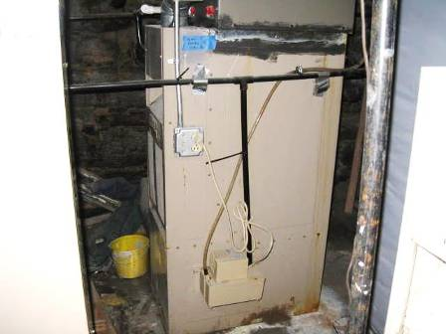
AHU in Basement

Picture 2
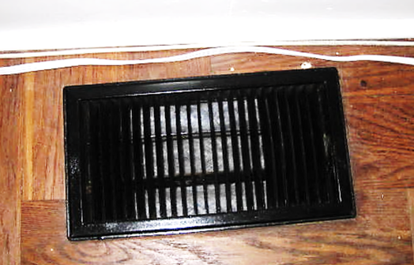
Floor air diffuser, note (white) filter media in vent
Picture 3
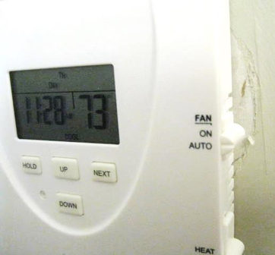
Digital thermostat
Picture 4
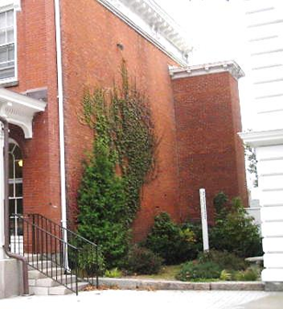
Clinging plants, trees and shrubbery on/against building exterior

Picture 5
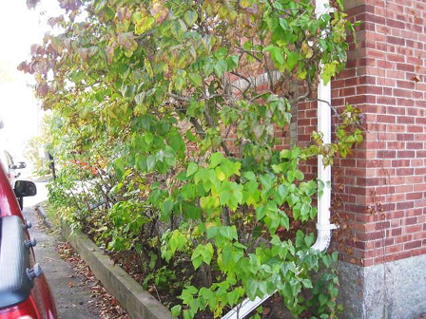
Trees growing in close proximity to building exterior
Picture 6
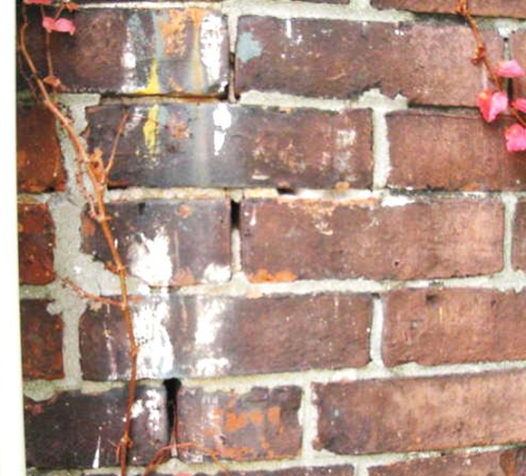
Missing/damaged mortar around exterior brick

Picture 7
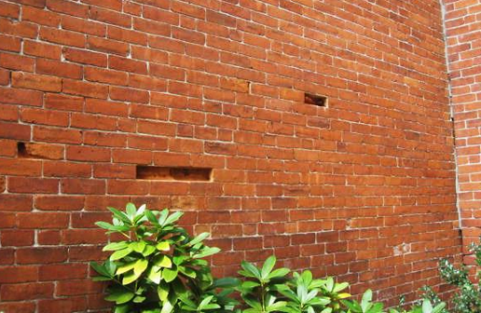
Missing/damaged exterior brick
Picture 8
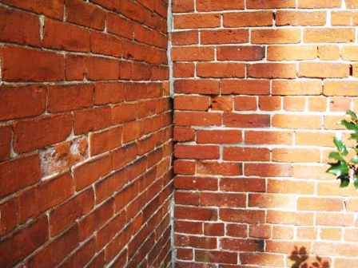
Missing/damaged mortar around exterior brick

Picture 9
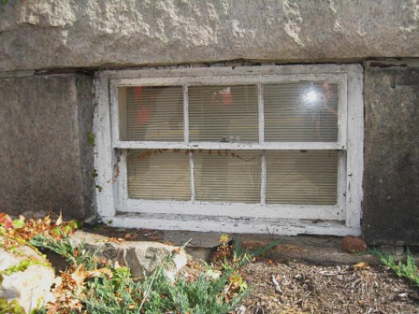
Damaged wooden window
Picture 10
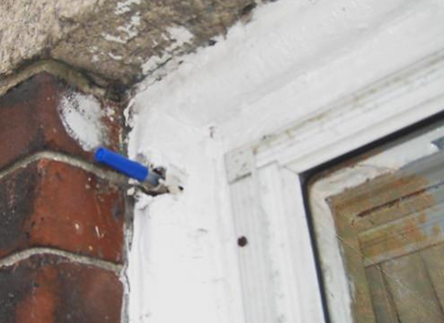
Hole in windowsill, pen inserted in hole to show depth

Picture 11
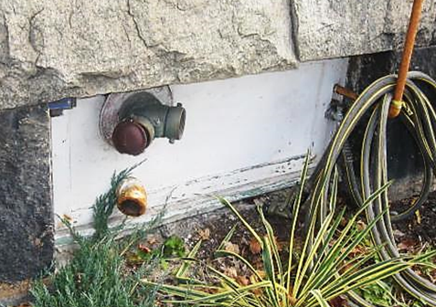
Breaches around utilities where light could be seen penetrating into the basement
Picture 12
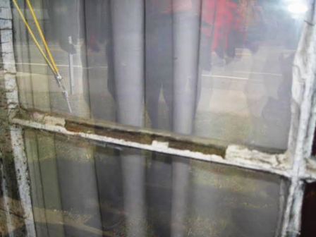
Missing/damaged window caulking

Picture 13
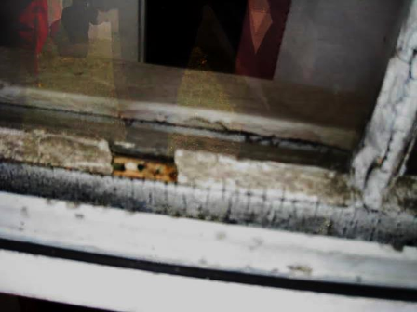
Missing/damaged window caulking
Picture 14
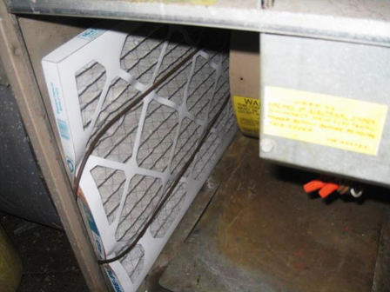
Pleated filter installed in AHU
Location | Carbon  Dioxide  (*ppm) | Carbon Monoxide  (ppm) | Temp  (°F) | Relative  Humidity  (%) | PM2.5  (µg/m³) | Occupants  in Room | Windows  Openable | Ventilation |  |  | Remarks
 |  |  |  |  |  |  |  | Intake | Exhaust |  | Remarks
Background | 389 | ND | 66 | 77 | 12 |  |  |  |  |  | Cloudy/overcast warm, moderate traffic
Reception/Entrance | 865 | ND | 71 | 51 | 2 | 3 | N | N |  | N
Main Office Area | 887 | ND | 72 | 48 | 3 | 2 | N | N |  | N | Thermostat fan “auto”
Interior Office | 777 | ND | 71 | 46 | 1 | 0 | N | N |  | N | Drop ceiling
Rear Office | 764 | ND | 72 | 47 | 1 | 0 | N | N |  | N | Window sealed with plexiglass-drafts
Kitchen | 737 | ND | 72 | 46 | 2 | 0 | N | N |  | N
Server Room | 778 | ND | 72 | 45 | 2 | 0 | N | N |  | N | No air conditioning
1st Floor Restroom |  |  |  |  |  |  | N | N |  | N | Window does not open, no mechanical exhaust ventilation

