The Bureau of Climate and Environmental Health (BCEH) works to protect the public from environmental exposures known or suspected to cause illness and disease.

BCEH also leads the Department’s environmental and climate justice work focused on communities disproportionately impacted by these exposures. The indoor air quality outreach and education unit (IAQ) is a part of the Division of Environmental Health Regulations and Standards.

WHAT WE DO

Our mission is to investigate environmental concerns in public buildings, including schools, through Indoor Air Quality (IAQ) assessments and technical assistance.

We provide school districts, state agencies, and municipalities with assessments to address concerns about indoor air quality and other environmental issues.

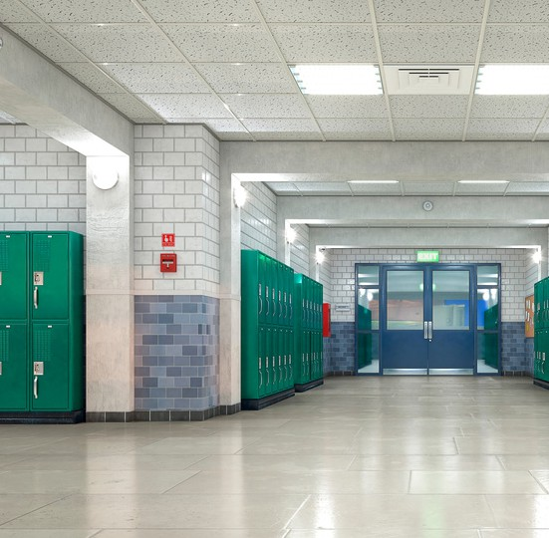

*The IAQ Program does not conduct inspections in housing or residential units. Our focus is on public buildings.

**WHAT AN IAQ ASSESSMENT IN A PUBLIC BUILDING INCLUDES\***

* Evaluation of mechanical ventilation systems
* Visual inspection for water-damaged materials/ microbial growth
* Exterior building envelope evaluation
* Identification of point sources of irritation (e.g., asthma triggers and allergens)
* A full report detailing issues identified and recommendations to improve indoor air quality.

# Indoor Air Quality Links and Resources



Division of Environmental Health Regulations and Standards (EHRS)

INDOOR AIR QUALITY OUTREACH AND EDUCATION UNIT

* [Indoor Air Quality Reports | Mass.gov](https://www.mass.gov/report/indoor-air-quality-reports)
* [Indoor Air Quality - Facts and Resources | Mass.gov](https://www.mass.gov/indoor-air-quality-facts-and-resources)
* [Sources of Indoor Air Pollution](https://www.mass.gov/sources-of-indoor-air-pollution)
* [Mold, Moisture, and Mildew](https://www.mass.gov/mold-moisture-and-mildew)
* [Apartments, Homes, and Condos](https://www.mass.gov/apartments-homes-and-condos)

# Contact Us

**Indoor Air Quality Outreach and Education Unit**

250 Washington St., 7th Floor, Boston, MA 02108

**Phone:** (617) 624-5757

**TTY:** (617) 624-5286

**Fax:** (617) 624-5183