|  |
| --- |
| **ONE-YEAR ALIGNMENT WITH NREMT** |
| **All individuals with Massachusetts certification expiring 2025 (MA 2025) and NREMT certification expiring 2026**  **(NR 2026) need to follow the steps outlined on this page. Please read it carefully.** |
| **OVERVIEW:**   * All training records are captured in the NREMT website for certification renewal. Massachusetts and the NREMT have the same continuing education recertification requirements so you simply have to renew your National Registry certification in order to meet the Massachusetts continuing education requirements. * Ensure your mailing and contact information is up to date on your [eLicensing](https://healthprofessionlicensing.mass.gov/) account. |
| **HOW:**   * All EMS personnel who hold National Registry and Massachusetts certifications are required to align their recertification cycles. * New this year, to complete the alignment, you submit an application using the [eLicensing](https://healthprofessionlicensing.mass.gov/) portal, which will recognize your expiration dates and direct you to submit a prorated recertification payment of $62.50. We recommend you complete this alignment by February 15, 2025 in order to ensure you have your new Massachusetts certification card processed prior to the March 31, 2025 expiration. There is no longer a separate paper form to complete. * After March 31, 2025, your certification **is expired and you cannot staff an ambulance.** You may submit your alignment renewal application late and the late submission deadline is one year after expiration, March 31, 2026. |
| **Other Off Cycle Circumstances:**  **Reverse Off Cycle**- All individuals with NREMT certification expiring 2025 (**NR 2025**) and Massachusetts certification expiring 2026(**MA 2026**) need to **recertify their NREMT certification to 2027** before completing the one year alignment process in Fall 2025.  **Expired NREMT**- All individuals who held NREMT certification which has expired, MUST regain NREMT certification in order to be eligible to recertify the Massachusetts certification. **If you do not regain NREMT certification, your Massachusetts certification cannot be renewed.** Please visit [NREMT.org](http://www.nremt.org/) for details.  **Alignment not yet due**- All individuals with NREMT certification expiring in 2027 (**NR 2027**) and Massachusetts certification expiring in 2026 (**MA 2026**) are not yet due for a one year alignment. Over the Fall of 2025 (prior to the 2026 recertification window), you will receive instructions explaining the process. |

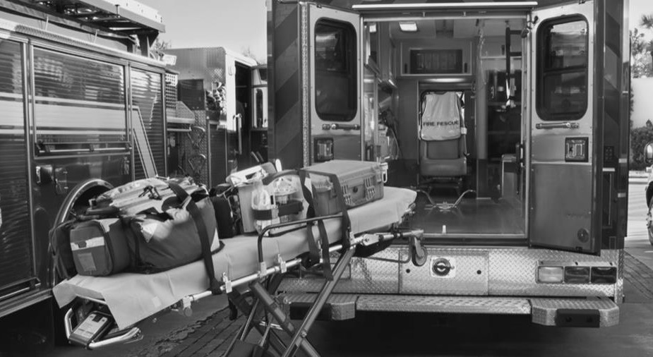

09/19/2024 v1