**LANGUAGE ACCESS PLAN**

**Operational Services Division (OSD)**



1. **Introduction**

The Operational Services Division (“OSD”) has developed and prepared this Language Access Plan (LAP) outlining ongoing efforts taken to provide language services to Limited English Proficiency (LEP) constituents.

This plan also defines the actions our office is taking to ensure meaningful access to programs, services, activities, and materials for all LEP constituents.

The Operational Services Division will review and update this LAP as needed to ensure continued responsiveness to community needs.

The Operational Services Division serves a diverse population of various ages and linguistic origins. An LEP person is someone who cannot speak, read, write, or understand the English language at a level that allows them to interact effectively with Operational Services Division staff. A constituent maintains the right to self-identify as LEP.

# Purpose

The purpose of this plan is to ensure meaningful access to services, programs, activities, and materials for all LEP constituents.

The Operational Services Division is committed to making services available to LEP persons as part of its mission. Based on this commitment, the Operational Services Division makes every attempt to assist LEP constituents in accessing our services.

This LAP does not create new services; rather it strives to eliminate barriers for LEP constituents accessing existing services and ensure that all staff can assist LEP constituents in accessing those resources. The Operational Services Division will provide quality language assistance to LEP constituents in a fair and timely manner, ensuring meaningful access to the agency’s services.

This LAP centralizes language access materials for staff and outlines the regular trainings for new hires to ensure that all staff can access the materials and services listed in the sections below.

The objectives of these Language Access Guidelines are to:

* 1. Improve access to and quality of state services, programs and activities for non-English speakers and LEP persons;
  2. Reduce any disparities and delays in the provision of services/programs to eligible LEP speakers; and
  3. Streamline training and resources for staff to increase effectiveness and ensure public satisfaction.

# Policy

It is the Operational Services Division’s policy to provide meaningful access to programs and services to persons who are limited in English proficiency.

# Applicability

This policy applies to all offices withing the Operational Services Division.

# Role

The Operational Services Division (OSD) is an oversight agency of the Commonwealth of Massachusetts within the Executive Office for Administration and Finance. OSD’s primary focus is to help our government buyers and business customers succeed in meeting their goals by providing outstanding customer service, competent advice and guidance, objectivity in our work, and high-quality products and services that exceed the expectations of those we serve.

OSD is comprised of several units that administer a broad range of activities, including: Strategic Sourcing, the Surplus Property Program, the Office of Vehicle Management, Commonwealth Print and Mail Services, and the Local Government Enablement Team, among others.

OSD interact with the public in a limited way with most contact coming in the form of private vendors and State and Municipal buyers. However, OSD does support a Help Desk, hosts regular trainings for buyers and vendors, and interacts with local government officials in the field.

# Language Access Plan

This LAP shall be fully implemented, subject to the availability of requisite fiscal resources. It represents the agency’s commitment to ensuring that all residents of Massachusetts can readily access information and resources from the Operational Services Division.

For staff, this plan centralizes resources, training, and the agency’s multilingual content and publications, while outlining the minimum standard of access to the agency for LEP constituents.

## Language Access Coordinator

The Operational Services Division’s Language Access Coordinator is Ashley Pierce, Human Resources Manager, ashley.e.pierce@mass.gov, 617-720-3379.

* 1. Language Resources

### Translating Publications

The Operational Services Division is committed to maintaining all its widely applicable publications in the five most spoken languages in the Commonwealth: English, Spanish, Portuguese, Haitian Creole, and Chinese (Simplified or Traditional). When reaching out to specific communities in the Commonwealth, OSD staff should ensure that these publications will be accessible in the languages prevalent in each community. Longer and more specific publications should be translated when there are accessibility concerns for the intended audience.

OSD will pay for these services out of its operating budget.

### Written Translations Guidelines

When translating a document, follow these steps:

1. Choose which language(s) are needed for translation. Keep in mind that broadly applicable flyers should be translated into Spanish, Portuguese, Haitian Creole, and Chinese (Simplified or Traditional). Section
2. E-mail a Word document version of the publication to be translated to the translation company and request a quote.
3. There are several [state vendors](https://www.mass.gov/service-details/find-a-statewide-contract-user-guide). on the PRF75 Statewide Contract
4. All requests for quotes should be coordinated with OSD’s Procurement Coordinator, Donna Ellis, donna.ellis5@mass.gov, 617-720-3118.

Questions? Contact Ashley Pierce, ashley.e.pierce@mass.gov, 617-720-3379 or Donna Ellis, donna.ellis5@mass.gov, 617-720-3118.

### In-Person Interpreting

When requesting an interpreter for an in-person event, follow these steps:

1. Obtain at least 3 quotes from any of the vendors on [this list](https://www.mass.gov/doc/prf75/download) (vendor list starts on page 11). Simply e-mail the vendors (using BCC so they can’t see the recipient list) with the specifics of your request. For example:

*The Operational Services Division is seeking quotes for in-person Spanish/English interpreter services.  The engagement is scheduled for _____________and will take place at ____________________.  The services requested are for a minimum of 1 hour.  Would you be interested in such an engagement, and if so, could you provide a quote for the one hour plus 15-minute increment price, no later than _________?  The maximum time needed for this engagement will not exceed 4 hours. Thank you for your consideration of this request.*

This request should be coordinated with OSD’s Procurement Coordinator, Donna Ellis, donna.ellis5@mass.gov, 617-720-3118.

### Correspondence

The generic babel below could be included with initial correspondence to constituents and as necessary thereafter. It could also be included below the signature line on automatic replies from general email inboxes. If you are already using your own customized babel or tagline notice, you could continue to use your own.

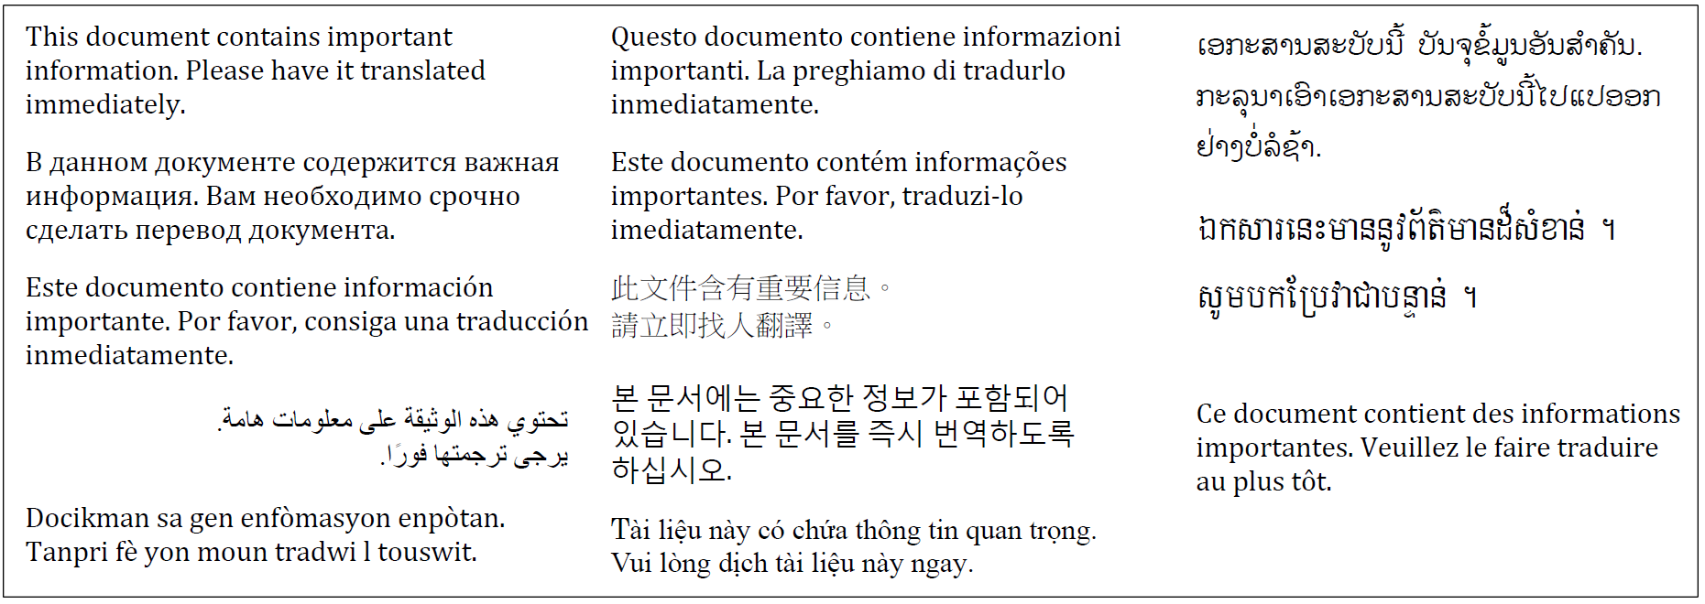

### Web Content

The Operational Services Division is committed to making our website and linked sites accessible to people with vision impairments and complies with EOTSS’ Enterprise Information Technology Accessibility Policy. OSD will monitor for additional needs translation services pertaining to our website.

### 

### Multilingual Staff at the Operational Services Division

The Operational Services Division is committed to hiring and retaining multilingual staff for all positions, but especially for public facing staff and on the agency’s hotlines.

### Interpreter Services for Walk-in Constituents

While the preference is to provide direct service to LEP constituents in their primary language, Operational Services Division staff will have access to an over-the-phone language service that includes over380+ languages. OSD is currently developing a plan for procuring these services. Vendors that OSD will utilize are found on [this list](https://www.mass.gov/doc/prf75/download). Step-by-step instructions on how to use the over-the-phone language services, including ASL, will also be developed by OSD.

A [Language Identification Flashcard](https://www.lep.gov/ISpeakCards2004.pdf) is posted on our homepage website for easy access. The card states “I speak” in 38 languages and can be used to identify the language spoken by LEP constituents accessing services provided by the Operational Services Division.

### Hotline & General Phone Lines

OSD has a Help Desk available for vendors and buyers to answer a variety of questions. Generally, the Help Desk is staffed by English speakers. This phone line also has a TTY line available. OSD will begin monitoring any requests or needs for languages other than English and make over-the-phone interpretation available, as needed. OSD is currently developing a plan for procuring over-the-phone services, as needed. Vendors that OSD will utilize are found on [this list](https://www.mass.gov/doc/prf75/download). Step-by-step instructions on how to use the over-the-phone language services, including ASL, will also be developed by OSD.

**Over-the-phone language services**

OSD is currently developing a plan for procuring over-the-phone services, as needed. Vendors that OSD will utilize are found on [this list](https://www.mass.gov/doc/prf75/download). All staff will have access to and be trained on the over-the-phone language service providers.

Interpretation for the Deaf and Hard of Hearing at OSD Events

The Operational Services Division must provide interpretation for the deaf and hard of hearing when requested. The organization hosting the event might request that our office provide interpretation when scheduling and confirming the event. When registering attendees for our office presentation/event, you should provide an option for attendees to request American Sign Language (ASL) interpretation for the deaf and hard of hearing.

Review these [First Time Use Instructions](https://www.mass.gov/doc/communication-spectrum-tip-sheet-for-first-time-interpretercart-requests/download) from the Massachusetts Commission for the Deaf and Hard of Hearing (MCDHH) to familiarize yourself with the different kinds of interpretation that could be requested.

If ASL interpretation is requested, follow the steps below to request an ASL interpreter. Requests should be made at least two weeks or more in advance of the event. If the services are no longer needed or the event is cancelled, you should provide notice to MCDHH at least three days before the scheduled date to avoid fees.

[**Massachusetts Commission for the Deaf and Hard of Hearing**](https://www.mass.gov/how-to/how-to-request-an-asl-interpreter-or-cart-provider) **(MCDHH)**

Interpreters should be requested from the Massachusetts Commission for the Deaf and Hard of Hearing. The process for requesting interpretation is laid out on the Commission’s website, linked above.

Request ASL for the date and time in question.

Most events will require two ASL Interpreters.

It is possible to request interpreters from multiple organizations you should make time prior to the event for the interpreters to connect.

## Staff Training

The Language Access Plan (LAP) will be:

1. Posted internally for all employees.
2. Incorporated into the orientation for new employees.
3. Presented to management so they are fully aware of and understand the LAP, in order to reinforce the plan’s importance and ensure its implementation by staff.
4. Presented to Operational Services Division staff having contact with the public, so such staff is trained to work effectively with LEP constituents and telephone interpreters.

# Monitoring

The Operational Services Division will review and update its Language Access Plan at least every two years or more frequently, as needed.

The review assesses:

1. Whether there have been any significant changes in the composition or language needs of thepopulation served;
2. Whether the staff knows and understands the LAP document, and is comfortable using the services described within;
3. Whether additional documents require translation;
4. Identification of any issues or problems related to serving LEP persons which may have emerged during the past year; and
5. Identification of any recommended actions to provide more responsive and effective language services (e.g., adding documents to be translated, creating, or expanding partnerships with community organizations, or changing staffing priorities).

Monitoring the effectiveness of a Language Access Plan may include:

1. Analyzing current and previous data on language assistance usage, including languages served;
2. Surveying staff on how often they use language assistance services, if they believe there should be changes to the services provided or the providers used, and if they believe that the language assistance services in place are meeting the needs of the LEP communities in their service area; and
3. Monitoring feedback from community-based organizations, legal services and other stakeholders about the agency’s effectiveness and performance in ensuring meaningful access for LEP individuals.