2021 Stakeholder Listening Sessions
Hosted by the MA Department of Public Health Office of Problem Gambling Services
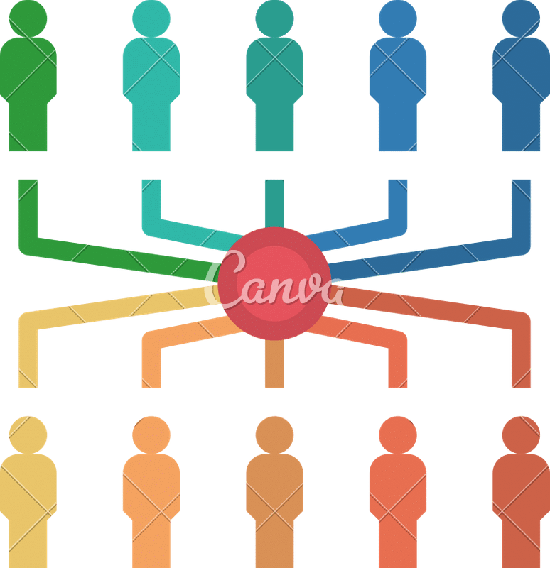
We want to hear from you!
Join us to discuss the Office’s work and how we can best serve the community.

Everett: Wednesday, March 10
5:30 - 7:30 pm
Held via Zoom
Springfield: Thursday, March 18
5:30 - 7:30 pm
Held via Zoom

Register today!

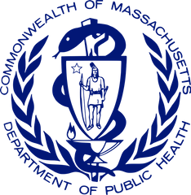
B e c a u s e y o u r v o i c e m a t t e r s .

Accessibility
I f y o u r e q u i r e t r a n s l a t i o n s e r v i c e s , a r e D e a f o r h a r d o f h e a r i n g , o r a r e a p e r s o n w i t h a d i s a b i l i t y w h o
r e q u i r e s a c c o m m o d a t i o n , p l e a s e c o n t a c t C o r i n a
P i n t o a t ( 6 1 7 ) 9 1 7 - 4 4 6 6 , o r c o r i n a _ p i n t o @ j s i . c o m b y F e b r u a r y 2 6 , 2 0 2 1 .

What to Expect ?
T h e s e s e s s i o n s a r e a n o p p o r t u n i t y t o
m a k e r e c o m m e n d a t i o n s a n d p r o v i d e y o u r i n s i g h t t o t h e O f f i c e ' s p r o g r a m s a n d
s e r v i c e s .

What is the
Office of Problem Gambling Services (OPGS) ?
W i t h i n t h e M a s s a c h u s e t t s D e p a r t m e n t o f P u b l i c H e a l t h , t h e O P G S e n s u r e s a c o m p r e h e n s i v e a n d i n t e g r a t e d p u b l i c h e a l t h r e s p o n s e t o p r o b l e m
g a m b l i n g b y u s i n g d a t a t o i n f o r m i n i t i a t i v e s , e n g a g i n g c o m m u n i t i e s , a n d e n s u r i n g c u l t u r a l i n t e l l i g e n c e a n d h u m i l i t y .

