Data Brief: Confirmed Unintentional/Undetermined¹ Opioid-related² Overdose Deaths Among Massachusetts Residents – Demographic Data Highlights
Massachusetts Department of Public Health Posted: AUGUST 2016

This data brief highlights demographic data from confirmed overdose deaths from January 2016 to June 2016.

Confirmed Unintentional/Undetermined¹ Opioid-related Deaths by Gender:
January 2016-June 2016

Unintentional/Undetermined Opioid Deaths by Gender:
January 2016-June 2016

Male | 365
Female | 123
Total | 488

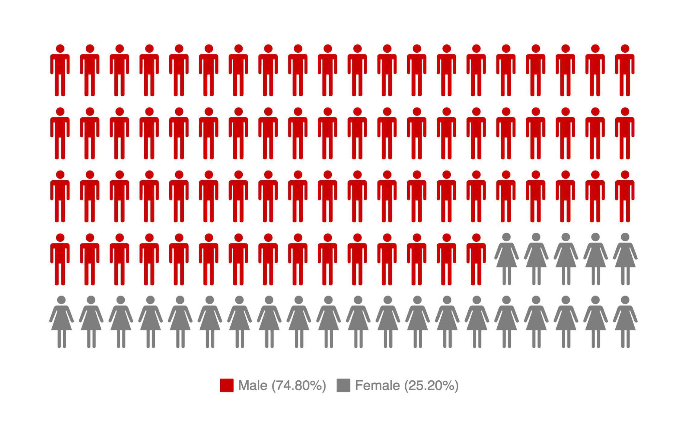

¹ Unintentional poisoning/overdose deaths combine unintentional and undetermined intents to account for a change in death coding that occurred in 2005. Suicides are excluded from this analysis.
² Opioids include heroin, opioid-based prescription painkillers, and other unspecified opioids.

Confirmed Unintentional/Undetermined¹ Opioid-related Deaths Compared to All Deaths by Age: January 2016-June 2016

 | Deaths by Age: January 2016-June 2016
 | 0-14 | 15-24 | 25-34 | 35-44 | 45-54 | 55-64 | 65+ | Unknown | Total
All Deaths | 166 | 209 | 569 | 645 | 1,459 | 2,916 | 21,074 | 4 | 27,042
Confirmed Unintentional / Undetermined¹ Opioid Deaths | 0 | 41 | 165 | 126 | 103 | 50 | 3 | 0 | 488

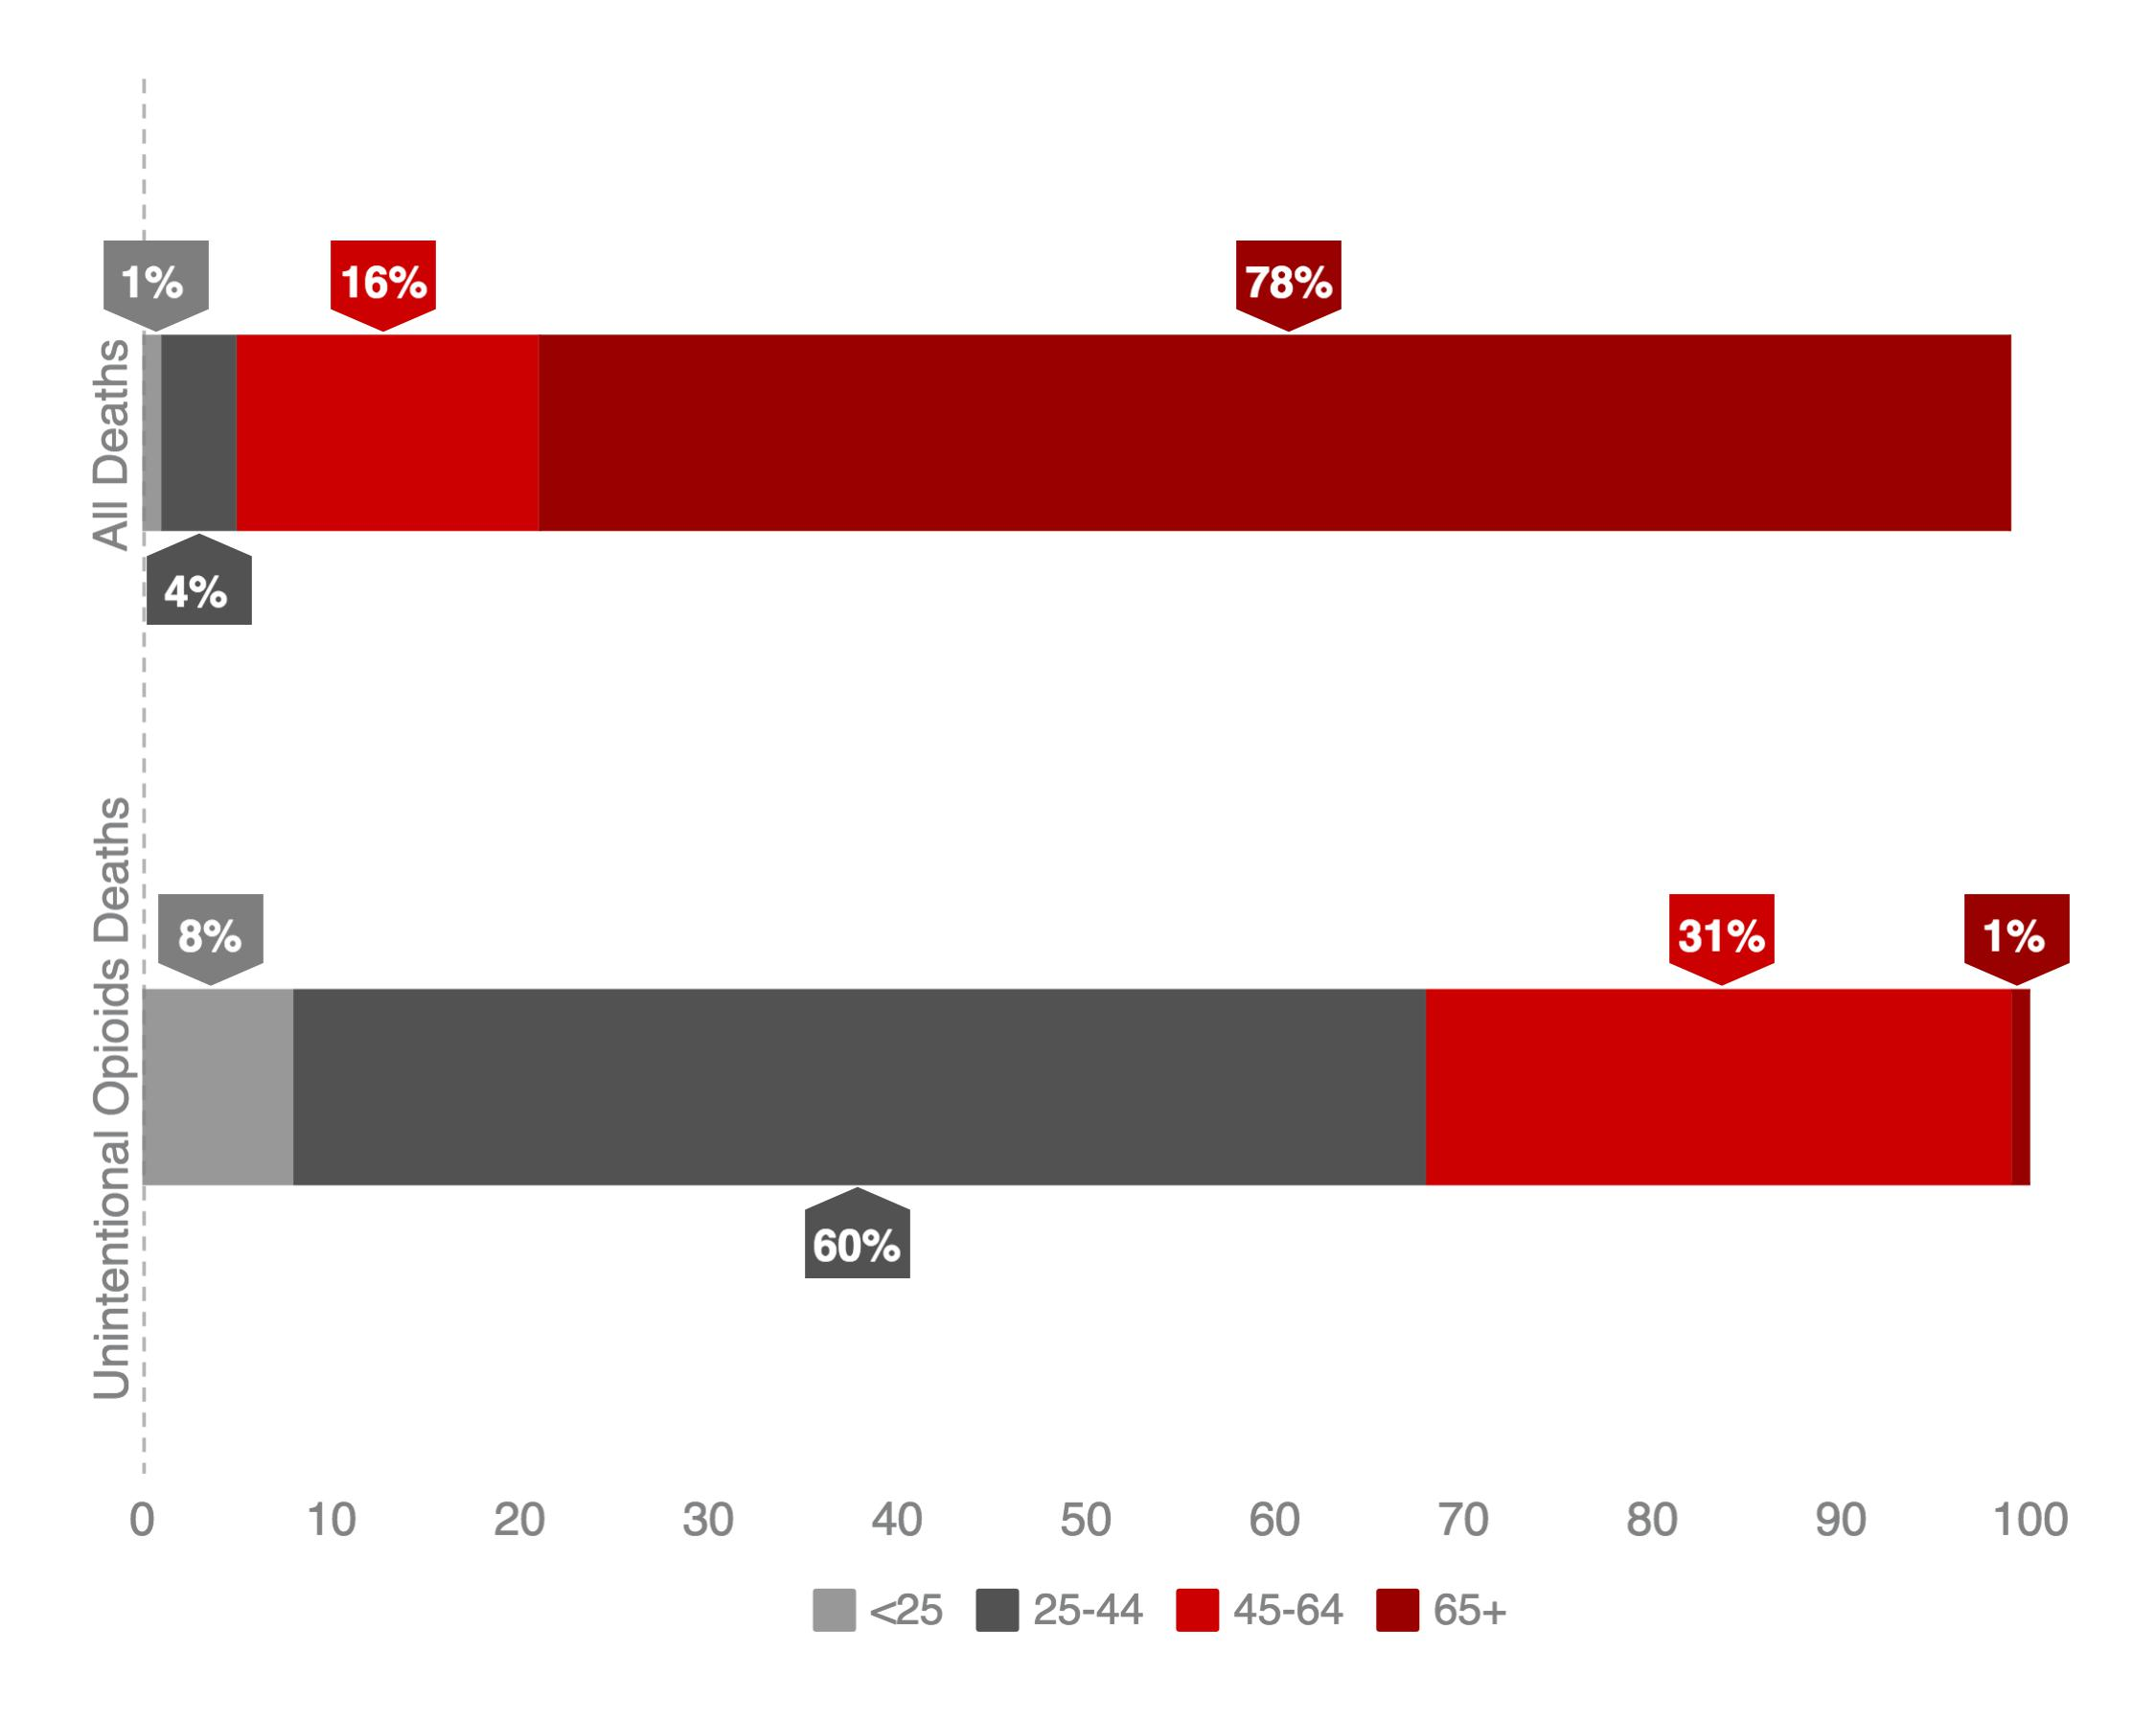

Note: Due to rounding, percentages under “All Deaths” do not add up to 100%.

¹ Unintentional poisoning/overdose deaths combine unintentional and undetermined intents to account for a change in death coding that occurred in 2005. Suicides are excluded from this analysis.

Confirmed Unintentional/Undetermined¹ Opioid-related Deaths Compared to All Deaths by Race: January 2016-June 2016

 | White non-Hispanic | Black non-Hispanic | Asian non-Hispanic | Hispanic | Other/  Unknown | Total
All Deaths | 24,163 | 1,156 | 483 | 961 | 279 | 27,042
Unintentional/Undetermined¹ Opioid Deaths | 391 | 19 | 4 | 67 | 7 | 488

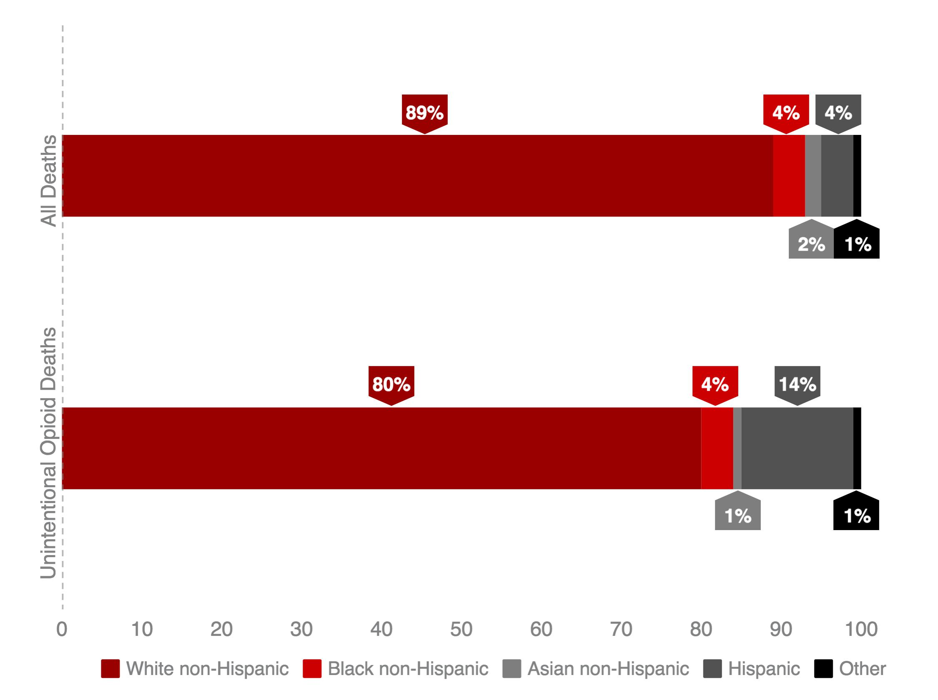

¹ Unintentional poisoning/overdose deaths combine unintentional and undetermined intents to account for a change in death coding that occurred in 2005. Suicides are excluded from this analysis.

Technical Notes

2016 death data are preliminary and subject to updates. Case reviews of deaths are evaluated and updated on an ongoing basis. A large number of deaths have yet to be assigned final cause-of-death codes. The information presented in this report only includes confirmed cases. Data updated on 06/30/2016.
Source: Registry of Vital Records and Statistics, MDPH

