This data brief highlights demographic data from confirmed opioid-related overdose deaths for all intents, from January 2017 to June 2017.



POSTED: AUGUST 2017

Massachusetts Department of Public Health

**Opioid1-Related Overdose Deaths, All Intents, MA Residents – Demographic Data Highlights**

# Confirmed Opioid1-Related Deaths, All Intents, by Gender: January 2017-June 2017

|  |  |
| --- | --- |
| **Confirmed Opioid1-Related Deaths, All Intents by Gender: January 2017-June 2017** | |
| Male | 460 |
| Female | 150 |
| **Total** | **610** |

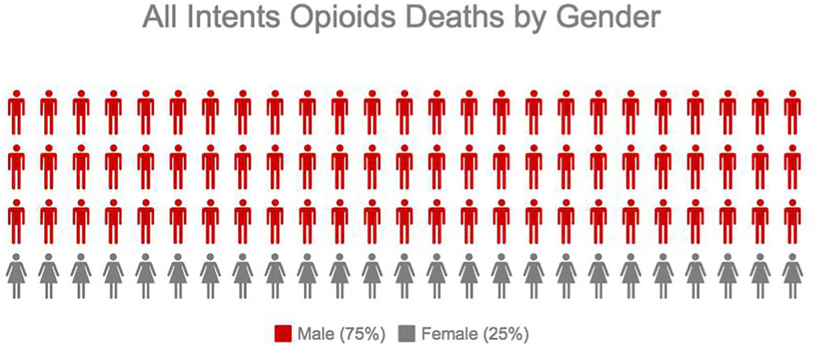

1 Opioids include heroin, opioid-based prescription painkillers, and other unspecified opioids.

# Confirmed Opioid1-Related Deaths, All Intents Compared to All Deaths by Age: January 2017-June 2017

|  |  |  |  |  |  |  |  |  |  |
| --- | --- | --- | --- | --- | --- | --- | --- | --- | --- |
|  | **Deaths by Age: January 2017-June 2017** | | | | | | | | |
|  | **0-14** | **15-24** | **25-34** | **35-44** | **45-54** | **55-64** | **65+** | **Unknown** | **Total** |
| All Deaths | 182 | 260 | 612 | 732 | 1,565 | 3,164 | 23,515 | 3 | **30,033** |
| Confirmed Opioid1-Related  Deaths, All Intents | 0 | 44 | 183 | 146 | 151 | 72 | 14 | 0 | **610** |

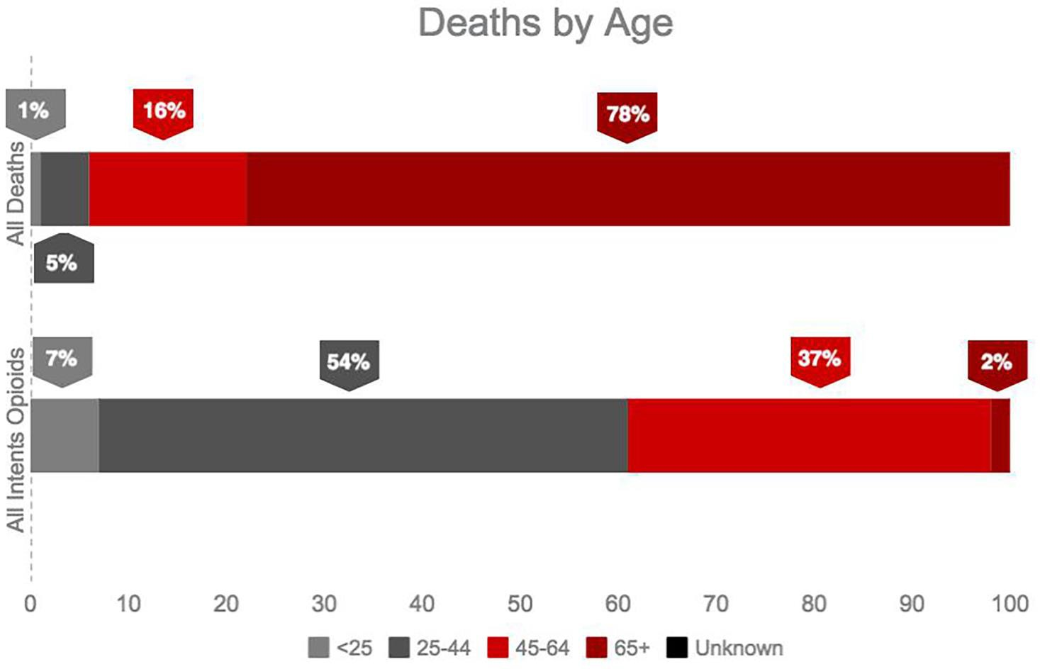

1 Opioids include heroin, opioid-based prescription painkillers, and other unspecified opioids.

# Confirmed Opioid1-Related Deaths, All Intents Compared to All Deaths by Race: January 2017-June 2017

|  |  |  |  |  |  |  |
| --- | --- | --- | --- | --- | --- | --- |
|  | **White non-**  **Hispanic** | **Black non-**  **Hispanic** | **Asian non-**  **Hispanic** | **Hispanic** | **Other/ Unknown** | **Total** |
| All Deaths | 26,767 | 1,262 | 595 | 1,119 | 290 | **30,033** |
| Confirmed Opioid1-Related Deaths, All Intents | 500 | 35 | 4 | 57 | 14 | **610** |

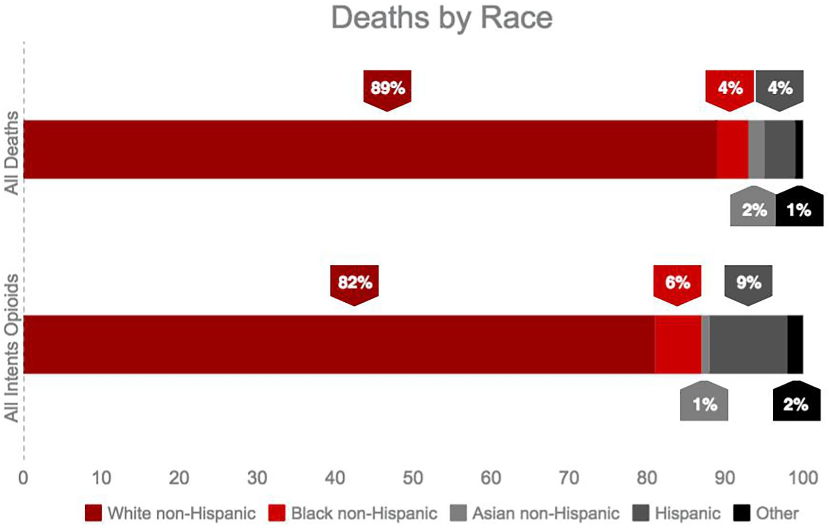

1 Opioids include heroin, opioid-based prescription painkillers, and other unspecified opioids.

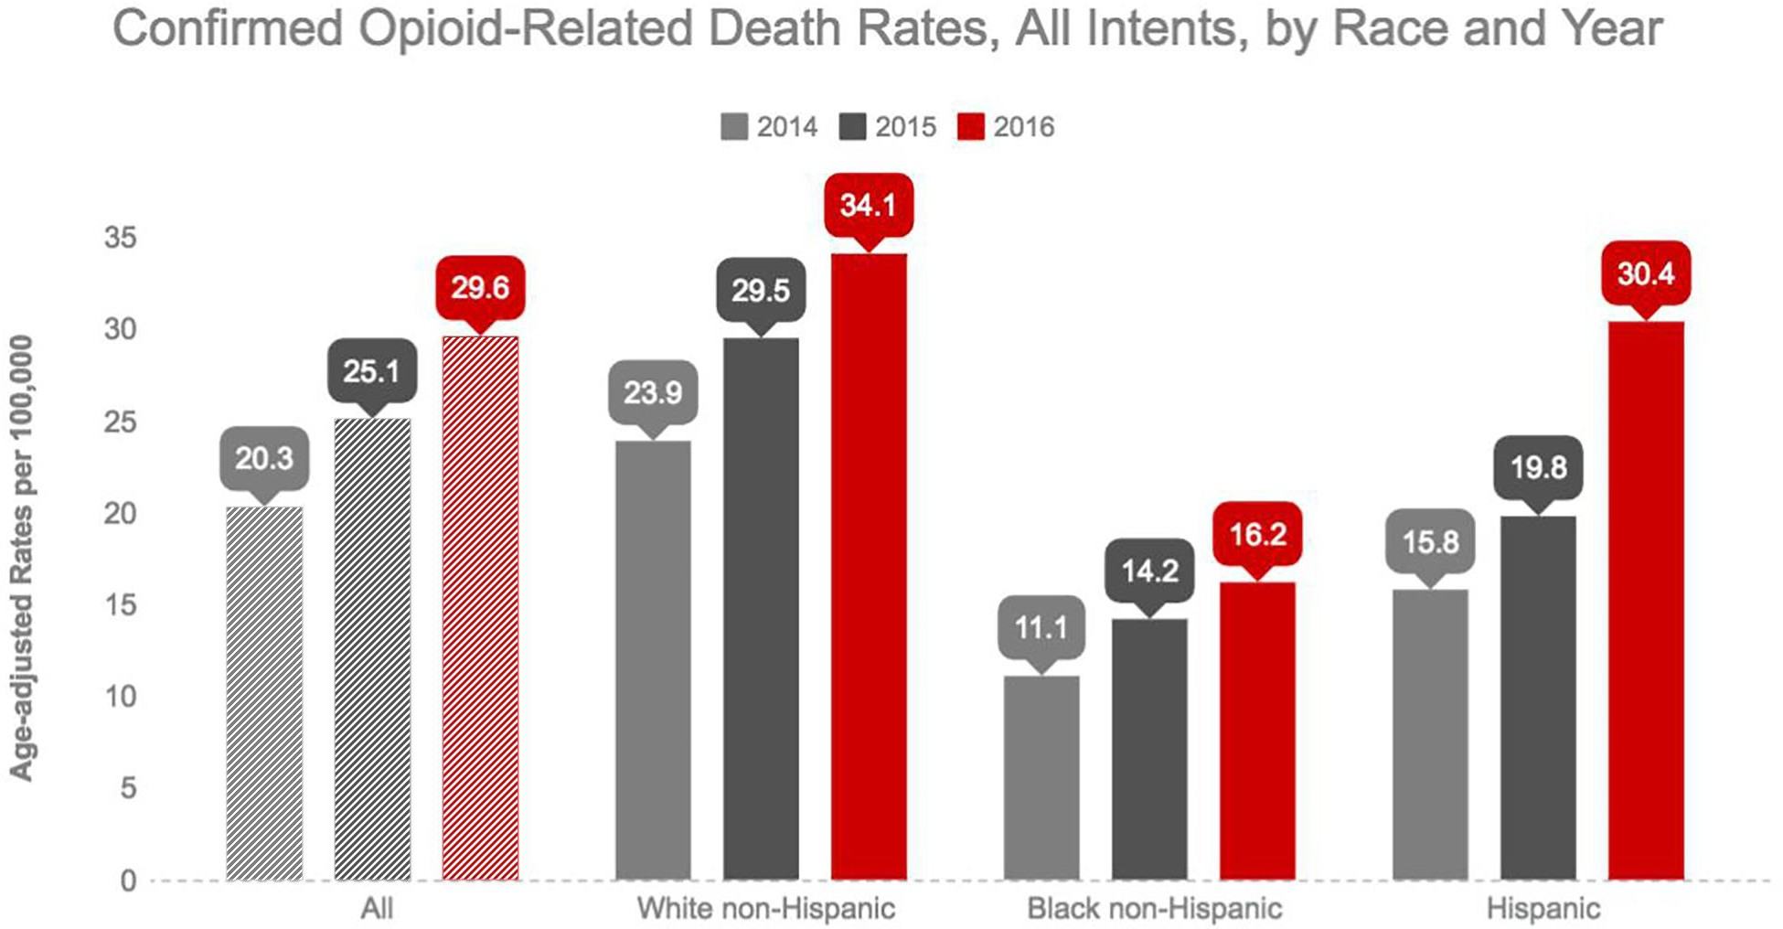

**Technical Notes**

2017 death data are preliminary and subject to updates. Case reviews of deaths are evaluated and updated on an ongoing basis. A large number of deaths have yet to be assigned final cause-of-death codes. The information presented in this report only includes confirmed cases. Data updated on 07/11/2017. Beginning with the May 2017 report, DPH started reporting opioid-related deaths for all intents, which includes unintentional/undetermined and suicide.

**Source: Registry of Vital Records and Statistics, MDPH**