This data brief highlights demographic data from confirmed opioid-related overdose deaths for all intents, from January 2017 through December 2017.



POSTED: FEBRUARY 2018

Massachusetts Department of Public Health

**Opioid1-Related Overdose Deaths, All Intents, MA Residents – Demographic Data Highlights**

# Confirmed Opioid1-Related Deaths, All Intents, by Gender: January 2017-December 2017

|  |  |
| --- | --- |
| Male | 1,160 |
| Female | 341 |
| **Total** | **1,501** |

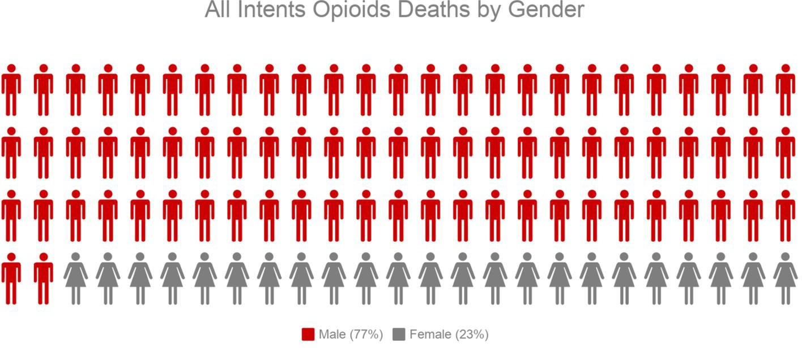

1 Opioids include heroin, opioid-based prescription painkillers, and other unspecified opioids.

# Confirmed Opioid1-Related Deaths, All Intents Compared to All Deaths by Age: January 2017-December 2017

|  |  |  |  |  |  |  |  |  |  |
| --- | --- | --- | --- | --- | --- | --- | --- | --- | --- |
|  | **0-14** | **15-24** | **25-34** | **35-44** | **45-54** | **55-64** | **65+** | **Unknown** | **Total** |
| All Deaths | 374 | 494 | 1,269 | 1,490 | 3,153 | 6,305 | 45,543 | 0 | **58,628** |
| Confirmed Opioid1-Related  Deaths, All Intents | 0 | 95 | 464 | 362 | 352 | 194 | 34 | 0 | **1,501** |

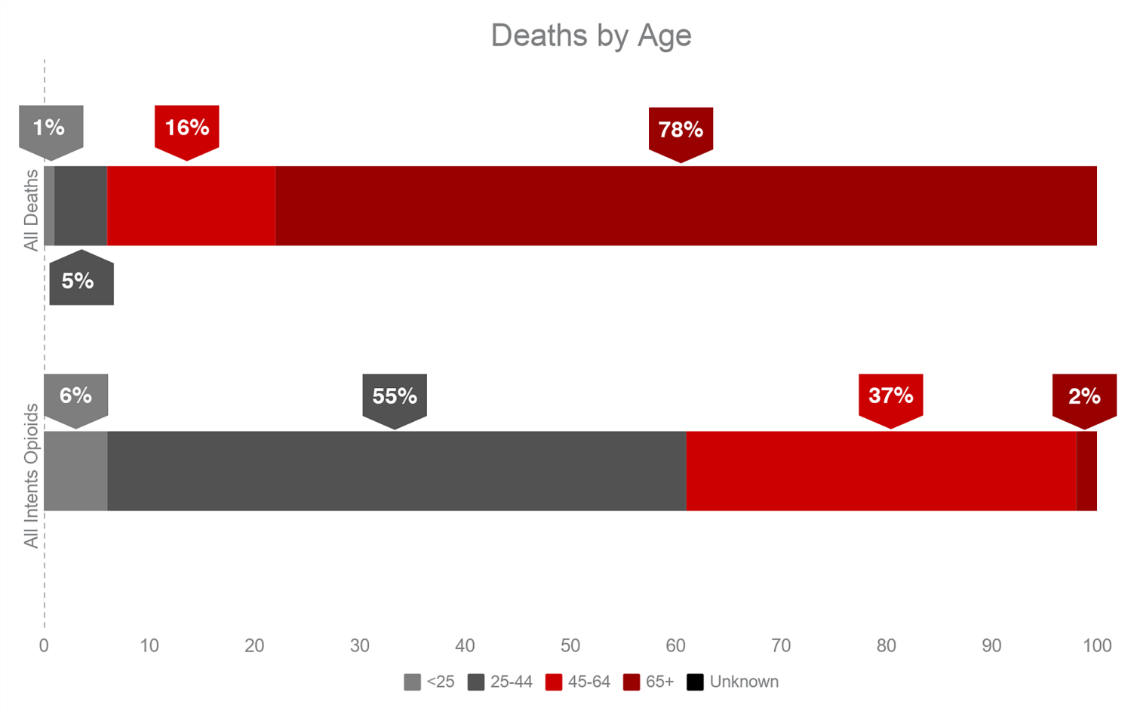

1 Opioids include heroin, opioid-based prescription painkillers, and other unspecified opioids.

# Confirmed Opioid1-Related Deaths, All Intents Compared to All Deaths by Race: January 2017-December 2017

|  |  |  |  |  |  |  |
| --- | --- | --- | --- | --- | --- | --- |
|  | **White non-**  **Hispanic** | **Black non-**  **Hispanic** | **Asian non-**  **Hispanic** | **Hispanic** | **Other/ Unknown** | **Total** |
| All Deaths | 51,883 | 2,627 | 1,161 | 2,339 | 618 | **58,628** |
| Confirmed Opioid1-Related Deaths, All Intents | 1,213 | 81 | 12 | 172 | 23 | **1,501** |

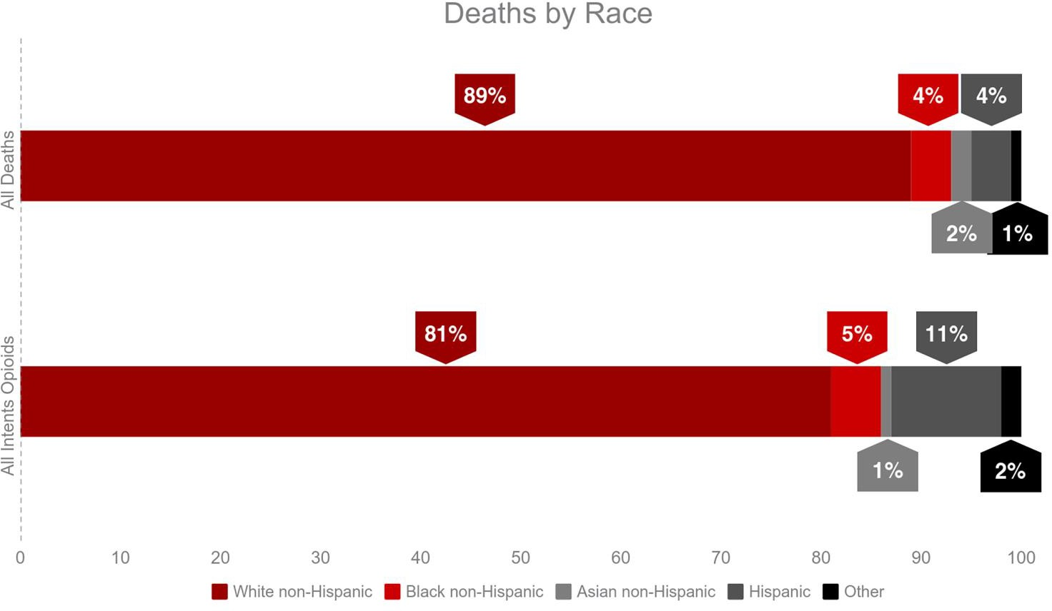

1 Opioids include heroin, opioid-based prescription painkillers, and other unspecified opioids.

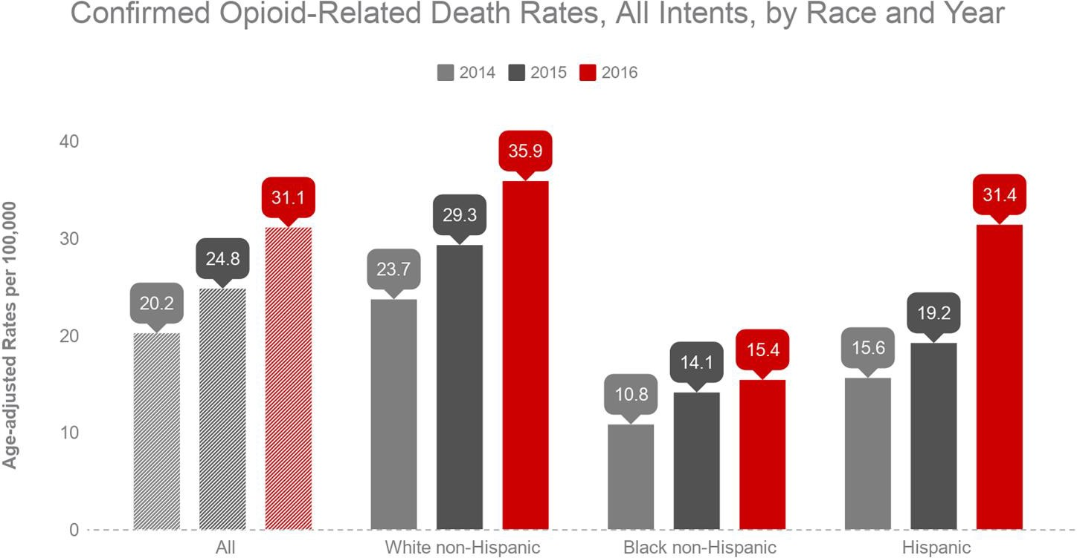

**Technical Notes**

2017 death data are preliminary and subject to updates. Case reviews of deaths are evaluated and updated on an ongoing basis. A large number of deaths have yet to be assigned final cause-of-death codes. The information presented in this report only includes confirmed cases. Data updated on 01/25/2018. Beginning with the May 2017 report, DPH started reporting opioid-related deaths for all intents, which includes unintentional/undetermined and suicide.

**Source: Registry of Vital Records and Statistics, MDPH**