Massachusetts Department of Public Health JANUARY 2016
Data Brief: Confirmed Unintentional/Undetermined¹ Opioid-related² Overdose Deaths Among Massachusetts Residents – Demographic Data Highlights
This data brief highlights demographic data from confirmed overdose deaths from January through September of 2015.
Confirmed Unintentional/Undetermined¹ Opioid Deaths by Gender:
January-September 2015
Unintentional/Undetermined Opioid Deaths by Gender: January-September 2015
Male | 604
Female | 187
Total | 791
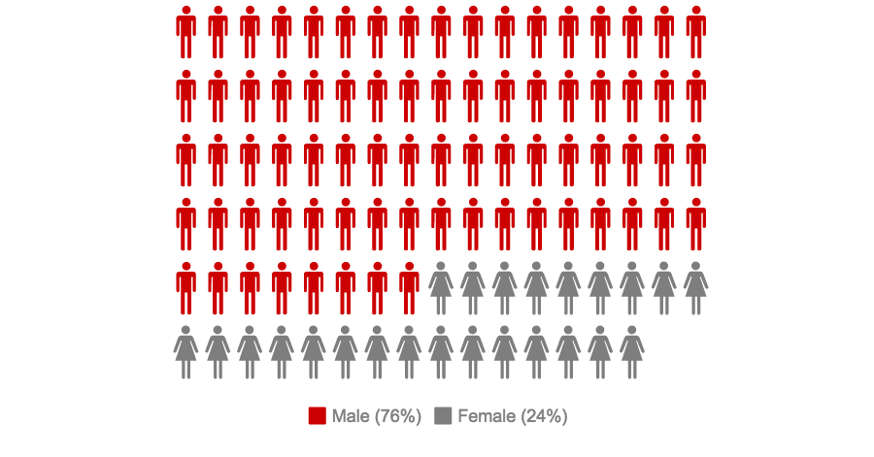

¹ Unintentional poisoning/overdose deaths combine unintentional and undetermined intents to account for a change in death coding that occurred in 2005. Suicides are excluded from this analysis.
² Opioids include heroin, opioid-based prescription painkillers, and other unspecified opioids.
Confirmed Unintentional/Undetermined¹ Opioid Deaths Compared to All Deaths by Age
January-September 2015
 | Confirmed Unintentional/Undetermined¹ Opioid Deaths by Age January-September 2015
 | 0-14 | 15-24 | 25-34 | 35-44 | 45-54 | 55-64 | 65+
2015(Jan-Sep) | 0 | 81 | 247 | 203 | 178 | 78 | 4 | 791

All deaths by age
January-September 2015
 | 0-14 | 15-24 | 25-34 | 35-44 | 45-54 | 55-64 | 65+ | Unknown
2015 (Jan-Sep) | 294 | 358 | 808 | 970 | 2332 | 4514 | 33404 | 4 | 42684

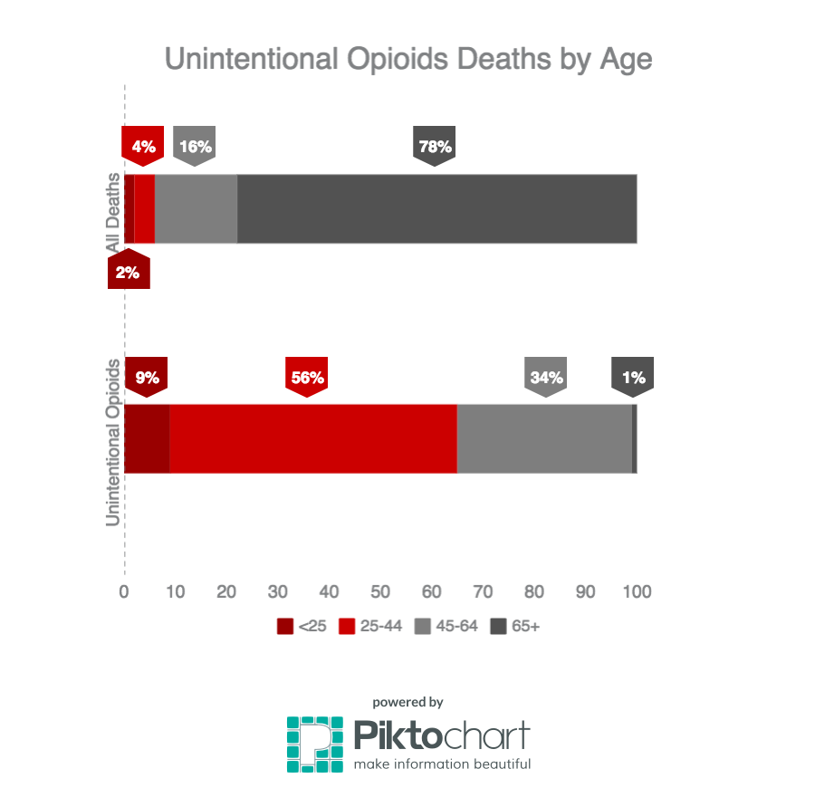

¹ Unintentional poisoning/overdose deaths combine unintentional and undetermined intents to account for a change in death coding that occurred in 2005. Suicides are excluded from this analysis.

Confirmed Unintentional/Undetermined¹ Opioid Deaths Compared to All Deaths by Race
January-September 2015
 | White non-Hispanic | Black non-Hispanic | Asian non-Hispanic | Hispanic | Other/  Unknown | Total
Unintentional/Undetermined¹ Opioid Deaths | 659 | 40 | 3 | 74 | 15 | 791
All Deaths | 38241 | 1763 | 782 | 1492 | 406 | 42684

Unintentional/Undetermined¹ opioid deaths, compared to all deaths:
January 2015-September 2015
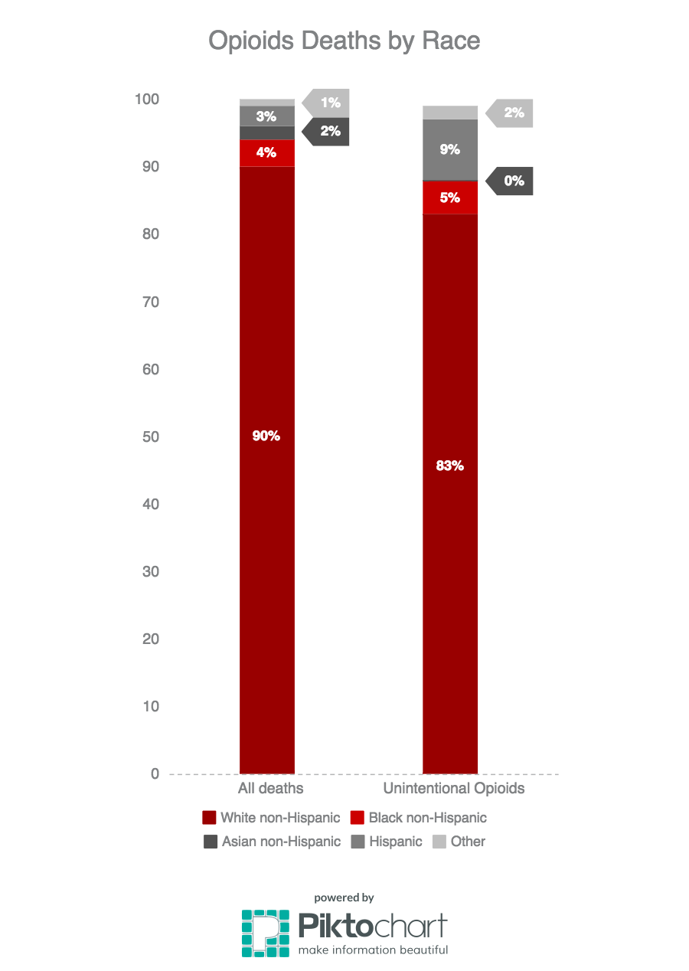
¹ Unintentional poisoning/overdose deaths combine unintentional and undetermined intents to account for a change in death coding that occurred in 2005. Suicides are excluded from this analysis.

Technical Notes
- 2014 and 2015 death data are preliminary and subject to updates. Case reviews of deaths are evaluated and updated on an ongoing basis. A large number of death certificates have yet to be received from the municipalities and some have yet to be assigned cause-of-death codes. The information presented in this report only includes confirmed cases. Data updated on 12/10/2015.
Source: Registry of Vital Records and Statistics, MDPH

