**Note To Readers:** This is the first quarterly report for 2017. Please note that throughout all sections of this report there has been a change in the category of deaths that are included. Death data that were previously reported as “Unintentional/Undetermined” has been updated to include deaths of **“All Intents”**, which means that opioid-related deaths that have been determined by the Office of the Chief Medical Examiner as the result of suicide will now be included in the totals. This will not add significantly to the death totals, however it will allow for consistency in interpretation in the data that are presented.



POSTED: MAY 2017

Massachusetts Department of Public Health

**Opioid1-Related Overdose Deaths, All Intents, MA Residents – Demographic Data Highlights**

This data brief highlights demographic data from confirmed opioid-related overdose deaths for all intents, from January 2016 to December 2016.

# Confirmed Opioid1-Related Deaths, All Intents, by Gender: January 2016-December 2016

|  |  |
| --- | --- |
| **Confirmed Opioid1-Related Deaths, All Intents by Gender: January 2016-December 2016** | |
| Male | 1,394 |
| Female | 539 |
| **Total** | **1,933** |

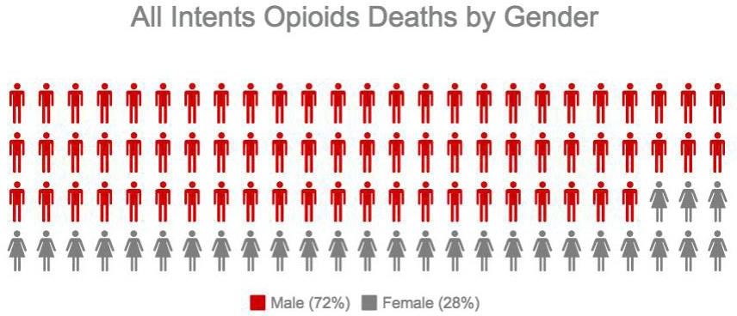

1 Opioids include heroin, opioid-based prescription painkillers, and other unspecified opioids.

# Confirmed Opioid1-Related Deaths, All Intents Compared to All Deaths by Age: January 2016-December 2016

|  |  |  |  |  |  |  |  |  |  |
| --- | --- | --- | --- | --- | --- | --- | --- | --- | --- |
|  | **Deaths by Age: January 2016-December 2016** | | | | | | | | |
|  | **0-14** | **15-24** | **25-34** | **35-44** | **45-54** | **55-64** | **65+** | **Unknown** | **Total** |
| All Deaths | 370 | 463 | 1,196 | 1,400 | 3,031 | 6,009 | 43,014 | 1,317 | **56,800** |
| Confirmed Opioid1-Related  Deaths, All Intents | 1 | 150 | 596 | 480 | 402 | 258 | 32 | 14 | **1,933** |

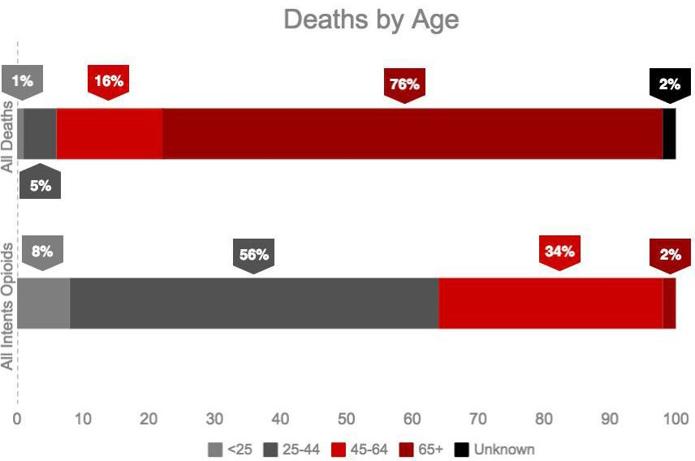

**Confirmed Opioid1-Related Deaths, All Intents Compared to All Deaths by Race: January 2016-December 2016**

|  |  |  |  |  |  |  |
| --- | --- | --- | --- | --- | --- | --- |
|  | **White non-**  **Hispanic** | **Black non-**  **Hispanic** | **Asian non-**  **Hispanic** | **Hispanic** | **Other/ Unknown** | **Total** |
| All Deaths | 50,527 | 2,502 | 1,028 | 2,111 | 632 | **56,800** |
| Confirmed Opioid1-Related Deaths, All Intents | 1,590 | 82 | 14 | 221 | 26 | **1,933** |

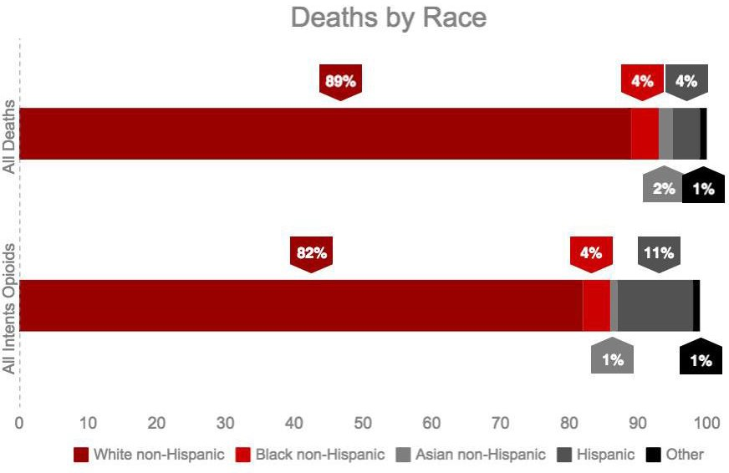

Note: Due to rounding, percentages under “All Intents Opioids” do not add up to 100%.

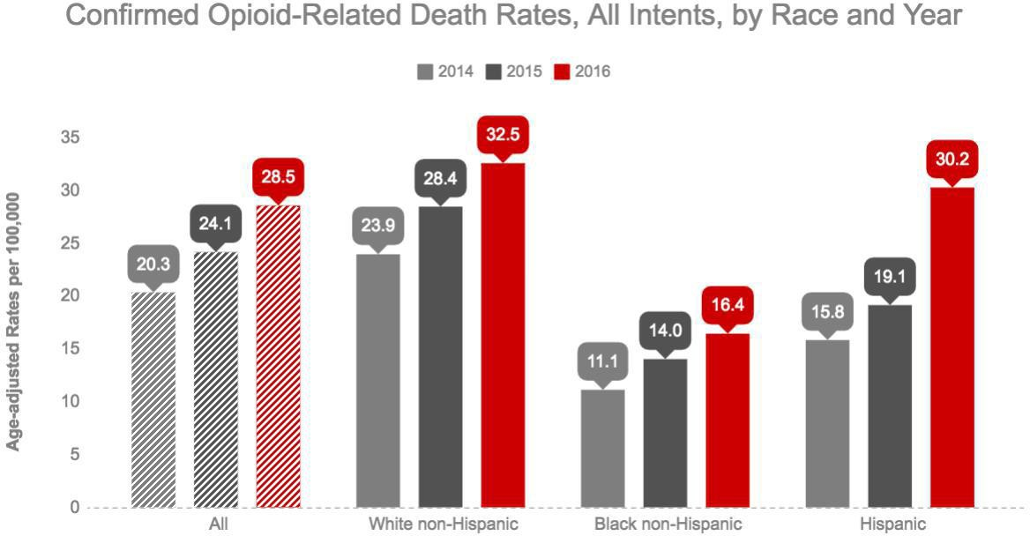

**Technical Notes**

2016 death data are preliminary and subject to updates. Case reviews of deaths are evaluated and updated on an ongoing basis. A large number of deaths have yet to be assigned final cause-of-death codes. The information presented in this report only includes confirmed cases. Data updated on 04/06/2017.

**Source: Registry of Vital Records and Statistics, MDPH**