

POSTED: MAY 2018

Massachusetts Department of Public Health

**Opioid1-Related Overdose Deaths, All Intents, MA Residents – Demographic Data Highlights**

This data brief highlights demographic data from confirmed opioid-related overdose deaths for all intents, from January 2017 through December 2017.

# Confirmed Opioid1-Related Deaths, All Intents, by Gender: January 2017-December 2017

|  |  |
| --- | --- |
| Male | 1,432 |
| Female | 442 |
| **Total** | **1,874** |

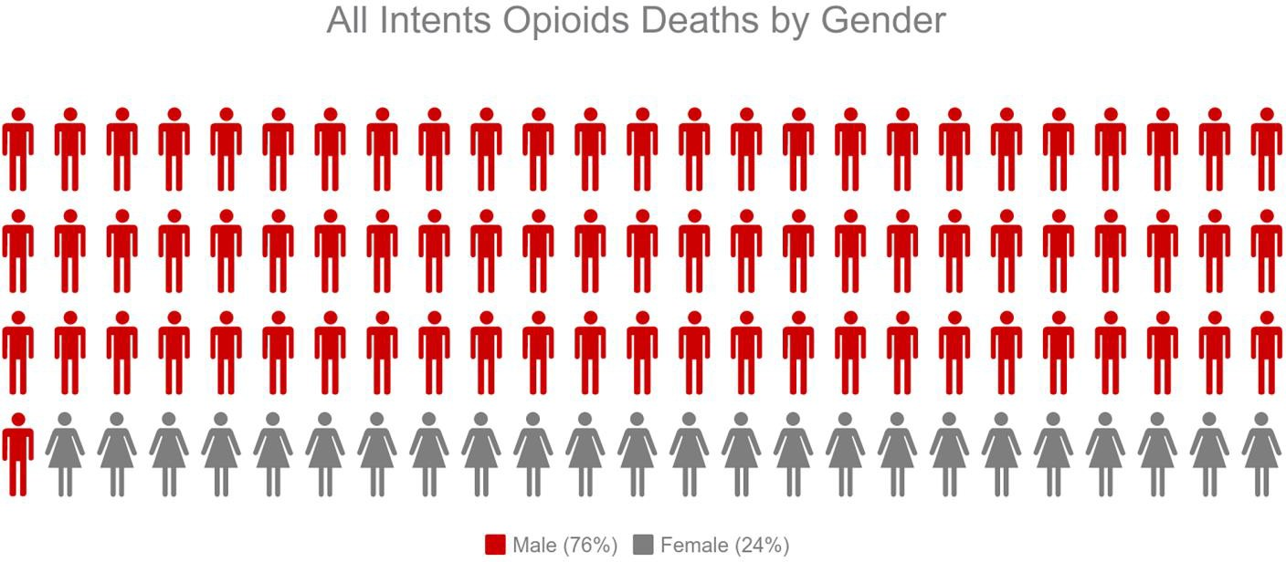

1 Opioids include heroin, opioid-based prescription painkillers, and other unspecified opioids.

# Confirmed Opioid1-Related Deaths, All Intents Compared to All Deaths by Age: January 2017-December 2017

|  |  |  |  |  |  |  |  |  |  |
| --- | --- | --- | --- | --- | --- | --- | --- | --- | --- |
|  | **0-14** | **15-24** | **25-34** | **35-44** | **45-54** | **55-64** | **65+** | **Unknow**  **n** | **Total** |
| All Deaths | 380 | 495 | 1,271 | 1,499 | 3,163 | 6,333 | 45,61  7 | 0 | **58,758** |
| Confirmed Opioid1-Related  Deaths, All Intents | 0 | 126 | 576 | 451 | 428 | 251 | 42 | 0 | **1,874** |

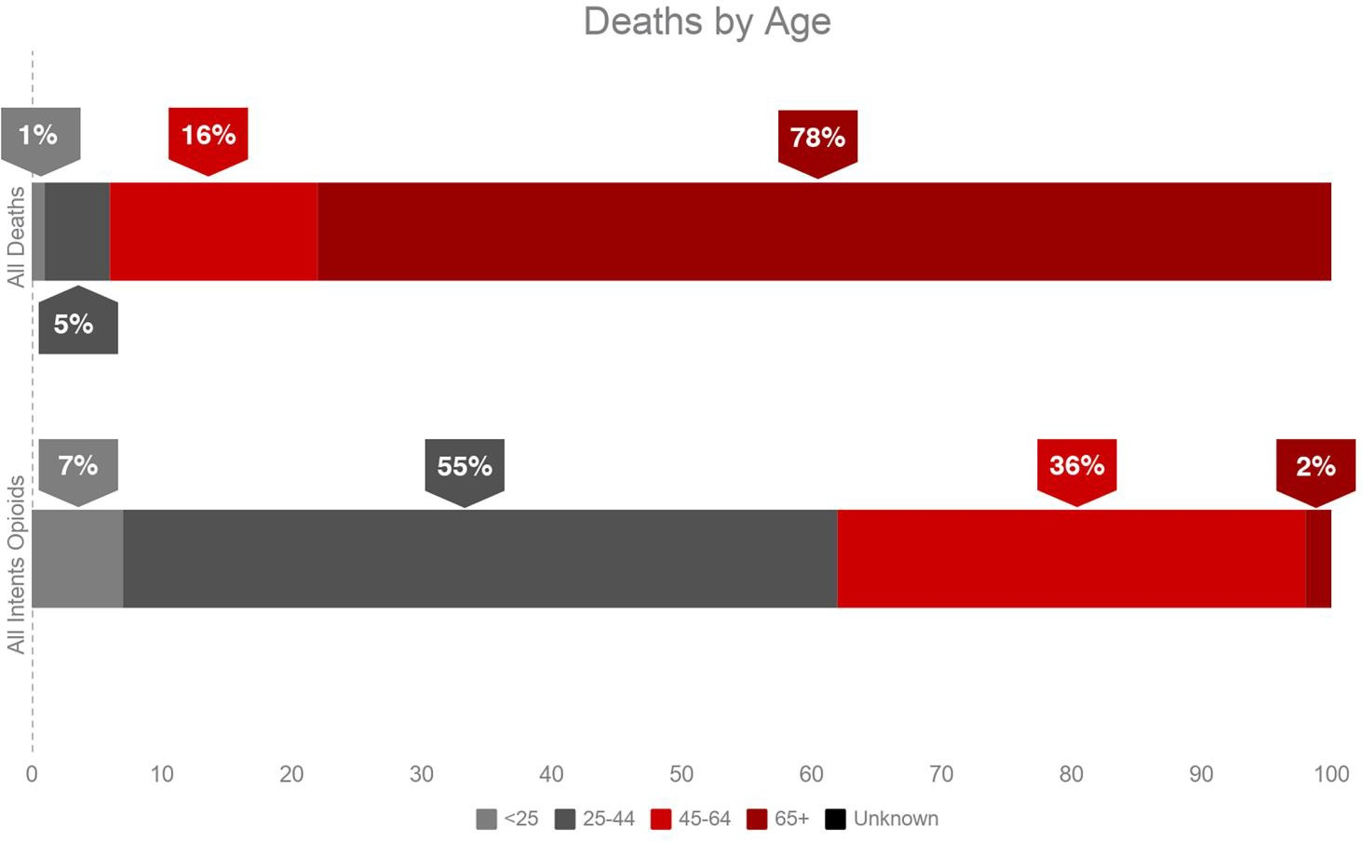

1 Opioids include heroin, opioid-based prescription painkillers, and other unspecified opioids.

# Confirmed Opioid1-Related Deaths, All Intents Compared to All Deaths by Race: January 2017-December 2017

|  |  |  |  |  |  |  |
| --- | --- | --- | --- | --- | --- | --- |
|  | **White non-**  **Hispanic** | **Black non-**  **Hispanic** | **Asian non-**  **Hispanic** | **Hispanic** | **Other/ Unknown** | **Total** |
| All Deaths | 51,985 | 2,634 | 1,162 | 2,352 | 625 | **58,758** |
| Confirmed Opioid1-Related Deaths, All Intents | 1,510 | 103 | 12 | 222 | 27 | **1,874** |

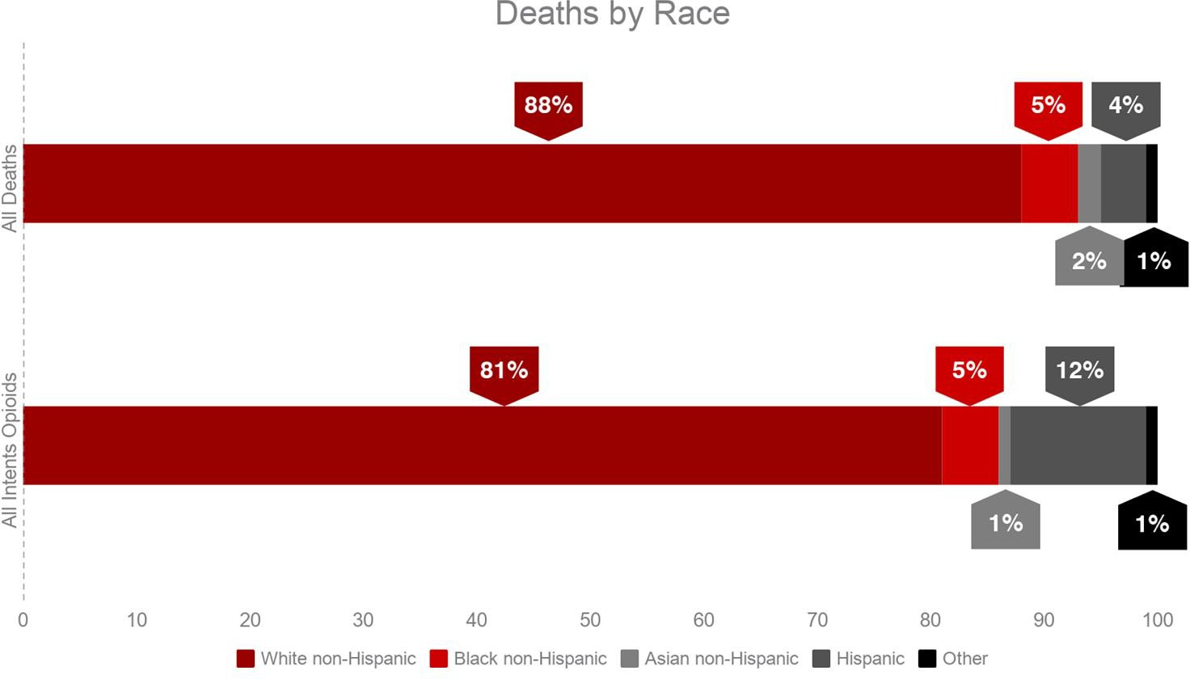

1 Opioids include heroin, opioid-based prescription painkillers, and other unspecified opioids.

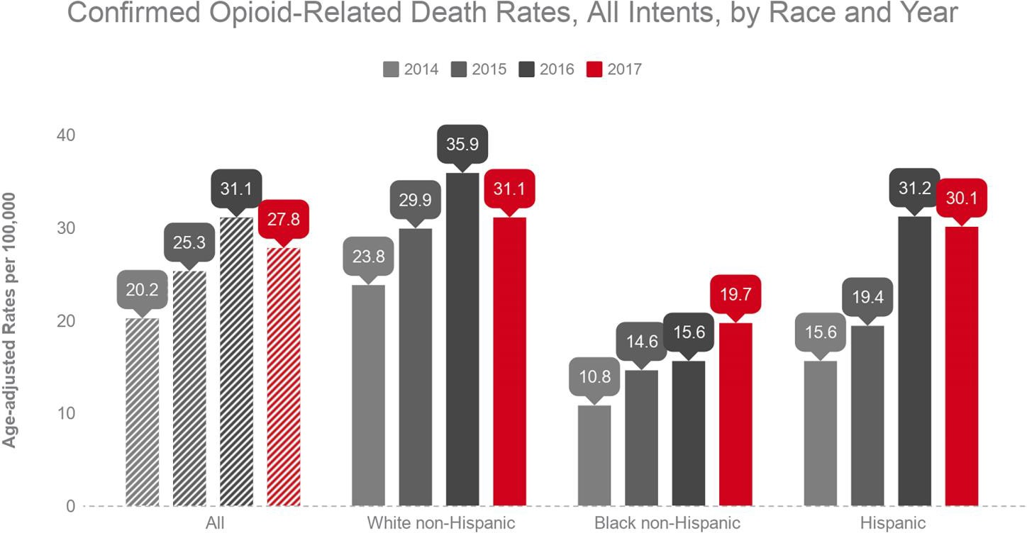

**Technical Notes**

2017 death data are preliminary and subject to updates. Case reviews of deaths are evaluated and updated on an ongoing basis. A large number of deaths have yet to be assigned final cause-of-death codes. The information presented in this report only includes confirmed cases. Data updated on 4/20/2018. Beginning with the May 2017 report, DPH started reporting opioid-related deaths for all intents, which includes unintentional/undetermined and suicide.

**Source: Registry of Vital Records and Statistics, MDPH**