

POSTED: NOVEMBER 2016

Massachusetts Department of Public Health

**Data Brief: Confirmed Unintentional/Undetermined1 Opioid-related2 Overdose Deaths Among Massachusetts Residents – Demographic Data Highlights**

This data brief highlights demographic data from confirmed overdose deaths from January 2016 to September 2016.

# Confirmed Unintentional/Undetermined1 Opioid-related Deaths by Gender: January 2016-September 2016

|  |  |
| --- | --- |
| **Unintentional/Undetermined Opioid Deaths by Gender: January 2016-September 2016** | |
| Male | 751 |
| Female | 254 |
| **Total** | **1,005** |

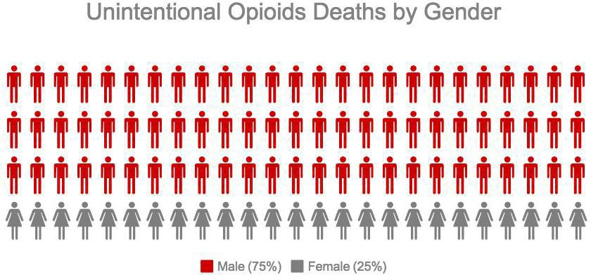

1 Unintentional poisoning/overdose deaths combine unintentional and undetermined intents to account for a change in death coding that occurred in 2005. Suicides are excluded from this analysis.

2 Opioids include heroin, opioid-based prescription painkillers, and other unspecified opioids.

# Confirmed Unintentional/Undetermined1 Opioid-related Deaths Compared to All Deaths by Age: January 2016-September 2016

|  |  |  |  |  |  |  |  |  |  |
| --- | --- | --- | --- | --- | --- | --- | --- | --- | --- |
|  | **Deaths by Age: January 2016-September 2016** | | | | | | | | |
|  | **0-14** | **15-24** | **25-34** | **35-44** | **45-54** | **55-64** | **65+** | **Unknown** | **Total** |
| All Deaths | 269 | 335 | 874 | 1,036 | 2,279 | 4,431 | 31,855 | 9 | **41,088** |
| Confirmed Unintentional /  Undetermined1 Opioid Deaths | 0 | 81 | 333 | 246 | 221 | 116 | 7 | 1 | **1,005** |

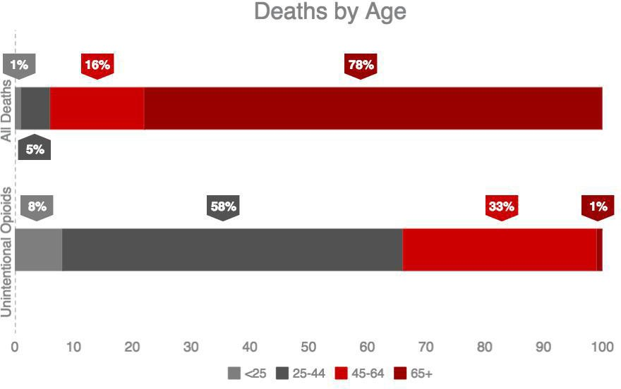

Note: Due to rounding, percentages under “All Deaths” do not add up to 100%.

1 Unintentional poisoning/overdose deaths combine unintentional and undetermined intents to account for a change in death coding that occurred in 2005. Suicides are excluded from this analysis.

# Confirmed Unintentional/Undetermined1 Opioid-related Deaths Compared to All Deaths by Race: January 2016-September 2016

|  |  |  |  |  |  |  |
| --- | --- | --- | --- | --- | --- | --- |
|  | **White non-**  **Hispanic** | **Black non-**  **Hispanic** | **Asian non-**  **Hispanic** | **Hispanic** | **Other/ Unknown** | **Total** |
| All Deaths | 36,634 | 1,785 | 719 | 1,511 | 439 | **41,088** |
| Unintentional/Undetermined1 Opioid Deaths | 826 | 39 | 8 | 119 | 13 | **1,005** |

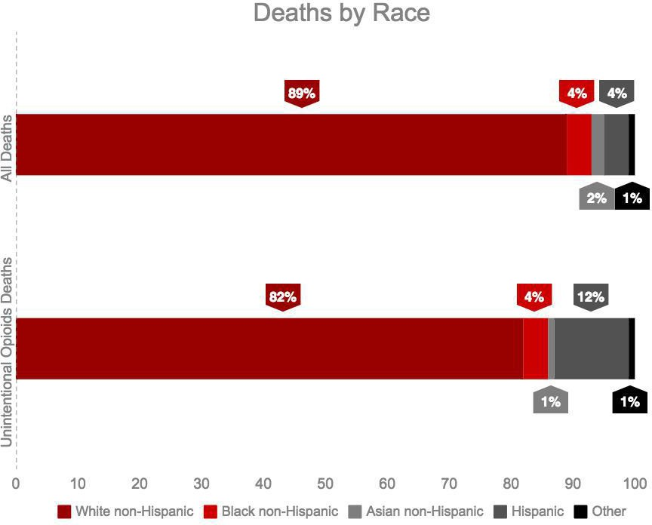

1 Unintentional poisoning/overdose deaths combine unintentional and undetermined intents to account for a change in death coding that occurred in 2005. Suicides are excluded from this analysis.

**Technical Notes**

2016 death data are preliminary and subject to updates. Case reviews of deaths are evaluated and updated on an ongoing basis. A large number of deaths have yet to be assigned final cause-of-death codes. The information presented in this report only includes confirmed cases. Data updated on 09/30/2016.

**Source: Registry of Vital Records and Statistics, MDPH**