This data brief highlights demographic data from confirmed opioid‐related overdose deaths for all intents, from January 2017 through September 2017.



**Opioid1‐Related Overdose Deaths, All Intents, MA Residents – Demographic Data Highlights**

Massachusetts Department of Public Health

POSTED: NOVEMBER 2017

# Confirmed Opioid1‐Related Deaths, All Intents, by Gender: January 2017‐September 2017

|  |  |
| --- | --- |
| **Confirmed Opioid1‐Related Deaths, All Intents by Gender: January 2017‐September 2017** | |
| Male | 710 |
| Female | 222 |
| **Total** | **932** |

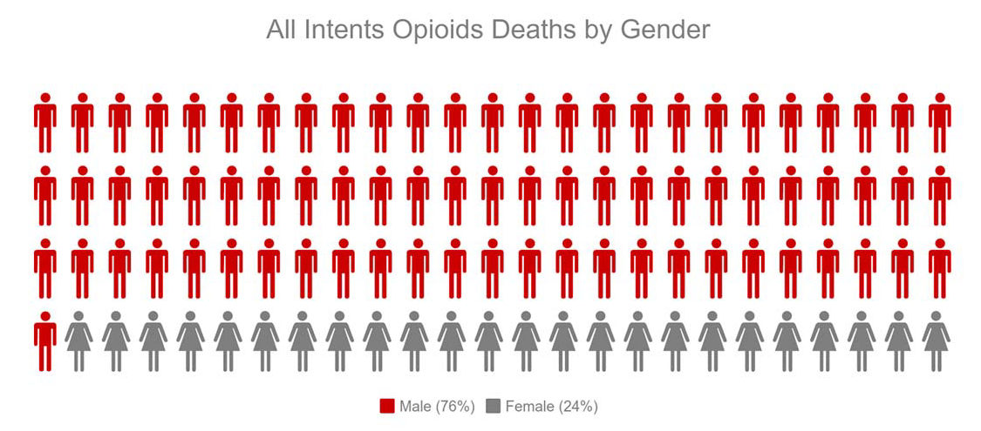

1 Opioids include heroin, opioid‐based prescription painkillers, and other unspecified opioids.

# Confirmed Opioid1‐Related Deaths, All Intents Compared to All Deaths by Age: January 2017‐September 2017

|  |  |  |  |  |  |  |  |  |  |
| --- | --- | --- | --- | --- | --- | --- | --- | --- | --- |
|  | **Deaths by Age: January 2017‐September 2017** | | | | | | | | |
|  | **0‐14** | **15‐24** | **25‐34** | **35‐44** | **45‐54** | **55‐64** | **65+** | **Unknown** | **Total** |
| All Deaths | 274 | 386 | 955 | 1,146 | 2,360 | 4,655 | 33,872 | 1 | **43,649** |
| Confirmed Opioid1‐Related  Deaths, All Intents | 0 | 67 | 281 | 226 | 213 | 117 | 28 | 0 | **932** |

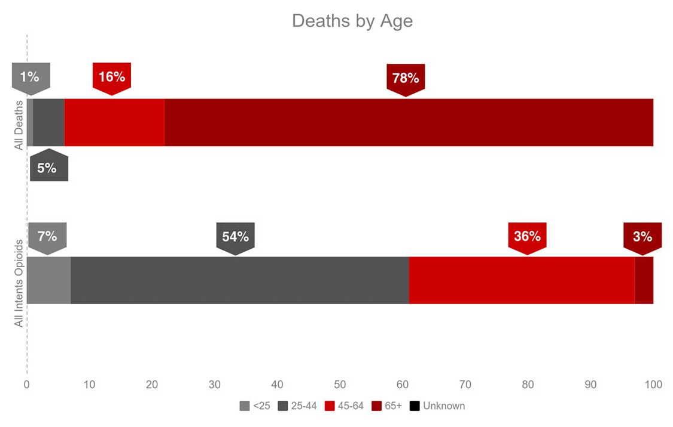

1 Opioids include heroin, opioid‐based prescription painkillers, and other unspecified opioids.

# Confirmed Opioid1‐Related Deaths, All Intents Compared to All Deaths by Race: January 2017‐September 2017

|  |  |  |  |  |  |  |
| --- | --- | --- | --- | --- | --- | --- |
|  | **White non‐**  **Hispanic** | **Black non‐**  **Hispanic** | **Asian non‐**  **Hispanic** | **Hispanic** | **Other/ Unknown** | **Total** |
| All Deaths | 38,709 | 1,922 | 872 | 1,693 | 453 | **43,649** |
| Confirmed Opioid1‐Related Deaths, All Intents | 753 | 49 | 8 | 104 | 18 | **932** |

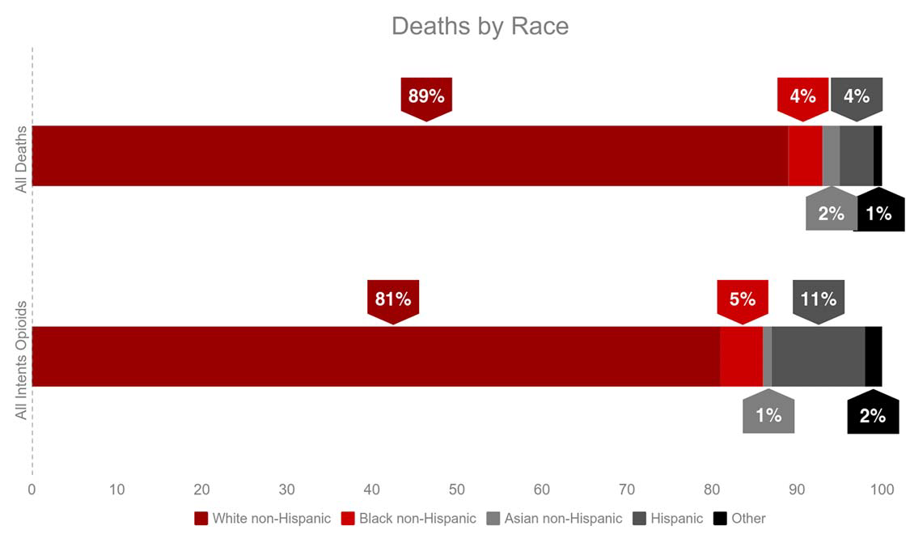

1 Opioids include heroin, opioid‐based prescription painkillers, and other unspecified opioids.

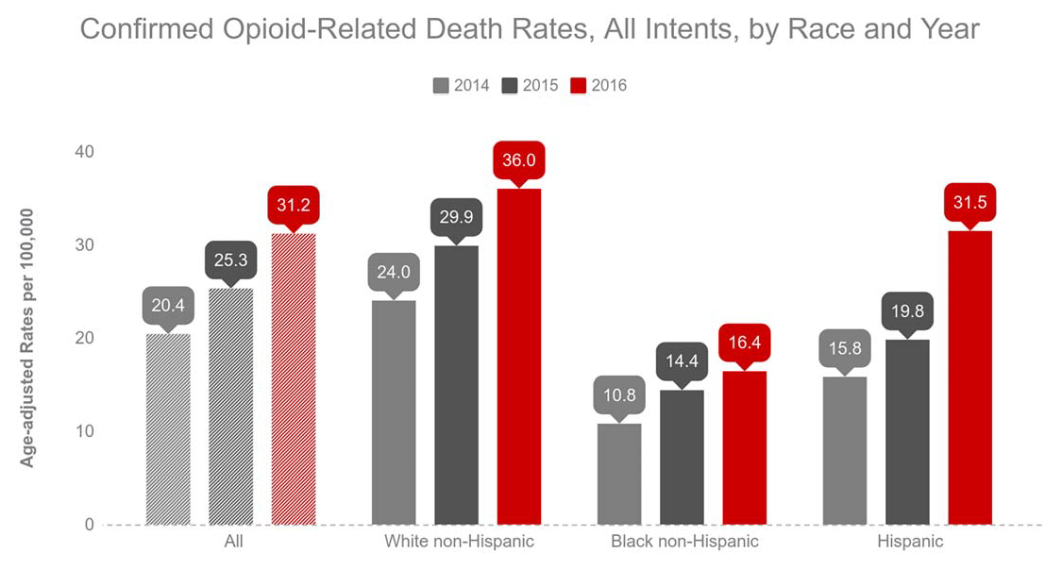

**Technical Notes**

2017 death data are preliminary and subject to updates. Case reviews of deaths are evaluated and updated on an ongoing basis. A large number of deaths have yet to be assigned final cause‐of‐death codes. The information presented in this report only includes confirmed cases. Data updated on 10/12/2017. Beginning with the May 2017 report, DPH started reporting opioid‐related deaths for all intents, which includes unintentional/undetermined and suicide.

**Source: Registry of Vital Records and Statistics, MDPH**