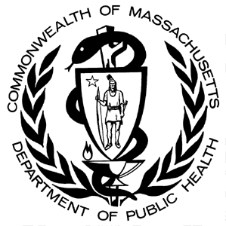

Massachusetts Department of Public Health, Occupational Health Surveillance Program SPRING 2024

**Opioid-Related Overdose Deaths Among Injured Workers in Massachusetts:**

Findings From the Public Health Data Warehouse

**INTRODUCTION**

Massachusetts continues to be impacted by the nationwide opioid epidemic. The state’s annual rate of opioid-related overdose deaths more than tripled over the past decade, increasing from 9.9 per 100,000 residents in 2011 to 32.7 per 100,000 residents in 2021,[1] and the emergency department visit rate of suspected opioid-related overdoses (including non-fatal) increased 28% in one year alone from 2019 to 2020.[2]

Our [previous analyses](https://www.mass.gov/doc/opioid-related-overdose-deaths-in-massachusetts-by-industry-and-occupation-2018-2020-0/download) of Massachusetts death certificate data indicated that the rate of fatal opioid-related overdose among residents of working age also increased by a similar magnitude from 2011 to 2020 (from 15.3 per 100,000 workers to 49.6 per 100,000 workers).[3] This burden was not borne equally; rates of opioid-related overdose deaths varied significantly by the industry[4] and occupation of the decedents. Workers in certain industry groups, such as Construction and Extraction; Farming, Fishing, and Forestry; and more recently, Accommodation and Food Services, had higher rates of opioid-related overdose death compared with workers in other industries during this period.[5] Furthermore, the rate of fatal opioid-related overdose was higher among workers employed in industries and occupations known to have high rates of work-related injuries and illnesses. This finding is consistent with evidence suggesting common use of prescribed opioids for the management of acute and chronic pain following a work-related injury. [6] [7] [8] [9]

Our past analyses have laid the groundwork for understanding how a work injury could be connected to fatal opioid-related overdose, but they have primarily relied on death certificate data. More evidence beyond what is available through death certificates is needed to understand how work injuries may be connected to fatal opioid-related overdose. A first step is being able to identify that a work injury has occurred among those who died from an opioid-related overdose, a step that was not previously possible in our analyses using death certificate data alone. Using the Massachusetts Department of Public Health (DPH) Public Health Data Warehouse (PHD), we are now able to link information about individuals’ employment and work injury status from workers’ compensation data with their death certificate data, as well as with information from multiple other state data sources, which can help take our work to the next step.

Our goals with this data brief are to:

1. demonstrate the linkage potential of the workers’ compensation data with one of the many datasets contained within the PHD for future analyses of occupational-health-related events and opioid-related morbidity and mortality; and,
2. describe a population of workers who were injured at work and also died between 2011 and 2020, focusing on those who suffered a fatal opioid-related overdose. We will characterize deaths among injured workers by demographic factors (binary sex, age, race/Hispanic ethnicity, and nativity), a sociodemographic factor (decedents’ occupation), as well as the type of work injury suffered at the time of or prior to death.

**DATA SOURCES AND METHODS**

We used the PHD to link individuals’ workers’ compensation claims from the Massachusetts Department of Industrial Accidents (DIA) with death certificate data from the Massachusetts Registry of Vital Records and Statistics (RVRS), which allowed us to identify Massachusetts residents who were injured or fell ill on the job (“injured workers”) in the years prior to their death.

The PHD is authorized by M.G.L c. 111 s237, directing DPH to collect data and analyze trends related to opioid-related overdose as well as other priority population health trends as established by the Commissioner of DPH. In addition to death records and workers’ compensation claims data, the PHD includes over 20 additional administrative datasets, such as acute care hospital discharge (Case Mix) records, All Payer Claims Database (APCD) insurance claims, Massachusetts Ambulance Trip Record Information System (MATRIS) records, birth certificate records, Bureau of Substance Addiction Services (BSAS) substance use treatment data, and postmortem toxicology reports from the medical examiner. The APCD, which, depending on the year, includes 80% to 98% of Massachusetts residents, forms the backbone of linkage with all the other datasets. Encrypted identifiers from individuals in each dataset are matched to encrypted identifiers from individuals in the APCD, and each individual is assigned a unique ID that allows datasets in the PHD to be linked. For additional technical information on the dataset linkage in the PHD, see <https://www.mass.gov/info-details/public-health-data-warehouse-phd-technical-documentation>.

Workers’ compensation is a social insurance system that every state, including Massachusetts, uses to provide benefits to workers who are injured on the job. In Massachusetts, these benefits include payment for medical care, as well as compensation for income lost during the period the employee cannot work. Injured workers are eligible for workers’ compensation lost wage benefits when an injury or illness results in five or more days away from work. At this point, the employer or insurer files a *First Report of Injury* with the DIA on behalf of the employee to initiate a claim. It is these claims for serious injuries or illnesses resulting in lost wages, maintained by the DIA, that comprise the workers’ compensation data in the PHD. In this analysis, ‘work-injured’ individuals were those with at least one workers’ compensation claim filed for an injury or illness sustained between 2011 and 2020. When an individual had claims for more than one injury/illness event in this time period, only the claim information for the most recent recorded injury/illness date was included. Information obtained from the workers’ compensation data in the PHD included the type/nature of work-related condition.

The Massachusetts RVRS mortality data included all deaths among Massachusetts residents that occurred between 2011 and 2020. Prior to merging with the workers’ compensation file, we restricted this death file to decedents of working age (16–64 years) to increase the likelihood of capturing persons who would have sustained a work injury in a time relatively proximal to their death. Fatal opioid-related overdoses were identified using the cause of death information on the death certificate, medical examiner reports, and toxicology results. Poisoning deaths from substances/drugs other than opioids (e.g., alcohol, stimulants, hallucinogens) were identified from specific ICD-10 codes[10] in the *underlying cause of death* field. All other deaths among injured workers were grouped as ‘other cause’ deaths and included deaths from heart disease, unintentional injury, cancer, and suicide to name a few. Additional information obtained from the death certificate file included decedents’ age, sex (only binary options of “male/female” available), race/Hispanic ethnicity, nativity status, and usual occupation.

Throughout this data brief, we present percentages with 95% confidence intervals in the text or figures. These intervals are indicators of reliability (or precision) of the estimates. We compare injured workers who died from an opioid-related overdose with injured workers who died of other causes. When comparing percentages, if the 95% confidence intervals around percentages being compared did not overlap, then the percentages were considered statistically significantly different from one another. In the event of a slight overlap of 95% confidence intervals, a chi-square test was performed and resulting p-value evaluated to determine if there were statistically significant differences between the percentages compared. Throughout this data brief, observed differences discussed in the text are ‘statistically significant’ unless otherwise noted.

**DESCRIPTIVE FINDINGS OF A PHD LINKAGE BETWEEN INJURED WORKERS (WORKERS’ COMPENSATION CLAIMANTS) AND DEATHS, 2011–2020**

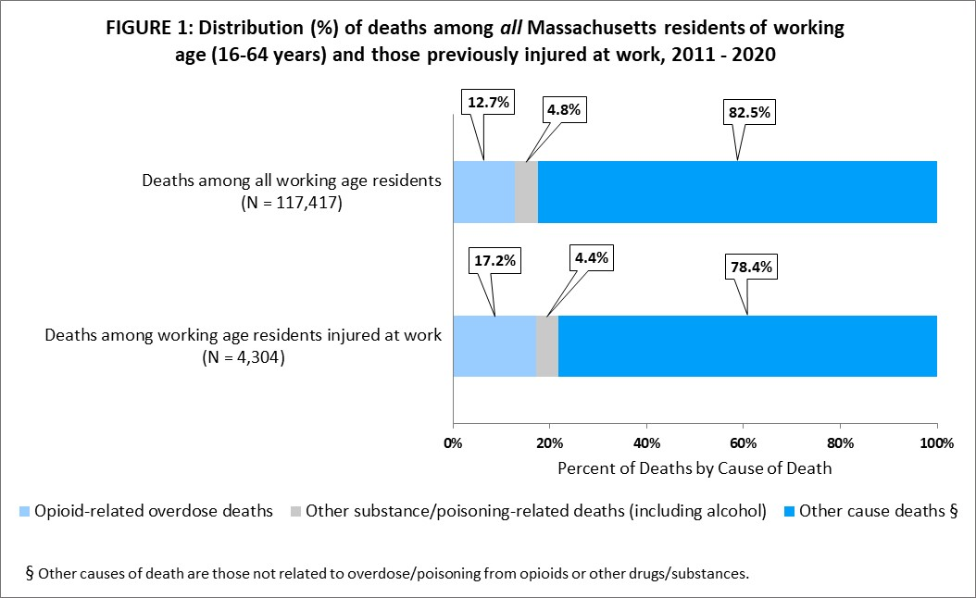

* Between 2011 and 2020, there were 117,417 deaths of working age (16–64 years) residents of Massachusetts.
* Just under 4.0% (N = 4,304) had at least one workers’ compensation claim for a work injury occurring from 2011-2020.
  + Of this cohort of injured workers who died, 741 (17.2%) suffered a fatal opioid-related overdose; 191 (4.4%) suffered other substance use/poisoning-related death (including alcohol use), and the remaining 3,372 decedents died of other causes.
* Figure 1 shows how this distribution by cause of death among deceased injured workers compares with that of *all* working age residents.
  + Seventeen percent (17.2%, 95% CI 16.1%-18.4%) of those injured at work died of an opioid-related overdose, which is 35% higher than the percentage of all deceased working age residents statewide who died of an opioid-related overdose (12.7%, 95% CI 12.5% - 12.9%) during 2011–2020.
* The analyses that follow focus in on the 4,304 decedents who had at least one workers’ compensation claim for a work injury in the years prior to their death.

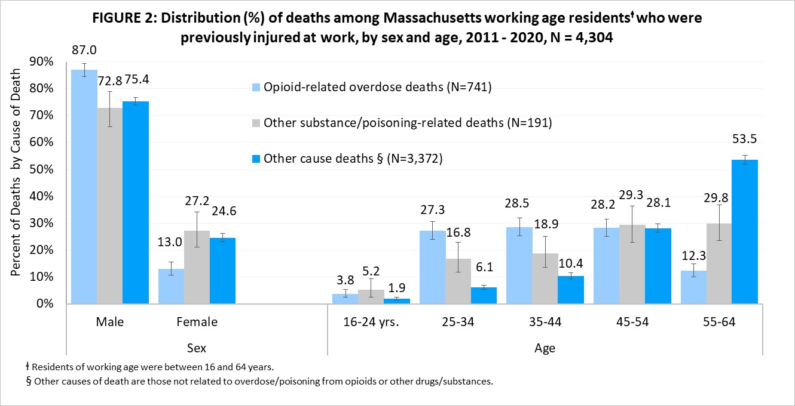

* Compared with their counterparts who died from other causes (including poisonings from use of other substances), a higher percentage of injured workers who died from opioid-related overdoses were male (87.0%).
  + Notably, males (16-64 years) injured at work were over-represented among all causes of death, yet males only represented an estimated 51.0%[11] of all Massachusetts working age (16-64 years) residents who were employed.
* Additionally, a higher percentage of injured workers who died from opioid-related overdoses died at a younger age (between 25 and 44 years) compared with those who died from other causes (including poisoning from use of other substances).
  + This percentage (55.8%) is slightly higher than this group’s representation in the Massachusetts workforce (45.1%)2.
  + The median age at death of injured workers who died from opioid-related overdose was 41 years — lower than the median age of both those who died from other drugs/substances (49 years) and from other causes unrelated to drug/alcohol use (55 years) (p<0.0001) *(data not shown).*

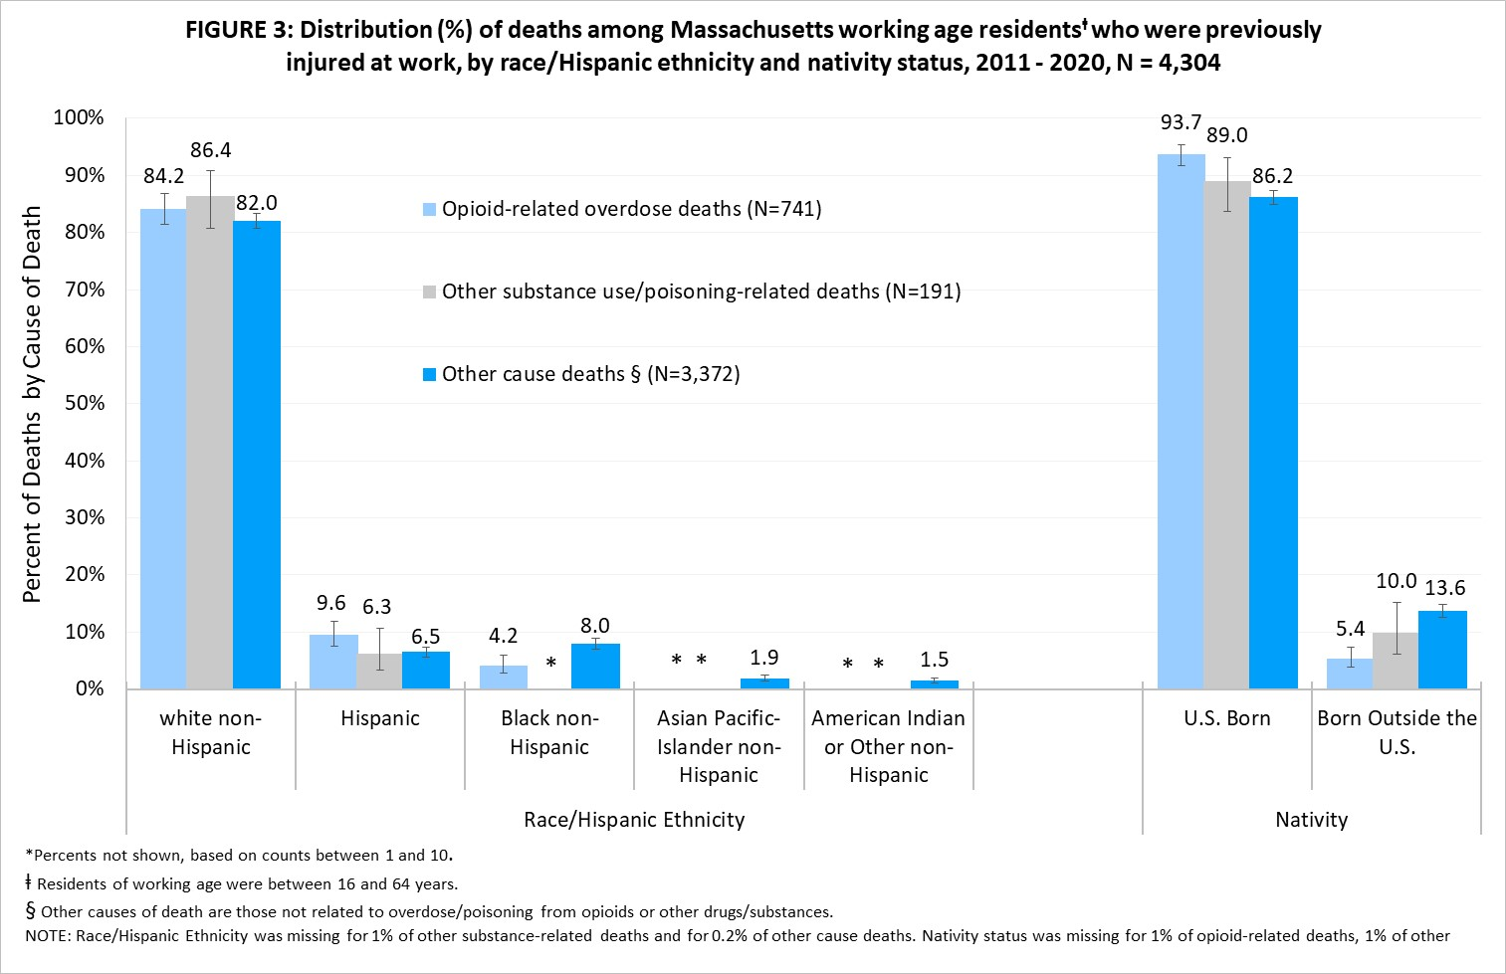

* The highest percentages of injured worker deaths from any cause were among white non-Hispanics.
  + Although these percentages (84.2% of opioid-related overdose deaths, 86.4% of other poisoning-related deaths, and 82.0% of other cause deaths) were much higher than the corresponding percentages among residents of color, it is notable that a similarly high percentage of the Massachusetts workforce (75.0%)[12] identified as white non-Hispanic during this same period, 2011-2020.
* The percentage of injured workers who were Hispanic was higher among those who died from opioids (9.6%) than among those who died from other causes (e.g., heart disease, unintentional injury) (6.5%).
* The percentage of injured workers who were Black non-Hispanic was lower among those who died from opioids (4.2%) compared with those who died from other causes (8.0%).
* While there were lower *numbers* of deaths among residents of color who were injured at work compared with white non-Hispanics, it is worth noting that in Massachusetts, Hispanic workers suffer the highest *rate* of death from workplace injury and, in the U.S., both Hispanic and Black workers disproportionately work in the most dangerous jobs.[13] [14]
* The percentage of injured workers who were born in the U.S. was higher among those who experienced an opioid-related overdose death (93.7%) compared with those who died from other causes (86.2%).
* There were also lower *numbers* of deaths among residents born outside of the U.S. who were injured at work compared with U.S.-born residents who were injured at work. Immigrant workers injured on the job may be least likely to enter the workers compensation system which may partially explain the low numbers seen in these data.
  + Although not all workers are eligible for workers’ compensation benefits, there are many barriers preventing immigrant workers (especially the undocumented) from obtaining the workers’ compensation benefits to which they are entitled [15] [16]

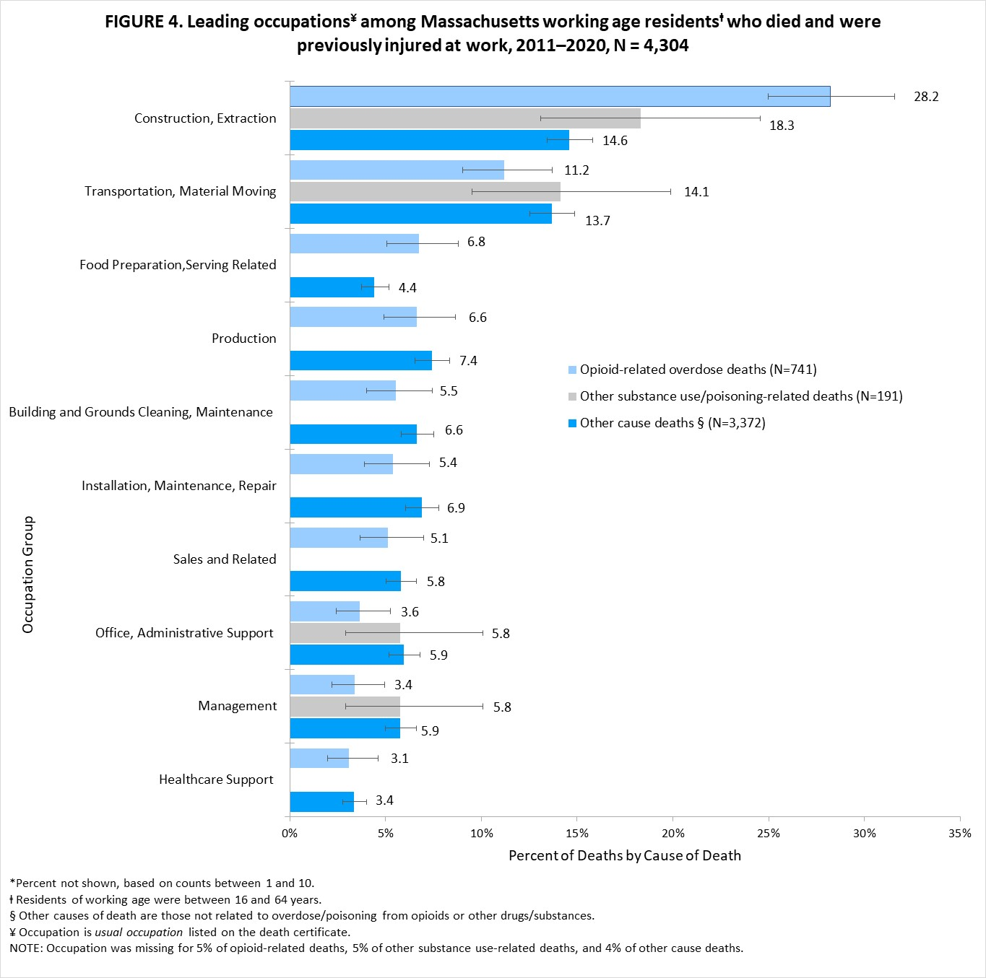

* Another group that continues to be adversely affected by the opioid epidemic are workers in industries and occupations[17] that require very physically demanding work and that have workplace injury rates much higher than the overall rate for all workers.
* Although Construction and Extraction occupations only represented an estimated 4%[18] of the Massachusetts’ workforce during this study period, injured workers in these occupations accounted for the highest percentage of deaths (17.1%) from *any* cause in this study *(data not shown).*
* Among workers previously injured on the job who died, those who died of an opioid-related overdose (28.2%) were more likely to be employed in Construction and Extraction jobs than those who died from a substance other than an opioid (18.3%) and those who died from another cause (14.6%).
  + A higher percentage of injured workers who died from opioids worked in Food Preparation and Serving-related jobs compared with injured workers in these same jobs who died from other causes (6.8% vs. 4.4%) (Figure 4).
* Although there is no statistically significant difference in the percentage of deaths of Transportation and Material Moving workers in each of the three cause of death groups (Figure 4), this occupation group accounted for the second highest percentage (13.3%) of *all* injured worker deaths, after Construction and Extraction (17.7%) *(data not shown).*

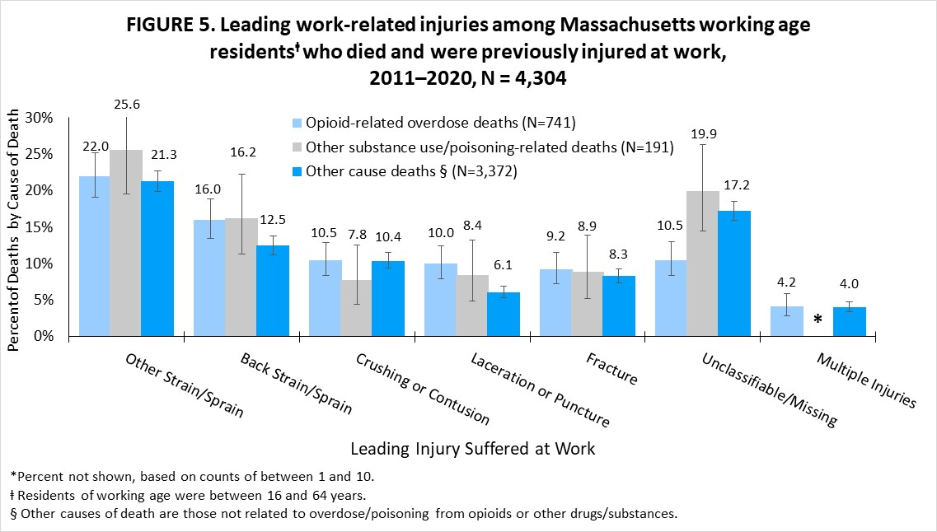

* From the workers’ compensation data, we had information about the nature of injury/pain suffered at work among those who died of an opioid overdose, allowing us to begin assessing the contribution of such injuries to opioid use and death.
* There were proportionately more back sprains/strains among those injured workers who died from an opioid-related overdose compared with those who died of other causes (16.0% vs.12.5%).
* A higher percentage of injured workers who died from an opioid-related overdose suffered a laceration or puncture at work compared with those who died of other causes (10.0% vs. 6.1%).

**SUMMARIZED DATA FINDINGS**

* As a result of the linkage of workers’ compensation data with death data in the PHD, for the first time on a large scale, we identified a cohort of decedents who were injured or fell ill at work (“injured workers”) between 2011 and 2020. Having this ability in the PHD to identify that a work injury has occurred among those who died from opioid-related overdose is an important step in being able to make clearer any connections that exist between injuries in the workplace, resulting pain, and opioid overdose deaths. In addition, since the death data contain information on the race/Hispanic ethnicity, as well as nativity status, of injured workers who died in Massachusetts, this linkage allowed us to look at the distribution of these critical data elements in the workers’ compensation data among injured workers who died. These data elements are not currently collected by the Massachusetts workers’ compensation system.
* From 2011 to 2020, there were 117,417 deaths of working age (16–64 years) Massachusetts residents. Among these decedents, 3.7% (N = 4,304) had at least one workers’ compensation claim with the Massachusetts Department of Industrial Accidents for a work injury occurring from 2011 to 2020. Of these injured workers who died, 741 (17.2%) suffered a fatal opioid-related overdose, 191 (4.4%) suffered another substance use/poisoning-related death (including alcohol use) and the remaining 3,372 (78.3%) died of other causes unrelated to drug/alcohol use (Figure 1).
* Among Massachusetts working-age residents (16-64 yrs.) who died between 2011 and 2020, those who had a work-related injury from 2011-2020 reported in the workers’ compensation system, were more likely to have died of an opioid-related overdose than all working working-age residents (17.2% vs. 12.7%).
* From Figures 2-4, among injured workers who died (N = 4,304), those who died from opioid-related overdose were more likely to be: *[19]
  + - Male (87.0%) than those who died of causes unrelated to drug/alcohol use (75.4%) *
    - Between 25 and 44 years of age (55.8%) than those who died of causes unrelated to drug/alcohol use (16.5%) *
    - Of Hispanic ethnicity (9.6%) than those who died of causes unrelated to drug/alcohol use (6.5%) *
    - Born in the U.S. (93.7%) than those who died of causes unrelated to drug/alcohol use (86.2%) *
    - Construction or Extraction workers (28.2%) than those who died of causes unrelated to drug/alcohol use (14.6%) *
    - Workers in Food Preparation/Serving occupations (6.8%) than those who died of causes unrelated to drug/alcohol use (4.4%) *
* From Figure 5, among injured workers who died (N = 4,304), those who died from opioid-related overdose were more likely to:
  + - Suffer a back strain/sprain at work (16.0%) than those who died of causes unrelated to drug/alcohol use (12.5%) *
    - Suffer a laceration or puncture at work (10.0%) than those who died of causes unrelated to drug/alcohol use (6.1%) *

**LIMITATIONS TO CONSIDER WHEN INTERPRETING FINDINGS**

There are limitations with respect to the representativeness and completeness of the workers’ compensation data available through the DIA. First, the workers’ compensation data are *only* claims for work injuries or illnesses that result in five or more days away from work (i.e., the more serious injuries). Thus, the claims for injuries/illnesses resulting in less than five lost workdays as well the claims filed only for medical benefits are not submitted to the DIA and therefore not included in the PHD. Records for these ‘medical-only’ claims are estimated to account for a majority of all workers’ compensation claims in Massachusetts.[20] Secondly, not all workers are covered by workers’ compensation, and some injured workers who are covered do not always have a claim filed for benefits. Additional individuals who were injured at work might only be captured with a more expansive linkage involving other PHD datasets (e.g., inpatient hospital discharges, emergency department discharges, emergency medical service encounters, all payer claims, and prescription monitoring data). Also, information on some of the key elements (e.g., industry, occupation) in the workers’ compensation claims records was incomplete, either because information was missing, or the information provided could not be coded. Therefore, we had to rely on *usual occupation* on the death certificate for our analysis. We assumed that decedents who had occupation reported on their death certificate were working in that occupation at the time of death or just preceding death. If decedents were retired, not employed, or working in another type of job at the time of death, the percentages by occupation may be slightly over- or underestimated.

**CONCLUSIONS AND NEXT STEPS**

This work has provided an initial demographic description of the Massachusetts working age residents who were injured at work between 2011-2020 and subsequently died of an opioid overdose or other cause. The findings show differences in the percent distributions of demographic and occupational variables by cause of death and raise questions around the connection between work and opioid-related overdose that can be addressed through more in-depth analyses of the PHD. The ability to perform large-scale linkage across the multiple data sources in the PHD including inpatient hospital discharges, emergency department discharges, EMS encounters, all payer claims (i.e., claims for healthcare provider visits), and prescription monitoring program records at the individual level is innovative and may help us better understand associations between work-related injury/musculoskeletal pain, opioid use, opioid overdose, opioid use disorder, and treatment. This data brief has established the possibility of occupational-focused analyses within the PHD to help provide further insight into the connection between work and opioid overdose. Future work will focus on the burden of opioid use (i.e., prescriptions filled) among workers injured on the job and the impact of opioid prescribing practices on the prevalence of opioid use disorder, opioid overdose, and treatment for drug use.

Concurrent with these data analysis efforts, stakeholders across Massachusetts, including the Massachusetts Department of Public Health, are intervening in novel ways to educate workers about the debilitating effects of opioids and to prevent or reduce opioid use among different worker groups (e.g., unionized and non-unionized workers in ‘high risk’ industries, such as construction). In addition to engaging workers in these efforts, stakeholders are also engaging employers and labor leadership. These entities can provide benefits, policies, and other practices that support workers’ use of safer alternatives for the treatment of pain and evidenced-based and culturally responsive treatment for opioid use disorder.

1. **REFERENCES**

   Massachusetts Department of Public Health, Data Brief: Opioid-Related Overdose Deaths among Massachusetts Residents – June 2023. https://www.mass.gov/doc/opioid-related-overdose-deaths-among-ma-residents-june-2023/download
2. Centers for Disease Control and Prevention. Drug Overdose Surveillance and Epidemiology (DOSE) System. Atlanta, GA: US Department of Health and Human Services, CDC; [2023 Jan 9]. Access at: <https://www.cdc.gov/drugoverdose/nonfatal/dashboard>
3. Massachusetts Department of Public Health (2022). Opioid-related Overdose Deaths in Massachusetts by Industry and Occupation: 2018–2020. <https://www.mass.gov/doc/opioid-related-overdose-deaths-in-massachusetts-by-industry-and-occupation-2018-2020-0/download>
4. Occupation describes the kind of work an individual does to earn a living (i.e., job title), while industry describes the type of business the employer is engaged in.
5. Massachusetts Department of Public Health (2022). Opioid-related Overdose Deaths in Massachusetts by Industry and Occupation: 2018–2020. <https://www.mass.gov/doc/opioid-related-overdose-deaths-in-massachusetts-by-industry-and-occupation-2018-2020-0/download>

  
6. Massachusetts Department of Public Health (2018). Opioid-related Overdose Deaths in Massachusetts by Industry and Occupation, 2011-2015. <https://www.mass.gov/files/documents/2020/03/19/opioid-industry-occupation.pdf>
7. Massachusetts Department of Public Health (2021). Opioid-related Overdose Deaths in Massachusetts by Industry and Occupation, 2016-2017. <https://www.mass.gov/doc/opioid-related-overdose-deaths-by-industry-and-occupation-2016-2017-0/download>
8. Durand Z, Nechuta S, Krishnaswami S, Hurwitz EL, McPheeters M. Prescription opioid use by injured workers in Tennessee: a descriptive study using linked statewide databases. Ann Epidemiol. 2019;32:7-13.
9. Savych B, Neumark D, Lea R. Do opioids help injured workers recover and get back to work? The impact of opioid prescriptions on duration of temporary disability. Ind Relat, 2019; 58:549-90.
10. International Classification of Diseases – 10th Edition (ICD-10) codes F10, F12, F13, F14, F15, F16, F17, F18, & F19.
11. Percent of employed Massachusetts residents, 16-64 years of age, was estimated from 2011–2020 Current Population Survey data for Massachusetts, extracted from the NIOSH Employed Labor Force (ELF) query system (wwwn.cdc.gov/wisards/cps/ ).
12. Percent of employed Massachusetts residents, 16-64 years of age, was estimated from 2011–2020 Current Population Survey data for Massachusetts, extracted from the NIOSH Employed Labor Force (ELF) query system (wwwn.cdc.gov/wisards/cps/ ).
13. Fatal Injuries at Work, 2020, Occupational Health Surveillance Program, Massachusetts Department of Public Health, https://www.mass.gov/doc/massachusetts-fatality-update-2020/download
14. Davis, Letitia, Health Equity: Work Matters. Oral Presentation at: Council of State and Territorial Epidemiologists (CSTE) Annual Conference, June 2018, West Palm Beach, FL.
15. Azaroff LS, Levenstein C., Wegman DH, Occupational injury and illness surveillance: conceptual filters explain underreporting. (2002) Am J Pub Hlth, 92(9): 1421-1429.

   
16. Azaroff LS, Davis LK, Naparstek R, Hashimoto D, Laing JR, Wegman DH. Barriers to use workers’ compensation for patient care at Massachusetts community health centers. (2013). Health Serv Res. Aug; 48(4):1375-92.
17. Occupation describes the kind of work an individual does to earn a living (i.e., job title), while industry describes the activities the individual’s employer is engaged in.
18. Percent of employed Massachusetts residents, 16-64 years of age, was estimated from 2011–2020 Current Population Survey data for Massachusetts, extracted from the NIOSH Employed Labor Force (ELF) query system (wwwn.cdc.gov/wisards/cps/ ).
19. Note: * indicates a statistically significant differences between the two percentages compared based on nonoverlapping 95% confidence intervals and p-values less than 0.05 from chi-square tests.
20. Using Massachusetts Workers’ Compensation Data to Identify Priorities for Preventing Occupational Injuries and Illnesses among Private Sector Workers. (2019) Findings from an Analysis of Massachusetts Workers’ Compensation Lost Wage Claims, 2014-2016.

    <https://www.mass.gov/doc/dph-dia-and-dls-release-new-study-on-utilization-of-workers-compensation-data/download>