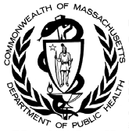

**Data Brief: Opioid1‐Related Overdose**

**Deaths Among Massachusetts Residents**

Massachusetts Department of Public Health

POSTED: AUGUST 2018

This report contains both confirmed and estimated data through June 2018.

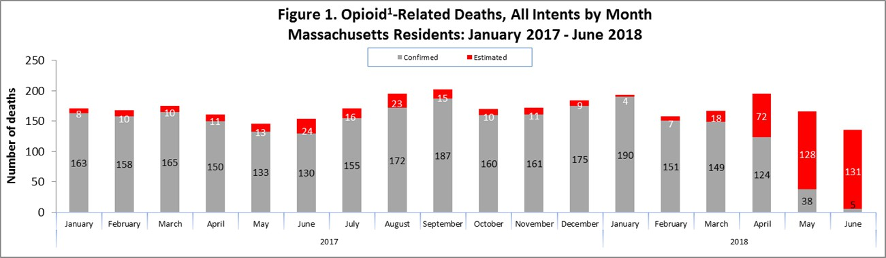

The chart above shows the month‐by‐month estimates for fatal opioid‐related overdoses for all intents from January 2017 through June 2018. For the first 6 months of 2018, there are 657 confirmed opioid‐related overdose deaths and DPH estimates that there will be an additional 322 to 396 deaths.

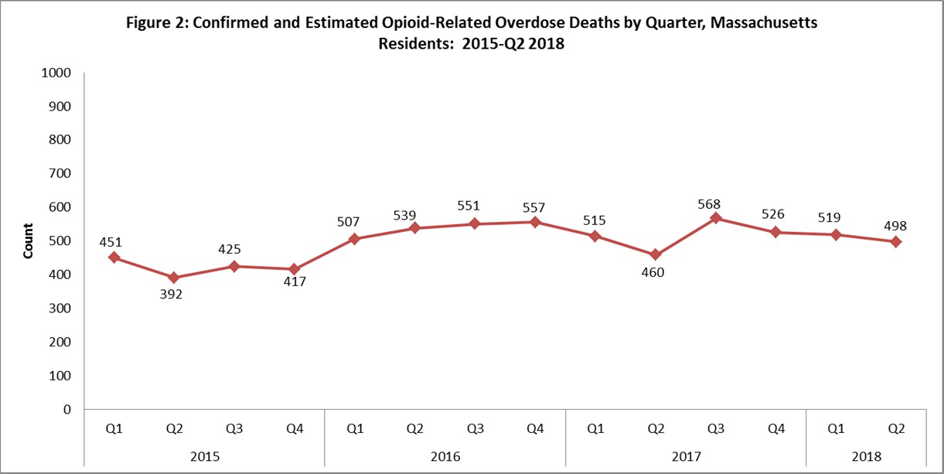

Note: Counts for 2016‐2018 are based on estimates and are subject to change.

From the fourth quarter of 2015 through the end of 2016, the count of opioid‐related overdose deaths increased. For the first two quarters of 2017, the count of opioid‐related overdose deaths decreased but then increased in the third quarter. Since the third quarter of 2017, the number of opioid‐related overdose deaths has steadily decreased, including

the first two quarters of 2018 (Figure 2). Despite the spike in the third quarter of 2017, overall, there was a 4% decrease in opioid‐related overdose deaths in 2017 compared with 2016.

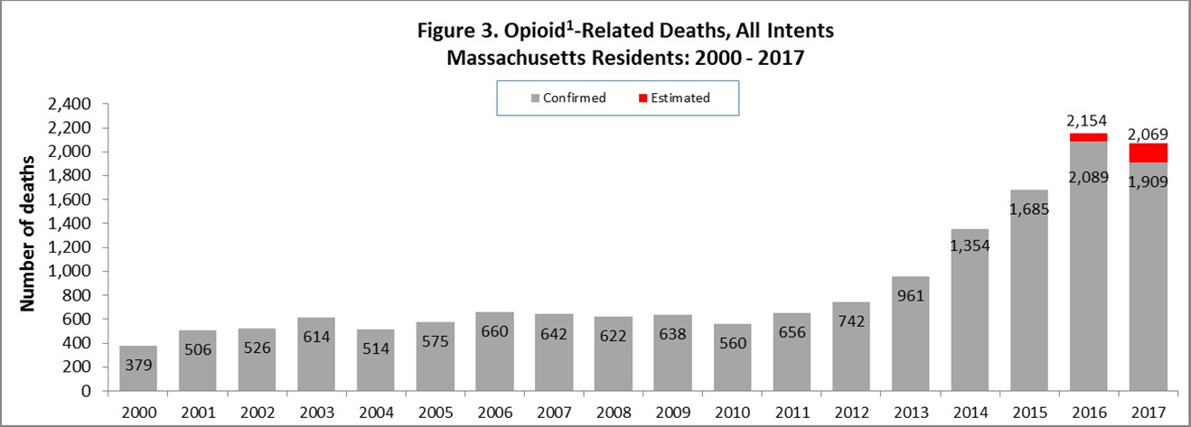

Figure 3 shows the number of confirmed and estimated cases of opioid‐related overdose deaths for all intents in 2017 (n=2,071). This represents a 4% decrease from 2016’s total confirmed and estimated cases (n=2,154). The updated number of confirmed and estimated cases for 2016 (n=2,154) shows a 28% increase over confirmed cases in 2015 (n=1,685). In order to obtain timelier estimates of the total number of opioid‐related overdose deaths in Massachusetts

‐ confirmed and probable ‐ DPH used predictive modeling techniques for all cases not yet finalized by the Office of the Chief Medical Examiner (OCME). Based on the data available as of July 19, 2018, DPH estimates that there will be an additional 61 to 68 deaths in 2016, and an additional 153 to 171 deaths in 2017, once these cases are finalized.

# Opioid‐Related Overdose Death Rates, All Intents

In 2017, there was a 4% decrease in opioid‐related overdose death rates from 2016.

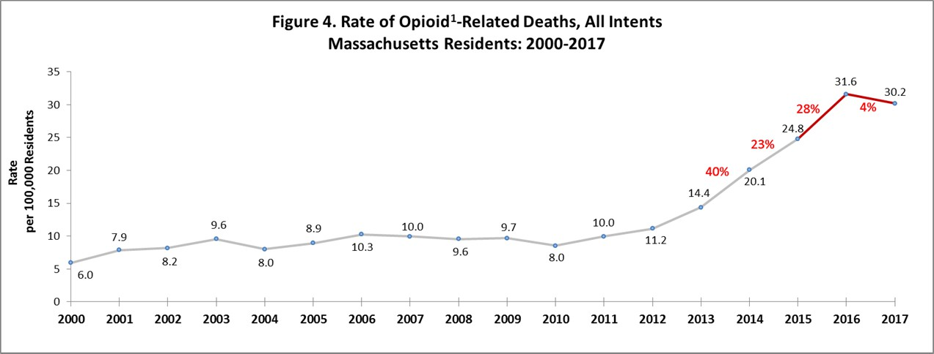 1

Opioids include heroin, opioid‐based prescription painkillers, and other unspecified opioids.

# Technical Notes

Beginning with the May 2017 report, DPH started reporting opioid‐related deaths for all intents, which includes unintentional/undetermined and suicide. This report tracks opioid‐related overdoses due to difficulties in identifying heroin and prescription opioids separately. The Department regularly reviews projections as more information becomes available. Information from the Office of the Chief Medical Examiner and the Massachusetts State Police are now incorporated into the predictive model. This additional information has improved the accuracy of the models that

predict the likelihood that the cause of death for any person was an opioid‐related overdose. DPH applied this model to death records for which no official cause of death was listed by the OCME. The model includes information from the death certificate, Medical Examiner’s notes, and the determination by the State Police of a suspected heroin death. DPH added this estimate to the number of confirmed cases in order to compute the total number of opioid‐related overdoses. Should new information become available that changes the estimates to any significant degree, updates will be posted. Estimated opioid‐related overdose death numbers were not produced for 2015 since the death file has been closed.

# Toxicology Analysis: Fentanyl and Other Drugs

Fentanyl is a synthetic opioid that has effects similar to heroin. It can be prescribed for severe pain. According to the

U.S. Department of Justice, Drug Enforcement Administration’s 2015 Investigative Reporting, while pharmaceutical fentanyl (from transdermal patches or lozenges) is diverted for abuse in the United States at small levels, much of the fentanyl in Massachusetts is due to illicitly‐produced fentanyl, not diverted pharmaceutical fentanyl.

The standard toxicology screen ordered by the Office of the Chief Medical Examiner includes a test for the presence of fentanyl. Among the 477 individuals whose deaths were opioid‐related in 2018 where a toxicology screen was also available, 423 of them (89%) had a positive screen result for fentanyl. In the first quarter of 2018, heroin or likely heroin was present in approximately 34% of opioid‐related deaths that had a toxicology screen. Cocaine was present in approximately 43% of these deaths; and benzodiazepines were present in approximately 42%. Since 2014, the rate of heroin or likely heroin present in opioid‐related deaths has been decreasing while the presence of fentanyl and cocaine is still trending upward.

While screening tests can be used to note the rate at which certain drugs are detected in toxicology reports, they are insufficient to determine the final cause of death without additional information. The cause of death is a clinical judgement made within the Office of the Chief Medical Examiner.

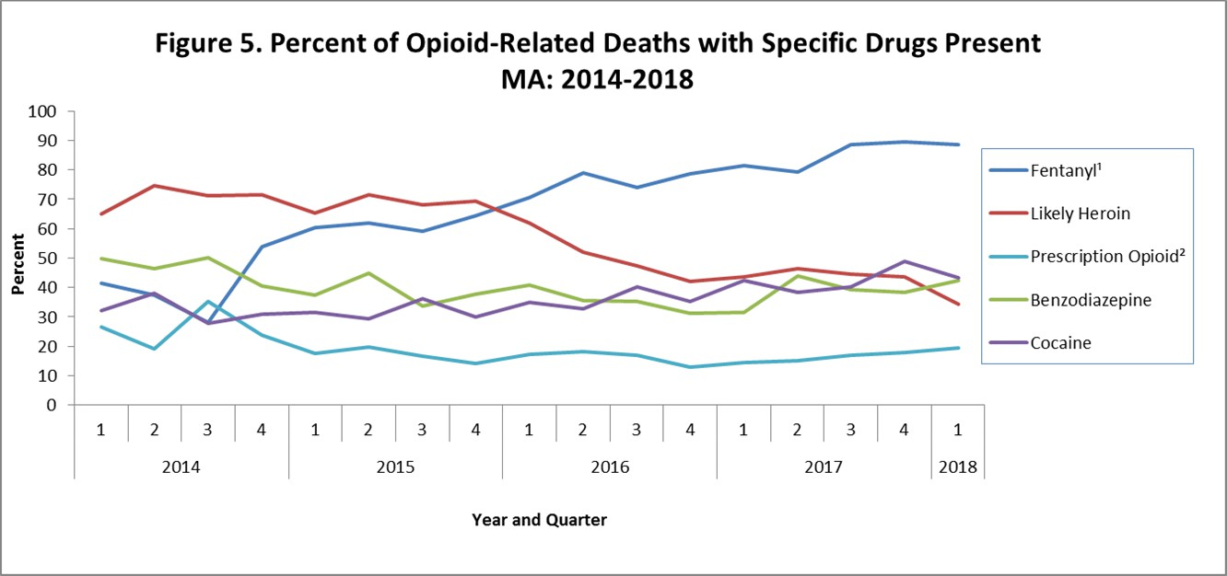

1. This is most likely illicitly produced and sold, **not** prescription fentanyl
2. Prescription opioids include: hydrocodone, hydromorphone, oxycodone, oxymorphone, and tramadol

**Please note that previous estimates may change slightly as DPH routinely receives updated toxicology data from the Office of the Chief Medical Examiner and the Massachusetts State Police.**