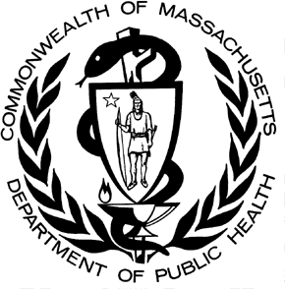

POSTED: FEBRUARY 2018

Massachusetts Department of Public Health

**Data Brief: Opioid1-Related Overdose Deaths Among Massachusetts Residents**

This report contains both confirmed and estimated data through December 2017.



**Figure 1. Opioid1-Related Deaths, All Intents by Month**

**Massachusetts Residents: January 2016 - December 2017**

250

200

7

7

8

5

6

3

6

5

25

150

6

5

7

7

9

12

24

14

11

17

116 164

19

22

44

100

185

176

194

183

202

152

172 169

169 166

161

154 157

146

160

145

148

163

171

50

119

115

50

0

4

January

March

May

July

September November

January

March

May

July

September November

2016 2017

123

Confirmed Estimated

**Number of deaths**

The chart above shows month-by-month estimates for fatal opioid-related overdoses for all intents from January 2016 through December 2017. For 2017, there are 1501 confirmed opioid-related overdose deaths and DPH estimates that there will be an additional 433 to 518 deaths.

**Figure 2. Opioid1-Related Deaths, All Intents**

**Massachusetts Residents: 2000 - 2017**

2,400

2,200

2,155

2,000

1,800

1,600

1,400

1,200

1,000

800

600

400

200

0

1,977

1,768

2,083

1,648

1,501

2000 2001 2002 2003 2004 2005 2006 2007 2008 2009 2010 2011 2012 2013 2014 2015 2016 2017

379

514

526

506

560

575

622

642

614

638

656

660

742

961

1,352

Confirmed Estimated

**Number of deaths**

The figure above shows the number of confirmed and estimated cases of opioid-related overdose deaths for all intents in 2017 (n=1,977). This represents an 8.3% decrease from 2016’s total confirmed and estimated cases (n=2,155).

Updated number of confirmed cases for 2016 (n=2,083) shows a 26% increase over confirmed cases in 2015 (n=1,648) and a 54% increase over 2014 (n= 1,352). In order to obtain timelier estimates of the total number of opioid-related overdose deaths in Massachusetts - confirmed and probable - DPH used predictive modeling techniques for all cases not yet finalized by the Office of the Chief Medical Examiner (OCME). Based on the data available as of January 25, 2018, DPH estimates that there will be an additional 113 to 128 deaths in 2015, and an additional 67 to 77 deaths in 2016, once these cases are finalized.

# Opioid-Related Overdose Death Rates, All Intents

For the first time in seven years, the death rate is decreasing: in 2014, there was a 39% increase from the prior year; in 2015, there was a 30% increase from the prior year; in 2016, there was a 22% increase from the prior year; and in 2017, there was an 8% decrease from 2016.

**Figure 3. Rate of Opioid1-Related Deaths, All Intents**

**Massachusetts Residents: 2000-2017**

35

31.6

30

29.0

25

26.0

20

20.0

15

10.3

10

7.9

9.6

10.0

9.7

11.2

14.4

8.2

8.9

9.6

10.0

8.0

5

8.0

6.0

0

**2000 2001 2002 2003 2004 2005 2006 2007 2008 2009 2010 2011 2012 2013 2014 2015 2016 2017**

**Rate**

**per 100,000 Residents**

1 Opioids include heroin, opioid-based prescription painkillers, and other unspecified opioids.

# Technical Notes

Beginning with the May 2017 report, DPH started reporting opioid-related deaths for all intents, which includes unintentional/undetermined and suicide. This report tracks opioid-related overdoses due to difficulties in identifying heroin and prescription opioids separately. The Department regularly reviews projections as more information becomes available. Information from the Office of the Chief Medical Examiner and the Massachusetts State Police are now incorporated into the predictive model. This additional information has improved the accuracy of the models that predict the likelihood that the cause of death for any person was an opioid-related overdose. DPH applied this model to death records for which no official cause of death was listed by the OCME. The model includes information from the

death certificate, Medical Examiner’s notes, and the determination by the State Police of a suspected heroin death. DPH added this estimate to the number of confirmed cases in order to compute the total number of opioid-related overdoses. Should new information become available that changes the estimates to any significant degree, updates will be posted. The confirmed opioid-related overdose death numbers for 2014-2016 are updated in this report and are slightly lower than previously reported following a quality check review of the causes of death. The cases determined not to be acute opioid-related overdoses were excluded in this update. Please note that there is rounding of counts for 2015-2017.

# Toxicology Analysis: Fentanyl and Other Drugs

Fentanyl is a synthetic opioid that has effects similar to heroin. It can be prescribed for severe pain. According to the

U.S. Department of Justice, Drug Enforcement Administration’s 2015 Investigative Reporting, while pharmaceutical fentanyl (from transdermal patches or lozenges) is diverted for abuse in the United States at small levels, much of the fentanyl in Massachusetts is due to illicitly-produced fentanyl, not diverted pharmaceutical fentanyl.

The standard toxicology screen ordered by the Office of the Chief Medical Examiner includes a test for the presence of fentanyl. Among the 1,262 individuals whose deaths were opioid-related in 2017 where a toxicology screen was also available, 1,053 of them (83%) had a positive screen result for fentanyl. In the third quarter of 2017, heroin or likely heroin was present in approximately 43% of opioid-related deaths that had a toxicology screen. Cocaine was present in approximately 41% of these deaths; and benzodiazepines were present in approximately 38%.

While screening tests can be used to note the rate at which certain drugs are detected in toxicology reports, they are insufficient to determine the final cause of death without additional information. The cause of death is a clinical judgement made within the Office of the Chief Medical Examiner.

**Figure 4. Percent of Opioid Deaths with Specific Drugs Present**

**MA: 2014-2017**

100

90

80

70

60

50

40

30

20

10

0

1

2

3

4

1

2

3

4

1

2

3

4

1

2

3

2014 2015 2016 2017

**Year and Quarter**

Fentanyl¹ Likely Heroin

Prescription Opioid²

Benzodiazepine Cocaine

**Percent**

1. This is most likely illicitly produced and sold, **not** prescription fentanyl
2. Prescription opioids include: hydrocodone, hydromorphone, oxycodone, oxymorphone, and tramadol

**Please note that previous estimates may change slightly as DPH routinely receives updated toxicology data from the Office of the Chief Medical Examiner and the Massachusetts State Police.**

The percentage of opioid-related overdose deaths where prescription drugs were present has trended downward since the beginning of 2014, when approximately a quarter of deaths with a toxicology screen showed evidence of a prescription opioid. In 2017, prescription opioids present in toxicology screens remained stable. Also notable, the rate of heroin or likely heroin present in opioid-related deaths has been decreasing while the presence of fentanyl is still trending upward.

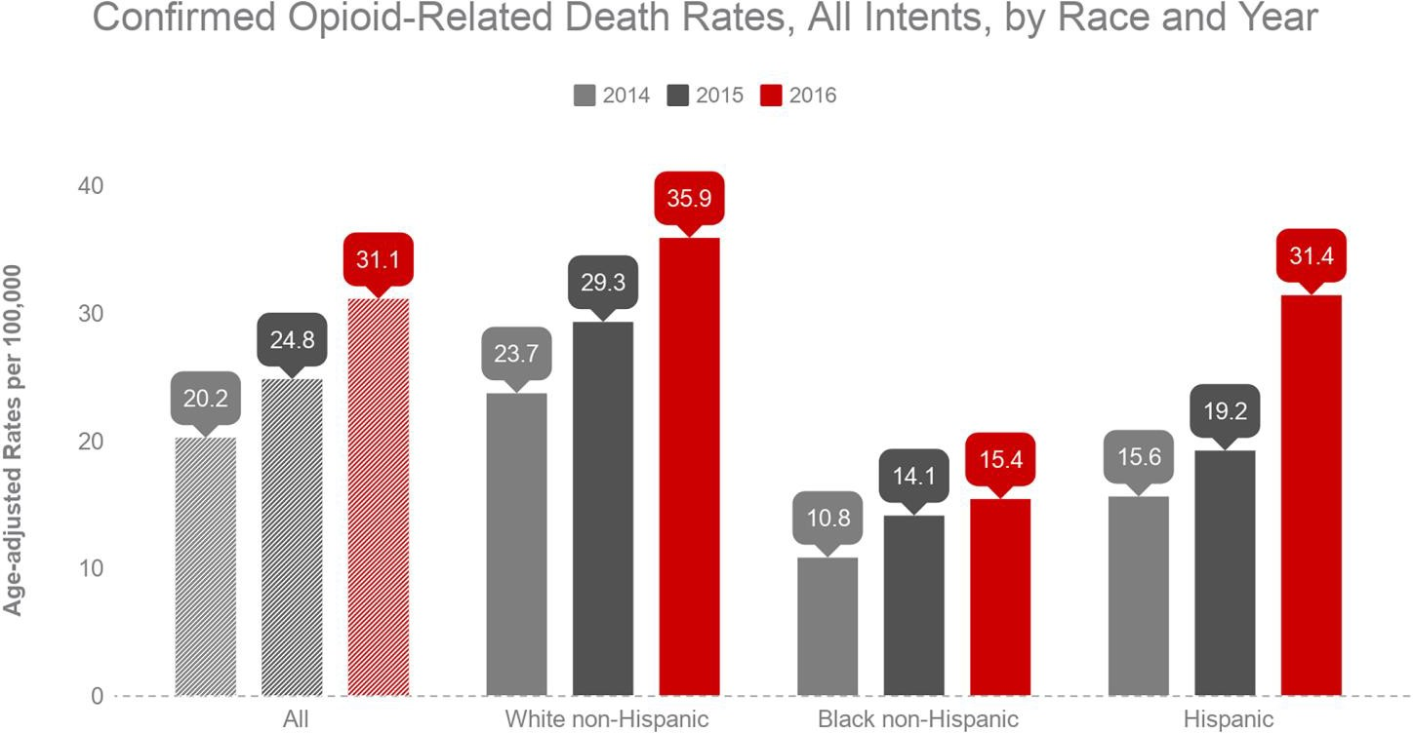

# Technical Notes

2017 death data are preliminary and subject to updates. Case reviews of deaths are evaluated and updated on an ongoing basis. A large number of deaths have yet to be assigned final cause-of-death codes. The information presented in this report only includes confirmed cases. Data updated on 01/25/2018. Beginning with the May 2017 report, DPH started reporting opioid-related deaths for all intents, which includes unintentional/undetermined and suicide.

**Source: Registry of Vital Records and Statistics, MDPH**