|  |
| --- |
| **Data Brief: Opioid-Related Overdose**  **Deaths among Massachusetts Residents** |
| Massachusetts Department of Public Health POSTED: JUNE 2022 |

This report contains both confirmed and estimated data through March 2022.

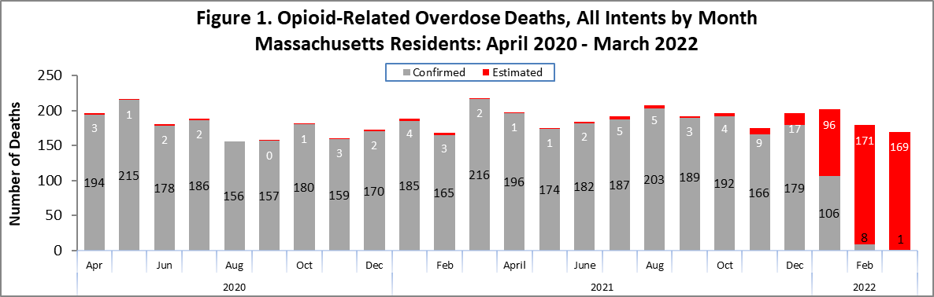

Figure 1 shows the month-by-month estimates for fatal opioid-related overdoses for all intents from April 2020 through March 2022. In 2021, there were 2,234 confirmed opioid-related overdose deaths and DPH estimates that there will be an additional 42 to 71 deaths, yielding 2,290 total confirmed and estimated opioid-related overdose deaths. This is an estimated 185 more deaths compared to 2020, for an 8.8% increase.

Preliminary data from January-March 2022 show there were 115 confirmed opioid-related overdose deaths and DPH estimates that there will be an additional 436 deaths, yielding 551 total confirmed and estimated opioid-related overdose deaths. This is an estimated 24 fewer deaths compared to the first three months of 2021, for a 4% decrease.

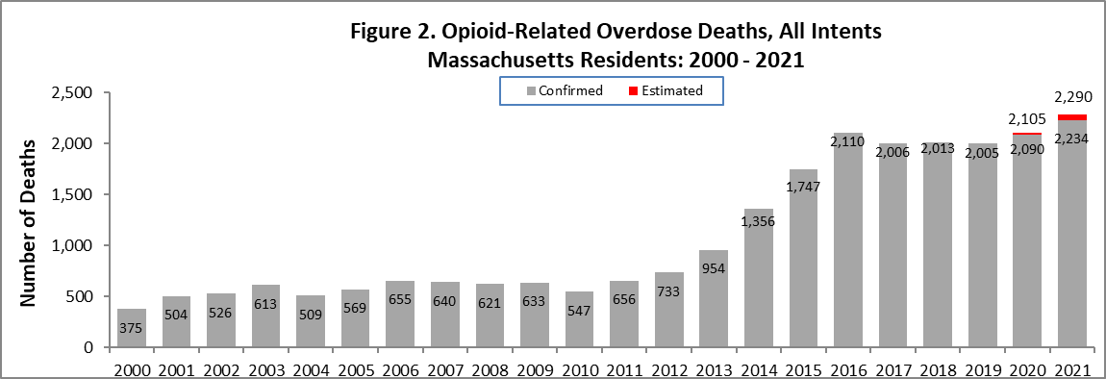

Figure 2 shows the trend in annual number of confirmed and estimated cases of opioid-related overdose deaths for all intents from 2000 to 2021. In order to obtain timelier estimates of the total number of opioid-related overdose deaths in Massachusetts - confirmed and estimated - DPH used predictive modeling techniques for all cases not yet finalized by the Office of the Chief Medical Examiner (OCME). Based on the data available as of April 1, 2022, there

were 2,234 confirmed opioid-related overdose deaths in 2021 and DPH estimates that there will be an additional 42 to 71 deaths once all cases are finalized.

**Opioid-Related Overdose Death Rates, All Intents**

The 2021 opioid-related overdose death rate (32.6 per 100,000 people) is 6.2% higher than in 2016 (30.7 per 100,000 people) and is an 9% increase over 2020 (29.9 per 100,000 people) this difference is statistically significant.

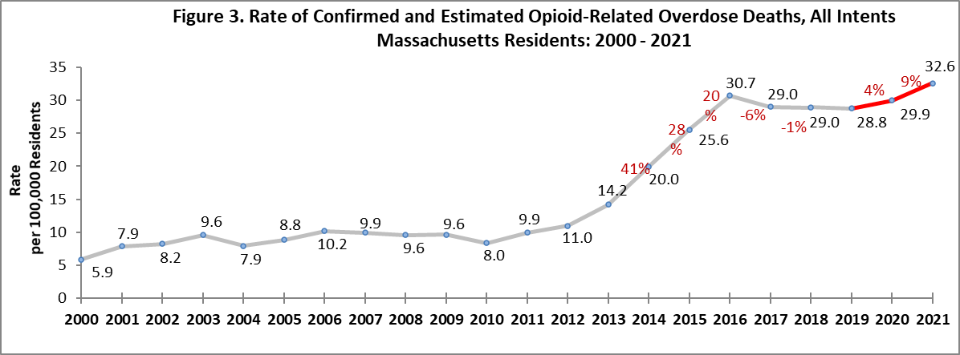

# Toxicology Analysis: Fentanyl and Other Drugs

Fentanyl is a synthetic opioid that has effects similar to heroin. It is administered in patients in fast-acting formulations for severe, acute pain and prescribed to patients with chronic pain in long-acting formulations. According to the U.S. Department of Justice, Drug Enforcement Administration’s 2015 Investigative Reporting, while pharmaceutical fentanyl (from transdermal patches or lozenges) is diverted for abuse in the United States at small levels, much of the fentanyl in Massachusetts is due to illicitly-produced fentanyl, not diverted pharmaceutical fentanyl.

The standard toxicology screen ordered by the Office of the Chief Medical Examiner includes a test for the presence of fentanyl.

In 2021 there were 2,119 opioid-related overdose deaths where a toxicology screen was also available. Among these deaths, fentanyl was present in 93%, cocaine in 51%, benzodiazepines in 31%, alcohol in 29%, prescription opioids in 13%, heroin in 10%, and amphetamines in 10%. The results are shown in Figure 4.

Fentanyl increased dramatically through the second quarter 2016 and has increased at about 1% per quarter ever since. Notably, the presence of stimulants in toxicology have increased since 2014: Cocaine has increased at about 2% per quarter since 2014, and amphetamines have increased about 6% per quarter since third quarter 2016. Between 2016 and the 2nd quarter of 2021, the percentage of heroin or likely heroin present in opioid-related overdose deaths decreased. The percentage of benzodiazepine has been declining since the last quarter in 2017.

While screening tests can be used to note the rate at which certain drugs are detected in toxicology reports, they are insufficient to determine the final cause of death without additional information. The cause of death is a clinical judgment made within the Office of the Chief Medical Examiner.

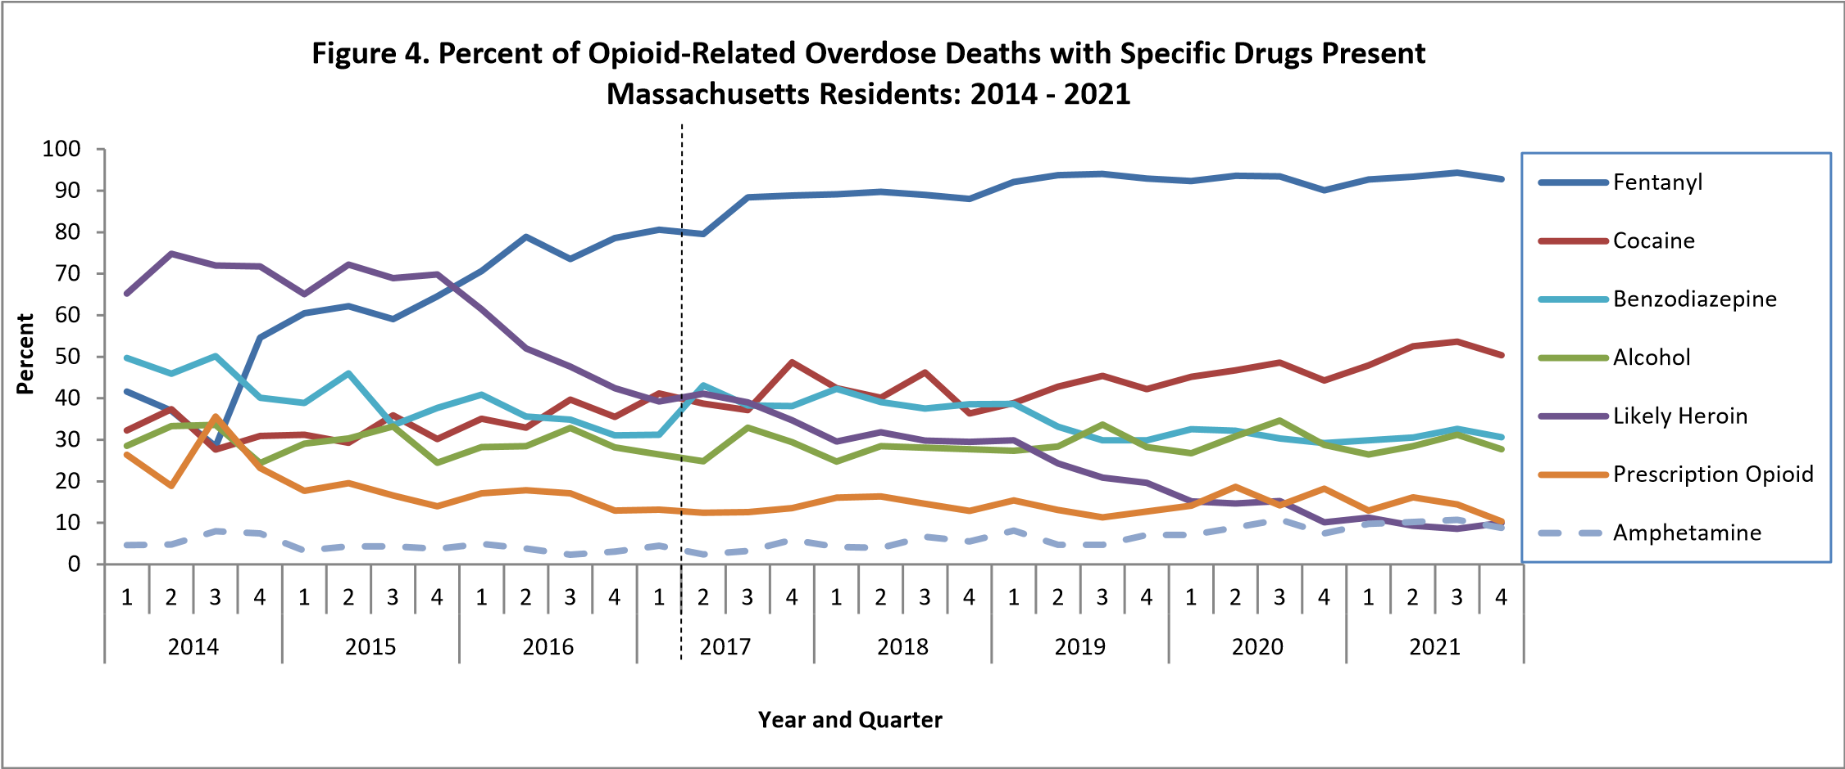

* Beginning with the November 2019 report, DPH began to use a new method to identify substances present in the toxicology data, which can only be applied from 2017 onward; this new method cannot be applied to the older data

1. This is most likely illicitly produced and sold, **not** prescription fentanyl
2. Prescription opioids include: hydrocodone, hydromorphone, oxycodone, oxymorphone, and tramadol
3. Beginning with the February 2020 report, amphetamine includes both amphetamine and methamphetamine; methamphetamine was previously excluded
4. Beginning with the February 2021 report, a category for alcohol was added

**Please note that previous estimates may change slightly as DPH routinely receives updated toxicology data from the Office of the Chief Medical Examiner and the Massachusetts State Police.**

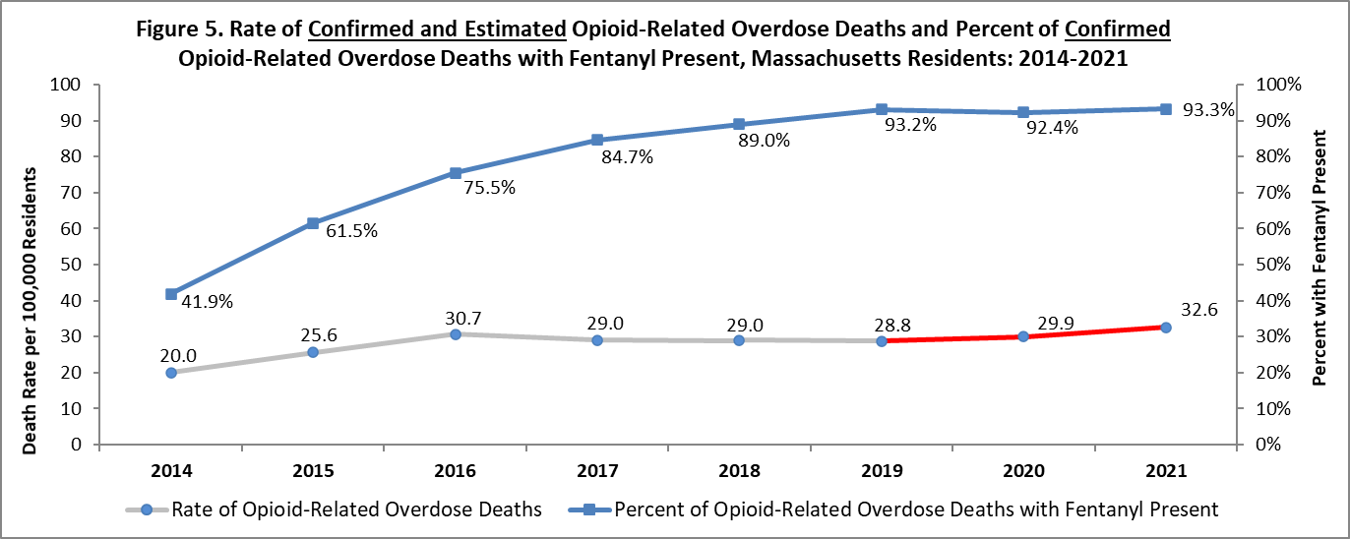

# Technical Notes

* Opioids include heroin, illicitly manufactured fentanyl, opioid-based prescription painkillers, and other unspecified opioids.
* Data for 2020-2022 deaths are preliminary and subject to updates.
* Beginning with the May 2017 report, DPH started reporting opioid-related overdose deaths for all intents, which includes unintentional/undetermined and suicide.
* Beginning with the August 2019 report, DPH updated the case definition used to identify opioid-related overdose deaths to match the CDC’s case definition. The following International Classification of Disease (ICD10) codes for mortality were selected from the underlying cause of death field to identify poisonings/overdoses: X40-X44, X60-X64, X85, and Y10-Y14. All multiple cause of death fields were then used to identify an opioidrelated overdose death: T40.0, T40.1, T40.2, T40.3, T40.4, and T40.6.
* This report tracks opioid-related overdoses due to difficulties in identifying heroin and prescription opioids separately. The Department regularly reviews projections as more information becomes available. Information from the Office of the Chief Medical Examiner and the Massachusetts State Police are now incorporated into the predictive model. This additional information has improved the accuracy of the model that predicts the likelihood that the cause of death for any person was an opioid-related overdose. DPH applied this model to death records for which no official cause of death was listed by the OCME. The model includes information from the death certificate, Medical Examiner’s notes, and the determination by the State Police of a suspected heroin death. DPH added this estimate to the number of confirmed cases in order to compute the total number of opioid-related overdoses. Should new information become available that changes the estimates to any significant degree, updates will be posted.

# Sources

* Massachusetts Registry of Vital Records and Statistics, MDPH
* Massachusetts Office of the Chief Medical Examiner
* Massachusetts State Police
* Population Estimates 2000-2010: National Center for Health Statistics. Postcensal estimates of the resident population of the United States, by year, county, age, bridged race, Hispanic origin, and sex (Vintage 2000-2010).
* Population Estimates 2011-2019, version 2020, Massachusetts Department of Public Health, Bureau of Environmental Health. Version 2020 years 2018-2019 apply updates from U.S. Census Bureau’s County

Population by Characteristics, vintage 2020; all previous years apply updates from U.S. Census Bureau’s County Population by Characteristics, vintage 2019 or earlier. These estimates were developed by the University of Massachusetts Donahue Institute (UMDI) in partnership with the Massachusetts Department of Public Health, Bureau of Environmental Health.

* UMDI Interim 2020 Population Estimates by Age, Sex, Race, and Municipality, UMass Donahue Institute Population Estimates Program, March 1, 2022.