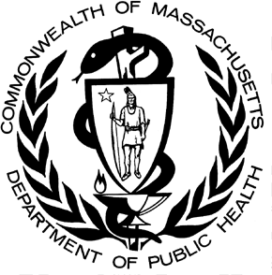

POSTED: JUNE 2024

Massachusetts Department of Public Health

**Data Brief: Opioid-Related Overdose Deaths among Massachusetts Residents**

This report contains both confirmed and estimated data through March 31, 2024. Figure 1 shows the month-by-month estimates for fatal opioid-related overdoses for all intents from October 2022 to March 2024. Preliminary data from January-March 2024 show there were 85 confirmed opioid-related overdose deaths and DPH estimates there will be additional 382 to 463 deaths, totaling approximately 507 confirmed and estimated opioid-related deaths.



**Figure 1. Opioid-Related Overdose Deaths, All Intents by Month**

**Massachusetts Residents: October 2022- March 2024**

250

200

150

100

92

50

65

0

18

2

Oct Nov Dec Jan Feb Mar Apr May Jun Jul Aug Sep Oct Nov Dec Jan Feb Mar

2022

2023

2024

5

147

2

150

4

163

1

165

1

165

152

0

167

2

176

1

177

178

4

174

1

188

1

193

2

199

2

198

1

214

3

230

Confirmed Estimated

**Number of Deaths**

Figure 2 shows the trend in annual number of confirmed and estimated cases of opioid-related overdose deaths for all intents from 2001 to 2023. To obtain timelier estimates of the total number of opioid-related overdose deaths in Massachusetts - confirmed and estimated - DPH used predictive modeling techniques for all cases not yet finalized by the Office of the Chief Medical Examiner (OCME). Based on the data available as of April 11, 2024,

in 2023, there were 2,104 confirmed opioid-related deaths, and DPH estimates that there will be an additional 13 to 32 deaths, yielding approximately 2,125 confirmed and estimated opioid-related overdose deaths. In 2023, there were 232 fewer confirmed and estimated deaths than 2022.

Figure 3 shows that the 2023 opioid-related overdose death rate (30.2 per 100,000 people) is 10% lower than in 2022 (33.5 per 100,000 people) which is a statistically significant decline. Joinpoint analysis indicated that there were statistically significant increases in opioid overdose death rates from 2012 to 2015 at an average annual increase of 37% per year and a statistically significant average annual increase of 2% per year from 2015 to 2023.

**Figure 2. Opioid-Related Overdose Deaths, All Intents**

**Massachusetts Residents: 2001 - 2023**

2,500

2,000

2,357

2,335 2,125

2,104

1,500

1,000

500

0

2001 2002 2003 2004 2005 2006 2007 2008 2009 2010 2011 2012 2013 2014 2015 2016 2017 2018 2019 2020 2021 2022 2023

**Year**

509

504

547

526

569

633

621

613

656

640

655

733

954

1,356

1,748

2,007

2,015

2,015

2,092

2,111

2,285

Confirmed Estimated

**Number of Deaths**

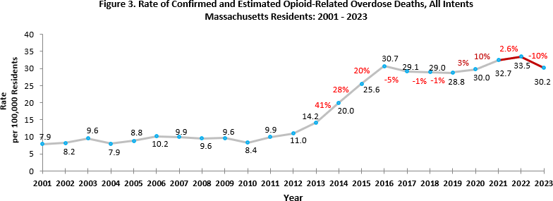

Figure 4 shows that in 2023 there were 1,971 opioid-related overdose deaths where a toxicology screen was also available. Among these deaths, fentanyl was present in 90%, cocaine in 54%, alcohol in 26%, benzodiazepines in 25%, amphetamines in 11%, prescription opioids in 7%, heroin in 5%, and xylazine in 9%.

The presence of fentanyl increased significantly by 11% per quarter on average from 2016 to 2018 and has decreased since, although not significantly. Since June of 2022, xylazine was routinely reported among opioid-related overdose deaths. By the end of 2023, the presence of xylazine in opioid-related overdose deaths had increased to 9% from 5% in 2022. Notably, the presence of stimulants in toxicology have increased since 2014: Cocaine has increased at about 6% per quarter on average since 2016, and amphetamines have increased about 19% per quarter on average since 2016. It’s important to note that the data cannot tell us whether the presence of cocaine and fentanyl together is due to purposeful co-use of fentanyl and cocaine or use of cocaine that is unknowingly contaminated with fentanyl. Heroin or likely heroin decreased by 22% per quarter between 2016 and 2019; and by 35% between 2019 and 2023. The percentage of benzodiazepine has been declining by 8% per quarter since 2018.

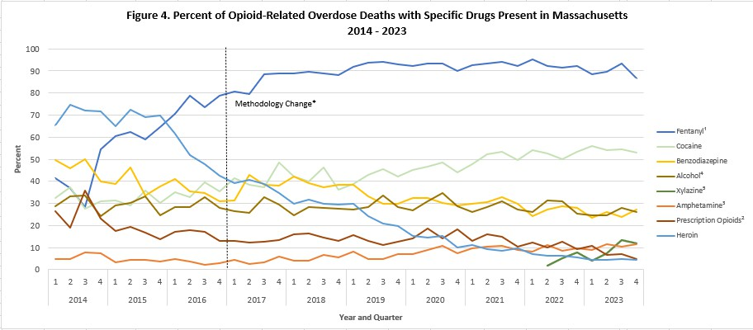

* Beginning with the November 2019 report, DPH began to use a new method to identify substances present in the toxicology data, which can only be applied from 2017 onward; this new method cannot be applied to the older data

1. This is most likely illicitly produced and sold, **not** prescription fentanyl
2. Prescription opioids include: hydrocodone, hydromorphone, oxycodone, oxymorphone, and tramadol
3. Beginning with the February 2020 report, amphetamine includes both amphetamine and methamphetamine; methamphetamine was previously excluded
4. Beginning with the February 2021 report, a category for alcohol was added
5. Beginning with the December 2022 report, a category for xylazine was added

**Please note that previous estimates may change slightly as DPH routinely receives updated toxicology data from the Office of the Chief Medical Examiner and the Massachusetts State Police.**

Fentanyl is a synthetic and highly potent opioid that is in the drug supply in Massachusetts. Most of the fentanyl in Massachusetts is due to illicitly produced fentanyl, not diverted pharmaceutical fentanyl. The drug supply is volatile with variable concentrations of active substances, which can increase the risk of toxicity and overdose.

While screening tests can be used to note the rate at which certain drugs are detected in toxicology reports, they are insufficient to determine the final cause of death without additional information. The cause of death is a clinical judgment made within the Office of the Chief Medical Examiner.

Communities were classified according to the Massachusetts State Office of Rural Health’s definition based on their population levels and proximity to urban areas. Towns classified as rural level 1 and rural level 2 are all rural communities, but towns in level 2 are less densely populated and more isolated from urban core areas. In 2023, rural level 2 communities had the highest age-adjusted opioid-related overdose death rate at 35.6 deaths per 100,000 residents (Figure 6). Between 2011-2016, age-adjusted rates have increased an average of 27% per year for urban/suburban communities and by 25% per year for communities classified as Rural Level 1, followed by a decline of 21% per year from 2021 to 2023. Rates for the most rural communities increased by 17% from 2011 to 2020 and have declined since, although not significantly.

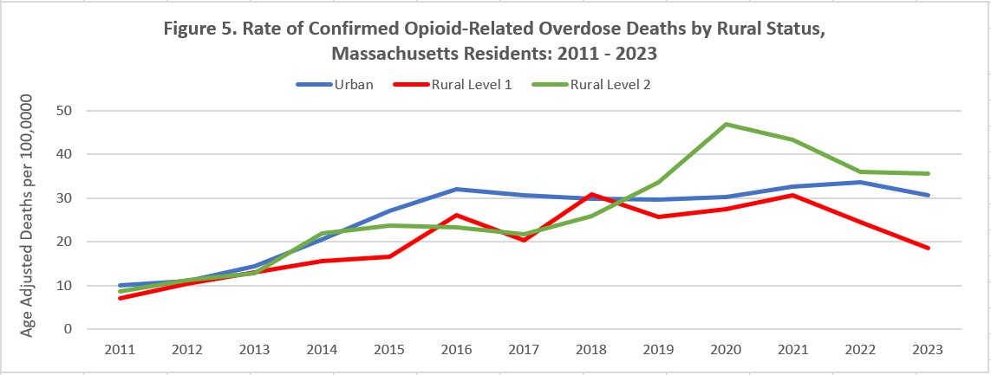

**Note**: For detailed information please refer to the companion data standard document and style guide located at: [https://www.mass.gov/service-](https://www.mass.gov/service-details/state-office-of-rural-health-rural-definition) [details/state-office-of-rural-health-rural-definition.](https://www.mass.gov/service-details/state-office-of-rural-health-rural-definition)

Rural towns are classified into two categories of rurality. Communities classified as rural level one (rural1) meet fewer rural criteria than Communities considered rural at level two (rural2).

* Communities in level two are less densely populated and more remote and isolated from urban core areas.
* Communities in level one and level two are both rural.
* Communities not in level one or two are considered urban.

# Technical Notes

* Opioids include heroin, illicitly manufactured fentanyl, opioid-based prescription painkillers, and other unspecified opioids.
* Data for 2022-2023 deaths are preliminary and subject to updates.
* Beginning with the May 2017 report, DPH started reporting opioid-related overdose deaths for all intents, which includes unintentional/undetermined and suicide.
* Beginning with the August 2019 report, DPH updated the case definition used to identify opioid-related overdose deaths to match the CDC’s case definition. The following International Classification of Disease (ICD- 10) codes for mortality were selected from the underlying cause of death field to identify poisonings/overdoses: X40-X44, X60-X64, X85, and Y10-Y14. All multiple cause of death fields were then used to identify an opioid- related overdose death: T40.0, T40.1, T40.2, T40.3, T40.4, and T40.6.
* This report tracks opioid-related overdoses due to difficulties in identifying heroin and prescription opioids separately. The Department regularly reviews projections as more information becomes available. Information from the Office of the Chief Medical Examiner and the Massachusetts State Police are now incorporated into the predictive model. This additional information has improved the accuracy of the model that predicts the likelihood that the cause of death for any person was an opioid-related overdose. DPH applied this model to death records for which no official cause of death was listed by the OCME. The model includes information from the death certificate, Medical Examiner’s notes, and the determination by the State Police of a suspected heroin death. DPH added this estimate to the number of confirmed cases to compute the total number of opioid- related overdoses. Should new information become available that changes the estimates to any significant degree, updates will be posted.

# Sources

* Massachusetts Registry of Vital Records and Statistics, MDPH
* Massachusetts Office of the Chief Medical Examiner
* Massachusetts State Police
* Population Estimates 2000-2010: National Center for Health Statistics. Postcensal estimates of the resident population of the United States, by year, county, age, bridged race, Hispanic origin, and sex (Vintage 2000-2010).
* Population Estimates 2011-2019, version 2020, Massachusetts Department of Public Health, Bureau of Environmental Health. Version 2020 years 2018-2019 apply updates from U.S. Census Bureau’s County Population by Characteristics, vintage 2020; all previous years apply updates from U.S. Census Bureau’s County Population by Characteristics, vintage 2019 or earlier. These estimates were developed by the University of Massachusetts Donahue Institute (UMDI) in partnership with the Massachusetts Department of Public Health, Bureau of Environmental Health.
* UMDI Interim 2020 Population Estimates by Age, Sex, Race, and Municipality, UMass Donahue Institute Population Estimates Program, March 1, 2022.