|  |
| --- |
| **Data Brief: Opioid-Related Overdose**  **Deaths among Massachusetts Residents** |
| Massachusetts Department of Public Health POSTED: MAY 2021 |

This report contains both confirmed and estimated data through March 2021.

**Figure 1. Opioid-Related Overdose Deaths, All Intents by Month**



185

177

168

141

176

171

191

210

176

183

153

155

173

156

150

86

11

2

~~2~~

~~4~~

~~4~~

~~5~~

~~3~~

~~4~~

~~7~~

~~1~~

~~1~~

~~5~~

~~6~~

27

79

146

183

0

50

100

150

200

250

Oct

Nov

Dec

Jan

Feb

Mar

Apr

May

Jun

Jul

Aug

Sep

October

November

Decem

ber

Jan

Feb

Mar

9

201

2020

2021

**Number of Deaths**

**Massachusetts Residents: October 2019**

**-**

**March 2021**

Confir

med

Estimate

d

Figure 1 shows the month-by-month estimates for fatal opioid-related overdoses for all intents from October 2019 through March 2021. In 2020, there were 2,035 confirmed opioid-related overdose deaths and DPH estimates that there will be an additional 66 to 70 deaths. In the first three months of 2021, there were 99 confirmed opioid-related overdose deaths and DPH estimates that there will be an additional 368 to 447 deaths. Preliminary data from JanuaryMarch 2021 show there were 507 confirmed and estimated opioid-related overdose deaths, an estimated 9 more deaths, which is a 1.9 percent increase compared to the first three months of 2020.

375

504

526

613

509

569

655

640

621

633

547

656

733

954

35

1

1

,

8

73

,

1

,

2

10

2

9

1

,

99

,

00

5

2

2

,

00

2

2

,

03

5

2,104

0

200

400

600

800

1,000

1,200

1,400

1,600

1,800

2,000

2,200

2,400

2000

2001

2002

2003

2004

2005

2006

2007

2008

2009

2010

2011

2012

2013

2014

2015

2016

2017

2018

2019

2020

**Number of Deaths**

**Figure 2. Opioid**

**-**

**Related Overdose Deaths, All Intents**

**Massachusetts Residents: 2000**

**-**

**2020**

Confirmed

Estimated

Figure 2 shows the trend in annual number of confirmed and estimated cases of opioid-related overdose deaths for all intents from 2000 to 2020. In order to obtain timelier estimates of the total number of opioid-related overdose deaths in Massachusetts - confirmed and probable - DPH used predictive modeling techniques for all cases not yet finalized by the Office of the Chief Medical Examiner (OCME). Based on the data available as of April 6, 2021, DPH estimates that there will be an additional 66 to 70 deaths in 2020, once these cases are finalized.

**Opioid-Related Overdose Death Rates, All Intents**

The 2020 opioid-related overdose death rate (30.2 per 100,000 people) is approximately 1% lower than in 2016

(30.6 per 100,000 people), though this difference is not statistically significant. Likewise, the increase in 2020 from 2019 is not statistically significant. Taken together, this indicates that the opioid-related overdose death rate has been stable for the past several years.

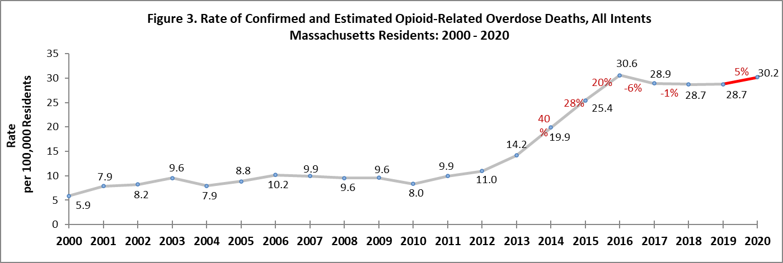

# Toxicology Analysis: Fentanyl and Other Drugs

Fentanyl is a synthetic opioid that has effects similar to heroin. It can be prescribed for severe pain. According to the U.S. Department of Justice, Drug Enforcement Administration’s 2015 Investigative Reporting, while pharmaceutical fentanyl (from transdermal patches or lozenges) is diverted for abuse in the United States at small levels, much of the fentanyl in Massachusetts is due to illicitly produced fentanyl, not diverted pharmaceutical fentanyl.

The standard toxicology screen ordered by the Office of the Chief Medical Examiner includes a test for the presence of fentanyl. In 2020, there were 1,895 opioid-related overdose deaths where a toxicology screen was also available. Among these deaths, fentanyl was present in 92%, heroin in 14%, cocaine in 46%, benzodiazepines in 31%, prescription opioids and amphetamines in 17% and 9%, respectively. Fentanyl increased through the second quarter 2016 and has leveled off at high numbers through 2020. Since 2016, the percentage of heroin or likely heroin present in opioidrelated overdose deaths has decreased, and benzodiazepine has been declining since 2018. Cocaine has increased since 2014, and amphetamines have increased since the fourth quarter of 2016.

While screening tests can be used to note the rate at which certain drugs are detected in toxicology reports, they are insufficient to determine the final cause of death without additional information. The cause of death is a clinical judgment made within the Office of the Chief Medical Examiner.

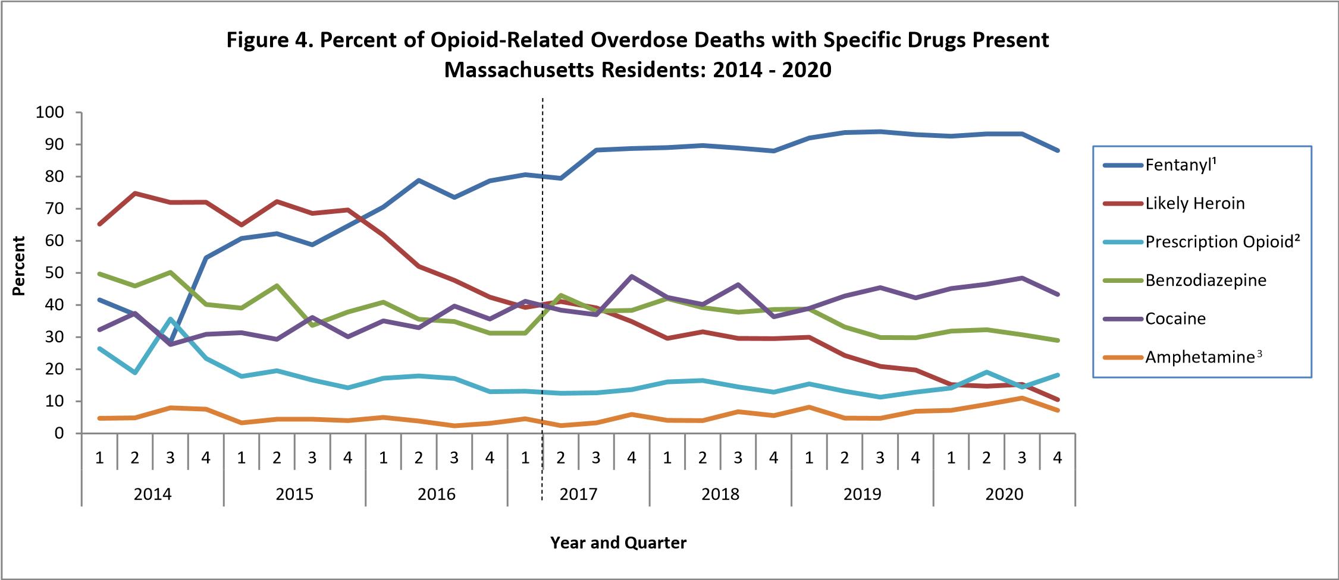

* Beginning with the November 2019 report, DPH began to use a new method to identify substances present in the toxicology data, which can only be applied from 2017 onward; this new method cannot be applied to the older data.

1. This is most likely illicitly produced and sold, **not** prescription fentanyl
2. Prescription opioids include: hydrocodone, hydromorphone, oxycodone, oxymorphone, and tramadol
3. Beginning with the February 2020 report, amphetamine includes both amphetamine and methamphetamine; methamphetamine was previously excluded

**Please note that previous estimates may change slightly as DPH routinely receives updated toxicology data from the Office of the Chief Medical Examiner and the Massachusetts State Police.**

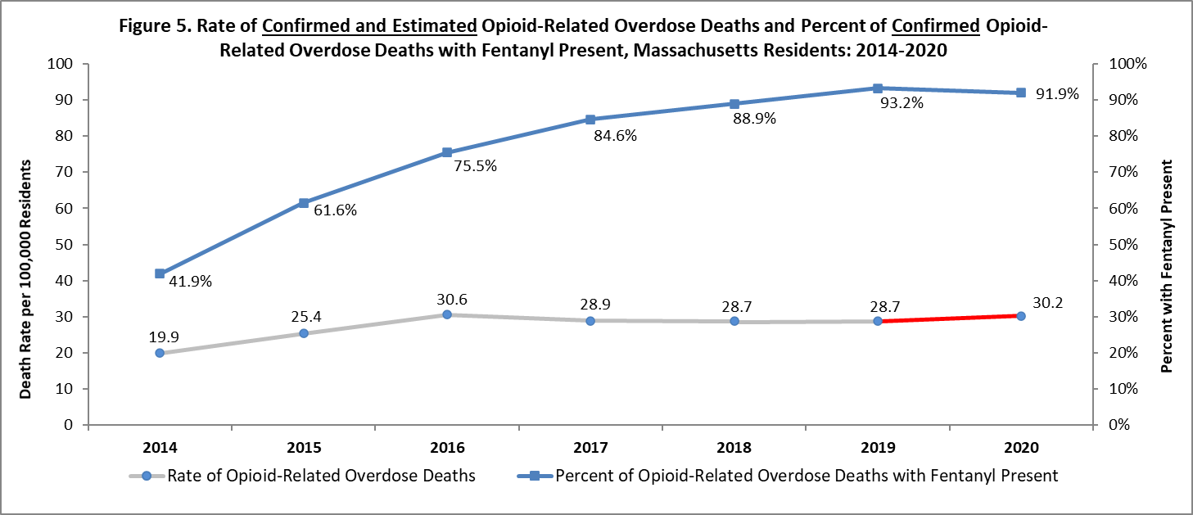

Although the presence of fentanyl in opioid-related overdose deaths continues to rise, the opioid-related overdose death rate has declined by 1% since 2016.

# Technical Notes

* Opioids include heroin, illicitly manufactured fentanyl, opioid-based prescription painkillers, and other unspecified opioids.
* Data for 2017-2020 deaths are preliminary and subject to updates.
* Beginning with the May 2017 report, DPH started reporting opioid-related overdose deaths for all intents, which includes unintentional/undetermined and suicide.
* Beginning with the August 2019 report, DPH updated the case definition used to identify opioid-related overdose deaths to match the CDC’s case definition. The following International Classification of Disease (ICD10) codes for mortality were selected from the underlying cause of death field to identify poisonings/overdoses: X40-X44, X60-X64, X85, and Y10-Y14. All multiple cause of death fields were then used to identify an opioidrelated overdose death: T40.0, T40.1, T40.2, T40.3, T40.4, and T40.6.
* This report tracks opioid-related overdoses due to difficulties in identifying heroin and prescription opioids separately. The Department regularly reviews projections as more information becomes available. Information from the Office of the Chief Medical Examiner and the Massachusetts State Police are now incorporated into the predictive model. This additional information has improved the accuracy of the model that predicts the likelihood that the cause of death for any person was an opioid-related overdose. DPH applied this model to death records for which no official cause of death was listed by the OCME. The model includes information from the death certificate, Medical Examiner’s notes, and the determination by the State Police of a suspected heroin death. DPH added this estimate to the number of confirmed cases in order to compute the total number of opioid-related overdoses. Should new information become available that changes the estimates to any significant degree, updates will be posted.

# Sources

* Massachusetts Registry of Vital Records and Statistics, MDPH
* Massachusetts Office of the Chief Medical Examiner
* Massachusetts State Police
* Population Estimates 2000-2010: National Center for Health Statistics. Postcensal estimates of the resident population of the United States, by year, county, age, bridged race, Hispanic origin, and sex (Vintage 2000-2010). • Population Estimates 2011-2018: Small Area Population Estimates 2011-2020, version 2018, Massachusetts Department of Public Health, Bureau of Environmental Health. Population estimates used for years following the decennial census were developed by the University of Massachusetts Donahue Institute (UMDI) in partnership with the Massachusetts Department of Public Health, Bureau of Environmental Health.