This report contains both confirmed and estimated data through September 2016. The number of confirmed cases of unintentional opioid overdose deaths for 2015 (n=1574) represents a 20% increase over 2014 (n=1316), and the 2014 number (n=1316) represents a 43% increase over cases for 2013 (n=918). In order to obtain timelier estimates of the total number of opioid overdose deaths in Massachusetts - confirmed and probable - DPH used predictive modeling techniques for all cases not yet finalized by the Office of the Chief Medical Examiner (OCME). Based on the data available as of 09/30/2016, DPH estimates that there will be an additional 62 to 72 deaths in 2014 and 162 to 185 deaths in 2015, once these cases are finalized. For the first 9 months of 2016, the number of confirmed cases of unintentional opioid overdose deaths was 1005, with an estimated additional 392 to 470 deaths. Current estimates for the first 9 months of 2016 are higher than the first 9 months of 2015.

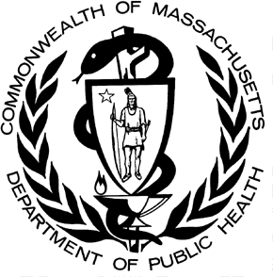

POSTED: NOVEMBER 2016

Massachusetts Department of Public Health

**Data Brief: Opioid-related Overdose Deaths Among Massachusetts Residents**

**Opioid-Related Deaths, Unintentional/Undetermined**

**Massachusetts: January 2000- December 2015**

2,000

1,800

1,600

1,400

1,200

1,000

800

600

400

200

0

1,747

1,383

1,574

1,316

2000 2001 2002 2003 2004 2005 2006 2007 2008 2009 2010 2011 2012 2013 2014 2015

355

494

505

486

532

554

610

587

587

613

617

635

698

918

Confirmed Estimated

**Number of deaths**

DPH has also made month-by-month estimates for all intents (unintentional/undetermined and intentional deaths) from January 2015 through September 2016. By combining data from the OCME and the Massachusetts State Police, DPH is now able to estimate opioid-related deaths much closer to real-time than was previously possible.



**Opioid-related Deaths, All Intents by Month**

**Massachusetts Residents: January 2015 - September 2016**

200

180

160

140

120

100

80

60

40

20

0

13

18

17

11

4

12

172

23

4

9

11

91

24

15

22

22

8

3

18

5

146

133

153

163

169

174

121

122

118

139

143

145

156

147

110

83

16

January March May July September November January March May July

4

September

2015 2016

111

137

154

135

Confirmed Estimated

**Number of deaths**

# Rate of Unintentional Opioid Deaths

In 2015, the estimated rate of unintentional opioid-related overdose deaths was 25.8 deaths per 100,000 residents. The 2015 rate is the highest ever for unintentional opioid overdoses and represents a 32% increase from the rate of 19.5 deaths per 100,000 residents in 2014.

**Rate of Unintentional/Undetermined1 Opioid2-Related Deaths**

**Massachusetts Residents: 2000-2015**

30

25.8

25

20

19.5

15

9.9

13.7

10

7.6

9.1

9.6

9.3

10.5

7.9

8.6

9.0

9.3

8.0

5

7.7

5.6

0

**2000 2001 2002 2003 2004 2005 2006 2007 2008 2009 2010 2011 2012 2013 2014 2015**

**Rate**

**per 100,000 Residents**

1Unintentional poisoning/overdose deaths combine unintentional and undetermined intents to account for a change in death coding that occurred in 2005. Suicides are excluded from this analysis.

2 Opioids include heroin, opioid-based prescription painkillers, and other unspecified opioids. This report tracks opioid-related overdoses due to difficulties in identifying heroin and prescription opioids separately.

# Technical Notes

The figures cited here for 2014-2016 are based on confirmed and estimated data. The Department regularly reviews projections as more information becomes available. Information from the Office of the Chief Medical Examiner and the Massachusetts State Police are now incorporated into the predictive model. This additional information has improved the accuracy of the models that predict the likelihood that the cause of death for any person was an opioid-related overdose. DPH applied this model to death records for which no official cause of death was listed by the OCME. The model includes information from the death certificate, Medical Examiner’s notes, and the determination by the State Police of a suspected heroin death. DPH added this estimate to the number of confirmed cases in order to compute the total number of opioid-related overdoses. Due to missing information on intent in the open files, the models predict the total number of fatal opioid-related overdoses. In order to estimate the numbers that are considered unintentional, the Department applied the average percentage of total opioid-overdose deaths that were considered unintentional for the previous 3-year period (97%) to the total estimate. Should new information become available that changes the estimates to any significant degree, updates will be posted.

# Toxicology Analysis: Fentanyl and Other Drugs

Fentanyl is a synthetic opioid that has effects similar to heroin. It can be prescribed for severe pain. According to the U.S. Department of Justice, Drug Enforcement Administration’s 2015 Investigative Reporting, while pharmaceutical fentanyl (from transdermal patches or lozenges) is diverted for abuse in the United States at small levels, much of the fentanyl in Massachusetts is due to illicitly-produced fentanyl, not diverted pharmaceutical fentanyl1.

The standard toxicology screen ordered by the Office of the Chief medical Examiner includes a test for the presence of fentanyl. In 2016, the number of fentanyl-related deaths continues to increase. Among the 693 individuals whose deaths were opioid-related in 2016 where a toxicology screen was also available, 510 of them (74%) had a positive screen result for fentanyl. In the second quarter of 2016, heroin or likely heroin was present in approximately 53% of opioid-related deaths that had a toxicology screen.

While screening tests can be used to note the rate at which certain drugs are detected in toxicology reports, they are insufficient to determine the final cause of death without additional information. The cause of death is a clinical judgement made within the Office of the Chief Medical Examiner.

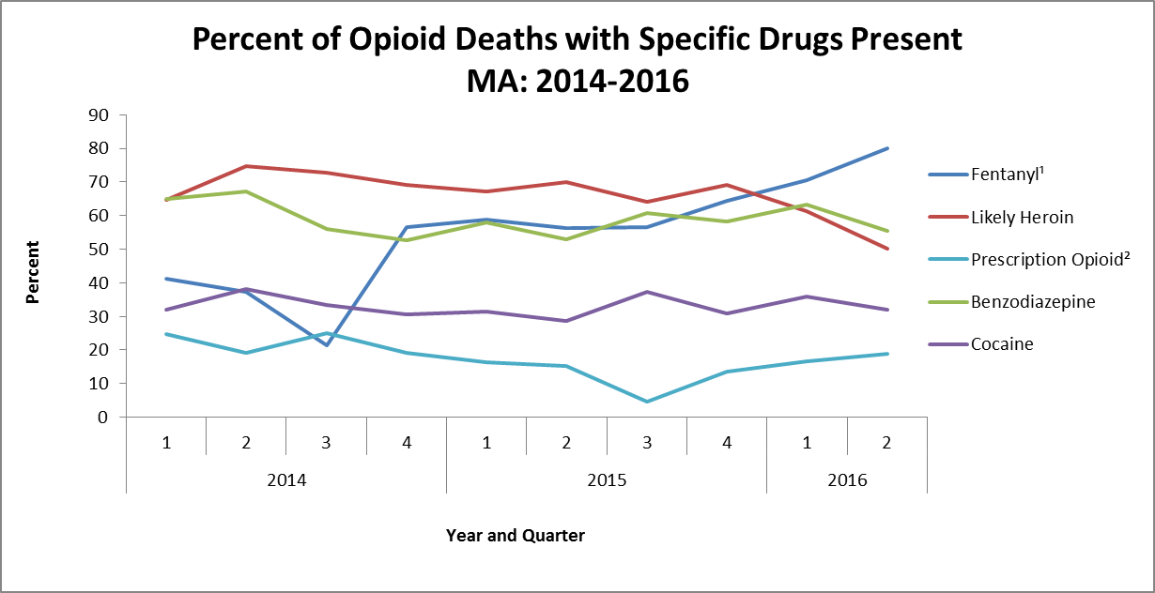

1. This is most likely illicitly produced and sold, **not** prescription fentanyl
2. Prescription opioids include: hydrocodone, hydromorphone, oxycodone, oxymorphone, and tramadol

In the second quarter of 2016, benzodiazepines were present in approximately half of opioid-related overdose deaths where toxicology results were available and cocaine was present in approximately 30%.

The rates of benzodiazepines and cocaine present in opioid-related overdose deaths have been fairly steady since 2014, while the rate for heroin has been decreasing at roughly the same rate that fentanyl has been increasing.

1 U.S. Department of Justice, Drug Enforcement Administration, DEA Investigative Reporting, January 2015.