|  |
| --- |
| **Data Brief: Opioid-Related Overdose**  **Deaths among Massachusetts Residents** |
| Massachusetts Department of Public Health POSTED: NOVEMBER 2020 |

This report contains both confirmed and estimated data through September 2020.



161

144

173

149

165

166

169

160

157

183

175

165

138

173

169

186

204

153

101

16

1

1

~~7~~

7

6

5

4

5

4

3

4

~~2~~

~~7~~

~~7~~

~~7~~

~~6~~

~~8~~

7

31

47

132

131

0

50

100

150

200

250

Jan

Feb

Mar

Apr

May

Jun

Jul

Aug

Sep

Oct

Nov

Dec

Jan

Feb

Mar

Apr

May

Jun

Jul

Aug

Sep

2019

2020

**Number of Deaths**

**Figure 1. Opioid-Related Overdose Deaths, All Intents by Month**

**Massachusetts Residents: January 2019-**

**September 2020**

Confirmed

Estimated

Figure 1 shows the month-by-month estimates for fatal opioid-related overdoses for all intents from January 2019 through September 2020. In 2019, there were 1,967 confirmed opioid-related overdose deaths and DPH estimates that there will be an additional 39 to 68 deaths. In the first nine months of 2020, there were 1,141 confirmed opioid-related overdose deaths. Preliminary data during this period indicate that there were 1,517 confirmed and estimated opioidrelated overdose deaths, an estimated 33 more deaths compared with the first nine months of 2019.

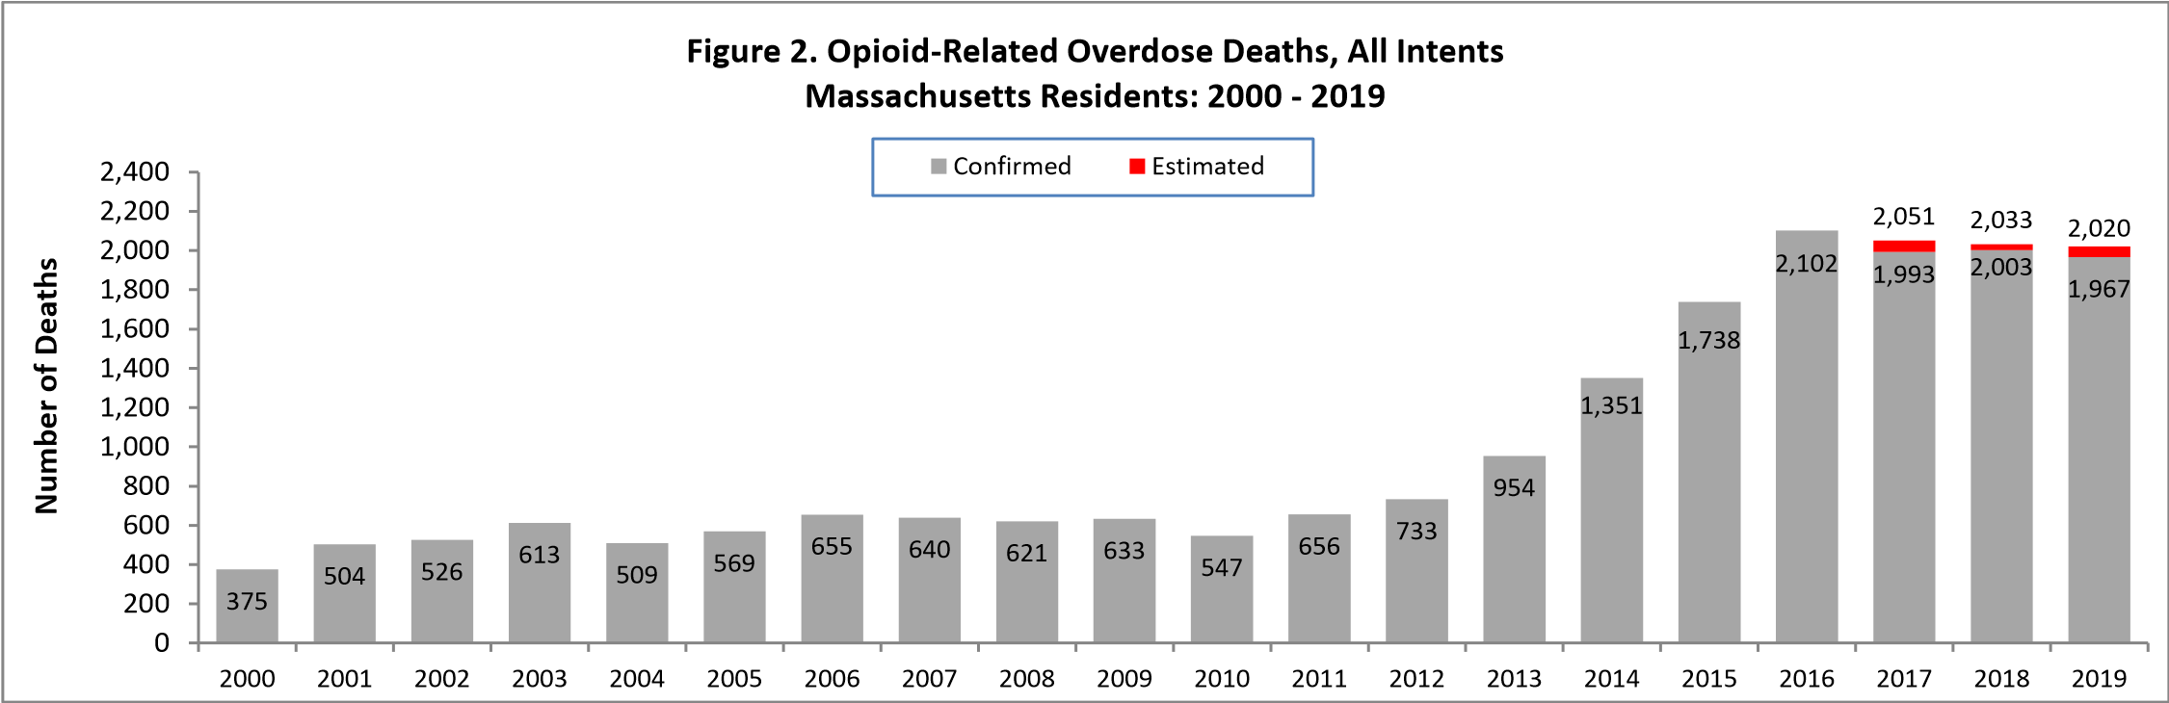

Figure 2 shows the trend in annual number of confirmed and estimated cases of opioid-related overdose deaths for all intents from 2000 to 2019. In order to obtain timelier estimates of the total number of opioid-related overdose deaths in Massachusetts - confirmed and probable - DPH used predictive modeling techniques for all cases not yet finalized by the Office of the Chief Medical Examiner (OCME). Based on the data available as of October 6, 2020, DPH estimates that there will be an additional 19 to 40 deaths in 2018 and an additional 39 to 68 deaths in 2019, once these cases are finalized.

# Opioid-Related Overdose Death Rates, All Intents

DPH estimates that the rate of opioid-related overdose deaths has stabilized in 2019 compared with 2018. This follows an estimated 2% decline in the rate of opioid-related overdose deaths from 2017 to 2018. The 2019 rate represents an estimated 5% decrease from 2016.

5.9

7.9

8.2

9.6

7.9

8.8

10.2

9.9

9.6

9.6

8.0

9.9

11.0

14.2

19.9

25.4

30.6

29.7

29.1

29.0

0

5

10

15

20

25

30

35

**2000**

**2001**

**2002**

**2003**

**2004**

**2005**

**2006**

**2007**

**2008**

**2009**

**2010**

**2011**

**2012**

**2013**

**2014**

**2015**

**2016**

**2017**

**2018**

**2019**

**Rate**

**per**

**100**

**,**

**000**

**Residents**

**Figure 3. Rate of Confirmed and Estimated Opioid-Related Overdose Deaths, All Intents**

**Massachusetts Residents: 2000 -**

**2019**

%

28

%

40

%

20

%

-3

%

-2

%

-0.4

# Toxicology Analysis: Fentanyl and Other Drugs

Fentanyl is a synthetic opioid that has effects similar to heroin. It can be prescribed for severe pain. According to the U.S. Department of Justice, Drug Enforcement Administration’s 2015 Investigative Reporting, while pharmaceutical fentanyl (from transdermal patches or lozenges) is diverted for abuse in the United States at small levels, much of the fentanyl in Massachusetts is due to illicitly-produced fentanyl, not diverted pharmaceutical fentanyl.

The standard toxicology screen ordered by the Office of the Chief Medical Examiner includes a test for the presence of fentanyl. Among the 1,878 opioid-related overdose deaths in 2019 where a toxicology screen was also available, 1,749 of them (93%) had a positive screen result for fentanyl. In 2019, heroin or likely heroin was present in approximately 24%of opioid-related overdose deaths that had a toxicology screen. Cocaine was present in approximately 31% of these deaths, benzodiazepines were present in approximately 33%, and amphetamines were present in 6% of these deaths. In the first six months of 2020, there were 943 opioid-related overdose deaths where a toxicology screen was also available. Among these deaths, fentanyl was present in 93%, heroin in 16%, cocaine in 46%, benzodiazepines in 32%, prescription opioids and amphetamines in 17% and 8% respectively. Since 2014, the rate of heroin or likely heroin present in opioid-related overdose deaths has been decreasing while the presence of fentanyl increased through the fourth quarter of 2015 and has leveled off at high numbers through the first nine months of 2020.

While screening tests can be used to note the rate at which certain drugs are detected in toxicology reports, they are insufficient to determine the final cause of death without additional information. The cause of death is a clinical judgment made within the Office of the Chief Medical Examiner.

0

10

20

30

40

50

60

70

80

90

100

1

2

3

4

1

2

3

4

1

2

3

4

1

2

3

4

1

2

3

4

1

2

3

4

1

2

2014

2015

2016

2017

2018

2019

2020

**Percent**

**Year and Quarter**

**Figure 4. Percent of Opioid-Related Overdose Deaths with Specific Drugs Present**

**Massachusetts Residents: 2014 -**

**Q2 2020**

Fentanyl¹

Likely Heroin

Prescription Opioid²

Benzodiazepine

Cocaine

Amphetamine

Methodology

Change*

3

* Beginning with the November 2019 report, DPH began to use a new method to identify substances present in the toxicology data, which can only be applied from 2017 onward; this new method cannot be applied to the older data

1. This is most likely illicitly produced and sold, **not** prescription fentanyl
2. Prescription opioids include: hydrocodone, hydromorphone, oxycodone, oxymorphone, and tramadol
3. Beginning with the February 2020 report, amphetamine includes both amphetamine and methamphetamine; methamphetamine was previously excluded

**Please note that previous estimates may change slightly as DPH routinely receives updated toxicology data from the Office of the Chief Medical Examiner and the Massachusetts State Police.**

19.9

25.4

30.6

29.7

29.1

29.0

%

41.8

61.5

%

%

75.6

84.6

%

88.9

%

%

93.1

0

%

%

10

%

20

%

30

40

%

%

50

%

60

%

70

80

%

%

90

%

100

0

10

20

30

40

50

60

70

80

90

100

**2014**

**2015**

**2016**

**2017**

**2018**

**2019**

**Percent with Fentanyl Present**

**Death Rate per 100,000 Residents**

**Confirmed and Estimated**

**Figure 5. Rate of**

**Confirmed**

**Opioid-Related Overdose Deaths and Percent of**

**Opioid-Related Overdose**

**Deaths with Fentanyl Present, Massachusetts Residents: 2014-2019**

Rate of Opioid-Related Overdose Deaths

Percent of Opioid-Related Overdose Deaths with Fentanyl Present

Although the presence of fentanyl in opioid-related overdose deaths continues to rise, the opioid-related overdose death rate has remained relatively stable since 2016.

# Technical Notes

* Opioids include heroin, illicitly manufactured fentanyl, opioid-based prescription painkillers, and other unspecified opioids.
* Data for 2017-2020 deaths are preliminary and subject to updates.
* Beginning with the May 2017 report, DPH started reporting opioid-related overdose deaths for all intents, which includes unintentional/undetermined and suicide.
* Beginning with the August 2019 report, DPH updated the case definition used to identify opioid-related overdose deaths to match the CDC’s case definition. The following International Classification of Disease (ICD10) codes for mortality were selected from the underlying cause of death field to identify poisonings/overdoses: X40-X44, X60-X64, X85, and Y10-Y14. All multiple cause of death fields were then used to identify an opioidrelated overdose death: T40.0, T40.1, T40.2, T40.3, T40.4, and T40.6.
* This report tracks opioid-related overdoses due to difficulties in identifying heroin and prescription opioids separately. The Department regularly reviews projections as more information becomes available. Information from the Office of the Chief Medical Examiner and the Massachusetts State Police are now incorporated into the predictive model. This additional information has improved the accuracy of the model that predicts the likelihood that the cause of death for any person was an opioid-related overdose. DPH applied this model to death records for which no official cause of death was listed by the OCME. The model includes information from the death certificate, Medical Examiner’s notes, and the determination by the State Police of a suspected heroin death. DPH added this estimate to the number of confirmed cases in order to compute the total number of opioid-related overdoses. Should new information become available that changes the estimates to any significant degree, updates will be posted.

# Sources

* Massachusetts Registry of Vital Records and Statistics, MDPH
* Massachusetts Office of the Chief Medical Examiner
* Massachusetts State Police
* Population Estimates 2000-2010: National Center for Health Statistics. Postcensal estimates of the resident population of the United States, by year, county, age, bridged race, Hispanic origin, and sex (Vintage 2000-2010). • Population Estimates 2011-2019: Small Area Population Estimates 2011-2020, version 2019, Massachusetts Department of Public Health, Bureau of Environmental Health. Population estimates used for years following the decennial census were developed by the University of Massachusetts Donahue Institute (UMDI) in partnership with the Massachusetts Department of Public Health, Bureau of Environmental Health.