|  |
| --- |
| **Data Brief: Opioid-Related Overdose Deaths among Massachusetts Residents** |
| Massachusetts Department of Public Health POSTED: NOVEMBER 2021 |

This report contains both confirmed and estimated data through September 2021.

# Figure 1. Opioid-Related Overdose Deaths, All Intents by Month



14

2

17

7

4

17

4

19

5

21

8

17

6

18

15

6

15

7

18

0

15

9

0

17

4

18

16

4

6

21

19

4

2

17

17

4

99

6

2

~~1~~

~~2~~

~~1~~

~~2~~

~~1~~

~~2~~

~~3~~

0

~~1~~

~~2~~

~~3~~

~~4~~

~~4~~

~~2~~

~~3~~

3

~~8~~

97

15

4

7

12

0

50

100

150

200

250

Jan

Mar

May

Jul

Sep

Novembe

r

Jan

Mar

May

July

Septembe

r

2020

2021

**Number of Deaths**

**Massachusetts Residents: January 2020**

**-**

**September 2021**

Confirmed

Estimated

Figure 1 shows the month-by-month estimates for fatal opioid-related overdoses for all intents from January 2020 through September 2021. In the first nine months of 2021, there were 1,211 confirmed opioid-related overdose deaths and DPH estimates that there will be an additional 362 to 441 deaths, yielding 1,613 total confirmed and estimated opioid-related overdose deaths. This is an estimated 21 more deaths compared to the first nine months of 2020, for a 1.3% increase.

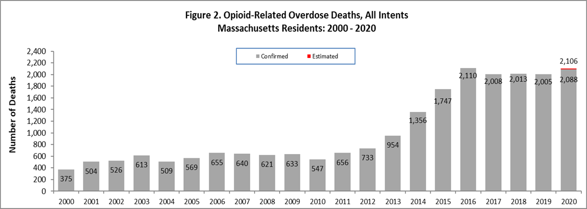

Figure 2 shows the trend in annual number of confirmed and estimated cases of opioid-related overdose deaths for all intents from 2000 to 2020. In order to obtain timelier estimates of the total number of opioid-related overdose deaths in Massachusetts - confirmed and estimated - DPH used predictive modeling techniques for all cases not yet finalized by the Office of the Chief Medical Examiner (OCME). Based on the data available as of October 7, 2021, there were 2,088 confirmed opioid-related overdose deaths in 2020 and DPH estimates that there will be an additional 17 to 19 deaths once all cases are finalized.

**Opioid-Related Overdose Death Rates, All Intents**

The 2020 opioid-related overdose death rate (30.2 per 100,000 people) is approximately 1.6% lower than in 2016

(30.7 per 100,000 people), though this difference is not statistically significant. Likewise, the 5% increase in 2020 from 2019 is not statistically significant. Taken together, this indicates that the statewide opioid-related overdose death rate has been stable for the past several years.

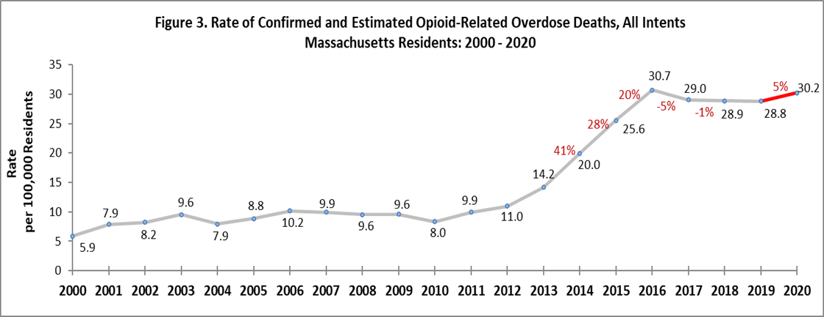

# Toxicology Analysis: Fentanyl and Other Drugs

Fentanyl is a synthetic opioid that has effects similar to heroin. It is administered in patients in fast-acting formulations for severe, acute pain and prescribed to patients with chronic pain in long-acting formulations. According to the U.S. Department of Justice, Drug Enforcement Administration’s 2015 Investigative Reporting, while pharmaceutical fentanyl (from transdermal patches or lozenges) is diverted for abuse in the United States at small levels, much of the fentanyl in Massachusetts is due to illicitly-produced fentanyl, not diverted pharmaceutical fentanyl.

The standard toxicology screen ordered by the Office of the Chief Medical Examiner includes a test for the presence of fentanyl.

Through 2020 there were 1,937 opioid-related overdose deaths where a toxicology screen was also available. Among these deaths, fentanyl was present in 92%, heroin in 14%, cocaine in 46%, benzodiazepines in 31%, prescription opioids and amphetamines in 16% and 9%, respectively. In the first six months of 2021, there were 1,032 opioid-related overdose deaths where a toxicology screen was also available. The results are shown in Figure 4. Among these deaths, fentanyl was present in 92%, heroin in 10%, cocaine in 52%, benzodiazepines in 30%, prescription opioids and amphetamines in 16% and 10% respectively. Fentanyl increased dramatically through the second quarter 2016 and has increased at about 1% per quarter ever since. Notably, the presence of Cocaine has increased from 39% in 2017 to 52% in Q2 2021, and amphetamines have increased from 2.4% to 9.8% in the same period. Since 2015, the percentage of heroin or likely heroin present in opioid-related overdose deaths has decreased. The percentage of benzodiazepine increased through 2016 and has been declining since 2018.

While screening tests can be used to note the rate at which certain drugs are detected in toxicology reports, they are insufficient to determine the final cause of death without additional information. The cause of death is a clinical judgment made within the Office of the Chief Medical Examiner.

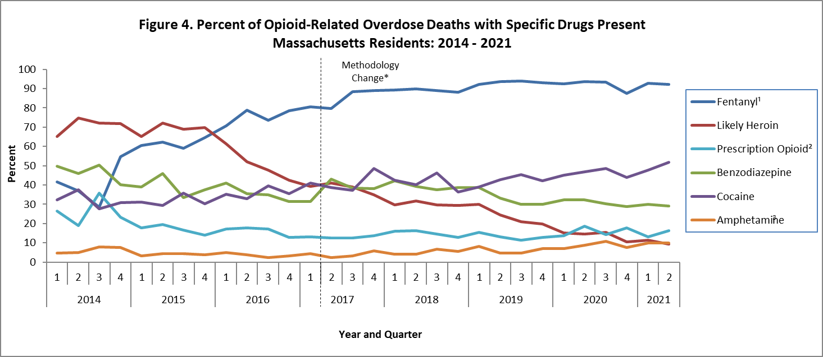

* Beginning with the November 2019 report, DPH began to use a new method to identify substances present in the toxicology data, which can only be applied from 2017 onward; this new method cannot be applied to the older data

1. This is most likely illicitly produced and sold, **not** prescription fentanyl
2. Prescription opioids include: hydrocodone, hydromorphone, oxycodone, oxymorphone, and tramadol
3. Beginning with the February 2020 report, amphetamine includes both amphetamine and methamphetamine; methamphetamine was previously excluded

**Please note that previous estimates may change slightly as DPH routinely receives updated toxicology data from the Office of the Chief Medical Examiner and the Massachusetts State Police.**

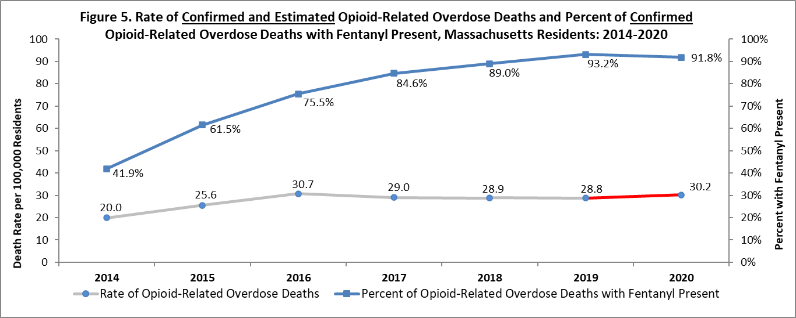

Although the presence of fentanyl in opioid-related overdose deaths remains high, it has declined by 1.5% since 2019.

# Technical Notes

* Opioids include heroin, illicitly manufactured fentanyl, opioid-based prescription painkillers, and other unspecified opioids.
* Data for 2017-Q3 2021 deaths are preliminary and subject to updates.
* Beginning with the May 2017 report, DPH started reporting opioid-related overdose deaths for all intents, which includes unintentional/undetermined and suicide.
* Beginning with the August 2019 report, DPH updated the case definition used to identify opioid-related overdose deaths to match the CDC’s case definition. The following International Classification of Disease (ICD10) codes for mortality were selected from the underlying cause of death field to identify poisonings/overdoses: X40-X44, X60-X64, X85, and Y10-Y14. All multiple cause of death fields were then used to identify an opioidrelated overdose death: T40.0, T40.1, T40.2, T40.3, T40.4, and T40.6.
* This report tracks opioid-related overdoses due to difficulties in identifying heroin and prescription opioids separately. The Department regularly reviews projections as more information becomes available. Information from the Office of the Chief Medical Examiner and the Massachusetts State Police are now incorporated into the predictive model. This additional information has improved the accuracy of the model that predicts the likelihood that the cause of death for any person was an opioid-related overdose. DPH applied this model to death records for which no official cause of death was listed by the OCME. The model includes information from the death certificate, Medical Examiner’s notes, and the determination by the State Police of a suspected heroin death. DPH added this estimate to the number of confirmed cases in order to compute the total number of opioid-related overdoses. Should new information become available that changes the estimates to any significant degree, updates will be posted.

# Sources

* Massachusetts Registry of Vital Records and Statistics, MDPH
* Massachusetts Office of the Chief Medical Examiner
* Massachusetts State Police
* Population Estimates 2000-2010: National Center for Health Statistics. Postcensal estimates of the resident population of the United States, by year, county, age, bridged race, Hispanic origin, and sex (Vintage 2000-2010). • Population Estimates 2011-2019: Small Area Population Estimates 2011-2020, version 2019, Massachusetts Department of Public Health, Bureau of Environmental Health. Population estimates used for years following the decennial census were developed by the University of Massachusetts Donahue Institute (UMDI) in partnership with the Massachusetts Department of Public Health, Bureau of Environmental Health.