

**Opioid1‐Related Overdose Deaths, All Intents, MA Residents – Demographic Data Highlights**

Massachusetts Department of Public Health

POSTED: AUGUST 2018

This data brief highlights demographic data from confirmed opioid‐related overdose deaths for all intents, from January 2018 through June 2018.

**Confirmed Opioid1‐Related Deaths, All Intents, by Gender: January 2018‐June 2018**

|  |  |
| --- | --- |
| Male | 488 |
| Female | 169 |
| **Total** | **657** |

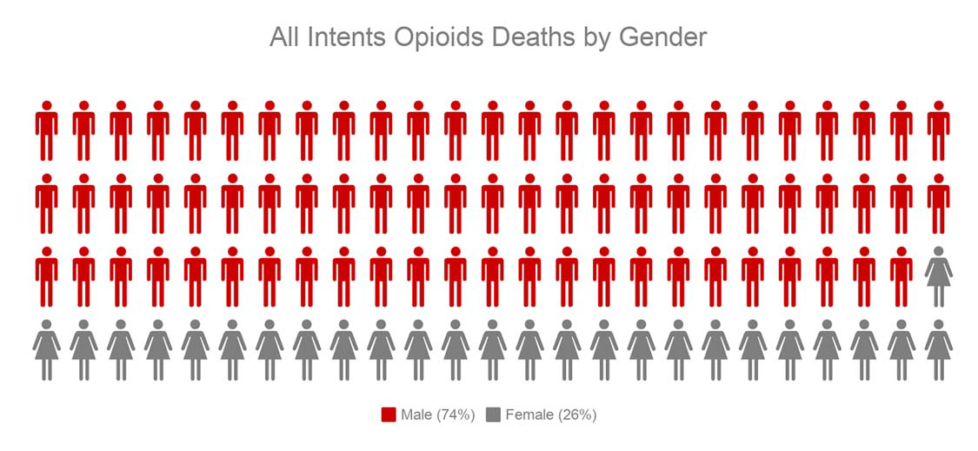

**Confirmed Opioid1‐Related Deaths, All Intents Compared to All Deaths by Age: January 2018‐June 2018**

|  |  |  |  |  |  |  |  |  |  |
| --- | --- | --- | --- | --- | --- | --- | --- | --- | --- |
|  | **<15** | **15‐24** | **25‐34** | **35‐44** | **45‐54** | **55‐64** | **65+** | **Unknown** | **Total** |
| All Deaths | 174 | 205 | 628 | 736 | 1,419 | 3,265 | 23,715 | 4 | **30,146** |
| Confirmed Opioid1‐Related  Deaths, All Intents | 1 | 39 | 215 | 183 | 135 | 72 | 12 | 0 | **657** |

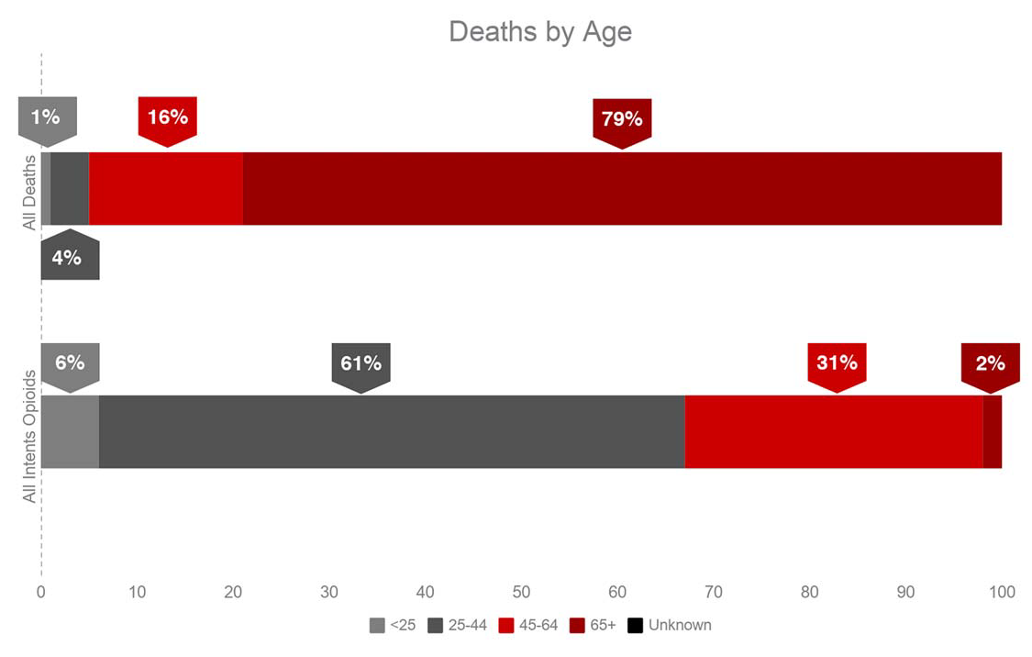

**Confirmed Opioid1‐Related Deaths, All Intents**

**Compared to All Deaths by Race and Hispanic Ethnicity: January 2018‐June 2018**

|  |  |  |  |  |  |  |
| --- | --- | --- | --- | --- | --- | --- |
|  | **White non‐**  **Hispanic** | **Black non‐**  **Hispanic** | **Asian non‐**  **Hispanic** | **Hispanic** | **Other/ Unknown** | **Total** |
| All Deaths | 26,639 | 1,352 | 634 | 1,201 | 320 | **30,146** |
| Confirmed Opioid1‐Related Deaths, All Intents | 534 | 28 | 6 | 79 | 10 | **657** |

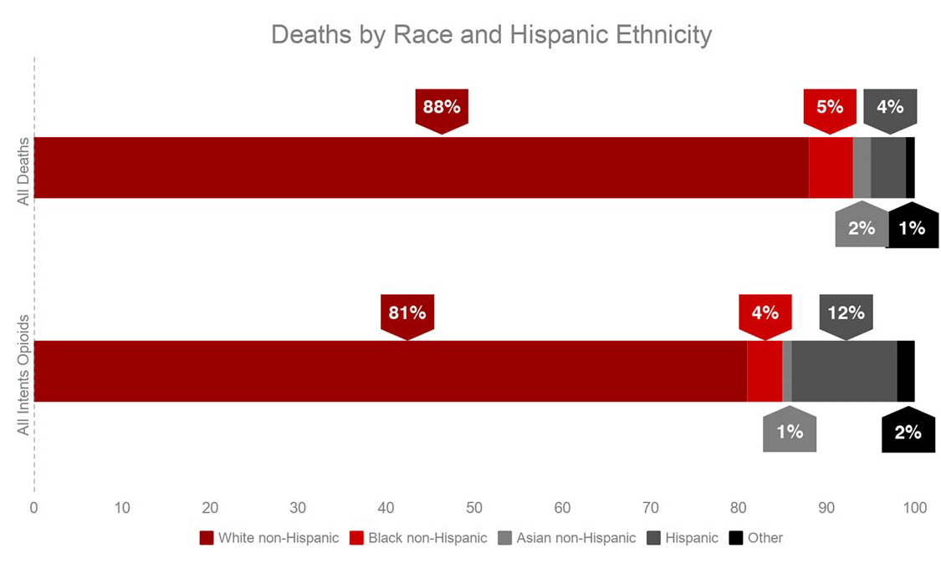

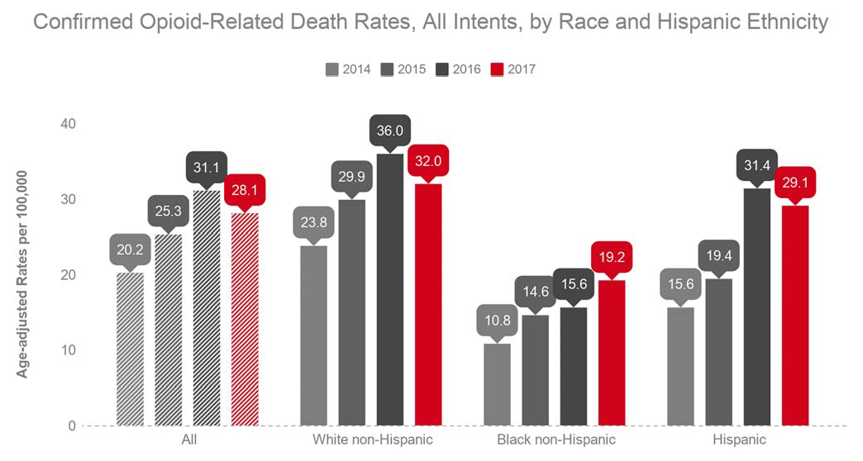

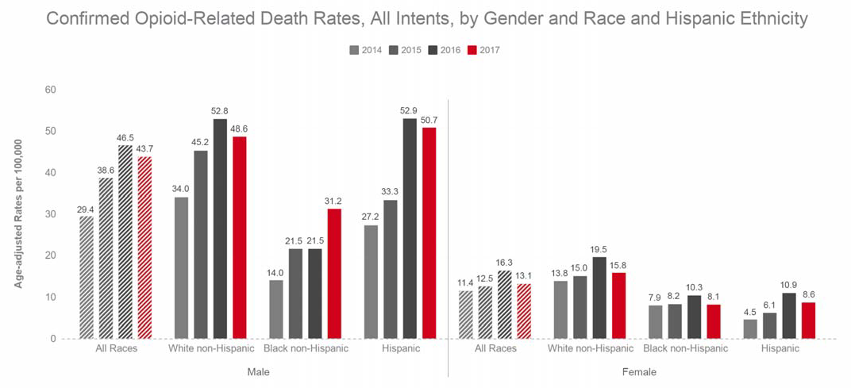

**Technical Notes**

2016‐2017 death data are preliminary and subject to updates. Case reviews of deaths are evaluated and updated on an ongoing basis. A large number of deaths have yet to be assigned final cause‐of‐death codes. The information presented in this report only includes confirmed cases. Data updated on 7/19/2018. Beginning with the May 2017 report, DPH started reporting opioid‐related deaths for all intents, which includes unintentional/undetermined and suicide.

**Source: Registry of Vital Records and Statistics, MDPH**