|  |
| --- |
| **Opioid-Related Overdose Deaths, All Intents, MA Residents – Demographic Data Highlights** |
| Massachusetts Department of Public Health POSTED: JUNE 2022 |

This data brief highlights demographic data from confirmed opioid-related overdose deaths for all intents, from January 2021 through December 2021.

**Confirmed Opioid-Related Overdose Deaths, All Intents, by Gender: January 2021- December 2021**

|  |  |
| --- | --- |
| Male | 1,632 |
| Female | 602 |
| **Total** | **2,234** |

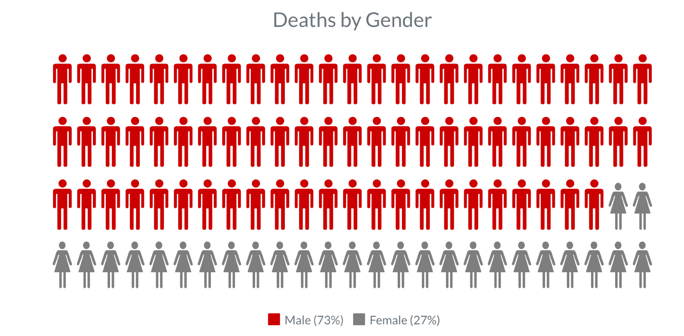

**Confirmed Opioid-Related Overdose Deaths, All Intents**

**Compared to All Deaths by Age: January 2021-December 2021**

|  |  |  |  |  |  |  |  |  |  |
| --- | --- | --- | --- | --- | --- | --- | --- | --- | --- |
|  | **<15** | **15-24** | **25-34** | **35-44** | **45-54** | **55-64** | **65+** | **Unknown** | **Total** |
| All Deaths | 335 | 429 | 1,225 | 1,858 | 3,144 | 7,385 | 48,722 | 0 | **63,098** |
| Confirmed Opioid-Related Overdose Deaths, All Intents | 0 | 119 | 476 | 630 | 504 | 412 | 93 | 0 | **2,234** |

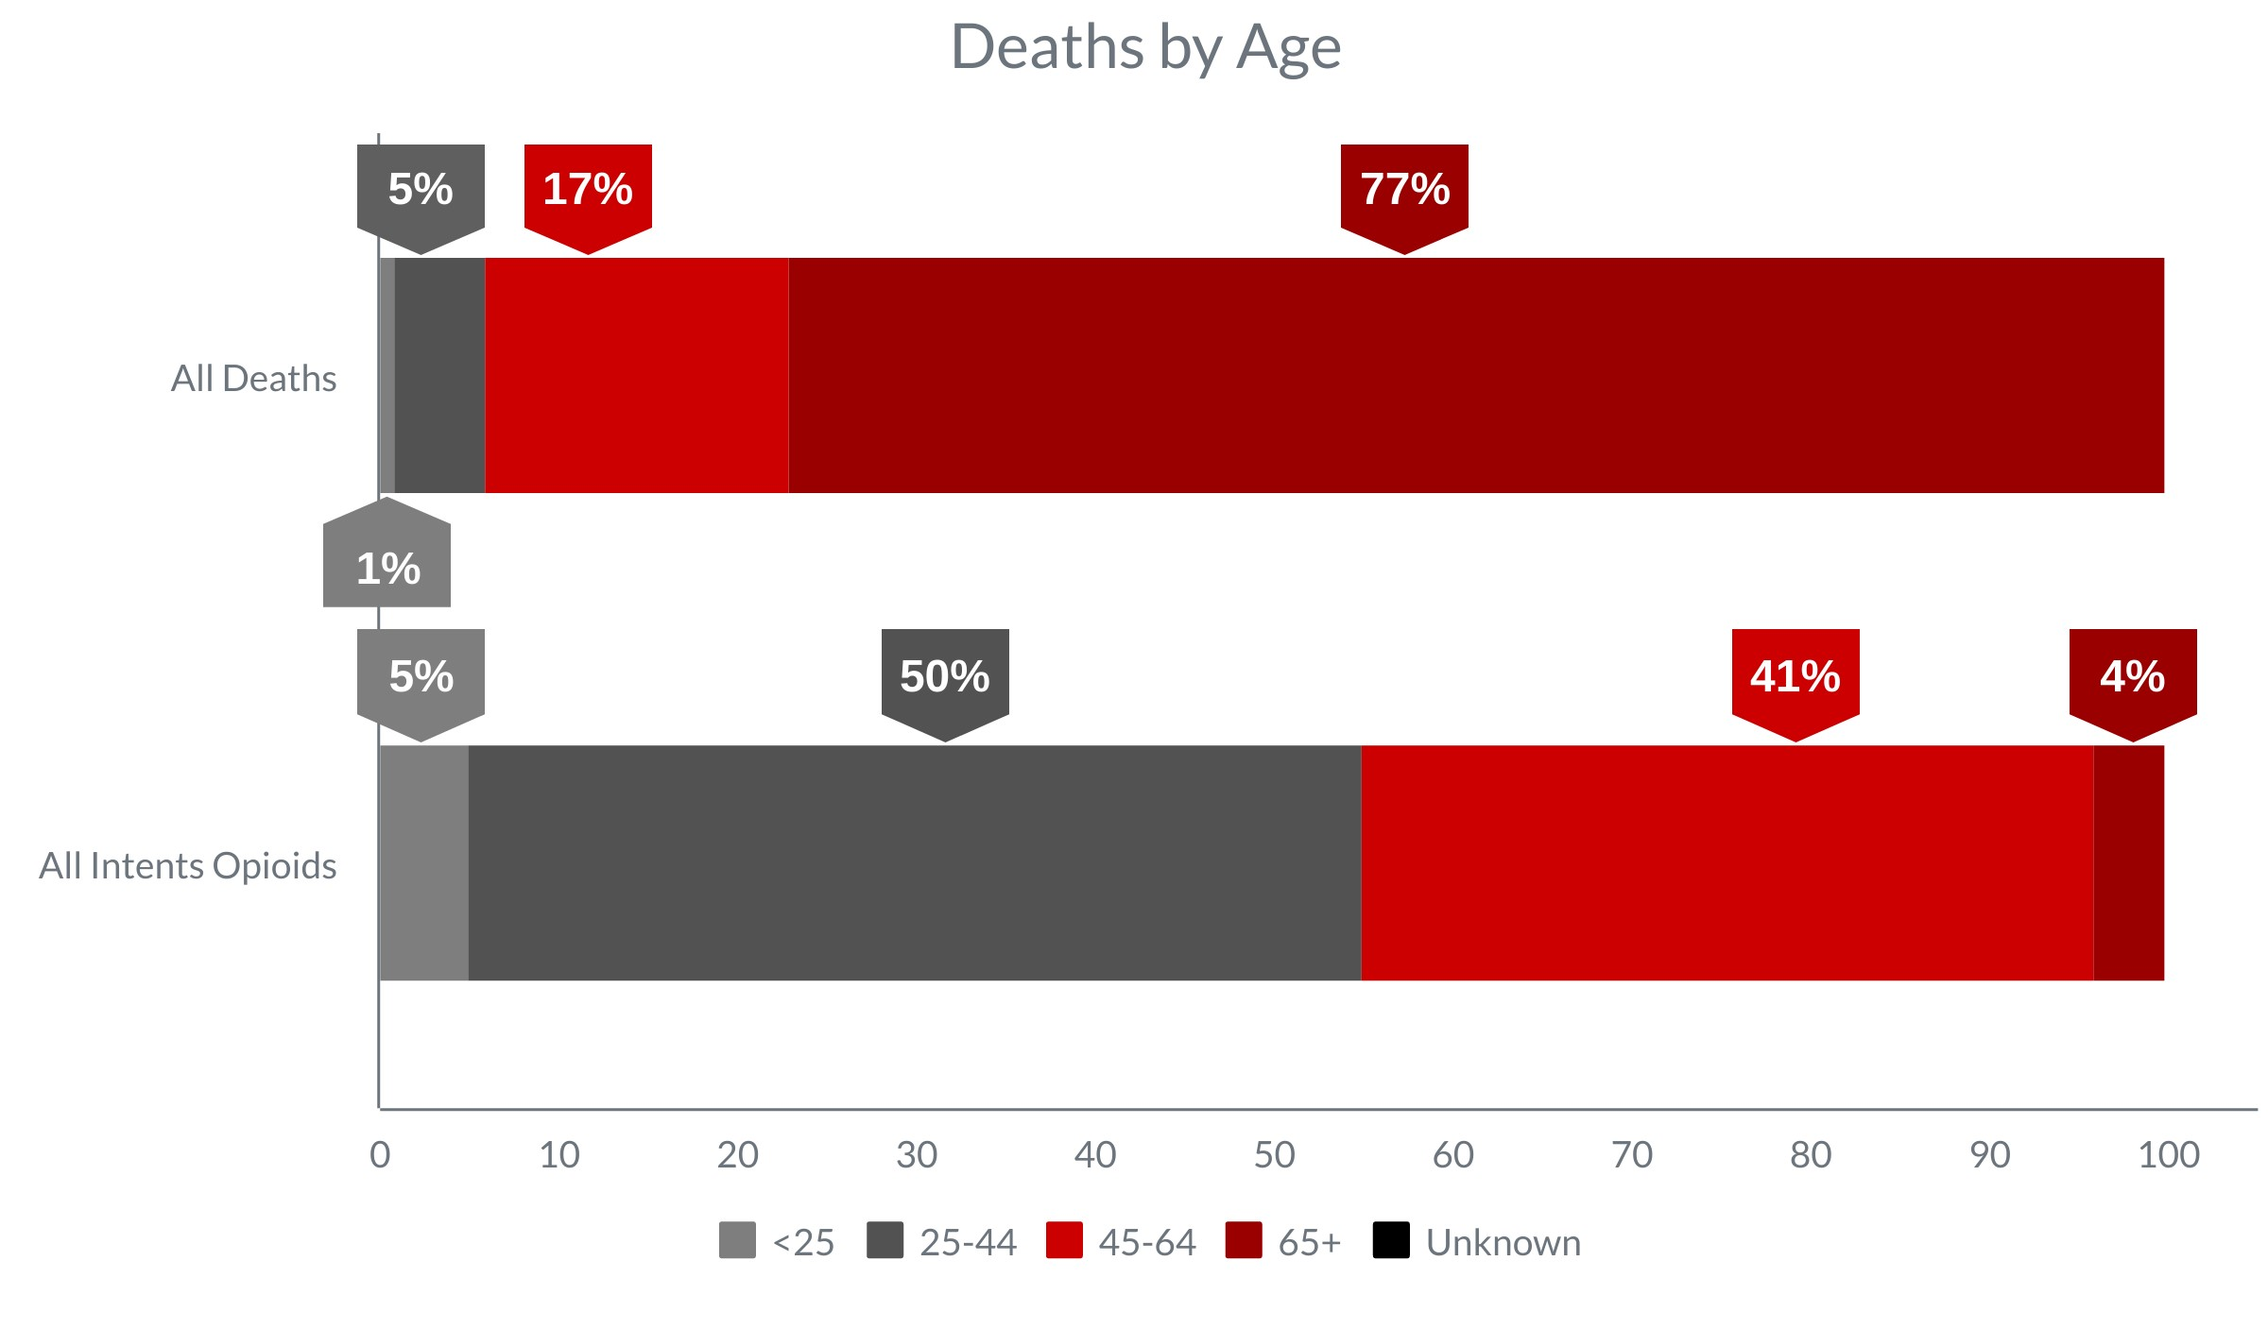

**Confirmed Opioid-Related Overdose Deaths, All Intents**

**Compared to All Deaths by Race and Hispanic Ethnicity: January 2021-December 2021**

|  |  |  |  |  |  |  |  |
| --- | --- | --- | --- | --- | --- | --- | --- |
|  | **White nonHispanic** | **Black nonHispanic** | **Asian nonHispanic** | **Hispanic** | **American**  **Indian nonHispanic** | **Other/**  **Unknown** | **Total** |
| All Deaths | 53,833 | 3,409 | 1,751 | 3,358 | 128 | 585 | **63,098** |
| Confirmed Opioid-Related Overdose Deaths, All Intents | 1,672 | 180 | 19 | 316 | 13 | 34 | **2,234** |

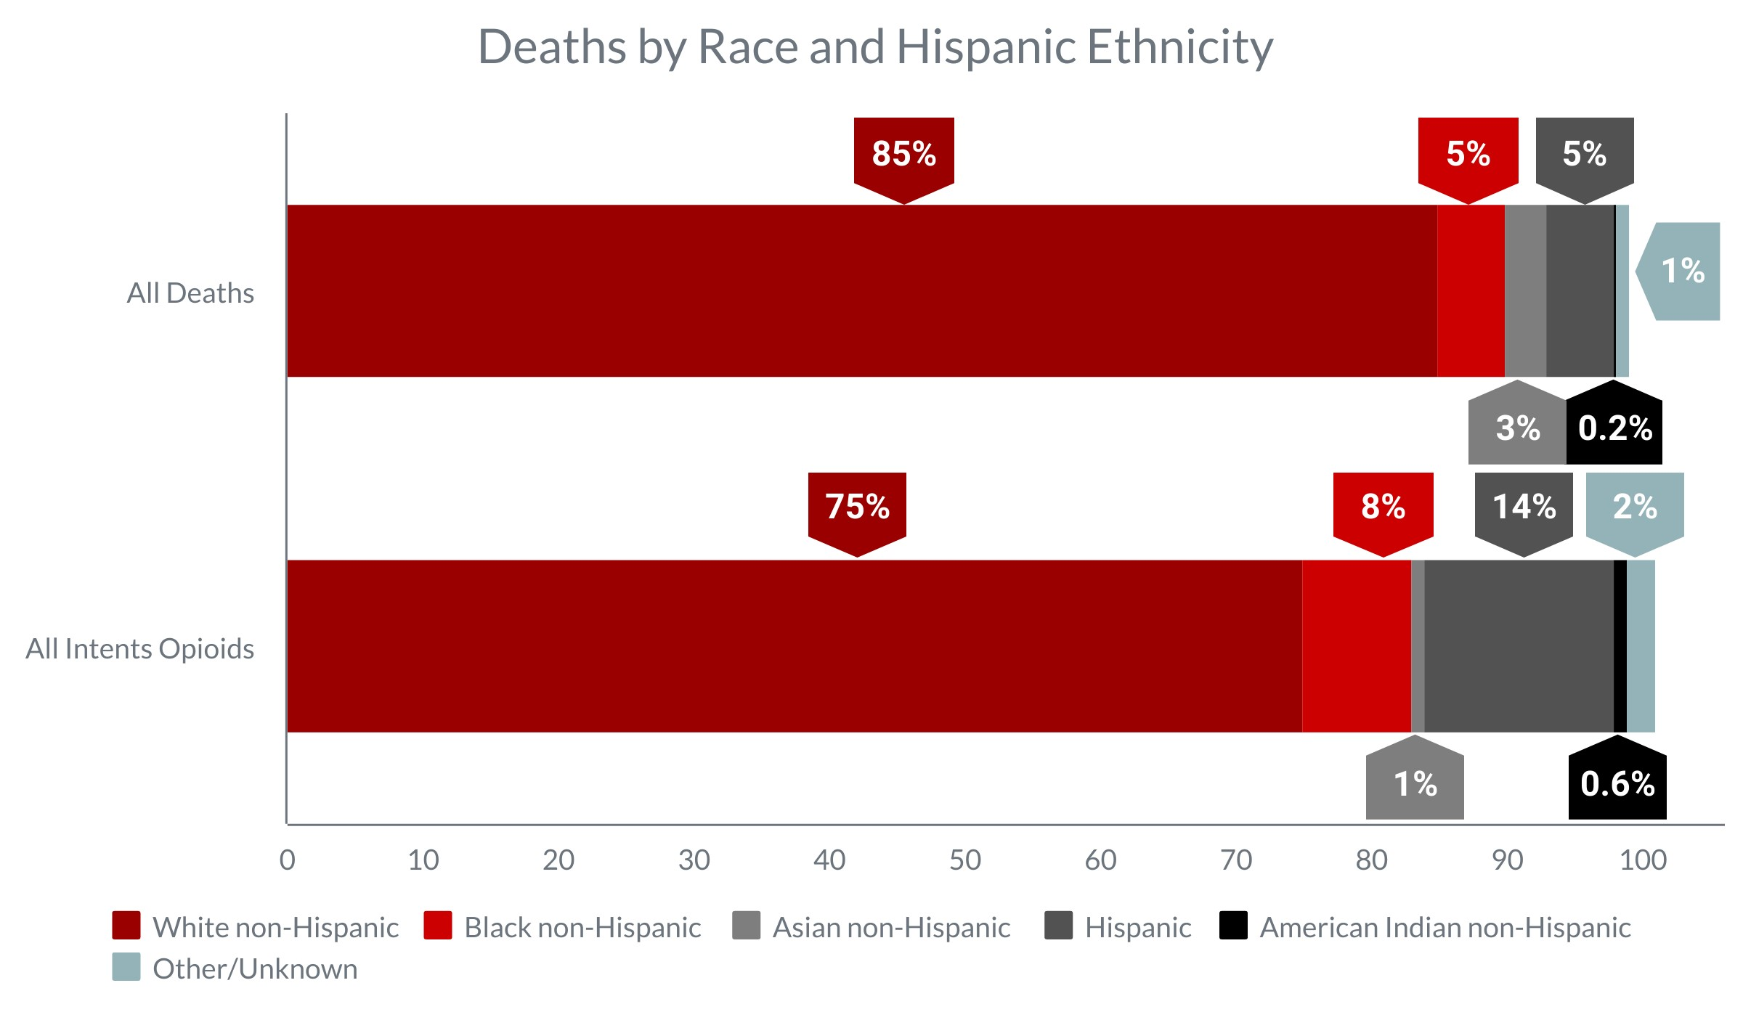

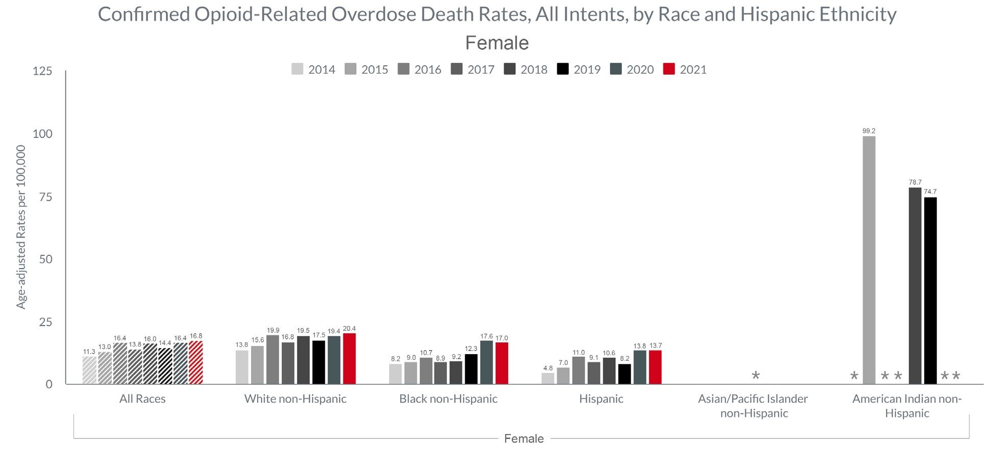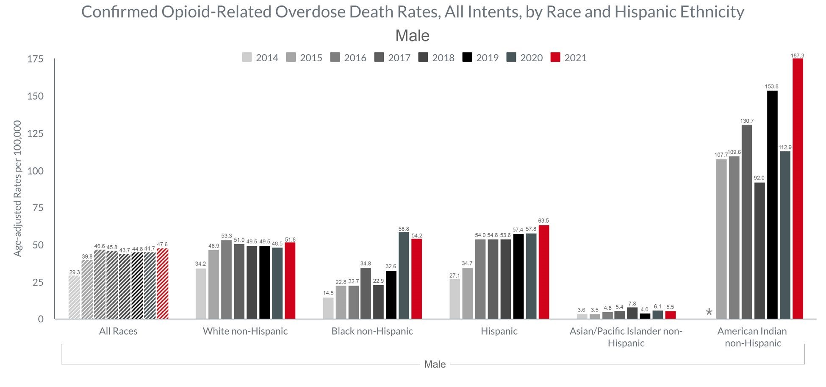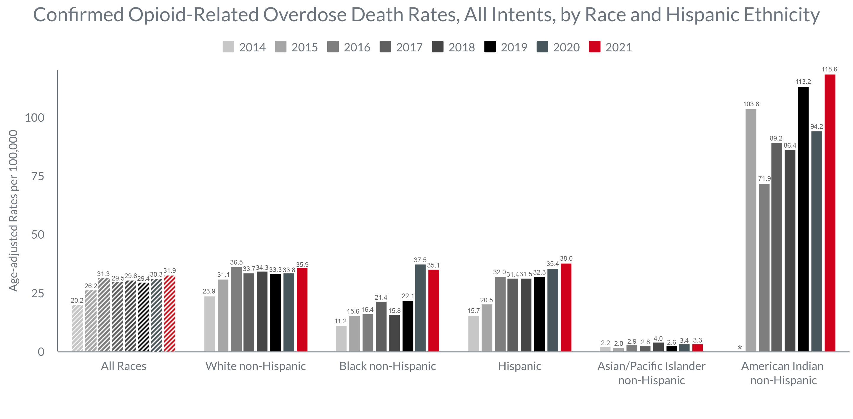

*Rate calculations based on death counts less than 5 are excluded due to rate instability.

**Technical Notes**

* Opioids include heroin, illicitly manufactured fentanyl, opioid-based prescription painkillers, and other unspecified opioids.
* 2020 - 2021 death data are preliminary and subject to updates. Case reviews of deaths are evaluated and updated on an ongoing basis. A large number of deaths have yet to be assigned final cause of death codes. The information presented in this report only includes confirmed cases. Data updated on 04/01/2022.
* Beginning with the May 2017 report, DPH started reporting opioid-related overdose deaths for all intents, which includes unintentional/undetermined and suicide.
* Beginning with the August 2019 report, DPH updated the case definition used to identify opioid-related overdose deaths to match the CDC’s case definition. The following International Classification of Disease (ICD10) codes for mortality were selected from the underlying cause of death field to identify poisonings/overdoses: X40-X44, X60-X64, X85, and Y10-Y14. All multiple cause of death fields were then used to identify an opioidrelated overdose death: T40.0, T40.1, T40.2, T40.3, T40.4, and T40.6.

**Sources**

* Massachusetts Registry of Vital Records and Statistics, MDPH
* Population Estimates 2011-2019, version 2020, Massachusetts Department of Public Health, Bureau of Environmental Health. Version 2020 years 2018-2019 apply updates from U.S. Census Bureau’s County

Population by Characteristics, vintage 2020; all previous years apply updates from U.S. Census Bureau’s County

Population by Characteristics, vintage 2019 or earlier. These estimates were developed by the University of Massachusetts Donahue Institute (UMDI) in partnership with the Massachusetts Department of Public Health, Bureau of Environmental Health.

* UMDI Interim 2020 Population Estimates by Age, Sex, Race, and Municipality, UMass Donahue Institute Population Estimates Program, March 1, 2022.