

POSTED: JUNE 2024

Massachusetts Department of Public Health

**Opioid-Related Overdose Deaths, All Intents, MA Residents – Demographic Data Highlights**

This data brief highlights demographic data from confirmed opioid-related overdose deaths for all intents, from January 2023 through December 2023.

**Confirmed Opioid-Related Overdose Deaths, All Intents, by Sex: January 2023-December 2023**

|  |  |
| --- | --- |
| Male | 1,513 |
| Female | 591 |
| **Total** | **2,104** |

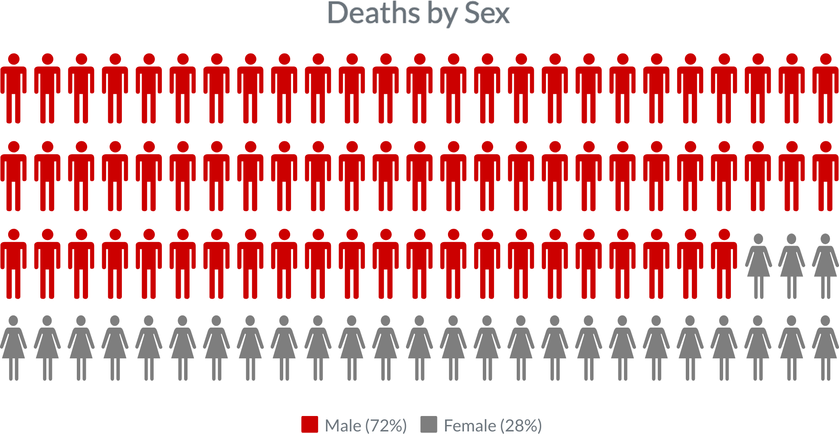

**Confirmed Opioid-Related Overdose Deaths, All Intents Compared to All Deaths by Age: January 2023-December 2023**

|  |  |  |  |  |  |  |  |  |  |
| --- | --- | --- | --- | --- | --- | --- | --- | --- | --- |
|  | **<15** | **15-24** | **25-34** | **35-44** | **45-54** | **55-64** | **65+** | **Unknown** | **Total** |
| All Deaths | 325 | 377 | 992 | 1,708 | 2,737 | 6,442 | 48,581 | 25 | **61,187** |
| Confirmed Opioid-Related  Overdose Deaths, All Intents | 2 | 64 | 388 | 605 | 483 | 425 | 135 | 2 | **2,104** |

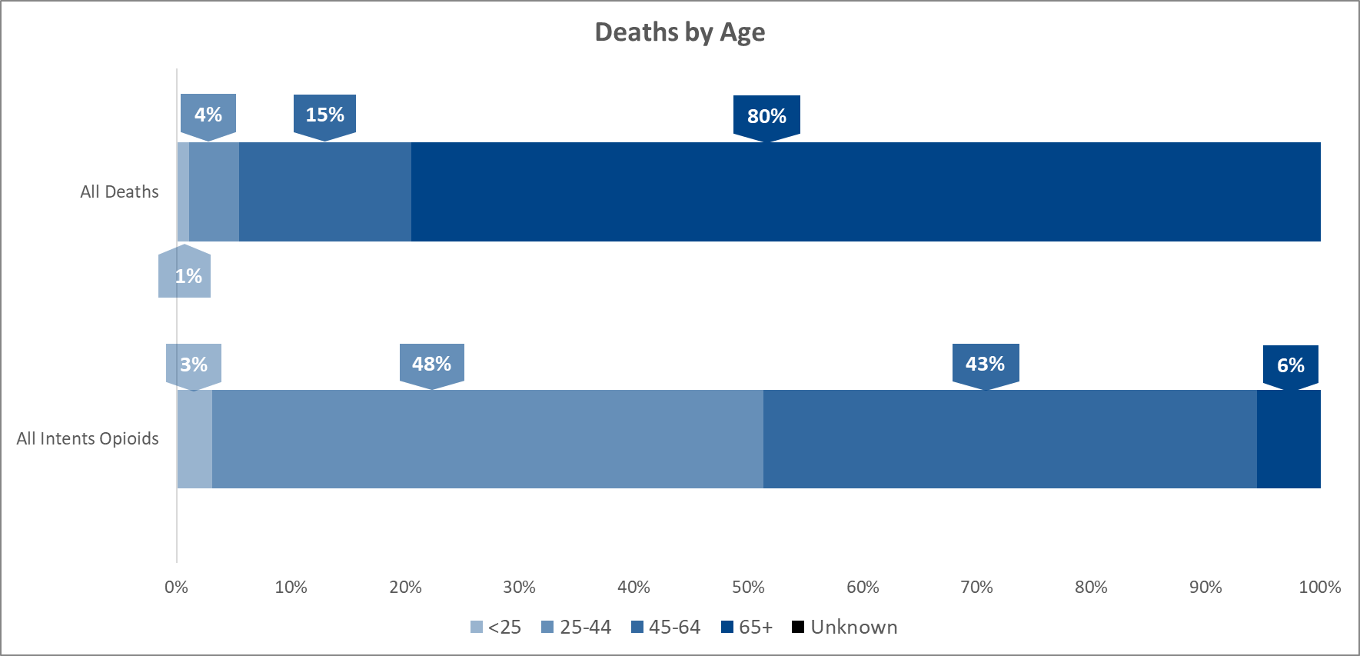

**Confirmed Opioid-Related Overdose Deaths, All Intents**

**Compared to All Deaths by Race and Hispanic Ethnicity: January 2023-December 2023**

|  |  |  |  |  |  |  |  |
| --- | --- | --- | --- | --- | --- | --- | --- |
|  | **White non- Hispanic** | **Black non- Hispanic** | **Asian non- Hispanic** | **Hispanic** | **American Indian non-**  **Hispanic** | **Other non- Hispanic** | **Total** |
| All Deaths | 52,436 | 3,380 | 1,658 | 3,108 | 99 | 408 | **61,187** |
| Confirmed Opioid-Related Overdose Deaths, All Intents | 1,402 | 272 | 25 | 361 | 8 | 23 | **2,104** |

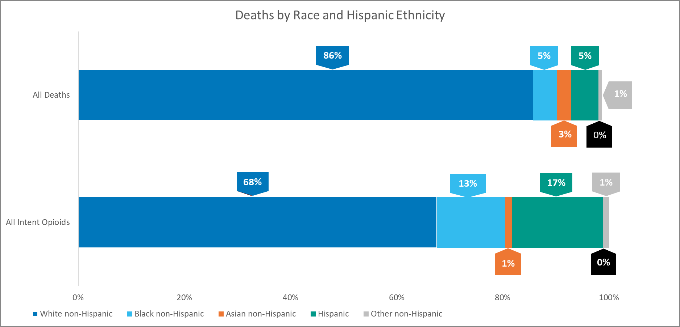

American Indian non-Hispanic count too small to display.



Confirmed Opioid-Related Overdose Rates, All Intents, by Race and Hispanic

Ethnicity

160

143.6

140

118.6

120

113.2

100

94.2

86.5

80

60

52.3 54.3

46.6 44.2

40

29.4 30.3 32.6 32.9 29.7

33.4 33.8 36.5 33.6

37.5 36.6

35.4 39.2

29.2

32.3

22.1

20

2.6 3.4 3.6 3.9

4.5

0

All Races

White non-Hispanic Black non-Hispanic

Hispanic

Asian/Pacific Islander American Indian non-

non-Hispanic Hispanic

**Age-adjusted rates per 100,000**

2019

2020

2021

2022

2023

2019

2020

2021

2022

2023

2019

2020

2021

2022

2023

2019

2020

2021

2022

2023

2019

2020

2021

2022

2023

2019

2020

2021

2022

2023

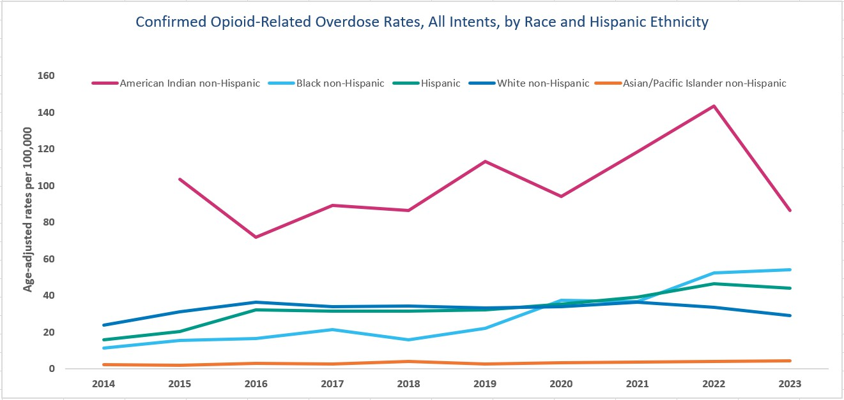



Confirmed Opioid-Related Overdose Rates, All Intents, by Race and Hispanic Ethnicity

Male

200.0

187.3

180.0

170.1

160.0

153.8

140.0

120.0

112.9

113.1

100.0

84.6

80.0

80.0

75.5 74.6

65.4

60.0

58.8 56.8

57.4 57.8

52.7

48.7 48.7

49.5 48.5

44.8 44.7

48.2

43.6

40.4

40.0

32.6

20.0

8.2

4.0

6.1 6.0 5.5

0.0

All Races

White non-Hispanic Black non-Hispanic

Hispanic

Asian/Pacific Islander American Indian non-

non-Hispanic Hispanic

**Age-adjusted rates per 100,000**

2019

2020

2021

2022

2023

2019

2020

2021

2022

2023

2019

2020

2021

2022

2023

2019

2020

2021

2022

2023

2019

2020

2021

2022

2023

2019

2020

2021

2022

2023

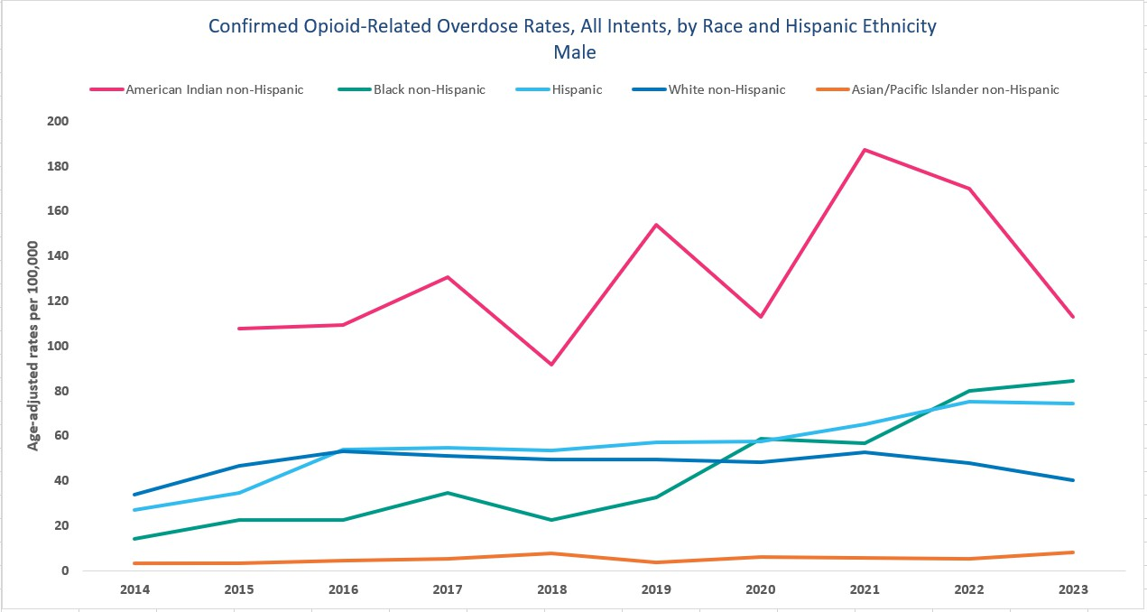



Confirmed Opioid-Related Overdose Rates, All Intents, by Race and Hispanic Ethnicity

Female

140.0

119

120.0

100.0

80.0

74.8

60.0

40.0

26.2 25.9

20.0

14.4 16.4

17.2 17.8

16.4

17.6 19.4 20.8 19.4 18.3

17.6 17.4

19.3

15.4

12.3

13.8 14.2

8.2

* *

*

2.4

*

* *

*

0.0

All Races

White non-Hispanic Black non-Hispanic

Hispanic

Asian/Pacific Islander American Indian non-

non-Hispanic Hispanic

*Rate calculations based on death counts less than 5 are excluded due to rate instability.

**Age-adjusted rates per 100,000**

2019

2020

2021

2022

2023

2019

2020

2021

2022

2023

2019

2020

2021

2022

2023

2019

2020

2021

2022

2023

2019

2020

2021

2022

2023

2019

2020

2021

2022

2023

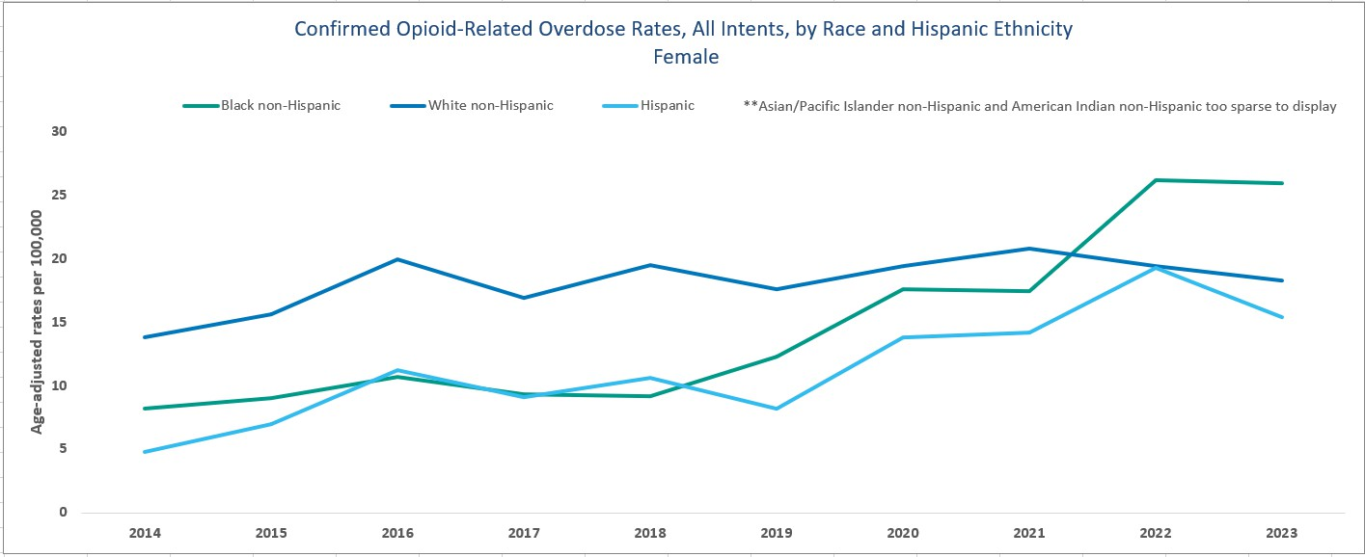

# Technical Notes

* Opioids include heroin, illicitly manufactured fentanyl, opioid-based prescription painkillers, and other unspecified opioids.
* 2022 - 2023 death data are preliminary and subject to updates. Case reviews of deaths are evaluated and updated on an ongoing basis. Many deaths have yet to be assigned final cause of death codes. The information presented in this report only includes confirmed cases. Data updated on 04/11/2024.
* Beginning with the May 2017 report, DPH started reporting opioid-related overdose deaths for all intents, which includes unintentional/undetermined and suicide.
* Beginning with the August 2019 report, DPH updated the case definition used to identify opioid-related overdose deaths to match the CDC’s case definition. The following International Classification of Disease (ICD- 10) codes for mortality were selected from the underlying cause of death field to identify poisonings/overdoses: X40-X44, X60-X64, X85, and Y10-Y14. All multiple cause of death fields were then used to identify an opioid- related overdose death: T40.0, T40.1, T40.2, T40.3, T40.4, and T40.6.

# Sources

* Massachusetts Registry of Vital Records and Statistics, MDPH
* *Population 2011-2019:* Population Estimates 2011-2019, version 2020, Massachusetts Department of Public Health, Bureau of Environmental Health. Version 2020 years 2018-2019 apply updates from U.S. Census Bureau’s County Population by Characteristics, vintage 2020; all previous years apply updates from U.S. Census Bureau’s County Population by Characteristics, vintage 2019 or earlier. These estimates were developed by the University of Massachusetts Donahue Institute (UMDI) in partnership with the Massachusetts Department of Public Health, Bureau of Environmental Health.
* *Population 2020-2022:* UMDI Interim 2020 Population Estimates by Age, Sex, Race, and Municipality, UMass Donahue Institute Population Estimates Program, March 1, 2022.