

POSTED: NOVEMBER 2019

Massachusetts Department of Public Health

**Opioid-Related Overdose Deaths, All Intents, MA Residents – Demographic Data Highlights**

This data brief highlights demographic data from confirmed opioid-related overdose deaths for all intents, from January 2019 through September 2019.

**Confirmed Opioid-Related Overdose Deaths, All Intents, by Gender: January 2019-September 2019**

|  |  |
| --- | --- |
| Male | 807 |
| Female | 284 |
| **Total** | **1,091** |

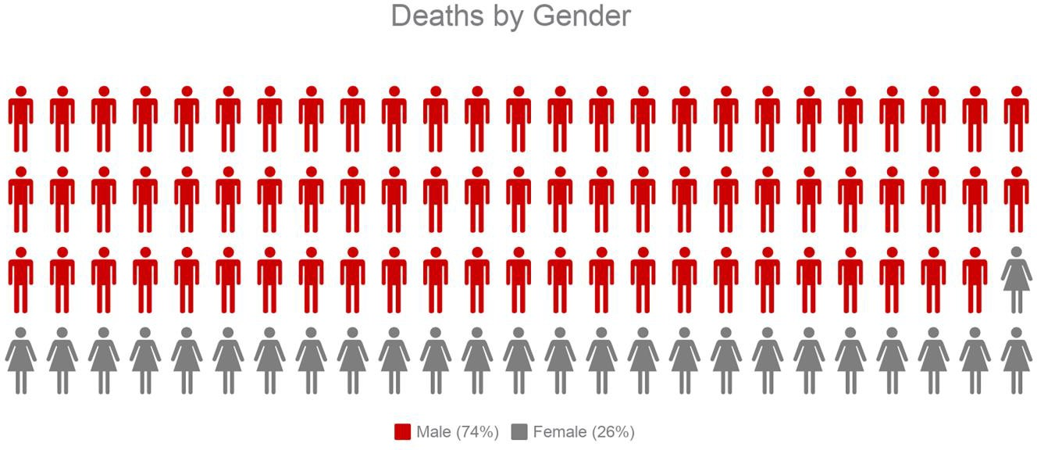

**Confirmed Opioid-Related Overdose Deaths, All Intents Compared to All Deaths by Age: January 2019-September 2019**

|  |  |  |  |  |  |  |  |  |  |
| --- | --- | --- | --- | --- | --- | --- | --- | --- | --- |
|  | **<15** | **15-24** | **25-34** | **35-44** | **45-54** | **55-64** | **65+** | **Unknown** | **Total** |
| All Deaths | 244 | 278 | 857 | 1,037 | 2,100 | 4,794 | 33,583 | 2 | **42,895** |
| Confirmed Opioid-Related  Overdose Deaths, All Intents | 1 | 64 | 320 | 252 | 253 | 170 | 31 | 0 | **1,091** |

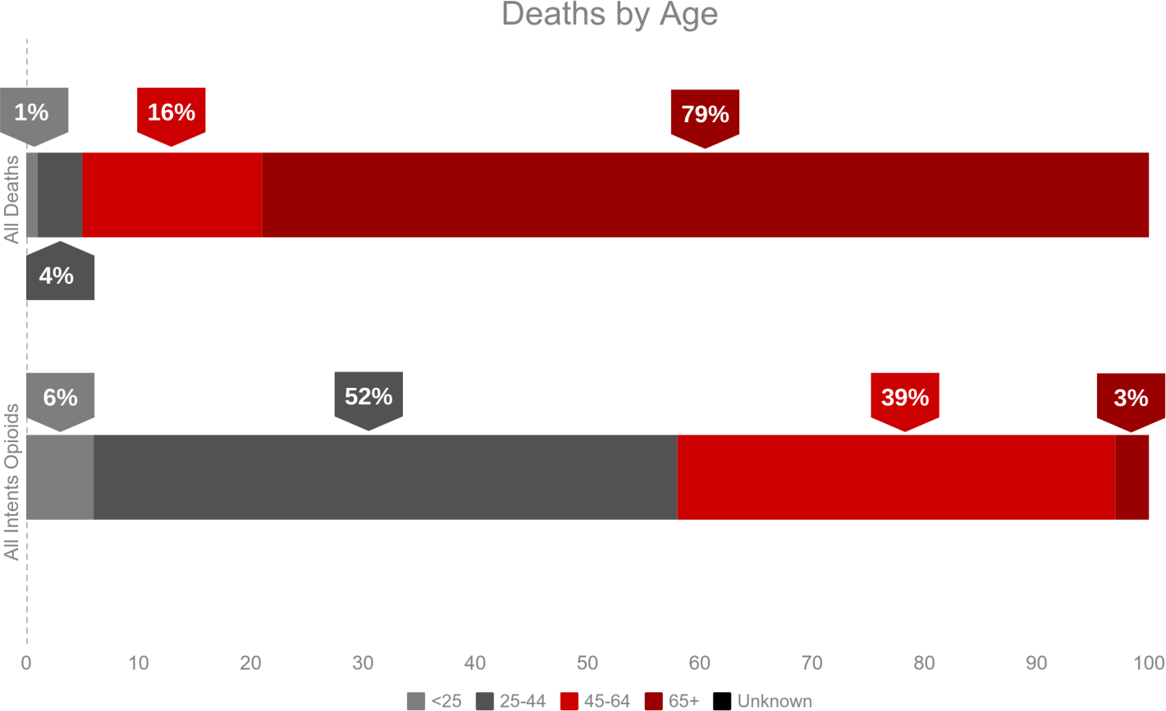

**Confirmed Opioid-Related Overdose Deaths, All Intents**

**Compared to All Deaths by Race and Hispanic Ethnicity: January 2019-September 2019**

|  |  |  |  |  |  |  |
| --- | --- | --- | --- | --- | --- | --- |
|  | **White non-**  **Hispanic** | **Black non-**  **Hispanic** | **Asian non-**  **Hispanic** | **Hispanic** | **Other/ Unknown** | **Total** |
| All Deaths | 37,710 | 1,991 | 930 | 1,812 | 452 | **42,895** |
| Confirmed Opioid-Related Overdose Deaths, All Intents | 873 | 56 | 5 | 139 | 18 | **1,091** |

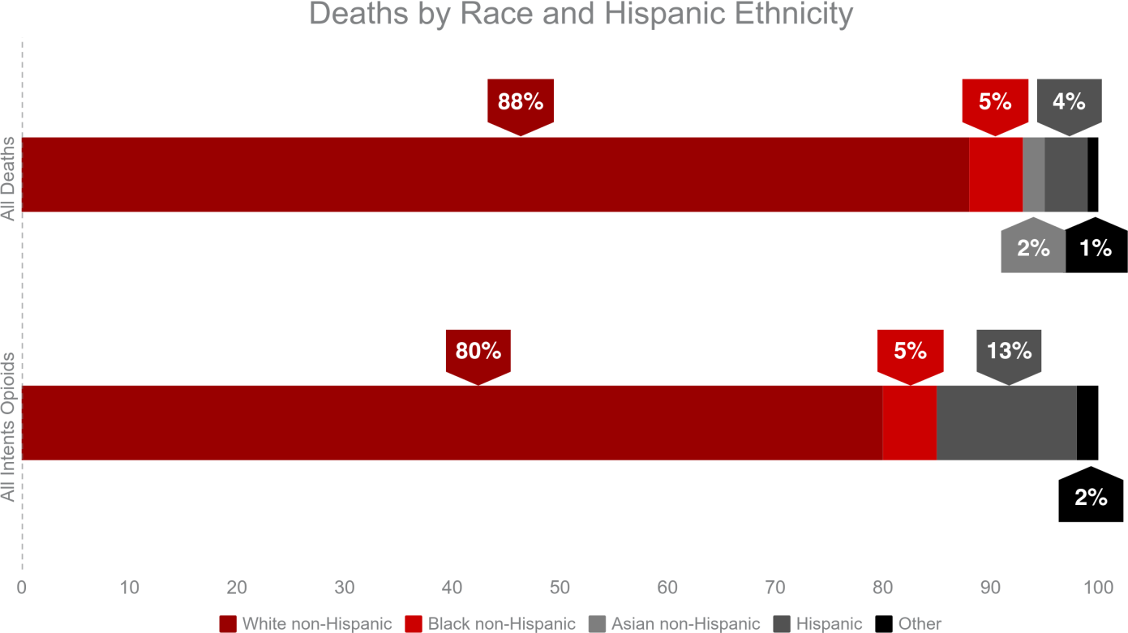

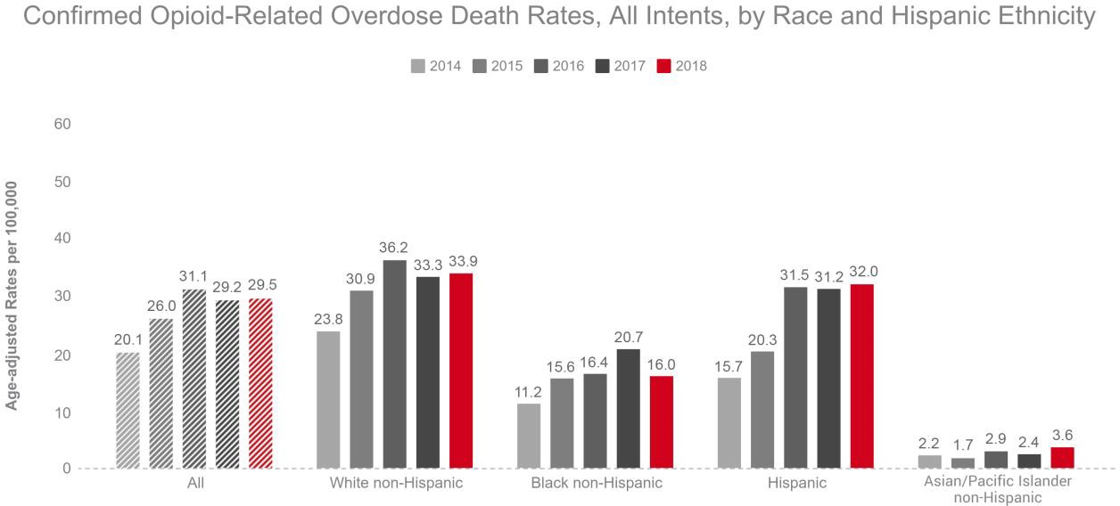

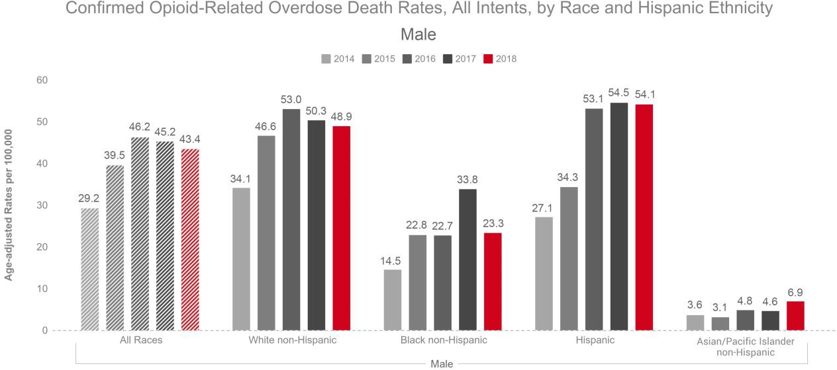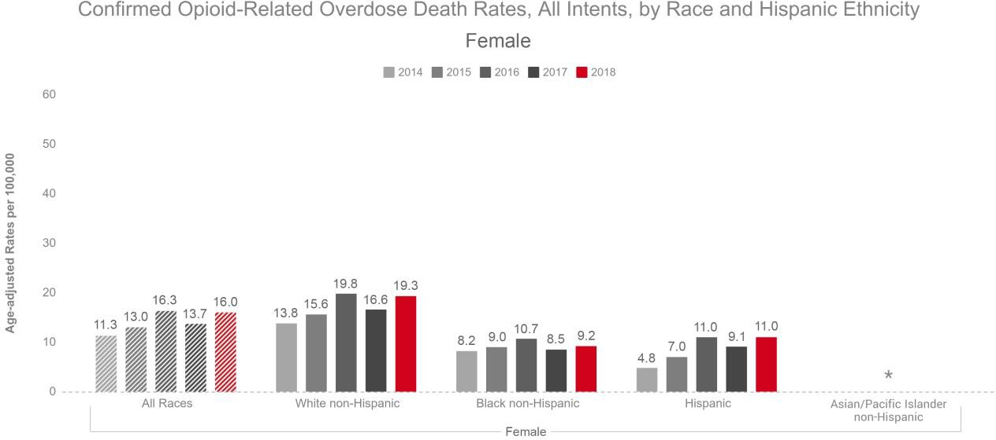

*Rate calculations based on death counts less than 5 are excluded due to rate instability.

# Technical Notes

* Opioids include heroin, illicitly manufactured fentanyl, opioid-based prescription painkillers, and other unspecified opioids.
* 2017 and 2018 death data are preliminary and subject to updates. Case reviews of deaths are evaluated and updated on an ongoing basis. A large number of deaths have yet to be assigned final cause-of-death codes. The information presented in this report only includes confirmed cases. Data updated on 10/4/2019.
* Beginning with the May 2017 report, DPH started reporting opioid-related overdose deaths for all intents, which includes unintentional/undetermined and suicide.
* Beginning with the August 2019 report, DPH updated the case definition used to identify opioid-related overdose deaths to match the CDC’s case definition. The following International Classification of Disease (ICD- 10) codes for mortality were selected from the underlying cause of death field to identify poisonings/overdoses: X40-X44, X60-X64, X85, and Y10-Y14. All multiple cause of death fields were then used to identify an opioid- related overdose death: T40.0, T40.1, T40.2, T40.3, T40.4, and T40.6.

# Sources

* Massachusetts Registry of Vital Records and Statistics, MDPH
* Population Estimates: Small Area Population Estimates 2011-2020, version 2017, Massachusetts Department of Public Health, Bureau of Environmental Health. Population estimates used for years following the decennial census were developed by the University of Massachusetts Donahue Institute (UMDI) in partnership with the Massachusetts Department of Public Health, Bureau of Environmental Health.