August, 2018
Opioid-related Overdose Deaths

in Massachusetts

by Industry and Occupation, 2011-2015

Acknowledgments

This project was supported by a grant (1UI7CE002724) from the Centers for Disease Control and Prevention to the Massachusetts Department of Public Health (DPH). The study was conducted by Devan Hawkins, James Laing and Letitia Davis of the Occupational Health Surveillance Program (OHSP) in the Massachusetts Department of Public Health. OHSP collaborated with the DPH Bureau of Substance Addiction Services, the Injury Surveillance Program and the Office of Special Analytic Projects in carrying out this work.

To obtain additional copies of this report, please contact:
Massachusetts Department of Public Health
Occupational Health Surveillance Program
250 Washington Street, 4th Floor
Boston, MA 02018
617-624-5632

The report is also available online at https://www.mass.gov/files/documents/2018/08/07/opioid-industry-occupation.pdf

Preferred citation: Massachusetts Department of Public Health Occupational Health Surveillance Program (2018); Opioid-related Overdose Deaths in Massachusetts by Industry and Occupation, 2011-2015.

Opioid-related Overdose Deaths in Massachusetts by
Industry and Occupation, 2011-2015

Summary and Key Findings

Information from Massachusetts death certificates was used to describe opioid-related overdose deaths from 2011 through 2015 by industry and occupation. Findings from several national surveys were used to explore factors that may potentially contribute to differences in the rates of fatal opioid overdose among workers in different industries and occupations. Key findings are:

- The rate of fatal opioid overdose varied significantly by industry and occupation of the decedents.

- Construction and extraction workers had both a high rate (150.6 deaths per 100,000 workers) and a high number of opioid-related overdose deaths (n=1,096). The opioid-related death rate for those employed in construction and extraction occupation was six times the average rate for all Massachusetts workers (25.1). Construction and extraction workers accounted for more than 24% of all opioid-related deaths among the working population (n=4,302). At least 97% of decedents within this occupation group were employed in construction occupations.

- Workers in the farming, fishing, and forestry occupation group also had a high rate. While there were fewer deaths in this group (n=61) than in construction, the rate of opioid-related death (143.9) was more than 5 times the average rate for Massachusetts workers (25.1). 74% of decedents within this occupation group were employed in fishing occupations.

- Other occupations with significantly higher than average rates of opioid-related deaths among Massachusetts workers included: material moving occupations (59.1); installation, maintenance, and repair occupations (54.0); transportation occupations (42.6); production occupations (42.1); food preparation and serving related occupations (39.5); building and grounds cleaning and maintenance occupations (38.3); and healthcare support occupations (31.8).

- The occupations with high rates of fatal opioid-related overdose varied by gender. Among males, workers in farming, fishing, and forestry occupations (205.9); construction and extraction occupations (152.3); and material moving occupations (71.9) had rates significantly higher than the average rate for Massachusetts male workers (38.2). Among females, workers in healthcare support occupations (30.1) and food preparation and serving related occupations (28.9) had rates significantly higher than the average rate for Massachusetts female workers (11.6).

- The rate of fatal opioid-related overdose was higher among workers employed in industries and occupations known to have high rates of work-related injuries and illnesses. This finding is consistent with previous research documenting common use of prescribed opioids for management of acute and chronic pain following work-related injury. The rate was also higher among workers in occupations with lower availability of paid sick leave and lower job security. More in-depth research is needed to characterize the potential contribution of these factors to opioid misuse and overdose.

These findings underscore the need for educational and policy interventions targeting high-rate worker populations to prevent opioid-related overdose deaths. Interventions should address workplace hazards that cause injuries for which opioids are prescribed, as well as appropriate pain management following injury, including safer opioid prescribing, access to evidence-based treatment for opioid use disorders, and overdose prevention education.

\
Introduction

Massachusetts is currently experiencing an epidemic of opioid-related overdoses and deaths. The estimated number of opioid-related overdose deaths in the state more than doubled from 2011 and 2015, and the rate of opioid-related overdose death is higher than the average for the nation. Efforts to end this epidemic require an understanding of the populations that are being most affected by it. This report seeks to contribute to this understanding by:
- characterizing opioid-related overdose deaths among Massachusetts residents from 2011 to 2015 by industry and occupation of the decedents, overall, and by demographic characteristics (gender, race/ethnicity, age); and
- exploring factors that may contribute to differences in the rate of opioid-related overdose death among workers in different industries and occupations.
Findings from this report can be used to target interventions within industries and occupations that are impacted most by the epidemic and to help identify strategies to address workplace and socioeconomic factors that may be contributing to the epidemic.

Methods

Opioid-related overdose deaths in Massachusetts occurring between 2011 and 2015 were identified using information from Massachusetts death certificates. The following International Classification of Diseases – 10th edition (ICD-10) codes were selected from the underlying cause of death field to identify all poisonings/overdoses: X40-X49, X60-X69, X85-X90, Y10-Y19, and Y35.2. All multiple cause of death fields were then used to identify opioid-related overdose deaths: T40.0, T40.1, T40.2, T40.3, T40.4, and T40.6. Additional opioid cases were identified by searching the cause of death text fields for opioid-related terms for deaths occurring in 2014 and 2015 that had not yet received an ICD-10 code. All opioid-related overdose deaths regardless of intent were included in the analysis. Information about age, gender, race, ethnicity and usual industry and occupation of the decedents was also obtained from death certificates. Occupation describes the kind of work a person does to earn a living (i.e., job title), whereas industry describes what a person’s employer or business does. Industry and occupation were coded according the North American Industry Classification System and the Standard Occupational Classification System respectively, using the National Institute for Occupational Safety and Health Industry and Occupation Computerized Coding System (NIOCCS) followed by manual review.

The data were used to describe the distribution and rates of opioid-related overdose death among Massachusetts residents by industry and occupation, overall and within gender, age, and racial/ethnic groups. Five-year average annual opioid-related overdose death rates among workers were calculated as the number of deaths per 100,000 workers. 95% confidence intervals were calculated for all rates presented. Differences in rates were considered statistically significant if the confidence intervals for the rates being compared did not overlap. Information on the average annual numbers of workers employed in Massachusetts during the study period was obtained from the American Community Survey, 2011-2015. Rates among workers calculated in this manner assume that all those who died and had occupation and/or industry reported on their death certificates were employed in that industry and occupation in the years prior to death (as the rate denominator is based on employment during the study period). Because death certificates contain information about usual, not current, industry and occupation, this assumption may not hold if the decedent’s usual industry and occupation were different from the industry and occupation he or she was working in the period prior to death. Studies, however, have found very high rates of concordance between current and usual industry and occupation, including on death certificates., This assumption may also not hold if the decedent has retired. To address this concern, an additional sensitivity analysis was conducted excluding decedents over age 55, who accounted for 11.4% of the deaths among those assumed to be working in this study (see below). The overall distributions of opioid-related overdose deaths by industry and occupation were found to be similar with and without the age restriction. Therefore, findings presented below are based on deaths among workers of all ages.

Data from several national surveys (American Community Survey, Bureau of Labor Statistics Survey of Occupational Injuries and Illnesses, National Health Interview Survey, and the Bureau of Labor Statistics Employee Benefits Survey) were used to examine potential associations between opioid-related overdose death rates and occupational health and socioeconomic factors known to vary by industry and occupation, including: work-related injury and illness rates, median income, job insecurity, and availability of paid sick leave. The observed associations are not proof that these factors are causing opioid-related overdose deaths, but suggest factors that may be contributing to them.

Findings

Study Group

There were a total of 5,580 opioid-related overdose deaths in Massachusetts from 2011 through 2015. Because this report was focused on opioid-related overdose deaths among Massachusetts residents, 191 deaths of out-of-state residents were excluded from the analysis. Additionally, because this report was focused on the employed population, an additional 888 deaths were excluded because the death certificates for these individuals indicated that they were not in the workforce either because they were homemakers (319), were unemployed or had never been employed (208), were unable to work due to disability or another reason (199), were students (160), or were a child (2). A further 199 individuals were excluded because their death certificates contained no information or not enough information to code either industry or occupation. If only industry or only occupation was coded, they were left in the analysis. This left 4,302 deaths with usable industry and/or occupation information for inclusion in the analysis. Those excluded due to missing industry and occupation information were similar to those in the final study group with respect to gender, and age, but were less likely to be white, non-Hispanic. This missing information may have resulted in underestimates of rates for racial/ethnic groups other than white, non-Hispanic.

888 opioid-related overdose deaths were excluded because the death certificates for these individuals indicated that they were not in the workforce either because they were
homemakers (319), unemployed or had never been employed (208), unable to work due to disability or another reason (199), students (160), or were children (2)
199 opioid-related overdose deaths were excluded because their death certificates contained no information or not enough information to code industry and occupation

191 opioid-related overdose deaths were excluded because they occurred to out-of-state residents

5,580 opioid-related overdose deaths in Massachusetts, 2011-2015

4,302 opioid-related overdose deaths with usable industry (4,273) and/or occupation (4,284) information

All Deaths by Industry

As shown in Figure 1, workers in five industry sectors had opioid-related overdose death rates (per 100,000 workers) that were significantly higher than the average rate for all workers (25.1):
- Construction (124.9)
- Agriculture, forestry, fishing and hunting (107.5)
- Transportation and warehousing (48.3)
- Administrative and support and waste management services (43.1)
- Accommodation and food services (36.5)

Numbers as well as rates of deaths are important to consider in targeting prevention efforts. With the exception of the agriculture, forestry, fishing and hunting sector, each of these five industry sectors with significantly elevated opioid-related overdose death rates accounted for over 200 opioid-related overdose deaths. Among the industry sectors where workers had rates of opioid-related overdose deaths that were not significantly higher than average, several still accounted for more than 200 opioid-related overdose deaths:
- Health care and social assistance (n=419, 9.7%)
- Retail trade (401, 9.3%)
- Manufacturing (342, 8.0%)
- Other services, except public administration (259, 6.0%)
Figure 1. Industry sectors with opioid-related overdose death rates significantly higher than the average rate for all workers, Massachusetts workers, 2011-2015, n=4,302
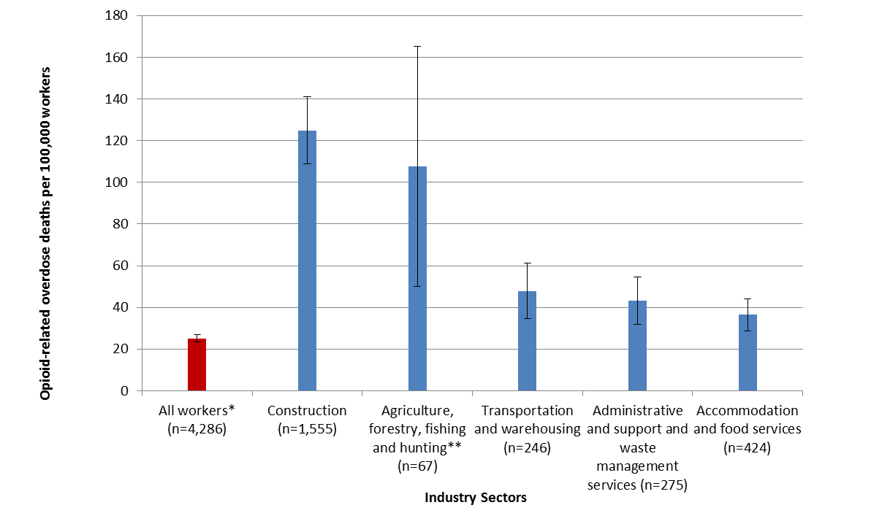
* This category excluded 16 deaths among those working in the military or military specific occupations due to lack of denominator information
** 67.2% of these deaths occurred among workers employed in fishing occupations.
Numerator source: Occupational Health Surveillance Program, 2011-2015
Denominator source: American Community Survey, 2011-2015

Findings for all industry sectors are presented in Table 1. As shown, there were opioid-related overdose deaths among workers in every industry sector.

Table 1. Rate, number, and percent of opioid-related overdose deaths by industry sector, Massachusetts workers, 2011-2015, n=4,302
Industry | Rate of opioid-related overdose deaths/100,000 workers  Mean (95% CI) | Opioid-related overdose deaths  N (%)
Construction | 124.9 (108.8-141.0)¹ | 1,155 (26.8)
Agriculture, forestry, fishing and hunting | 107.5 (49.9-165.1)¹ | 67 (1.6)
Transportation and warehousing | 48.3 (34.8-61.8)¹ | 246 (5.7)
Administrative and support and waste management services | 43.1 (31.7-54.5)¹ | 275 (6.4)
Accommodation and food services | 36.5 (28.7-44.2)¹ | 424 (9.9)
Other services, except public administration | 34.3 (24.9-43.6) | 259 (6.0)
Mining, quarrying, and oil and gas extraction | — ² | —²
Arts, entertainment, and recreation | 25.4 (13.3-37.5) | 85 (2.0)
Wholesale trade | 23.4 (12.9-34.0) | 95 (2.2)
Utilities | 22.3 (2.4-42.3) | 24 (0.6)
Retail trade | 21.8 (17.0-26.6) | 401 (9.3)
Manufacturing | 21.8 (16.6-27.0) | 342 (8.0)
Information | 20.0 (10.1-29.8) | 79 (1.8)
Management of companies and enterprises | —² | —²
Health care and social assistance | 15.0 (11.8-18.3) | 419 (9.7)
Real estate and rental and leasing | 14.5 (4.8-24.1) | 43 (1.0)
Public administration | 12.3 (6.4-18.3) | 84 (2.0)
Finance and insurance | 6.6 (3.1-10.2) | 66 (1.5)
Professional, scientific, and technical services | 6.4 (3.6-9.2) | 103 (2.4)
Educational services | 4.3 (2.2-6.3) | 85 (2.0)
Military | —³ | 16 (0.4)
Unknown | —³ | 29 (0.7)
Total | 25.1 (23.4-26.8) | 4,302 (100.0)
¹ Rate significantly higher than rate for all industry categories
² Suppressed due to cell size restriction
³ Unable to calculate rate due to lack of denominator
Numerator source: Occupational Health Surveillance Program, 2011-2015
Denominator source: American Community Survey, 2011-2015

All Deaths by Occupation

As shown in Figure 2, workers in nine occupation groups had opioid-related overdose death rates (per 100,000 workers) that were significantly higher than the average rate for all workers (25.1):
- Construction and extraction occupations (150.6)
- Farming, fishing, and forestry occupations (143.9)
- Material moving occupations (59.1)
- Installation, maintenance, and repair occupations (54.0)
- Transportation occupations (42.6)
- Production occupations (42.1)
- Food preparation and serving related occupations (39.5)
- Building and grounds cleaning and maintenance occupations (38.3)
- Healthcare support occupations (31.8)

With the exception of farming, fishing, and forestry occupations, each of these nine occupation groups with high opioid-related overdose death rates accounted for over 100 opioid-related overdose deaths.

Among workers in occupation groups with rates of opioid-related overdose death that were not significantly higher than average, several still accounted for more than 100 opioid-related overdose deaths:
- Sales and related occupations (n=342, 7.9%)
- Office and administrative support occupations (248, 5.8%)
- Management occupations (164, 3.8%)
- Personal care and service occupations (153, 3.6%)
- Healthcare practitioner and technical occupations (122, 2.8%)

Figure 2. Occupation groups with opioid-related overdose death rates significantly higher than the average rate for all workers, Massachusetts workers, 2011-2015, n=4,302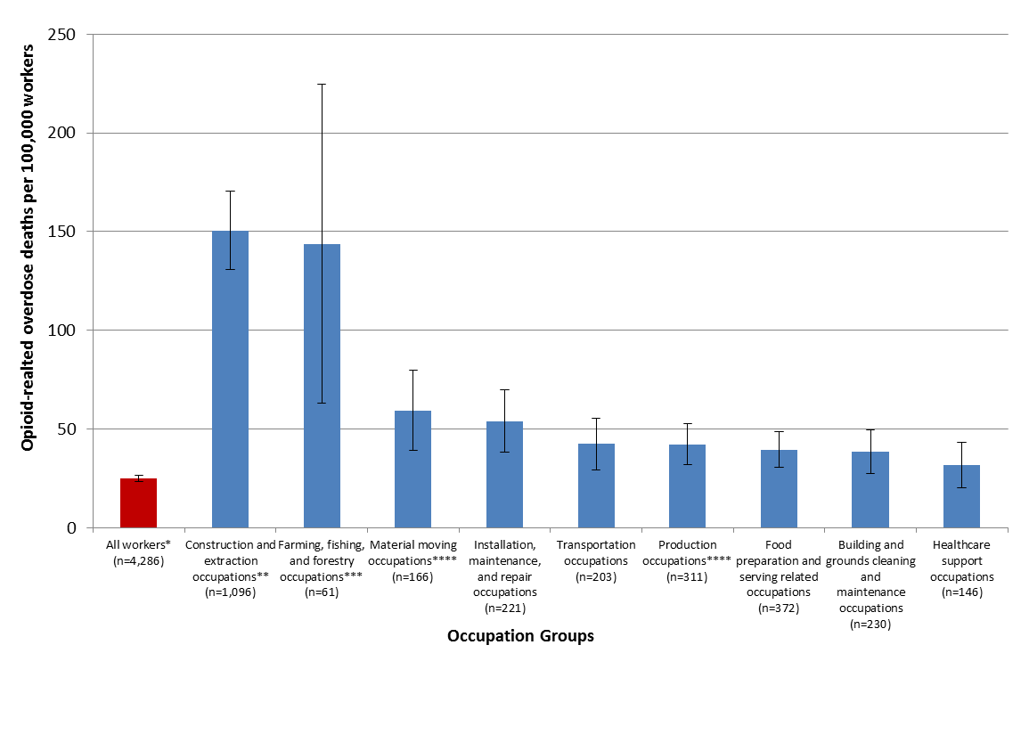
* This category excluded 16 deaths among those working in the military or military specific occupations due to lack of denominator information.
** At least 97.0% of these deaths occurred among workers employed in construction occupations.
*** 73.8% of these deaths occurred among workers employed in fishing occupations.
**** This category excludes 1 death among a worker employed in the military industry.
Numerator source: Occupational Health Surveillance Program, 2011-2015
Denominator source: American Community Survey, 2011-2015

Findings for all occupation groups are included in Table 2. As shown, there were opioid-related overdose deaths among workers in every occupation group.

Table 2. Rate, number, and percent of opioid-related overdose deaths by occupation group, overall and by gender, Massachusetts workers, 2011-2015, n=4,302
Occupation | Rate of opioid-related overdose deaths/100,000  Mean (95% CI) workers |  |  | Opioid-related overdose deaths  N (%)
 | Overall | Males | Females | Total | Males | Females
Construction and extraction | 150.6 (146.0-155.1) ¹ | 152.3 (132.1-172.6) ¹ | 73.5 (0-166.6) | 1,096 (24.8) | 1,084 (32.6) | 12 (1.2)
Farming, fishing, and forestry | 143.9 (125.4-162.3) ¹ | 205.9 (89.4-322.5) ¹ | — ² | 61 (1.4) | — ² | — ²
Material moving | 59.1 (54.5-63.7) ¹ | 71.9 (46.7-97.0) ¹ | 14.4 (0-35.5) | 167 (3.9) | 158 (4.8) | 9 (0.9)
Installation, maintenance, & repair | 54.0 (50.4-57.6) ¹ | 54.3 (38.0-70.6) | 47.8 (0-121.9) | 221 (5.1) | 213 (6.4) | 8 (0.8)
Transportation | 42.6 (39.6-45.6) ¹ | 46.1 (31.3-60.9) | 22.4 (0-47.0) | 203 (4.7) | 187 (5.6) | 16 (1.6)
Production | 42.1 (39.7-44.5) ¹ | 53.1 (39.0-67.2) | 17.0 (4.9-29.0) | 312 (7.3) | 274 (8.2) | 38 (3.9)
Food preparation and serving related | 39.5 (37.5-41.6) ¹ | 51.6 (36.6-66.6) | 28.9 (18.4-39.4) ¹ | 372 (8.6) | 227 (6.8) | 145 (14.8)
Building/grounds cleaning & maintenance | 38.3 (35.8-40.9) ¹ | 54.2 (37.7-70.7) | 10.2 (0.7-19.8) | 230 (5.3) | 207 (6.2) | 23 (2.4)
Healthcare support | 31.8 (29.2-34.5) ¹ | 43.1 (6.7-79.5) | 30.1 (18-42.1) ¹ | 146 (3.4) | 27 (0.8) | 119 (12.2)
Personal care and service | 23.7 (21.8-25.6) | 43.1 (20.0-66.2) | 17.5 (9.2-25.8) | 153 (3.6) | 67 (2.0) | 86 (8.8)
Sales and related | 20.0 (18.9-21.1) | 26.2 (18.6-33.8) | 13.5 (7.9-19.1) | 342 (7.9) | 230 (6.9) | 112 (11.5)
Arts, design, entertainment, sports, & media | 19.5 (17.2-21.8) | 31.5 (13.2-49.8) | 8.6 (0-17.7) | 74 (1.7) | 57 (1.7) | 17 (1.7)
Community and social services | 16.6 (14.3-18.8) | 28.5 (5.3-51.7) | 11.4 (1.8-21.0) | 56 (1.3) | 29 (0.9) | 27 (2.8)
Protective service | 15.4 (13.3-17.4) | 16.1 (6.0-26.2) | 12.1 (0-30.8) | 58 (1.3) | 50 (1.5) | 8 (0.8)
Architecture and engineering | 12.5 (10.6-14.3) | 12 (3.5-20.5) | 15.1 (0-37.1) | 47 (1.1) | 38 (1.1) | 9 (0.9)
Office & administrative support | 11.7 (10.9-12.4) | 15.9 (8.9-22.9) | 9.9 (6.4-13.5) | 248 (5.8) | 98 (2.9) | 150 (15.3)
Healthcare practitioner and technical | 11.1 (10.1-12.1) | 11.5 (2.1-20.8) | 11.0 (6.0-16.0) | 122 (2.8) | 29 (0.9) | 93 (9.5)
Management | 8.6 (7.9-9.3) | 12.5 (7.8-17.2) | 3.5 (0.7-6.4) | 164 (3.8) | 135 (4.1) | 29 (3.0)
Legal | 7.9 (6.1-9.8) | 8.9 (0-20.7) | 6.9 (0-17.6) | 19 (0.4) | 11 (0.3) | 8 (0.8)
Business and financial operations | 7.4 (6.6-8.3) | 11.2 (4.6-17.9) | 4.0 (0.2-7.7) | 76 (1.8) | 55 (1.7) | 21 (2.1)
Life, physical, and social science | 6.5 (5.0-7.9) | 9.8 (0-20.9) | — ² | 20 (0.5) | — ² | — ²
Computer and mathematical | 5.6 (4.6-6.5) | 6.5 (1.4-11.6) | — ² | 36 (0.8) | — ² | — ²
Education, training, and library | 4.0 (3.4-4.5) | 4.4 (0-9.2) | 3.8 (0.9-6.7) | 49 (1.1) | 16 (0.5) | 33 (3.4)
Military specific | — ³ | — ³ | — ² | 12 (0.3) | — ² | — ²
Unknown | — ³ | — ³ | — ² | 18 (0.4) | — ² | — ²
All Occupations | 25.1 (23.4-26.8) | 38.2 (35.3-41.2) | 11.6 (10.0-13.2) | 4,302 (100) | 3,324 (100) | 978 (100)
¹ Rate significantly higher than rate for all industry categories
² Suppressed due to cell size restriction
³ Unable to calculate rate due to lack of denominator
Numerator source: Occupational Health Surveillance Program, 2011-2015
Denominator source: American Community Survey, 2011-2015

Because both the number and rate of opioid-related overdose death were so high among workers in construction and extraction occupations, Table 3 provides a look at the detailed occupations of the workers with the highest number of opioid-related overdose deaths within this group. The five leading occupations within construction and extraction were:
- construction laborers (n=374, 34.2% of all construction worker deaths),
- carpenters (201, 18.4%),
- painters, construction and maintenance (92, 8.4%),
- pipe layers, plumbers, pipefitters, and steamfitters (66, 6.0%), and
- roofers (64, 5.9%)

Table 3. Number and percent of opioid-related overdose deaths by detailed occupation within the construction and extraction occupations group, Massachusetts workers, 2011-2015, n=1,096
Occupation | Opioid-related overdose deaths  N (%)
Construction laborers | 374 (34.2)
Carpenters | 201 (18.4)
Painters, construction and maintenance | 92 (8.4)
Pipe layers, plumbers, pipefitters, and steamfitters | 66 (6.0)
Roofers | 64 (5.9)
Electricians | 62 (5.7)
First-line supervisors of construction trades and extraction workers | 59 (5.3)
Brick masons, block masons, and stone masons | 39 (3.6)
Carpet, floor, and tile installers and finishers | 20 (1.8)
Operating engineers and other construction equipment operators | 19 (1.7)
Sheet metal workers | 11 (1.0)
Insulation workers | 10 (0.9)
Structural iron and steel workers | 10 (0.9)
All others | 69 (6.3)
Total | 1,096 (100)
Source: Occupational Health Surveillance Program, 2011-2015

Deaths by Gender and Occupation

Similar to findings for all opioid-related overdose deaths among Massachusetts residents, the majority—77.3% (3,324)—of opioid-related overdose deaths in this population occurred among males, compared with 22.7% (978) among females. The opioid-related overdose death rate was also significantly higher among male workers (38.3 per 100,000 workers) compared with female workers (11.6). Findings for all occupation groups are presented by gender in Table 2 and findings for the five occupation groups with the highest rates among males and females are highlighted in Table 4. As shown in Table 2, the rates of opioid-related overdose death was higher among males than females for all occupation groups except architecture and engineering occupations, but these differences were not always statistically significant. Among males, workers in three occupation groups had opioid-related overdose death rates that were significantly higher than the rate for all male workers:
- Farming, fishing, and forestry occupations (205.9)
- Construction and extraction occupations (152.3)
- Material moving occupations (71.9)

The vast majority of fatal opioid related overdoses within the following occupation groups occurred among men:
- Farming, fishing, and forestry occupations (98.4% were men)
- Construction and extraction occupations (98.9%)
- Material moving occupations (94.6%)

These were also the three occupation groups with highest rates among all workers.

Despite the higher rate and number of opioid-related overdose deaths among males, there are still a number of occupation groups where females had a high rate and/or number of deaths. Among females, workers in two occupation groups had opioid-related overdose death rates that were significantly higher than the rate for all female workers:
- Healthcare support occupations (30.1)
- Food preparation and serving related occupations (28.9)

These occupation groups also had significantly higher opioid-related overdose death rates among all workers. Within the healthcare support occupation group, 81.5% of opioid-related overdose deaths occurred among females although the rate of opioid-related overdose death was higher among men, but this difference was not statistically significant.

Table 4. Rate, number, and percent of opioid-related overdose deaths by occupation groups with five highest rates by gender, Massachusetts workers, 2011-2015, n=4,302
Males |  |  | Females
Occupation | Rate of opioid-related overdose deaths/100,000  Mean (95% CI) workers | Opioid-related overdose deaths  N (%) | Occupation | Rate of opioid-related overdose deaths/100,000  Mean (95% CI) workers | Opioid-related overdose deaths  N (%)
Farming, fishing, and forestry | 205.9 (89.4-322.5)¹ | — ² | Construction and extraction | 73.5 (0-166.6) | 12 (1.2)
Construction and extraction | 152.3 (132.1-172.6) ¹ | 1,084 (32.6) | Installation, maintenance, & repair | 47.8 (0-121.9) | 8 (0.8)
Material moving | 71.9 (46.7-97.0) ¹ | 158 (4.8) | Healthcare support | 30.1 (18-42.1) ¹ | 119 (12.2)
Installation, maintenance, & repair | 54.3 (38.0-70.6) | 213 (6.4) | Food preparation and serving related | 28.9 (18.4-39.4) ¹ | 145 (14.8)
Building/grounds cleaning & maintenance | 54.2 (37.7-70.7) | 207 (6.2) | Transportation | 22.4 (0-47.0) | 16 (1.6)
All Occupations | 38.2 (35.3-41.2) | 3,324 (100) | All Occupations | 11.6 (10.0-13.2) | 978 (100)
¹Rate significantly higher than rate for all industry categories
²Supressed due to cell size restriction
Numerator source: Occupational Health Surveillance Program, 2011-2015
Denominator source: American Community Survey, 2011-2015

Deaths by Race/Ethnicity and Occupation

Similar to findings for all opioid-related overdose deaths among Massachusetts residents, among workers the rate of opioid-related overdose death was significantly higher among white, non-Hispanics (27.1 per 100,000 workers) compared with Hispanics (19.7), and black, non-Hispanics (14.4) (Figure 3). As described above, the rates for Hispanics and black, non-Hispanics may be an underestimate because death certificates among these racial/ethnic groups were more likely to have missing industry and occupation information and therefore be excluded. It was not possible to generate detailed findings about the rates of opioid-related overdose deaths by industry and occupation within race/ethnicity categories because of low sample size of opioid-related overdose deaths among those other than white, non-Hispanics. There were, however, differences in broad occupation groups with the highest percentages of deaths across race/ethnicity categories:
- White, non-Hispanics: natural resources, construction, and maintenance occupations (n=1,255 33.1%),
- Hispanics: natural resources, construction, and maintenance occupations (76, 26.0%), followed closely by service occupations (66, 22.6%), and
- Black, non-Hispanics: service occupations (51, 32.1%).

Figure 3. Rate of opioid-related overdose deaths by race/ethnicity, Massachusetts workers, 2011-2015, n=4,302*
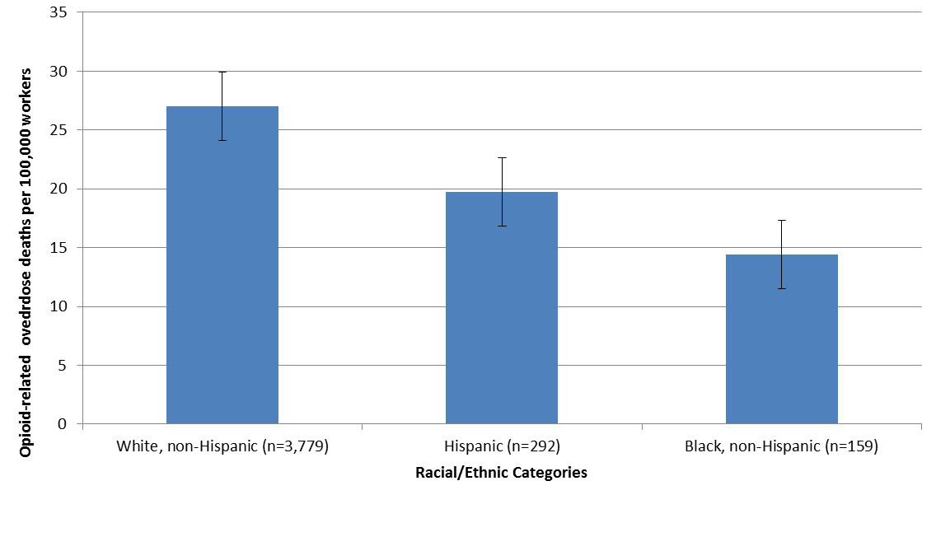
*The figure excludes 56 opioid-related deaths among those who fell into other or unknown racial/ethnic categories and 16 deaths among those working in the military or military specific occupations due to lack of denominator information.
Numerator source: Occupational Health Surveillance Program, 2011-2015
Denominator source: American Community Survey, 2011-2015

Occupational Health/Safety and Socioeconomic Factors

Pain is a common feature among injured workers and previous research indicates that opioids are frequently prescribed for pain management following work-related injuries, which has the potential to lead to opioid use disorders., In order to gain insight into whether occupational injuries and illnesses may be a gateway to opioid use disorders, industry sectors and occupation groups were classified according to their respective work-related injury and illness rates obtained from the 2015 Survey of Occupational Injuries and Illnesses published by the Bureau of Labor Statistics (BLS SOII). As is shown in Figure 4, workers in industry sectors with fewer than two injuries and illnesses per 100 full-time workers had the lowest rate of opioid-related overdose deaths (13.5 per 100,000 workers), while workers in industries with four or more occupational injuries and illnesses per 100 full-time workers had the highest opioid-related overdose death rate (43.1 per 100,000 workers).

Figure 4. Rate of opioid-related overdose deaths among Massachusetts workers by industry-specific injury and illness rate category, 2011-2015, n=4,302*
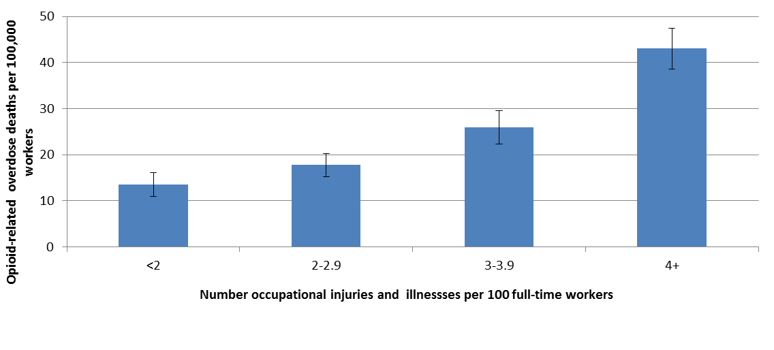
* The figure excludes 16 deaths among those working in the military or military specific occupations and 29 deaths with unknown industry, which lacked corresponding denominators.
Numerator source: Occupational Health Surveillance Program, 2011-2015
Denominator source: Bureau of Labor Statistics, MA Survey of Occupational Injuries and Illnesses, industry, 2015

An even stronger association was observed when categorizing occupation groups according to their injury and illness rates. Workers within occupation groups with fewer than 50 injuries per 10,000 full-time workers had an opioid-related overdose death rate of 11.3 per 100,000, while workers within occupations with 200 or more injuries and illnesses per 10,000 workers had an opioid-related overdose death rate of 77.2 per 100,000. (Figure 5.) This association remained significant even when construction and extraction occupations, which had the highest opioid-related overdose death rate, were removed from the highest injury and illness rate category, which suggests that the high rate of opioid-related overdose death among occupations known to have high rates of occupational injuries and illnesses is not attributable solely to the inclusion of construction workers in that category.

Figure 5. Rate of opioid-related overdose deaths among Massachusetts workers by occupation-specific injury and illness rate category, 2011-2015, n=4,302*
* The figure excludes 16 deaths among those working in the military or military specific occupations and 18 deaths with unknown occupation, which lacked corresponding denominators. An additional 389 deaths were excluded because occupational injury and illness rates were not available for some occupational groups.
Numerator source: Occupational Health Surveillance Program, 2011-2015
Denominator source: Bureau of Labor Statistics, MA Survey of Occupational Injuries and Illnesses, occupation, 2013

Errata (1/24/2020): Please note in the original version of this report (August 2018), the denominator was incorrectly listed as 2015. It has been corrected to 2013, noted above. This correction resulted in two changes to overdose death rates referenced in the text and the accompanying figure. There are no changes to the overall trends in the data or the conclusions.

In order to gain further insight into how economic factors may impact opioid-related overdose deaths, opioid-related overdose deaths were classified into income categories based on occupation-specific median income information available from the American Community Survey. The highest rates of opioid-related overdose death were observed among workers in the $10,000- $19,999, $20,000- $29,999, and $40,000- $49,999 income categories, while lower rates were observed among workers in the $30,000 -$39,999 and $50,000 or more income categories. (Figure 6.)

Figure 6. Rate of opioid-related overdose death among Massachusetts workers by level of occupation-specific median income, 2011-2015, n=4,302*
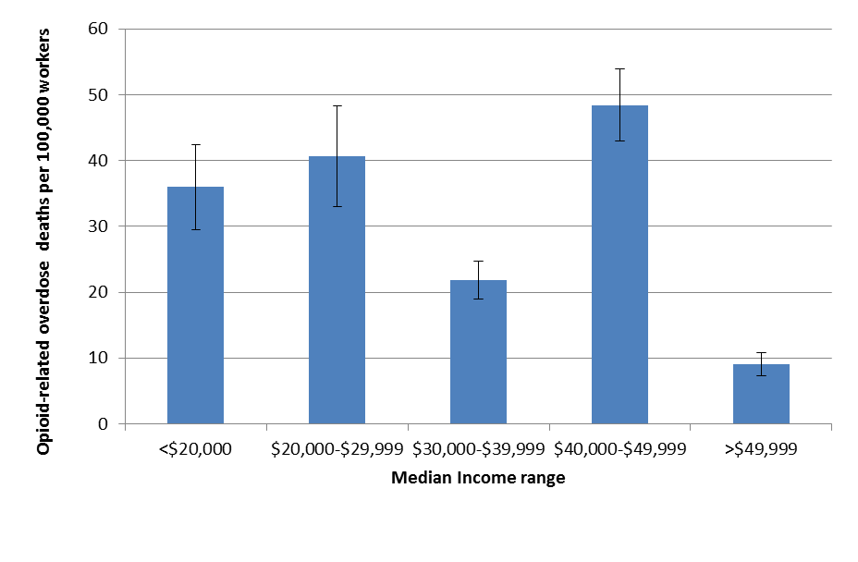
* The figure excludes 16 deaths among those working in the military or military specific occupations and 18 deaths with unknown occupations, which lacked median income information. An additional 389 deaths were excluded because injury rates were not available for some occupational categories.
Numerator source: Occupational Health Surveillance Program, 2011-2015
Denominator source: American Community Survey, 2011-2015

Opioid-related overdose death rates were also examined in relation to two other factors that vary by occupation: job insecurity and availability of paid sick leave, both of which have potential to increase the need to work while in pain and may increase reliance on pain medication. Occupation groups were categorized as having high or low job insecurity based on findings from the National Health Interview Survey. A significantly higher death rate was observed among workers in occupation groups with high job insecurity compared with workers in occupation groups with low job insecurity (Figure 7).

Figure 7. Rate of opioid-related overdose deaths among Massachusetts workers by level of job insecurity*, n=4,302**
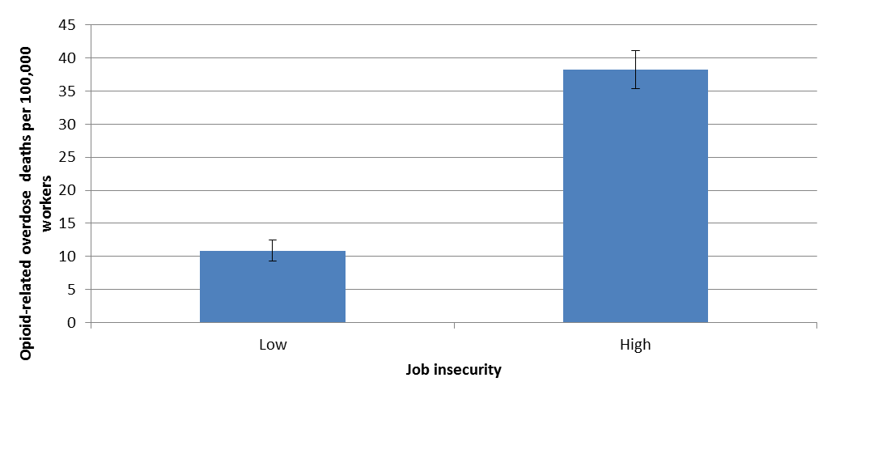
* High job insecurity was based on 30% or more of respondents to the National Health Interview Survey within specific occupation categories reporting being worried about becoming unemployed.
** 16 deaths among those working in the military or military specific occupations and 18 deaths with unknown occupations that lacked information about job insecurity.
Numerator source: Occupational Health Surveillance Program, 2011-2015
Denominator source: National Health Interview Survey, 2011-2015

Occupation groups were also categorized into having either a high or low percentage of workers with paid sick leave based on responses to the BLS Employee Benefits Survey. A significantly higher opioid-related overdose death rate was observed among workers in occupation groups with lower percentages of workers covered by paid sick leave compared with workers in occupation groups with higher percentages covered by paid sick leave. (Figure 8.)

Figure 8. Rate of opioid-related overdose deaths among Massachusetts workers by percentage of workers by level of availability of paid sick leave, n=4,302*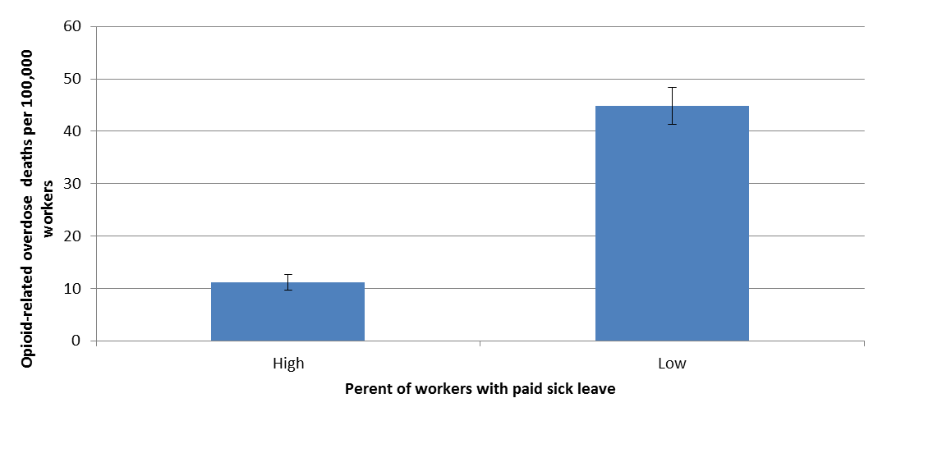
* 16 deaths among those working in the military or military specific occupations and 18 deaths with unknown occupations, which lacked information about paid sick leave.
** High prevalence of paid sick leave was based on 70% or more of respondents to the Bureau of Labor Statistics Employee Benefits Survey within specific occupation categories reporting having paid sick leave.
Numerator source: Occupational Health Surveillance Program, 2011-2015
Denominator source: Bureau of Labor Statistics, Employee Benefits Survey, March 2017

Discussion

This descriptive study based on Massachusetts death certificate data revealed significant differences in the rates of opioid-related overdose death among workers by industry and occupation. The rate of opioid-related overdose death among workers was higher for males than females and among white-non Hispanic workers than among workers in other race/ethnicity categories, similar to findings for all Massachusetts residents. The rates for Hispanics and black, non-Hispanics may be an underestimate because death certificates among these racial/ethnic groups were more likely to have missing industry and occupation information and therefore be excluded. High opioid-related overdose death rate occupations varied by gender. A detailed analysis of how rates differed by industry and occupation within various race/ethnicity categories was not possible given the small sample size. There were, however, differences in the occupation groups with the highest percentages of deaths across the race /ethnicity categories.

Further examination of opioid-related overdose death rates by factors known to vary by occupation and industry shed light on several factors that may contribute to the observed differences in rate by industry and occupation. The rates of opioid-related overdose death were significantly higher among workers employed in industries and occupations known to have high rates of work-related injuries and illnesses. Rates were also significantly higher among workers in occupations with lower availability of paid sick leave and lower job security, suggesting that the need to return to work soon after an injury may be contributing to high rates of opioid-related overdose death.

The construction industry stands out in this study as having both a high rate and number of opioid-related overdose deaths. These findings are consistent with previous reports that opioids are widely used for pain management following work-related injuries and suggest that these injuries and the need to work while in pain may contribute to the use and potential misuse of opioids. Construction is physically demanding work and the workers in this sector have among the highest rates of non-fatal and fatal occupational injuries. In Massachusetts, in 2015, according to data reported by employers to the Bureau of Labor Statistics, (BLS) 4 out of every 100 construction workers were injured on the job, with half of these injuries resulting in time lost from work, and these are conservative estimates., Construction workers are also known to have high prevalence of musculoskeletal pain, far higher than the prevalence of work-related injury. In a 2010 nationwide household survey, over one-third of constructions workers reported back pain during the previous three months. The prevalence of back pain was higher among construction workers compared to workers in other industries for all age groups. In a 2012 study, almost 40% of construction workers older than 50 years reported chronic back pain. In a recent Massachusetts study of construction workers on a large commercial construction site, 74% reported having some kind of musculoskeletal pain in the last three months and about 40% reported having one or more injuries in the last month. This study also found high rates of mental distress and lack of treatment in this study population, and the authors hypothesized that “stigmatization and fear of job loss may interfere with help-seeking behaviors.”

Workers in the fishing industry were also found to have high rates of opioid-related overdose death. Commercial fishing is one of the most hazardous occupations in the United States with a work-related injury fatality rate 25 times higher than the national average., Like construction, it is very physically demanding as well as precarious, and nonfatal injuries and musculoskeletal disorders among fishermen are common. In one study, 35% of fisherman reported symptoms causing work interference within the last 12 months, with low back pain being the most common symptom. In a recent study of lobsterman in the Northeast, the annual rate of all reported occupational injuries was 50 per 100 full time workers with close to a third of these injuries requiring medical treatment. Many workers with low back injuries did not seek treatment.

The findings of high-rate industries and occupations in this report provide important new information for targeting intervention efforts to reduce substance use disorders. Numbers, however, as well as rates should be taken into account, as many people can be affected in large industries even if the rates of opioid-related overdose death are not elevated. Opportunities to intervene in these larger, lower rate industries and occupations should not be overlooked.

The observation that opioid-related overdose death rates were higher in those industries and occupations that have high rates of work-related injuries and illnesses has important implications for interventions to reduce use and potential substance use disorders. This finding is consistent with a report from Utah, which found that 57% of those who had an opioid-related overdose death had suffered a work-related injury at some point in their life, and that 13% had experienced a work-related injury within three years of their death. It is also consistent with previous research documenting common use of prescribed opioids for management of acute and chronic pain following work-related injury. In a 2011 review of studies reporting on the use of prescribed opioids among workers receiving workers’ compensation benefits, it was found that the average percent of injured workers prescribed opioids was 31.8, but this ranged from 8.8% to 52.2% depending on the study.^{xii} The National Council on Compensation Insurers reported that 25% of workers’ compensation prescription drug claim costs in 2011 were for opioid pain medications. Opioid prescribing for work-related injuries is not only common but may be different than that for non-work-related pain, as different studies have found that workers’ compensation claims involved more opioid use than claims in non-workers’ compensation settings. ^{xii,} Many states, including Massachusetts, have taken steps to reduce opioid prescribing within the workers’ compensation systems and according to a more recent study of workers’ compensation practices in 26 states, there have been noticeable decreases in utilization of prescription opioids. In Massachusetts, there was a 24% decline in the average amount of opioid use per injured worker in the Commonwealth when the 2010 to 2012 time period was compared to the 2013 to 2015 period. In this most recent time period, Massachusetts still ranked 5th of the 26 states analyzed for average highest morphine equivalent amount per claim with opioids. While use of prescribed opioids among workers is widely recognized, the extent to which this serves as a gateway to subsequent substance use disorders is not known and more research is needed.

This study has a number of limitations. It is possible that some of the decedents had not been employed in the occupations and industries reported on their death certificates during the study period. If they were not working during the study period, this could result in an inflation of rates. If this occurred and varied by occupation or industry, it could also affect the relative rankings of industries and occupations. Additionally, if industries and occupations reported on the death certificates were not the same as those in which the decedents were working at time of death, this misclassification could reduce our ability to determine differences in rates between industry and occupation groups. While these issues could affect the point estimates presented in this report, the extent of misclassification would have to be very high to substantially change the main findings of this study, especially regarding the industries and occupations with the highest rates. As cited previously there is a high correlation between usual and current occupation. It is also unlikely that age, a known risk factor for opioid-related overdose death, accounted for much of the observed differences in opioid-related overdose deaths by industry and occupation. Findings of the analysis excluding workers over age 55 were similar to those based on all workers. Additionally, when age-standardized rates were calculated for industry categories using a different denominator source than that used in this analysis, rates were very similar to the non-age standardized rates.

Another limitation was the lack of individual level data on occupational health and socioeconomic factors. Analysis of the association between opioid-related overdose deaths and these factors was carried out using information from other data sources, which means that the most we can say is that industries that had higher prevalence of the factors examined also had a higher rate of opioid-related overdose deaths. For example, in the case of the analysis of the relationship between occupational injuries and illnesses and opioid-related overdose deaths, it is true that those who worked in industries and occupations with the highest injury and illness rates also had the highest rate of opioid-related overdose deaths, this does not necessarily mean that those who died also had occupational injuries and/or illnesses. Additionally, opioids can interfere with performance, and it is possible that opioid use among the people in the study may have preceded injury and therefore may have contributed to high injury rates., While conclusions about causality cannot be drawn from these associations, the findings are suggestive of factors that may be contributing to differences in the rate of opioid-related overdose deaths by industry and occupation.

Understanding the many complex factors contributing to the opioid epidemic is very challenging and additional research is necessary to understand the manner and extent to which work-related injuries, job insecurity, access to paid-sick leave, and other occupational and socioeconomic factors contribute to opioid use disorders in the working population. However, interventions can and should be implemented before all research questions are answered. Educational and policy interventions targeting high rate worker groups identified in this study are needed. These should address workplace hazards that cause injuries for which opioids are prescribed, as well as appropriate pain management following injury, including safer opioid prescribing, access to evidence-based treatment for opioid use disorders, and overdose prevention education. Employers, unions, employee assistance programs, and community organizations as well healthcare providers, insurers and government agencies need to be engaged in these efforts.

Some efforts are already underway. In 2017, the Massachusetts Department of Industrial Accidents launched a two year pilot program called the Opioid Alternative Treatment Pathway (OATP) as a tool to address the state’s opioid epidemic by giving attorneys, judges, and injured workers within the workers’ compensation system quicker access to medical professionals to make treatment decisions. The Department of Public Health with support from the federal Centers for Disease control and Prevention is planning further research to assess the extent to which work-related injuries serve as initiation for opioid pain medication leading to subsequent opioid misuse. Several community organizations funded by the DPH are engaged in opioid overdose surveillance and prevention activities focused on high risk worker groups. DPH is also conducting outreach to involve additional stakeholders in identifying and developing intervention strategies to prevent opioid misuse among high risk working populations.

Death files were prepared on the following dates: 2011 and 2012: January 13, 2017, 2013: May 4, 2017, 2014: June 1, 2017, 2015: June 1 2017 with an update on August 22, 2017
67.2% of these deaths occurred among workers employed in fishing occupations.
This industry sector includes landscaping services; services to buildings and dwellings (except cleaning during construction and immediately after construction); business support services; investigation and security services; waste management and remediation services; employment services, which include temporary staffing agencies; and travel arrangements and reservation services.
This industry sector includes automotive repair and maintenance; beauty salons, nail salons and other personal care services; barber shops; other personal services; civic, social, advocacy organizations, and grant making and giving services; car washes; religious organizations; personal and household goods repair and maintenance; funeral homes, and cemeteries and crematories; commercial and industrial machinery and equipment repair and maintenance; business, professional, political, and similar organizations; dry cleaning and laundry services; electronic and precision equipment repair and maintenance; labor unions; and private households employing individuals.
At least 97.0% of these deaths occurred among workers employed in construction occupations.
73.8% of these deaths occurred among workers employed in fishing occupations.
Nationwide in 2015 injuries accounted for 95.2% of all injuries and illnesses monitored by the BLS SOII. Bureau of Labor Statistics Survey of Occupational Injuries and Illnesses, Employer-reported Workplace Injuries and Illnesses – 2015. https://www.bls.gov/news.release/pdf/osh.pdf
Massachusetts Department of Public Health. (2017). An Assessment of Fatal and Nonfatal Opioid Overdoses in Massachusetts (2011 – 2015). https://www.mass.gov/files/documents/2017/08/31/legislative-report-chapter-55-aug-2017.pdf
World Health Organization. (1992). The ICD-10 classification of mental and behavioral disorders: Clinical descriptions and diagnostic guidelines. Geneva: World Health Organization.
The 2002 and 2012 North American Industry Classification System (NAICS) manuals area available from http://www.census.gov/eos/www/naics/.
The 2010 Standard Occupational Classification (SOC) manuals are available from http://www.bls.gov/soc/.
National Institute for Occupational Safety and Health, NIOSH Industry and Occupation Computerized Coding System. https://wwwn.cdc.gov/niosh-nioccs/
U.S. Census Bureau, American Fact Finder, American Community Survey, 2011-2015.
Luckhaupt, S. E., Cohen, M. A., & Calvert, G. M. (2013). Concordance between current job and usual job in occupational and industry groupings: assessment of the 2010 national health interview survey. Journal of Occupational and Environmental Medicine/American College of Occupational and Environmental Medicine, 55(9), 1074-1090.
Schade, W. J., & Swanson, G. M. (1988). Comparison of death certificate industry and occupation data with lifetime occupational histories obtained by interview: variations in the accuracy of death certificate entries. American Journal of Industrial Medicine, 14(2), 121-136.
Massachusetts Department of Public Health. (2017). Opioid-Related Overdose Deaths, All Intents, MA Residents – Demographic Data Highlights. https://www.mass.gov/files/documents/2017/08/31/opioid-demographic-aug-2017.pdf
Massachusetts Department of Public Health. (2017). Opioid-Related Overdose Deaths, All Intents, MA Residents – Demographic Data Highlights. https://www.mass.gov/files/documents/2017/08/31/opioid-demographic-aug-2017.pdf
Franklin, G. M., Stover, B. D., Turner, J. A., Fulton-Kehoe, D., & Wickizer, T. M. (2008). Early opioid prescription and subsequent disability among workers with back injuries: the Disability Risk Identification Study Cohort. Spine, 33(2), 199-204.
Dembe, A., Wickizer, T., Sieck, C., Partridge, J., & Balchick, R. (2012). Opioid use and dosing in the workers' compensation setting. A comparative review and new data from Ohio. American Journal of Industrial Medicine, 55(4), 313-324.
Bureau of Labor Statistics Survey of Occupational Injuries and Illnesses, 2015 Massachusetts.
U.S. Census Bureau, American Fact Finder, American Community Survey, 2011-2015.
Alterman, T., Luckhaupt, S. E., Dahlhamer, J. M., Ward, B. W., & Calvert, G. M. (2013). Job insecurity, work‐family imbalance, and hostile work environment: Prevalence data from the 2010 National Health Interview Survey. American Journal of Industrial Medicine, 56(6), 660-669.
Bureau of Labor Statistics Employee Benefits in the United States – March 2017. https://www.bls.gov/news.release/archives/ebs2_07212017.pdf
Bureau of Labor Statistics, Survey of Occupational Injuries and Illnesses, 2015 Massachusetts.
Spieler, E. A., & Wagner, G. R. (2014). Counting matters: Implications of undercounting in the BLS survey of occupational injuries and illnesses. American Journal of Industrial Medicine, 57(10), 1077-1084.
CPWR – The Center for Construction Research and Training, Chart Book: Fatal and Nonfatal Injuries, Back Injuries in Construction and Other Industries, produced with support from the National Institute for Occupational Safety and Health grant number OH009762. https://www.cpwr.com/sites/default/files/publications/CB%20page%2048.pdf
Dong, X. S., Wang, X., Fujimoto, A., & Dobbin, R. (2012). Chronic back pain among older construction workers in the United States: a longitudinal study. International Journal of Occupational and Environmental Health, 18(2), 99-109.
Jacobsen, H. B., Caban-Martinez, A., Onyebeke, L. C., Sorensen, G., Dennerlein, J. T., & Reme, S. E. (2013). Construction workers struggle with a high prevalence of mental distress and this is associated with their pain and injuries. Journal of occupational and environmental medicine/American College of Occupational and Environmental Medicine, 55(10), 1197.
U.S. Bureau of Labor Statistics (2016) Census of Fatal Occupational Injuries Charts, 1992-2014, http://www/bls.gov/iff/oshwc/cfoi/cfch0013.pdf
Walter, A. W., Morocho, C., King, L., Bartlett, J., Kelsey, D., DeSousa, M., ... & Punnett, L. (2018). Preventing opioid use disorders among fishing industry workers. International Journal of Environmental Research and Public Health, 15(4), 648.
Lipscomb, H. J., Loomis, D., McDonald, M. A., Kucera, K., Marshall, S., & Li, L. (2004). Musculoskeletal symptoms among commercial fishers in North Carolina. Applied Ergonomics, 35(5), 417-426.
Fulmer, S., Buchholz, B., Jenkins, P., & Scribani, M. (2016). Work-time exposure and acute injuries in inshore lobstermen of the Northeast United States. Journal of Agromedicine, 21(2), 190-199.
Cheng, M., Sauer, B., Johnson, E., Porucznik, C., & Hegmann, K. (2013). Comparison of opioid‐related deaths by work‐related injury. American journal of industrial medicine, 56(3), 308-316.
Lipton, B., Chris, L., & Li, L. (2013, August). Workers Compensation Prescription Drug Study 2013 Update. Retrieved from National Council on Compensation Insurance Inc.: https://www.ncci.com/Articles/Documents/II_Prescription_Drugs-2013.pdf http://www.ncci.com/ documents/2012_ncci_research_rxdrug_study.pdf
Kraut, A., Raymond, C. B., Ekuma, O., & Shafer, L. A. (2016). A comparison of opioid use between WCB recipients and other Manitobans for knee, shoulder, back and carpal tunnel release procedures. American Journal of Industrial Medicine, 59(4), 257-263.
Massachusetts Department of Industrial Accidents (2016). Treatment guidelines/protocols for injured workers, Opioid/controlled substance protocol. https://www.mass.gov/files/documents/2017/09/27/opioid-controlled-substance-protocol.pdf
Thumula V., Wang D., Liu T-C. Interstate Variations in Use of Opioids, 4th Edition. Workers Compensation Research Institute June 2017. https://www.wcrinet.org/images/uploads/files/wcri2837.pdf.
Kowalski-McGraw, M., Green-McKenzie, J., Pandalai, S. P., & Schulte, P. A. (2017). Characterizing the interrelationships of prescription opioid and benzodiazepine drugs with worker health and workplace hazards. Journal of Occupational and Environmental Medicine, 59(11), 1114-1126.
Hegmann, K. T., Weiss, M. S., Bowden, K., Branco, F., DuBrueler, K., Els, C., ... & Nadig, R. J. (2014). ACOEM practice guidelines: opioids and safety-sensitive work. Journal of Occupational and Environmental Medicine, 56(7), e46-e53.

