Opioid Recovery & Remediation Fund Advisory Council

State Seal
Commonwealth of MA state seal

Executive Office of Health & Human Services

Wednesday, June 4, 2025

The ORRF Team

SmartArt: Bending Picture Caption List with Eight Pictures

Picture 1

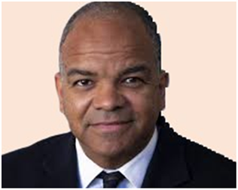

Text: Kiame Mahaniah (EHS)

Undersecretary for Health

Picture 2

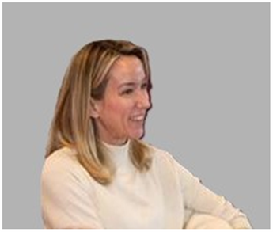

Text: Deirdre Calvert (BSAS)

BSAS Director

Picture 3

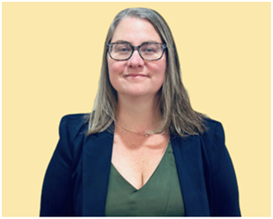

Nicole Schmitt (BSAS)

Director of Strategy & Innovation

Picture 4

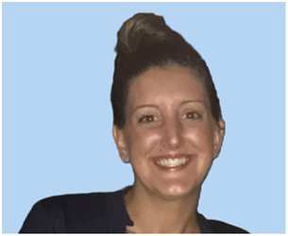

Julia Newhall (BSAS)

Director of Opioid Abatement Strategy & Implementation

Picture 5

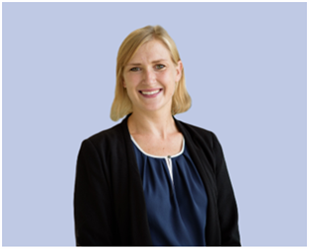

Casey Leon (BSAS)

Epidemiologist

Picture 6

Millie Bhatia (EHS)

Health Policy Manager

Millie Bhatia (EHS)

Health Policy Manager

Picture 7

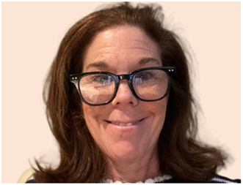

Susan Weiss (BSAS)

Executive Assistant

Picture 8

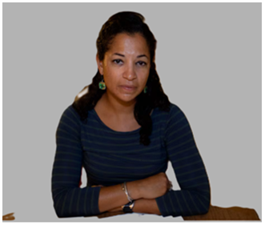

Casey Chamberlain (EHS)

Executive Assistant

Today’s Agenda

SmartArt: Two-level Icon Circle List with Six Icons

Icon 1. Meeting

Text: Welcome New Members

Meeting 


Icon 2. Stopwatch

Text: Approval of 03/12/25 Meeting Minutes



Icon 3. Megaphone

Text: Important Announcements



Icon 4. Eye

Text: ORRF Mission, Vision, & Principles



Icon 5: Checkmark Sign

Text: Updates on Strategic Priorities



Icon 6: Bar Graph

Text: Spotlight: Mobile Addiction Services



Welcome New Members

Text Box:

Thank you, Maureen Cavanaugh and John Rosenthal for your service!

Senator Patrick O’Connor

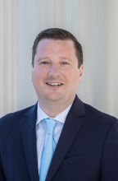

Text Box:

Patrick M. O’Connor has served as the State Senator for the 1st Plymouth and Norfolk district since 2016. Patrick was elected to the Weymouth Town Council in 2005 and became the Town Council President in 2014. From 2008-15, he served as legislative director to State Senator Bob Hedlund and ran for State Senate following Hedlund’s election as mayor of Weymouth. He won the Special Election in May 2016, and again in the General Election in November 2016, and has held the seat ever since. Whenever Patrick returned home from college to visit his family, he would notice alarming numbers of former classmates falling victim to the opioid epidemic. Patrick has dedicated his career to public service to support and prioritize fighting the opioid epidemic, protect the vulnerable, ensure public safety, preserve the environment, strengthen the economy, invest in education, and secure record local aid.

Marci Bailey

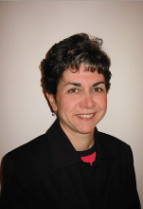

Text Box:

Marci Bailey has been a member of the North Reading Youth Substance Use Prevention Coalition since 2017 and was Coalition Chair from 2017-2020. Through , Marci works closely with North Reading’s Drug-Free Community Grant Coordinator and the town’s Mental Health Clinician as well as other town officials on various Coalition initiatives focused on primary prevention. She is also a volunteer at the *Open-Door Food Pantry* in Gloucester and the Magnolia Community Library. Previously, Marci served on the North Reading Select Board and North Reading Library Board of Trustees, among other organizations. Marci’s professional background is in financial editing and journalism. She resides in Rockport.

Vote on 03/12/25 Meeting Minutes

Important Announcements

SmartArt: Alternating Picture Blocks

Icon 1. Microphone

Text: [Regional Listening Sessions](https://forms.office.com/pages/responsepage.aspx?id=Fh2GPrdIDkqYBowE2Bt7KuMQBnTHvsVHs1VnJYVRtVZUQ0JGTzRRQlpKNk5JNFk1Qlk1MFBNTlhQVy4u&route=shorturl)



Icon 2. Information

Text: [BSAS Municipal Guidance Document](https://caremass.org/wp-content/uploads/2025/03/Muni_Opioid_Abatement-_Supplemental_Guidance.pdf)



Icon 3. Info Sharing

Text: [Municipal Opioid Abatement Conference](https://caremass.org/mmoac2025/)



Regional Listening Session

Text Box:

Southeast Regional Listening Session, Thursday, June 12th, 2025, 5:00 PM – 7:30 PM, Plymouth Public Library

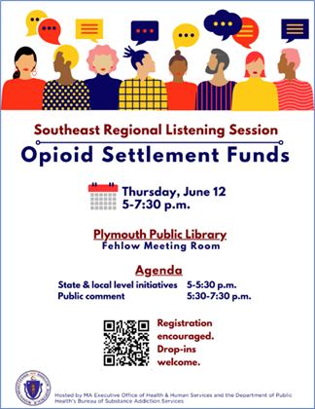

Municipal Guidance Document

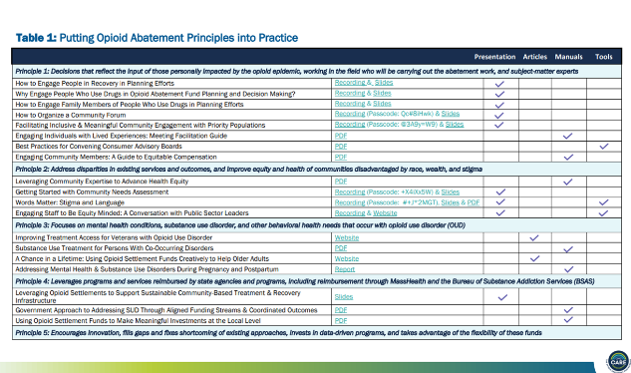

Link: [Muni_Opioid_Abatement-_Supplemental_Guidance.pdf](https://caremass.org/wp-content/uploads/2025/03/Muni_Opioid_Abatement-_Supplemental_Guidance.pdf)

Municipal Abatement Conference

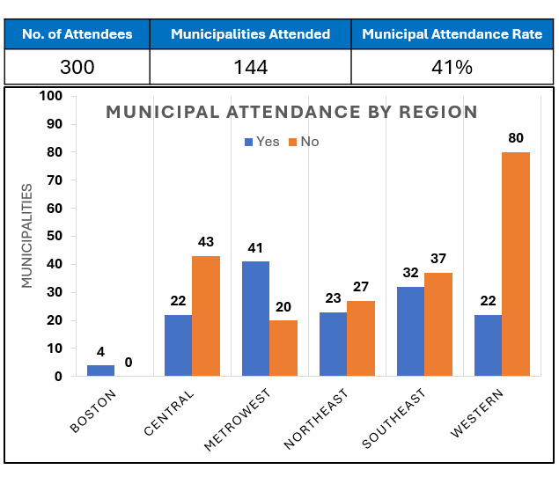

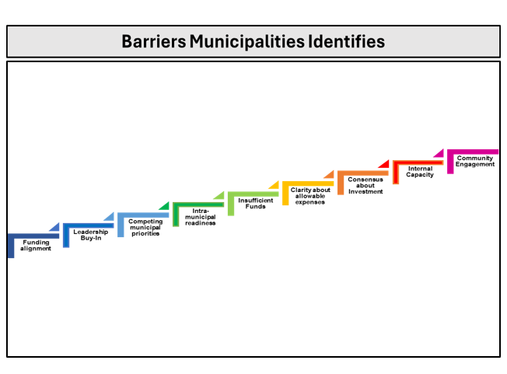

ORRF Mission & Vision

SmartArt: Converging Arrows

***Mission*:*** Mitigate the effects of the opioid epidemic on individuals and families, particularly in historically underserved communities that have experienced disproportionately high rates of opioid related overdose deaths

***Vision*:*** Fund activities across the full continuum of prevention, harm reduction, treatment, services to support individual’s recovery from opioid addiction and in support of their loved ones

Link for ORRF Strategic Framework: <https://www.mass.gov/doc/orrf-advisory-council-meeting-presentation-12622/download>

Strategic Priorities

SmartArt: One-level Trapezoid List

Level 01

01: Equity

02: Service Expansion/Enhancement

03: Workforce Development

04: Supporting Families

05: Social Determinants of Health

06: Data Collection & Analysis

Initiatives Updates

SmartArt: Two-Level Stacked List

Level 01: Data & Analysis

* BSAS Dashboard

Level 02: Social Determinants of Health

* Mosaic Grant-Making Program

BSAS Dashboard

Text Box

Key Changes

Data Update: ​

Metrics from 9 sources updated with most recent data ​

Redesigns: ​

Centering Equity in Language and Data ​

Improving ER Data Consistency and Visibility ​

New Views in Services Dashboard

Accessibility to BSAS-Licensed Providers ​

Individuals Who Received Buprenorphine Prescriptions

Linking Data to Action for MOUD Coverage

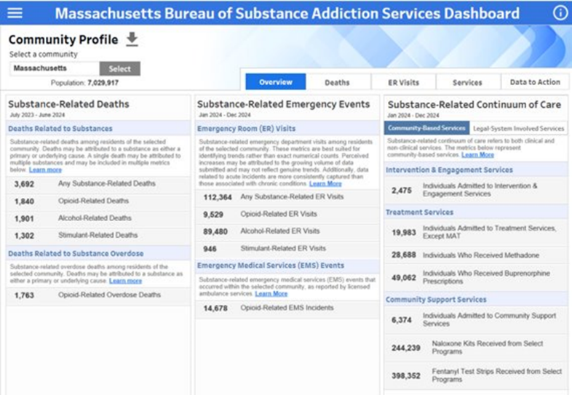

Mosaic Grant-Making Program

SmartArt: Two-Level Picture Strip

Level 01:



Icon – One



Icon – Two



Icon - Three

Level 02

Community-based Opioid Response Efforts (CORE)

Municipal Matching Grant

Family Resilience Grant Program

Text Box

Round 3

The Family Resilience Grant Program will award $7.5 million over three years to community-based organizations that are building comprehensive support systems for families across Massachusetts

|  |  |
| --- | --- |
| **Key Dates** | |
| Application Released | April 22 |
| Informational Webinar | April 28 |
| Office Hours | May 19 |
| **Application Due** | **June 17** |
| **Awards Announced** | **Early Nov.** |
|  | |

Mobile Addiction Services





Text Box

The Community Care in Reach® Model  
June 4, 2025

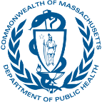

Outline

SmartArt: One-Level Line List

Mobile Model & Annual Investment

History of a Public/Private Partnership

Locations

High Level Statistics

The Patient Experience



Program Overview

Text Box

Mobile Addiction Services (MAS) provides low barrier, low threshold clinical care and harm reduction services utilizing a mobile model (mobile health vehicle) to individuals who are at high risk for overdose and other medical complications associated with substance use.

DPH-funded MAS programs serve communities in Massachusetts that have high numbers or rates of fatal overdose. All funded programs are serving Advancing Health Equity in Massachusetts (AHEM) communities.

MAS is a unique public-private partnership with the Kraft Center for Community Health.

DPH/BSAS & ORRF funds the services and staff time (ORRF investment) manages the program and contracts for the vendors.

The Kraft Center for Community Health purchases the vehicles outfitted for clinical services provides technical assistance to the vendors and holds a subcontract with Brandeis University for program evaluation

Allowable Expenses & Restrictions

Text Box

Funding can be used for:

Personnel

Vehicle maintenance and upkeep, insurance, & gas

Medical equipment and supplies

Harm reduction supplies

Some food, drinks, and personal supplies for patients

Patient transportation

Text Box

MAS annual encumbrance: $3,401,204.61

Six programs contracted through FY2027

Text Box

Funding cannot be used for:​

The purchase or lease of vehicles​

The purchase of lease of buildings

Community Care in Reach® Mobile Addiction Services Model



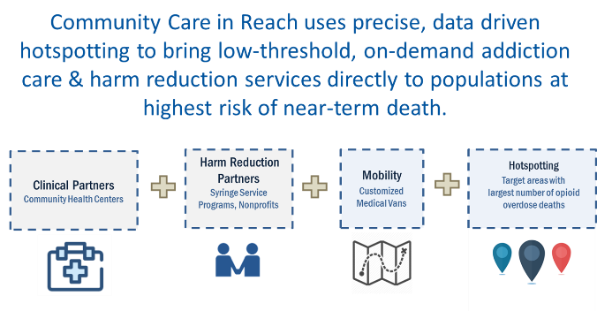

History of a Public/Private Partnership

Text Box

Mobile addiction program combines clinical care and harm reduction on a mobile medical unit

Launched in Boston in January 2018

MA Department of Public Health committed nearly $20 million over 9 years to expand services to 6 sites

MDPH providing annual operating costs, Kraft Center providing 5 of 6 vehicles for use

Kraft Center funded by the State to provide technical assistance and evaluation to 6 state-funded sites since 2020

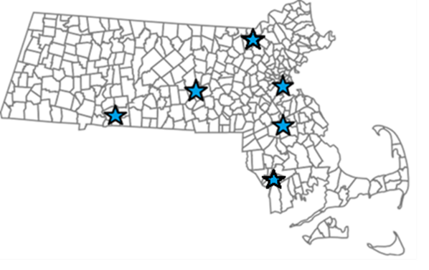

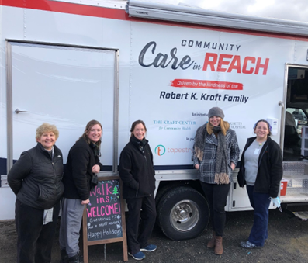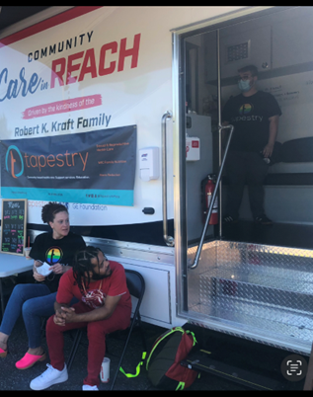



Site Locations

|  |  |  |
| --- | --- | --- |
| **Launch Year** | **Clinical Partner** | **Location** |
| **2018** (DPH funded since 2020) | Boston Healthcare for the Homeless Program | Boston |
| **2021** (DPH funded since 2023) | Brockton Neighborhood Health Center | Brockton |
| **2022** | Tapestry | Springfield/Holyoke |
| **2022** | UMass Memorial Medical Center | Worcester |
| **2022** | SSTAR | Fall River/New Bedford |
| **2025** | Lowell Community Health Center | Lowell |



Elements of Mobile Model

|  |  |
| --- | --- |
| **Elements of Mobile Model** | |
| ❶  **Acute & Preventive Care** | * Immunizations (prioritize Hepatitis A and B, Influenza, Tetanus) * TB screening * Age/gender appropriate cancer screening * Screening for Sexually Transmitted Illness * Wound care for skin abscesses, including incision/drainage |
| ❷  **Chronic Disease Management** | * HIV treatment * Substance Use Disorder treatment * Hypertension management * Diabetes management |
| ❸  **Referrals** | * Behavioral Health * HCV treatment * Specialty medical care at MGH and BMC * Other community-based referral locations based on patient preference |
| ❹  **On Demand Addiction Treatment** | * + Inpatient detox (transportation arranged) * Medications for opioid use disorder (MOUD): * Buprenorphine: Prescribed directly on van, with ongoing monitoring for diversion and compliance, in conformance with state Prescription Monitoring Program * Naltrexone oral or intramuscular, prescribed and administered directly on the van * Methadone, referral to Opioid Treatment Programs |
| ❺  **Harm Reduction** | * + Naloxone kit distribution and overdose prevention education   + HIV, HCV testing   + Syringe exchange   + Risk reduction counseling   + Fentanyl testing |

A Day on the Mobile Unit

Text Box

Each team staffs 4-6 sessions/week

Van parked in same spot each week; team disperse by foot to engage potential patients

Offer new syringes, collect used syringes, and distribute naloxone

Interested patients brought back to the van to meet clinicians

Can receive primary care or addiction treatment (e.g. buprenorphine)

Outreach workers walk patients to nearby pharmacy to fill prescriptions immediately

Facilitate referrals as needed

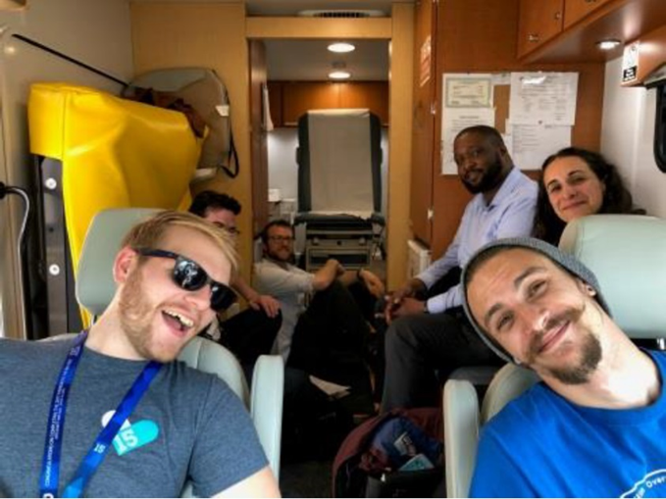



Statistics & Technical Assistance

Text Box

January 2022 to March 2025

46,424 encounters with people who use drugs

27,598 harm reduction encounters for an average of about 420 unique persons per month

21,161 clinical encounters for 5,470 unique individuals’ total

1,084 unique individuals started on buprenorphine for opioid use disorder (OUD)

Mobile sites meet monthly to share, updates, best practices, challenges, and hear speakers

Generating toolkit and compendium of resources

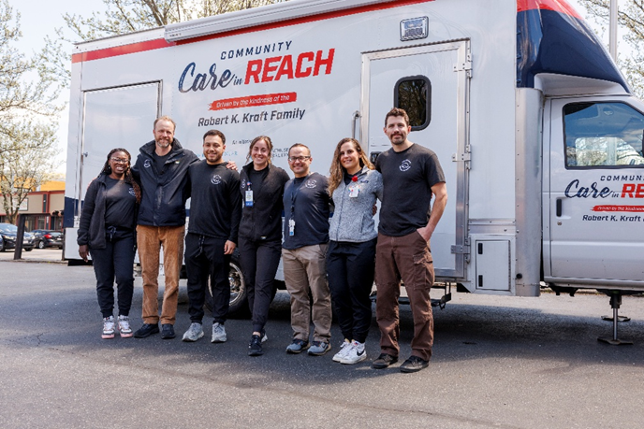



Patient Experience

Text Box

CCiR is an effective tool for linking patients to and from our other BSAS/DPH-funded services

Helps promote low-threshold access

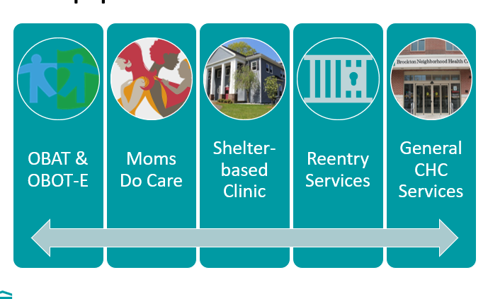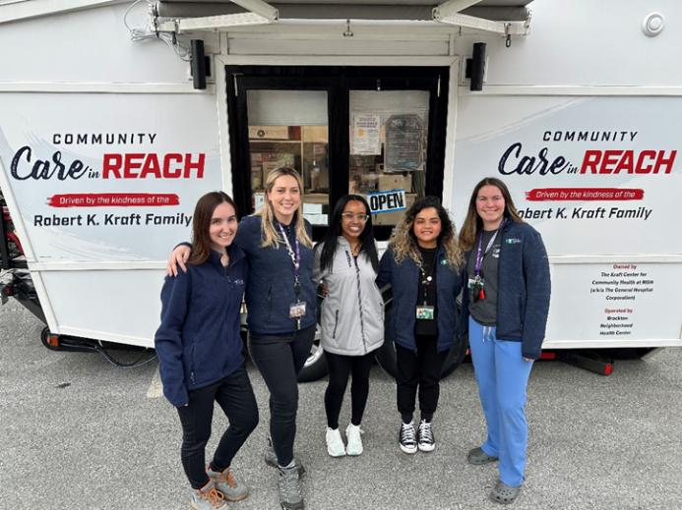

Text Box

An example: in 2024, 23% of our Moms Do Care patients also received services on the mobile unit

The Patient Experience

Text Box

Case Report

50-year-old Puerto Rican Male

Pt of CCiR since opening in 2021

Dx: Poly SUD, PTSD, Schizophrenia, HCV

IV opioid use, ETOH, cocaine, unsheltered homelessness, periodic carceral involvement

Deep mistrust of providers & others

Frequently seen for safer use supplies, hygiene items, wound care, and trauma-related urgent care

Connected well with Friday CCiR team … took 2 years, but finally able to conduct full PE/physical in Nov. 2024 for pt. to complete disability paperwork

Questions and Answers





Icon – Envelope

Text Box

OpioidRecoveryandRemediationFund@mass.gov

2025 Meeting Schedule

|  |  |  |  |
| --- | --- | --- | --- |
| **Quarter** | **Date** | **Format** | **Initiative Spotlight** |
| ~~Q1~~ | ~~Wed. 03/12/25~~ | ~~Virtual (Zoom)~~ | ~~Black and Latino Men's Re-Entry~~ |
| ~~Q2~~ | ~~Wed. 06/04/25~~ | ~~Virtual (Zoom)~~ | ~~Mobile Addiction Services~~ |
| **Q3** | **Wed. 09/10/25** | **Hybrid (Southeast Region)** | **Municipal Training & Tech. Assistance** |
| Q4 | Wed. 12/10/25 | Virtual (Zoom) | Statewide Dashboard |