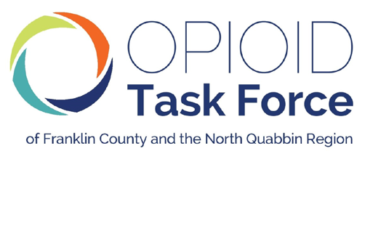

Lori M. Streeter | John F. Merrigan | David E. Sullivan
Franklin County Sheriff | Franklin County Register of Probate | Northwestern District Attorney
Co-Chair | Co-Chair | Co-Chair
May 21, 2026

William Anderson
Office of the General Counsel
Massachusetts Department of Public Health
250 Washington Street
Boston, MA 02108

RE: DPH Regulation 105 CMR 272.000 Standards Regulating the Care of Infants Identified as Being Affected by Prenatal Substance Exposure

Dear Mr. Anderson,

The Opioid Task Force of Franklin County and the North Quabbin Region (Opioid Task Force) would like to comment on proposed DPH Regulation 105 CMR 272.000 Standards Regulating the Care of Infants Identified as Being Affected by Prenatal Substance Exposure, in its role to help reduce opioid and heroin addiction, prevent overdose deaths, and improve the quality of life in our community across 30 communities in our rural region.

The long-awaited and hard-won legislative change that occurred last March, finally divorcing prenatal substance exposure from automatic child welfare reporting, was an impactful change in the care of people with perinatal substance use and their children.

In anticipation of this change and in the year since, a group, first facilitated by the EDC (Education Development Collaborative) and then turned over to DPH has been working on what has been referred to as IPSE (infants prenatally substance exposed) and has resulted, as expected, in the promulgation of new DPH regulations and the establishment of standards across the practice of Family Care Planning (formerly Plan of Safe Care). All of this is to 1) remain compliant with CAPTA (Child Abuse Prevention and Treatment Act) and 2) establish best practices.

We understood that this work would produce a dual reporting system, like most of our state neighbors, where a DCF report could be filed where there is serious concern of risk due to abuse or neglect, and de-identified information for public health purposes would also be entered into a database in order to track infants born substance-exposed. In both cases, it would be incumbent upon the dyad's multidisciplinary providers to offer, complete, and follow up on Family Care Planning to ensure access to any desired/necessary services.

However, through our collaborative work with the Moms Do Care/EMPOWER Program, we have recently learned that the proposed regulation will include:

1) Identifying the families,
2) Including cannabis in the reporting, and
3) Making the attending clinician at the time of birth responsible for the FCP and reporting process.

This is very concerning.

First, identifying families will undo much of the success that has been achieved (following the hard work of DPH) in creating a new safe environment for families who are surveilled, traumatized, and punished because of their experience with substance use disorder, causing families to withhold socially and clinically relevant information from their medical and other providers.

It is important to note that current practices in our rural region include universal comprehensive verbal health screening in the prenatal period and upon admission to labor and delivery. Pregnant people using cannabis or other drugs, experiencing intimate partner violence, food insecurity, lack of essential basic needs, or concerned about perinatal mood are in discussions with their providers, building trust, care, and treatment plans, working on family care plans, creating safety, and reducing risk together. To be advised that they will now be subject to statewide record-keeping will set back the achievements our community providers have made in the last year, reintroducing the trauma of automatic filing that they addressed.

Second, no insight has been offered into the goal of including cannabis in this part of the regulation. It will significantly increase the volume of families impacted by the regulation. Many people utilizing cannabis do so with a prescription, and so this would be the only non-MOUD prescription medication included in the regulation, where others have a much more well-defined clinical significance to infant outcomes. As a result, the inclusion of cannabis appears to serve the function of surveilling and alienating along lines of class and race. There is no internal coherence in the regulation between infants exposed to substances, infants impacted by substance exposure, and/or families impacted by substance use disorder.

Third, it is unclear why DPH is proposing a system with identification rather than a de-identified database. There is some mention that it is designed to hold providers accountable for offering family care plans. While we understand that goal, we are concerned that vulnerable families will be negatively impacted when the technology exists to maintain a system for de-identified tracking. We have excellent systems for de-identified data management at our disposal.

Lastly, there is no mechanism for billing/time for providers to complete Family Care Plans (FCP). The most successful use of FCP occurs in hospitals such as Baystate Franklin Medical Center through Moms Do Care/EMPOWER and similar grant-funded programs. Any regulation that requires changes in patient care must be accompanied by measures that support sensible implementation.

We hope you will take these considerations under advisement as you contemplate a change to this regulation to keep family wellness at the center of this work.

Thank you for your attention to the above and for all DPH does to support our communities.

Sincerely,

John F. Merrigan
Franklin County Register of Probate

Lori M. Streeter Franklin County Sheriff

David E. Sullivan
Northwestern District Attorney

Co-Chairs, Opioid Task Force of Franklin County and the North Quabbin Region

Administered by the Franklin County Sheriff’s Office

43 Hope Street, Room 1705, Greenfield, MA 01301 • 413.775.7474 • info@opioidtaskforce.org • www.opioidtaskforce.org

