Bureau of Substance Addiction Services (BSAS)
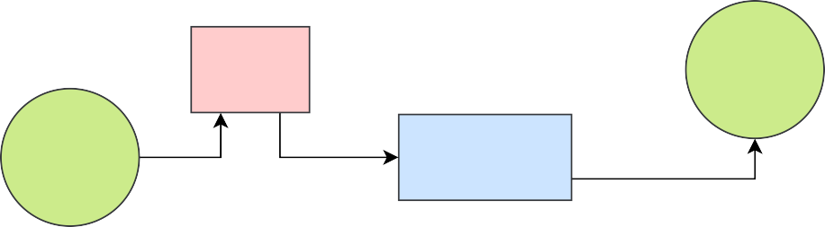
Community Opioid Treatment Programs (OTP) & Federally Certified OTP Withdrawal Management Service (WMS) New Applicant Licensing Workflow
DEA registration(s) issued if inspection satisfactory and once MCSR, BSAS license, and CSAT approval is received.
BSAS Inspection
MCSR, DEA, & SAMHSA/CSAT
received by BSAS
Licensing inspector reviews
application, provides technical assistance,
& schedules inspection
If application requirements fulfilled & inspection satisfactory, license is conditionally approved

Applicant submits BSAS OTP or ATS
Applicant should start all applications simultaneously.
Timelines for each agency will differ.
BSAS
license application
BSAS issues final approval, program may begin operating

Applicant submits DEA application
DEA

Applicant submits DCP MCSR
DCP
application

DCP & DEA
coordinate joint inspection

DCP issues MCSR registration(s) if inspection satisfactory

Applicant sends copies of
DEA & MCSR
If application requirements fulfilled and inspection satisfactory, license is conditionally approved
registrations to BSAS Licensing Inspector

Applicant Submits SAMHSA/CSAT
SAMHSA/CSAT
OTP certification application

SAMHSA/CSAT OTP
Provisional Certification issued if BSAS &
DEA approve
Applicant sends copy of SAMHSA/CSAT
Certification to BSAS Licensing Inspector

Helpful Information & Links

Bureau of Substance Addiction Services (BSAS) Opioid Treatment Program & Acute Treatment Services
- Opioid Treatment Programs (OTP) are subject to all BSAS licensure requirements in 105 CMR 164 and all applicable federal laws
- For BSAS licensure regulations visit:
https://www.mass.gov/doc/105-cmr-164-licensure-of-substance-abuse-treatment-programs/download
- Prior to submitting an application for licensure the organization must pass Suitability per 105 CMR 164.010
- For more information visit:
https://www.mass.gov/service-details/information-for-licensed-substance-use-disorder-treatment-programs

Drug Enforcement Administration (DEA) Narcotic Treatment Clinic
Application: https://www.deadiversion.usdoj.gov/drugreg/index.html
- Recommended to submit DEA application before the DCP application
- Use form 363 Narcotic Treatment Clinics
- For BSAS license number (if not provided tentatively yet), enter #0000 to be able to proceed
- For the MCSR license number (if not provided tentatively yet), enter #0000 to be able to proceed
- For expiration dates, enter the last date of the current year (ie 12/31/2020)
- A reference number will be created for this application, add this number in a cover letter to DCP
- Make sure the full address and program name matches what was used on BSAS license application

Drug Control Program (DCP) Massachusetts Controlled Substance Registration (MCSR)
Application: https://www.mass.gov/how-to/apply-for-renew-or-amend-information-for-your-facility-mcsr
- Apply for or renew your facility MCSR here: https://healthprofessionlicensing.mass.gov/login-register.
- If application requires upload of Letter of Intent, upload a blank document to move forward.
- If this is your first time using this new portal, please visit: https://www.mass.gov/info-details/health-professions-licensing- system-user-guide for information on how to get started.

Substance Abuse and Mental Health Services Administration/Center for Substance Abuse Treatment (SAMHSA/CSAT)
Application: https://www.samhsa.gov/medication-assisted-treatment/become-accredited-opioid-treatment-program
- SAMHSA/CSAT OTP Extranet Log In Page: https://otp-extranet.samhsa.gov

Workflow Legend

Applicant's responsibility

Inspection

Registration or certification issued

BSAS final approval

