# MassHealth Standing Order for Prescribing and Dispensing Over-the-counter Oral Hormonal Contraceptives

This MassHealth standing order is issued pursuant to M.G.L. c. 118E, § 83, which provides that a qualified practitioner designated by the assistant secretary for MassHealth may issue a standing order that may be used for a licensed pharmacist to dispense an over-the counter (OTC) oral contraceptive to a MassHealth member or Health Safety Net (HSN) patient. This MassHealth standing order authorizes licensed pharmacists to dispense over-the-counter oral hormonal contraceptives to any MassHealth member or HSN patient who states that they are of reproductive potential and age.

M.G.L. c. 118E, § 83 protects the practitioner signing this standing order, and all practitioners prescribing or dispensing OTC oral hormonal contraceptives in good faith, from criminal or civil liability or any professional disciplinary action except for gross negligence or willful misconduct.

## For Oral Administration

* **Norgestrel 0.075 mg tablet**

Dispense up to 365-day supply

Directions for use: Take one tablet by mouth at the same time every day and no later than three hours following the time of the previous day’s dose. Administration is continuous, with no interruption between pill packs.

## Prescribing and Dispensing Protocol

Pharmacists must follow the following protocol for dispensing OTC oral hormonal contraceptives to MassHealth members and HSN patients.

1. Patient states they are of reproductive potential and age
2. Confirm selected OTC product is covered by MassHealth standing order as listed above
3. Review patient profile for drug-drug interactions
4. Counsel patient on the following contraindications.
   1. Known or suspected pregnancy
   2. Known or suspected breast cancer or other progestin-sensitive cancer now or in the past
   3. Undiagnosed abnormal uterine bleeding
   4. Hypersensitivity/allergy to any component of the product
   5. Benign or malignant liver tumors
   6. Acute liver disease
5. Counsel patient on proper use/administration, including the following.
   1. OTC oral hormonal contraceptives should not be used for emergency contraception and should not be taken to try and prevent pregnancy after unprotected sex.
   2. OTC oral hormonal contraceptives do not protect against HIV/AIDS or other sexually transmitted infections. Barrier methods such as condoms should be used for protection.
   3. A condom or other barrier method should be used during the first 48 hours after starting OTC oral hormonal contraceptives.
   4. Remind individuals of the importance of taking their OTC oral hormonal contraceptive at the same time every day and no later than three hours following the time of the previous day’s dose.
   5. Individuals should review the patient instructions provided with the OTC oral hormonal contraceptive
6. Counsel patient that side effects may include changes in menstrual periods (bleeding), headaches, dizziness, nausea, increased appetite, abdominal pain, cramps, or bloating.
7. Advise the patient to follow up and consult with their primary care physician or obstetrician/gynecologist.

Records of dispensing must be maintained in the patient profile of the pharmacy dispensing system.

January 27, 2025

**Physician Signature Date**

Viveka Prakash-Zawisza, MD, MS, MBA, FACOG MA 250333

**Physician’s Name and MA License No.**

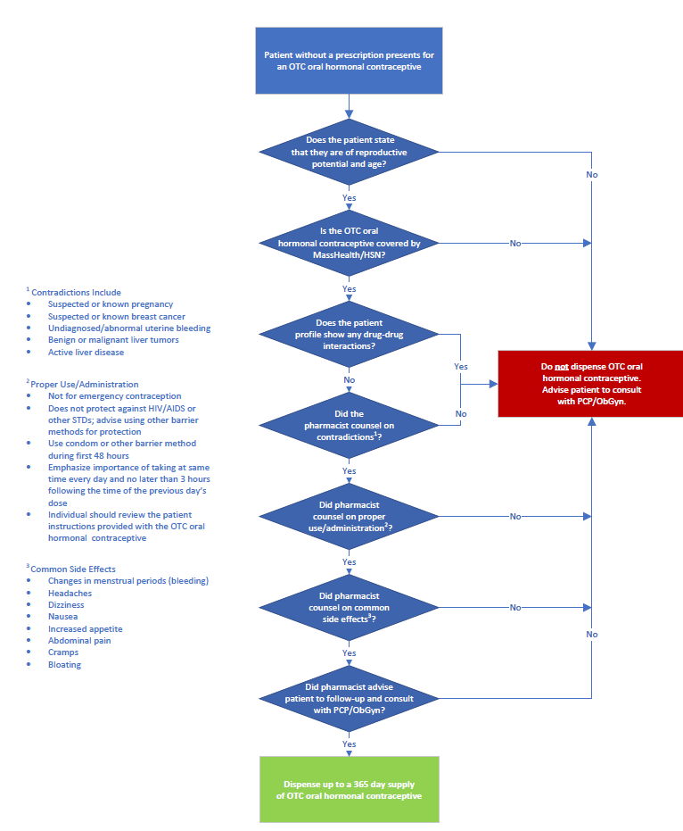

Reference

1. Opill® [consumer information leaflet on the internet]. Allegan (MI): Perrigo; 2023. [cited 2025 Jan 24]. Available from: <https://cdn.shopify.com/s/files/1/0753/6653/1352/files/Consumer_Information_Leaflet.pdf?v=1709218835>