Suggested Citation:

Massachusetts Department of Public Health. *Oral Health Basics*. Office of Oral Health. Boston, MA; October 2022.

Massachusetts Department of Public Health

ORAL HEALTH BASICS

Office of Oral Health

Matthew Horan, DMD, MPH

Dental Director

What’s part of “Oral Health Basics”?

Why is oral health important?

What causes a cavity?

How to take care of your oral health?

When to see oral health providers?

How to get oral health care?

What to expect at your visit?

Disclaimer

* These slides (or this transcription of them) are not a replacement for dental care.
* Always consult with your own healthcare provider to review your personal circumstances prior to making any changes in your health routine(s).
* These slides aim to incorporate evidence-based guidelines, but they also include some clinical opinions.
* Medical and dental clinical guidance may change over time as more research is completed and new science develops.
* Any products, companies, trade names, trademarks or otherwise that are visible or referenced within these slides does not constitute or imply its endorsement or recommendation.

Why is Oral Health Important?

Health

Eat

Talk

Smile

School / Work

Saliva

Prevent Disease

Why is oral health important?

* Oral health is overall health.
  + It matters across the lifespan and for everyone.
* Oral health status is linked to chronic diseases and cancers.
  + Diabetes, heart disease, respiratory disease, obesity … o Oral cancers and cancers spreading from elsewhere in the body

Why is oral health important?

1 in 3 High School Students reported having a cavity in the past year.

* Dental cavities are the most common chronic condition in children.
* 25% of middle school students in MA reported having a cavity in the past year.
* Adults who are low-income, have less than a high school education, non-Hispanic Black, and current smokers are 2 times more likely to have untreated cavities than comparison groups.

Cavities are preventable.

2021 Community Water Fluoridation Status

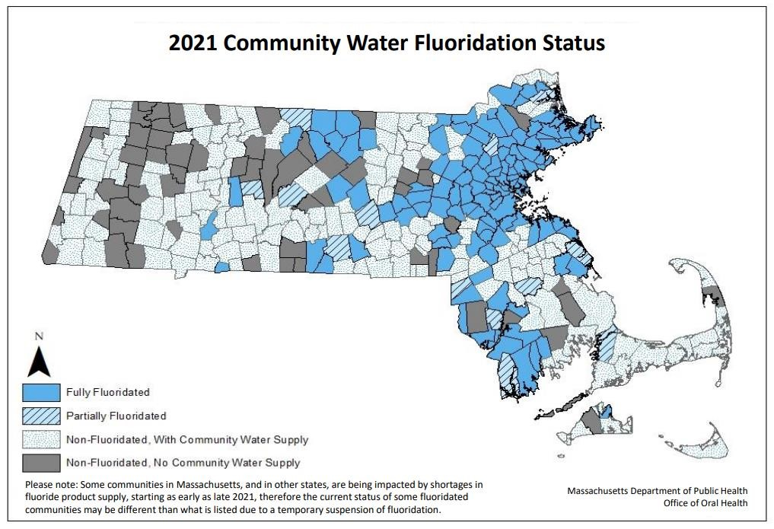

Community Water Fluoridation:

Learn more about your water!

<https://www.mass.gov/community-water-fluoridation-resources>

What causes a cavity?

<https://youtu.be/zGoBFU1q4g0>

What causes a cavity?

Step 1: Germs (bacteria) + Breads/Grains/Sugars (carbohydrates) + Time and mouth status (saliva amount, make-up) = Acid (from plaques)

Step 2: Healthy Tooth + Acid (from plaques) – Homecare, dental home, saliva & mouth status = Sick Tooth (Dental Cavity)

How to take care of your oral health?

* Practice prevention:
  + Get vaccinated and work to improve chronic health conditions where you are able • Pick healthy foods and drinks
  + Pick water with fluoride
* Two times per day, clean all teeth surfaces
* Avoid/reduce harmful habits
* Get quality sleep and exercise
* Community, mental health, reduce stress

How to take care of your oral health?

With the dental healthcare professional:

* Visit at least once per year or as directed by a dental healthcare professional (Have a “dental home” – a place you regularly go.)
* Focus on preventive care and ask about it:
  + “Check-ups” and “teeth cleanings”
  + Fluoride varnish (a fluoride mixture that can help prevent cavities) o Dental sealants (longer-lasting protective teeth coatings to help prevent cavities) • Don’t wait for tooth pain to go

There’s more to the story…

“The Social Determinants of Health”

* The environment and safety where you live.
* Housing status.
* Income.
* Education.
* Health care access and quality.
* Healthy food and water access.
* Community and support systems.
* And more…

Things we cannot change.

Certain health conditions. The need for some medications.

Disability. Age. Race. Sexual Orientation. And more…

Mouth care throughout the lifespan:

* Infancy – start twice a day routine with a clean wet cloth over your finger.
* Age of first tooth in mouth – start brushing twice a day.
* Any 2 teeth touching – start to floss between them.
* Reminder – 1st dental visit by the 1st Birthday
* Ask about fluoride varnish at medical and dental visits.
* Child able to spit out -- start using a pea-sized amount of toothpaste containing fluoride.
* Childhood – parent/guardian continues to inspect/guide and re-brush and re-floss to ensure a good job.
* Adulthood – continue twice a day routine.
  + Dental care is safe during pregnancy.
* Seniors – continue adult routine unless directed by dental healthcare professionals. Caregivers may need to assist.
  + Clean all removable teeth.
  + Make a plan for dry mouth care.
* Disabilities – all ages – work with your dental healthcare professionals on modifications/accommodations that work for your specific needs.
* Caregivers – all ages – monitor homecare routine and actively re-brush and re-floss as needed and agreed.

Brushing Teeth

Adult Brushing Basics:<https://youtu.be/xm9c5HAUBpY>

* Brush for 2 minutes
* Use a soft brush
* Brush all the teeth, gumline, and the tongue
* Use toothpaste with fluoride
* Brush twice a day

TIPS:

* Don’t share toothbrush with others.
* Get a new brush about every 3 months or after being sick.
* Frayed bristles likely mean there is too much pressure being used.
  + Try using 2 fingers to hold the brush instead of a full fisted grip.

Toothpaste Guidance:

* Pick a toothpaste containing fluoride o Always look at the “active ingredient” section on the label:

▪ Look for “fluoride ion” and/or “fluoride”

* Recommend looking for the “ADA Accepted” ® seal of approval
* Use only a smear (grain of rice size) of toothpaste (until able to spit) • Use a pea-sized amount of toothpaste (once able to spit)

Brushing Teeth

Child Brushing: <https://youtu.be/kuLxz5IrZ6Y>

Instructions for Caregivers & Accommodations to Consider: <https://youtu.be/UQoMtRGjowc>

What about flossing?

* The goal of homecare is to clean ALL the teeth surfaces.
  + If any of your teeth touch each other, flossing may help to clean where the brush doesn’t reach.
* Floss at least once a day between all the teeth that touch.

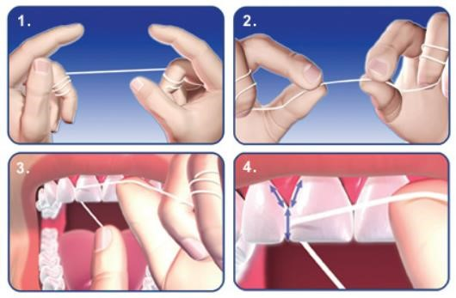

Image Credit: <https://www.madisonsmilecare.com/blog/post/facts-on-flossing.html>

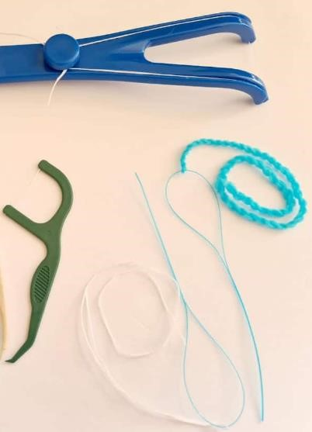

Image Credit: <https://www.electricteeth.com/best-flosser-flossing-tools/>

Other Tips:

Looking to do more?

* Try not to rinse after brushing.
  + Leave the toothpaste foam alone.
  + If you must use a mouth rinse, consider an alcohol free anticavity rinse.
* Space brushing time about 1 hour from mealtimes o Either before or after breakfast. o Best after your last meal and prior to sleeping.

Consult your dental healthcare provider for homecare advice around “braces,” removable teeth, mouthguards, or any other needs.

Patient and Caregiver Working Together:

Patient:

* Help to prepare
* Comfortable location/position
* Fun feature by age/state
* A comfort item?
* A fidget item?
* Helps to set a goal and/or prize

Caregiver:

* Review preparations for care
* Patience
* Start early in life, set a routine
* Ensure patient comfort o Prevent injury o Take breaks as needed
* Ensure accommodations wherever possible
* Motivations – goal and/or prize

When to see oral health professionals?

* First visit when the first tooth comes o By the 1st birthday
* At least once per year for a check-up o Even if without any natural teeth left
* Find a place that you will regularly go for care “a dental home” to help prevent pain and problems before they start.

Help avoid the emergency room for dental needs:

Emergency Room:

* Go here only for:
  + Serious mouth injuries or infections/swellings that make it hard to breathe or swallow o For major jaw problems (like fracture of dislocation) o If directed by your dental provider o If unsure what to do or unable to get help

Dental Healthcare Provider:

* Go here for most everything else:
  + General tooth pain, a lost tooth, broken replacement teeth, discomfort from a cavity, wisdom tooth pain, a lost filling or crown, bleeding gums
  + Plan to call and/or visit here first

For most dental pain or problems, the dental healthcare provider is the best place to go for help.

What to expect at your visit:

How to prepare: Dental Insurance

* How will you pay?
  + Employer-sponsored dental insurance plan o Medicaid/Medicare, Health Safety Net o No insurance and paying out of pocket
* MA Health Connector ([https://www.mahealthconnector.org/)](https://www.mahealthconnector.org/) o Need more assistance?
  + - Consider contacting your local community health center and meeting with an insurance navigator one on one

[(https://www.massleague.org/findahealthcenter/index.php)](https://www.massleague.org/findahealthcenter/index.php)

* + - City of Boston Residents – consider the mayor’s health line 617.534.5050

What to expect at your visit:

How to prepare: Finding Places for Care

* If you have an insurance card, call the number listed or use the plan’s website to find a provider
* Consider one of the state’s schools of dental medicine or hygiene schools o <https://www.mass.gov/service-details/dental-dental-hygiene-schools-in-massachusetts>
* Private office setting:
  + Word of mouth, internet search, American Dental Association <https://findadentist.ada.org/>
* Portable dental care offered at your child’s school, community centers, or elsewhere o Public health dental hygienists, school-based health centers, other portable programs
* MassHealth (Medicaid) or Health Safety Net:
  + [https://provider.masshealth-dental.net/MH_Find_a_Provider#/home](https://provider.masshealth-dental.net/MH_Find_a_Provider)
  + MassHealth Dental Program Customer Service: 1-800-207-5019, TTY: 1-800-466-7566

What to expect at your visit:

How to prepare: Accommodations

When making an appointment make the office aware of help needed or accommodations, or any other special requests you might have.

* Need a ride or help getting there? That may be covered by insurance.
* Spoken language translation needed?
* Building access concerns? Other enabling needs?

What to expect at your visits:

Not feeling well or other concerns?

* Call your dental care team as soon as possible to review your concerns. Care is usually rescheduled unless urgent.
* Telehealth/teledentistry may be another option.

Before the appointment:

* Aim not to bring any extra people that are not required.
* Review the location, parking, access to the building.
* Bring your insurance card, if you have one.

What to expect at your visits:

Expectations:

* Expect to be asked to follow special rules for safety.
* Have a list of your health conditions, medications, allergies, and questions ready.
* Ask questions when you are unsure of anything.
* Review costs of treatments planned.

What to expect at your visits:

Dental Fear:

* Dental fear is common.
  + For many patients it is the unknown, a feeling of loss of control, or a related experience with trauma. Review a plan with the provider.
* Providers can share a signal to stop that the patient can give anytime – such as a raised hand.
* Providers can also explain what they are doing as they work.
* Tips – headphones, a weighted blanket, a fidget item.

What to expect at your visits:

In the Dental Chair:

* Focus on preventive care and ask for it.
  + Teeth cleanings, protective sealants, fluoride varnish.
* Expect an exam first.
  + X-rays (radiographs) may be needed and other tests.
* The provider will be able to review what’s going on, the options available to help, and the need for any medicines.
* The provider will also review the risks and benefits of the options available. There will likely be a list of things being recommended called a “treatment plan.” Ask for a copy of the plan, review it, and be sure you understand.

What to expect at your visits:

When you leave:

* Double check all questions are answered.
* Understand the instructions for after your care that day and anything you need to do before the next visit.
* Ask any unresolved payment questions.
* Understand your planned future treatments.