GUEST PRESENTATION

ORAL HEALTH BASICS

**For Questions & Additional Information:**

**Matthew Horan, DMD, MPH, Dental Director**

**Office of Oral Health, Massachusetts Department of Public Health** [**Oral.Health@mass.gov**](mailto:Oral.Health@mass.gov)

**What’s part of “Oral Health Basics”?**

Why is oral health important?

What causes a cavity?

How to take care of your oral health?

When to see oral health providers?

How to get oral health care?

What to expect at your visit?

**Disclaimer:**

* These slides are not a replacement for dental care.
* Always consult with your own healthcare provider to review your personal circumstances prior to making any changes in your health routine(s).
* These slides aim to incorporate evidence-based guidelines, but they also include some clinical opinions.
* Medical and dental clinical guidance may change over time as more research is completed and new science develops.
* Any products, companies, trade names, trademarks or otherwise that are visible or referenced within these slides does not constitute or imply its endorsement or recommendation.

**Why is Oral Health Important?**

 

Health Eat Talk Smile



School / Work Saliva Prevent Disease

**Why is oral health important?**

* Oral health is overall health.
  + It matters across the lifespan and for everyone.



* Oral health status is linked to chronic diseases and cancers.
  + Diabetes, heart disease, respiratory disease, obesity …
  + Oral cancers and cancers spreading from elsewhere in the body

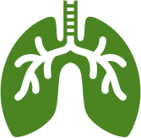

**Why is oral health important?**

* + - Dental cavities are the most common chronic condition in children.



1 in 3 High School Students reported having a cavity in the past year.

* + - 25% of middle school students in MA reported having a cavity in the past year.
    - Adults who are low-income, have less than a high school education, non-Hispanic Black, and current smokers are 2 times more likely to have untreated cavities than comparison groups.

# Cavities are preventable.

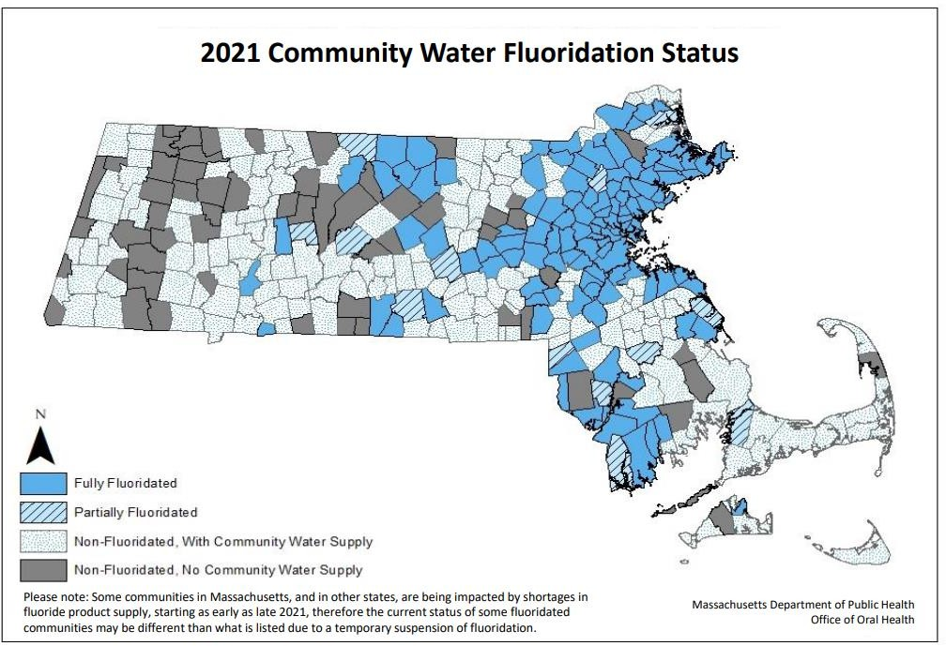

7



**Community Water Fluoridation:**

Learn more about your water!

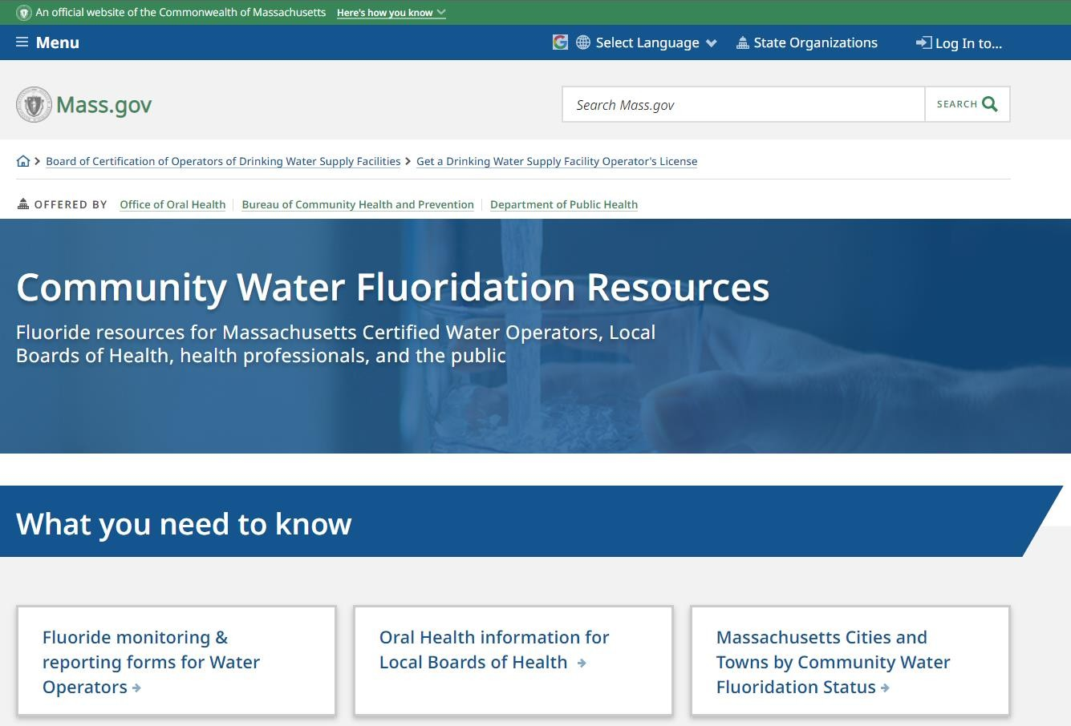 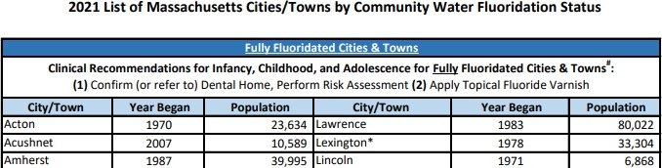

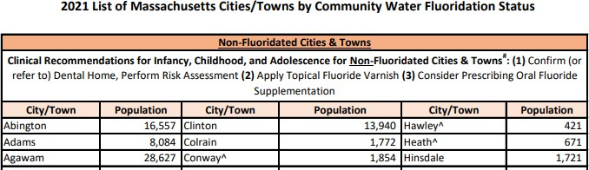http[s://www.mass.gov/community-water-fluoridation-resources](http://www.mass.gov/community-water-fluoridation-resources)

**What causes a cavity?**

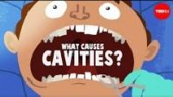 

https://youtu.be/zGoBFU1q4g0

=



**Step 1**

Germs (bacteria)

Breads/Grains/Sugars

(carbohydrates)

Time & mouth status (saliva amount, make-up)

Acid (from plaques)

− =



**Step 2**



Healthy

Tooth

Acid (from plaques)

Homecare, dental home, saliva & mouth status

Sick Tooth

(Dental Cavity)

**What causes a cavity?**

10

* Practice prevention:

**How to take care of your oral health?**

* + Get vaccinated & work to improve chronic health conditions where you are able
* Pick healthy foods and drinks
  + Pick water with fluoride
* 2x per day, clean all teeth surfaces



* Avoid/reduce harmful habits
* Get quality sleep & exercise



* Community, mental health, reduce stress



**How to take care of your oral health?**

With the dental healthcare professional:

* Visit at least once per year or as directed by a dental healthcare

professional (Have a “dental home” – a place you regularly go.)

* Focus on preventive care and ask about it:
  + “Check-ups” and “teeth cleanings”
  + Fluoride varnish (a fluoride mixture that can help prevent cavities)
  + Dental sealants (longer-lasting protective teeth coatings to help prevent cavities)
* Don’t wait for tooth pain to go

“The Social Determinants of Health”

**There’s more to the story…**

* The environment and safety where you live.
* Housing status.
* Income.



* Education.
* Heath care access and quality.
* Healthy food and water access.
* Community and support systems.
* And more…

Things we cannot change.

Certain health conditions. The need for some medications.

Disability. Age. Race. Sexual



Orientation. And more…

* Infancy – start twice a day routine with a clean wet cloth over your finger.
* Age of first tooth in mouth – start brushing



twice a day.

* Any 2 teeth touching – start to



floss between them.

* Seniors – continue adult routine unless directed by dental healthcare professionals. Caregivers may need to assist.



* **Clean all removable teeth.**



* **Make a plan for dry mouth care.**
* **Reminder – 1st dental visit by the 1st Birthday**
* **Ask about fluoride varnish at medical and dental**

**visits.**

* + Child able to spit out, start using a pea-sized amount of toothpaste containing fluoride.



* + - Childhood - parent/guardian continues to inspect/guide and re-brush and re-floss to ensure a good job.



* + - Adulthood – continue twice a day routine
    - Disabilities- all ages - work with your dental healthcare

**Mouth care throughout the lifespan:**

professionals on modifications/accommodations that

work for your specific needs.

* + - Caregivers – all ages - monitor homecare routine and actively re-brush and re-floss as needed and agreed.
* **Dental care is safe during pregnancy.**

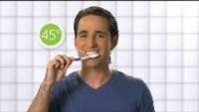Adult Brushing Basics:

Use a soft brush

Brush for 2 minutes

Brush all the teeth, gumline, and the tongue

Use toothpaste with fluoride

https://youtu.be/xm9c5HAUBpY

**Brushing Teeth**



TIPS:

Brush twice a day

* Don’t share toothbrush with others.
* Get a new brush about every 3 months or after being sick.
* Frayed bristles likely mean there is too much pressure being used.
  + *Try using 2 fingers to hold the brush instead of a full-fisted grip.*
  + Pick a toothpaste containing fluoride
    - Always look at the “active ingredient” section on the label:

– Look for “fluoride ion” and/or “fluoride”

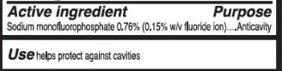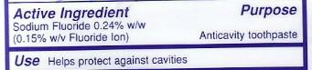

* + Recommend looking for the “ADA Accepted”® seal of approval 

Use only a smear (grain of rice size), Until able to spit

**Toothpaste Guidance:**

Use a pea-sized amount, Once able to spit

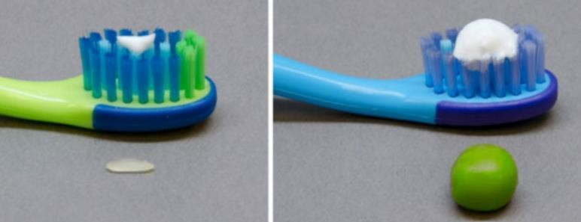Image credit:

https:[//www.anzspd.org.au/post/toothpaste#.YzXi23bMJPY](http://www.anzspd.org.au/post/toothpaste#.YzXi23bMJPY)

Child Brushing:

**Brushing Teeth**

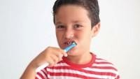

https://youtu.be/kuLxz5IrZ6Y

Instructions for Caregivers &

Accommodations to Consider :

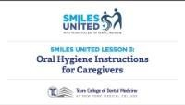

https://youtu.be/UQoMtRGjowc

* The goal of homecare is to clean ALL the teeth surfaces.
  + If any of your teeth touch each other, flossing may help to clean

where the brush doesn’t reach.

* 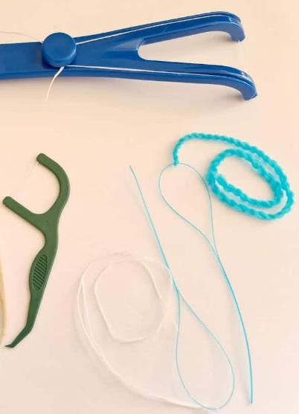Floss at least once a day between all the teeth that touch.

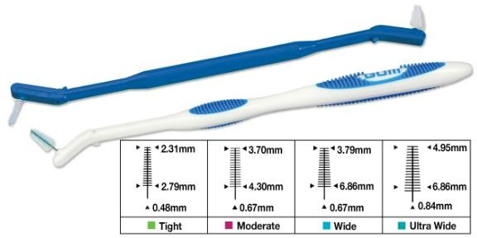

**What about flossing?**

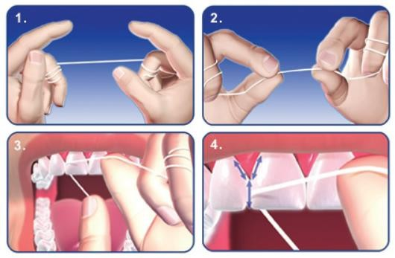Image Credit: https:/[/www.madisonsmilecare.com/blog/post/facts-on-flossing.html](http://www.madisonsmilecare.com/blog/post/facts-on-flossing.html)

https:/[/www.electricteeth.com/best-flosser-flossing-tools/](http://www.electricteeth.com/best-flosser-flossing-tools/)

https:/[/www.safcodental.com/catalog/preventives/int](http://www.safcodental.com/catalog/preventives/int) erdental-brushes/gum-proxabrush-go-betweens- handles-and-refills?

Looking to do more?

Try not to rinse after brushing.

* Leave the toothpaste foam alone.



* If you must use a mouth rinse, consider an alcohol-free anticavity rinse.

Space brushing time about 1 hour from

mealtimes.

* Either before or after breakfast.
* Best after your last meal and prior to

sleeping.

**Other Tips:**

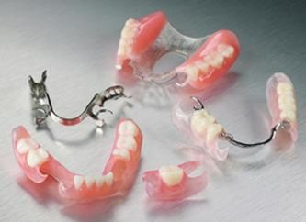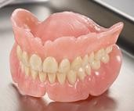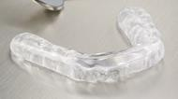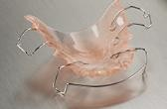

Consult your dental healthcare provider for homecare advice around “braces”,

removable teeth, mouthguards, or any other needs.

https://nationaldentex.com/products/dentures-partials

https://nationaldentex.com/products/appliances

19

Patient:

**Patient & Caregiver Working Together:**

* Help to prepare
* Comfortable location/position
* Fun feature by age/state
* A comfort item?
* A fidget item?
* Helps to set a goal and/or prize

Caregiver:

* + Review preparations for care
  + Patience
  + Start early in life, set a routine
  + Ensure patient comfort
    - Prevent injury
    - Take breaks as needed
  + Ensure accommodations wherever possible
  + Motivations - goal and/or prize

**When to see oral health professionals?**

* First visit when the first tooth comes
  + By the 1st birthday
* At least once per year for a check-up
  + Even if without any natural teeth left
* Find a place that you will regularly go for care “a dental home” to help prevent pain and problems before they start.

Emergency Room:

* + Go here only for:
    - serious mouth injuries or infections/swellings that make it hard to breathe or swallow
    - for major jaw problems (like

fracture or dislocation)

* + - if directed by your dental provider
    - if unsure what to do or unable to

get help

Dental Healthcare Provider:

* + Go here for most everything else:
    - general tooth pain, a lost tooth, broken replacement teeth, discomfort from a cavity, wisdom tooth pain, a lost filling or crown, bleeding gums
    - plan to call and/or visit here first

**Help avoid the emergency room for dental needs:**

For most dental pain or problems, the dental healthcare provider is the best place to go for help.

**What to expect at your visit:**

How to prepare: Dental Insurance

* + - * How will you pay?
        + Employer-sponsored dental insurance plan
        + Medicaid/Medicare, Health Safety Net
        + No insurance and paying out of pocket
      * MA Health Connector (<https://www.mahealthconnector.org/>)
        + Need more assistance?

Consider contacting your local community health center and meeting with an insurance navigator one on one (<https://www.massleague.org/findahealthcenter/index.php>)

City of Boston Residents – consider the mayor’s health line 617.534.5050

**What to expect at your visit:**

How to prepare: Finding Places for Care

* If you have an insurance card, call the number listed or use the plan’s website to find a

provider

* Consider one of the state’s schools of dental medicine or hygiene schools
* Private office setting:
  + Word of mouth, internet search, American Dental Association <https://findadentist.ada.org/>
* Portable dental care offered at your child’s school, community centers, or elsewhere
  + Public health dental hygienists, school-based health centers, other portable programs
* MassHealth (Medicaid) or Health Safety Net:
  + [https://provider.masshealth-dental.net/MH_Find_a_Provider#/home](https://provider.masshealth-dental.net/MH_Find_a_Provider%23/home)
  + MassHealth Dental Program Customer Service: 1-800-207-5019, TTY: 1-800-466-7566

**What to expect at your visit:**

How to prepare: Accommodations

When making an appointment make the office aware of help needed or accommodations, or any other special requests you might have.

* Need a ride or help getting there? That may be covered by insurance.
* Spoken language translation needed?
* Building access concerns? Other enabling needs?

**What to expect at your visit:**

# Not feeling well or other concerns?

* Call your dental care team as soon as possible to review your concerns. Care is usually rescheduled unless urgent.
* Telehealth/teledentistry may be another option.

# Before the appointment:

* Aim not to bring any extra people that are not required.
* Review the location, parking, access to the building.
* Bring your insurance card, if you have one.

**What to expect at your visit:**

# Expectations:

* Expect to be asked to follow special rules for safety.
* Have a list of your health conditions, medications, allergies, and questions ready.
* Ask questions when you are unsure of anything.
* Review costs of treatments planned.

**What to expect at your visit:**

# Dental Fear:

* + Dental fear is common.
    - For many patients it is the unknown, a feeling of loss of control, or a related experience with trauma. Review a plan with the provider.
  + Providers can share a signal to stop that the patient can give anytime- such as a raised hand.
  + Providers can also explain what they are doing as they work.
  + Tips- headphones, a weighted blanket, a fidget item.

**What to expect at your visit:**

In the Dental Chair:

* + Focus on preventive care and ask for it.
    - Teeth cleanings, protective sealants, fluoride varnish.
  + Expect an exam first.
    - X-rays (radiographs) may be needed and other tests.
  + The provider will be able to review what’s going on, the options

available to help, and the need for any medicines.

* + The provider will also review the risks and benefits of the options available. There will likely be a list of things being recommended

called a “treatment plan”. Ask for a copy of the plan, review it, and be

sure you understand.

**What to expect at your visit:**

# When you leave:

* + Double check all questions are answered.
  + Understand the instructions for after your care that day and anything you need to do before the next visit.
  + Ask any unresolved payment questions.
  + Understand your planned future treatments.

**Thank you.**