INDOOR AIR QUALITY ASSESSMENT

Orange Armory
141 East Main Street
Orange, Massachusetts

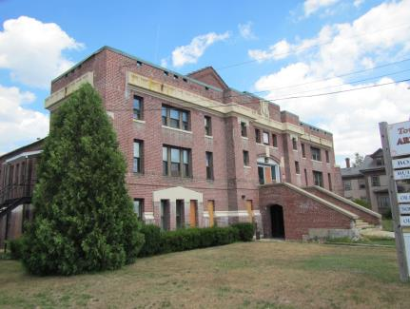

Prepared by:
Massachusetts Department of Public Health
Bureau of Environmental Health
Indoor Air Quality Program
November 2016

BACKGROUND
Building: | Orange Armory (OA)
Address: | 141 East Main Street, Orange, MA
Assessment Contacts: | Diana M. Schindler, Orange Town Manager
Reason for Request: | Odors in hallways
Date of Assessment: | 7/22/2016  8/25/2016  10/21/2016
Massachusetts Department of Public Health/Bureau of Environmental Health (MDPH/BEH) Staff Conducting Assessment: | Mike Feeney, Director, Indoor Air Quality (IAQ) Program
Date of Building Construction: | 1913
Windows: | Openable

Building Description
The OA was constructed in 1913 as a two-story armory. The first floor is mostly on cement slab, with the exception of the office space at the front of the building which is over a cellar and passageways for the furnace, oil tanks and water heater (Picture 1). The second floor is an assembly hall (Picture 2). Orange town officials reported that the assembly hall was used for vehicle repair when in the custody of the MA National Guard. The first floor contained a secure armory which is now used as a dining hall (Picture 3) with a kitchen equipped with gas-fueled cooking equipment. Administrative offices are located in the front of the building. The building also contained a shooting range (Picture 4) that is sealed off by a cement block wall.

METHODS
Please refer to the IAQ Manual and appendices for methods, sampling procedures, and interpretation of results (MDPH, 2015).

RESULTS and DISCUSSION
The following is a summary of indoor air testing results (Table 1).
- Carbon dioxide levels were below 800 parts per million (ppm) in all areas surveyed, indicating adequate air exchange for the population at the time of assessment.
- Temperature was within the MDPH recommended range of 70°F to 78°F in most areas, above in a few areas.
- Relative humidity was above the MDPH recommended range of 40 to 60% in most areas.
- Carbon monoxide levels were below the National Ambient Air Quality Standards (NAAQS) guideline of 9 ppm.
- Particulate matter (PM2.5) concentrations were below the NAAQS guideline of 35 μg/m³ in all but two areas of the building during testing.

Ventilation
It can be seen from Table 1 that carbon dioxide levels were below 800 ppm in all areas surveyed. The building does not have mechanical ventilation to introduce fresh air into the space. Fresh air is supplied primarily by opening windows and infiltration through gaps in the building envelope. The building is heated by radiators or ceiling-mounted fan coil units. This building was constructed as an armory to be used on a periodic nature by the MA National Guard.

Odors Assessment
Upon entering the OA, a skunk-like odor was noted at the main entrance that extended to the area outside the restrooms in the main hallway. A similar odor was also noted on the second floor in the foyer outside the assembly hall. This odor is attributed to the carpeting (Picture 5), which is repeatedly moistened. The source of moisture affecting the carpeting is likely condensation that occurs due to the exterior door being propped open during hot humid weather. It is also important to note that carpeting, if well maintained, is expected to have a service life of 7 to 11 years (Bishop, 2002).
In order to ascertain if the carpeting was moistened, IAQ staff conducted both moisture sampling of floors and carpeting as well as floor temperature measurements on October 21, 2016. Carpeting should not be moistened since it is prone to mold growth. Carpeting in all areas was wet. As an example, the carpet in the hallway of the main entrance had moisture measurements of a range of 20 to 95 % (Table 2). Moisture measurements of the hallway painted floor was 98+ %, indicating moisture below the surface of the paint. These measurements indicate that moisture is likely wicking from beneath the cement slab floor to accumulate beneath the floor paint and carpeting. This condition indicates that neither a vapor barrier nor insulation exists below the floor slab and that the paint would serve as a vapor barrier. If no paint exists on the cement beneath the hallway carpet, moisture from the slab regularly wets the carpeting.
The lack of insulation and vapor barrier would influence the temperature of the floor to match the temperature of the soil in contact with the cement. IAQ staff measured the floor temperature in first floor rooms and hallways. Floors temperatures ranged from 52 ºF to 72 ºF (Table 2). During the course of the assessment, the dew point in the greater Orange area was in a range of 63 ºF to 66 ºF (WU, 2016). These measurements indicate that all areas, except for the Council on Aging, had floor temperatures that were below the dew point and would be moistened with condensation. Condensation is the collection of moisture on a surface that has a temperature below the dew point. The dew point is a temperature that is determined by air temperature and relative humidity. For example, at a temperature of 80º F and relative humidity of 80%, the dew point for water to collect on a surface is approximately 76 ºF. If the temperature of the floor was at or below the dew point, water vapor in air would condense on the floor to wet the carpet.
Of note is persistent standing water in the cellar (Picture 6). The chronic water penetration may result in mold growth and associated odors in the basement area. A passage exists in the cellar that appears to lead to a set of steel covers that are located in the Orange Council on Aging. The steel floor covers in this office do not appear to be airtight, which can result in water vapor and odors migrating into occupied space from the chronically wet cellar. In addition, OA staff reported that wall-to-wall carpet was also installed over other similar grates (Picture 7). If the steel grates under the carpet were not rendered airtight, this carpeting may also be chronically exposed to water vapor, which can lead to mold growth. In addition, it is possible that the floor beneath the carpeting likely consists of asbestos-containing floor tile. Removal of the carpet would likely require compliance with federal and state asbestos laws and regulations.
The former pistol range had significant mold odors. The exterior wall of this section of the building showed signs of water penetration as well as moistened floors. This condition is likely attributed to the lack of a gutter/downspout along the roof edge above the pistol range (Picture 8). A cement apron exists below the roof that has plants growing from the apron wall seam (Picture 9). Moisture can readily pass through brick to increase relative humidity, which can raise the dew point to cause moistening of stored materials in this area.
The assembly hall on the second floor had numerous water-damaged ceiling tiles that appear to be from historic leaks (Picture 10). Some areas of the suspended ceiling had missing ceiling tiles and exposed insulation (Picture 11). If moistened, insulation’s ability to prevent heat loss is diminished.
The US Environmental Protection Agency and the American Conference of Governmental Industrial Hygienists (ACGIH) recommends that porous materials (carpeting, etc.) be dried with fans and heating within 24 to 48 hours of becoming wet (US EPA, 2008; ACGIH, 1989). If porous materials are not dried within this time frame, mold growth may occur. Water-damaged porous materials cannot be adequately cleaned to remove mold growth. The application of a mildewcide to moldy porous materials is not recommended.
A number of conditions that can lead to water infiltration due to shifting of building components were noted:
- The floor at the main entrance appears to have sunken (Picture 12). This location is adjacent to a cement block wall which was added to the building to seal the pistol range from the main hallway. In the experience of IAQ staff, the weight of a cement block wall can cause damage to an unreinforced cement floor.
- Wood support beams in the music room are cracked (Pictures 13 through 15). Orange town officials reported that the Assembly Hall was used for motor vehicle repair during cold weather, which would put stress on these beams.
- The floor around a support post in the main hallway is also sunken (Picture 16).
- A brick wall in a storeroom adjacent to the Board of Health office has significantly separated (Pictures 17 and 18). The separation has cause the plaster wall (Picture 19) and doorway (Picture 20) to distort.
- A roof over the main entrance shows signs of brick deterioration (Picture 21).
Each of these observations indicates that the western portion of the building has both walls and portions of the floor that have shifted, which can result in water penetration into the building.

Other Concerns
As mentioned, the armory contains an abandoned pistol range that is used for storage. The use of firearms can produce lead contamination of surfaces in firing ranges. Information as to whether this space had undergone lead decontamination was not available. IAQ staff used 3M LeadCheck ® lead testing swabs on selected surfaces in the abandoned pistol range, including an old painted door (Picture 22), floor sections (Picture 23) and shelving (Pictures 24 and 25). Tests of shelving and the door were positive for the presence of lead. Infants, young children and pregnant women are especially vulnerable to the harmful effects of lead exposure. Precautions should be taken to minimize their lead exposure. It is highly recommended that employees who are pregnant do not access the former pistol range. All individuals who have access to this area should increase hand and face washing in order to reduce exposure from residual lead that may contaminate flat surfaces.
The kitchen uses a number of gas-fueled cooking appliances, including the stove which has continuously burning pilot lights (Picture 26). The kitchen is designed such that the products of combustion and cooking odors are to be drawn in and subsequently ejected from the building via a large exhaust hood that is connected to an exhaust fan on the side of the building (Picture 27). The exhaust hood was not operable. Lack of exhaust ventilation would account for PM 2.5 measurements to be above outdoor background levels (Table 1).
The process of combustion produces a number of pollutants, depending on the composition of the material. In general, common combustion emissions can include carbon dioxide, carbon monoxide, water vapor and smoke. Of these constituents, carbon monoxide can produce immediate, acute health effects upon exposure. While no carbon monoxide was measured during the assessment, the use of this type of stove would require that the exhaust hood operate continuously to vent pilot light emissions from the building.

CONCLUSIONS and RECOMMENDATIONS
The conditions observed at the OA are complicated. Water readily accumulates on and through the cement slab floor, resulting in chronic moistening of carpeting, which is the likely source of reported odors in the building. The detection of lead on bare wood shelves in the abandoned pistol range indicates that this area was not cleaned of lead dust, which may result in cross-contamination of stored materials. Due to various conditions involving the building envelope, it is also likely that long-term issues involving the floor, exterior walls, and cellar have resulted in cracks and other breaches that allow moisture to penetrate the building.
Short-term and long-term recommendations are provided to address the conditions described in this assessment and to improve IAQ. The short-term recommendations can be implemented as soon as practicable. Long-term measures are more complex and will require planning and resources to adequately address overall IAQ concerns within the building.

Short-term Recommendations
- It is not recommended to use the former pistol range for any purpose, including unless it is deleaded.
- Materials stored in the former pistol range need to be examined:
  - If an item is water-damaged or colonized with visible mold, it should be discarded in a manner consistent with recommendations made in “Mold Remediation in Schools and Commercial Buildings” published by the US EPA (2008). This document can be downloaded from the US EPA website at: https://www.epa.gov/mold/mold-remediation-schools-and-commercial-buildings-guide. Ensure all regulations and guidelines regarding the disposal of lead-contaminated waste are followed.
  - If boxed toys and musical instruments stored in the former pistol range are not water-damaged or mold-colonized and can be used, should be cleaned in a manner consistent with “What Can You Do in the House to Protect Children From Lead?” published by the MA DPH Childhood Lead Poisoning Prevention Program at:
http://www.mass.gov/eohhs/gov/departments/dph/programs/environmental-health/exposure-topics/lead/child-health/protect-children/protect-children-from-lead-in-the-house.html. These steps are attached as Appendix A of this report. Once cleaned, these materials should be stored in a different location.
  - All other materials stored in the former pistol range should be either discarded or cleaned and stored in a different location afterward.
- Remove the carpeting in the main hallways in a manner consistent with recommendations made in “Mold Remediation in Schools and Commercial Buildings”. It is recommended not to use carpeting as a floor covering due to cement slab moisture.
- Remove all water-damaged ceiling tiles in a manner consistent with recommendations made in “Mold Remediation in Schools and Commercial Buildings”. Ensure leaks are repaired that caused water damage to ceiling tiles in the assembly hall. Make roof repairs as needed; consider long-term plans for roof replacement.
- Repair the kitchen exhaust fan and operate continuously. Install carbon monoxide detectors in the kitchen and dining hall. Consideration should be given to replacing the stove with an automatic ignition system.
- Remove plants from the wall/apron junction. Seal the wall/apron junction with an appropriate material.
- Repoint exterior wall brick as needed.
- For buildings in New England, periods of low relative humidity during the winter are often unavoidable. Therefore, scrupulous cleaning practices should be adopted to minimize common indoor air contaminants whose irritant effects can be enhanced when the relative humidity is low. To control for dusts, a high efficiency particulate arrestance (HEPA) filter equipped vacuum cleaner in conjunction with wet wiping of all surfaces is recommended. Drinking water during the day can help ease some symptoms associated with a dry environment (throat and sinus irritation).
- Refer to resource manual and other related indoor air quality documents located on the MDPH’s website for further building-wide evaluations and advice on maintaining public buildings. These documents are available at http://mass.gov/dph/iaq.

Long-term Recommendations
- Consider installing a gutter downspout system with a sufficient capacity to drain rainwater from the roof to prevent direct impact on the exterior wall.
- Consult a building engineer as to the best method for assessing the cause, as well as preventing/minimizing water penetration through the exterior wall of the former pistol range.
- Consult with a building engineer regarding the cracked floor support beams in Pictures 13 through 15.
- Consult with a building engineer regarding the best manner to reduce/eliminate water accumulation in the cellar.
- Consult with a building engineer regarding the brickwork in Picture 21 to assess the structure of the floor and wall above this section and best practice to repair the damage.
- Consult with a building engineer regarding the sunken floors denoted in this report and to make recommendations regarding arresting further movement.

REFERENCES
ACGIH. 1989. Guidelines for the Assessment of Bioaerosols in the Indoor Environment. American Conference of Governmental Industrial Hygienists, Cincinnati, OH.
ATSDR. 1999. Toxicological Profile for Lead (Update). Agency for Toxic Substances and Disease Registry, Atlanta, GA. July 1999.
Bishop, J. & Institute of Inspection, Cleaning and Restoration Certification. 2002. A Life Cycle Cost Analysis for Floor Coverings in School Facilities.
IICRC. 2012. Institute of Inspection, Cleaning and Restoration Certification. Carpet Cleaning: FAQ. Retrieved from http://www.iicrc.org/consumers/care/carpet-cleaning.
Massachusetts Department of Public Health (MDPH). 2015. Indoor Air Quality Manual: Chapters I-III. Available at: http://www.mass.gov/eohhs/gov/departments/dph/programs/environmental-health/exposure-topics/iaq/iaq-manual/.
US EPA. 2008. Mold Remediation in Schools and Commercial Buildings. US Environmental Protection Agency, Office of Air and Radiation, Indoor Environments Division, Washington, D.C. EPA 402-K-01-001. http://www.epa.gov/mold/mold-remediation-schools-and-commercial-buildings-guide.
WU. 2016. Weather History for KORE-October 2016. Weather Underground. https://www.wunderground.com/history/airport/KORE/2016/10/21/DailyHistory.html?req_city=Orange&req_state=MA&req_statename=&reqdb.zip=01364&reqdb.magic=1&reqdb.wmo=99999

Picture 1
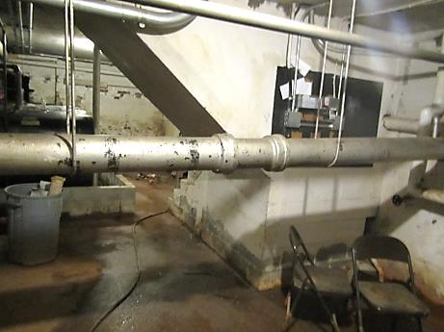
Basement
Picture 2
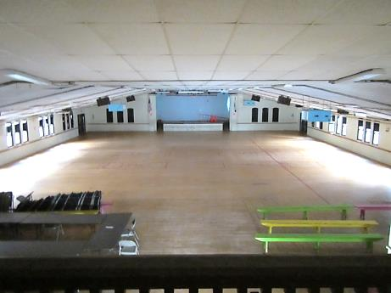
Assembly Hall
Picture 3
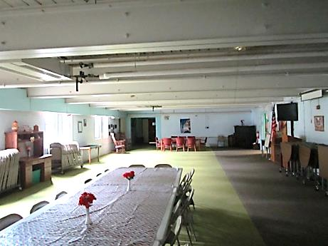
Dining Hall
Picture 4
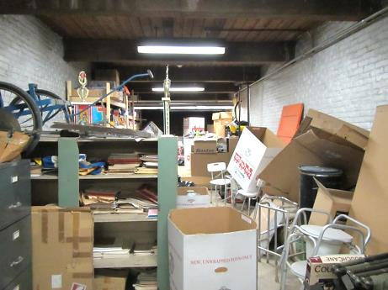
Abandoned pistol range
Picture 5
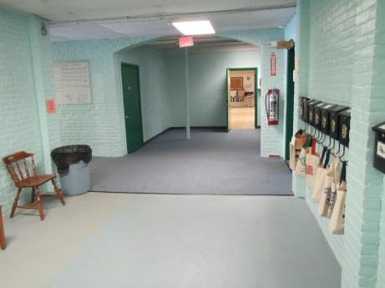
Carpeting in the main hallway
Picture 6
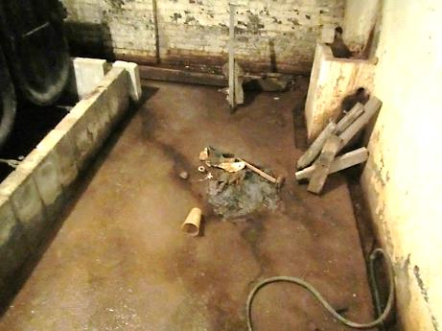
Water in the cellar
Picture 7
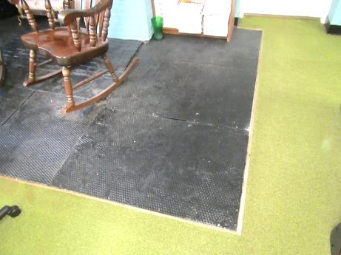
Metal grate in the Council for the Aging office
Picture 8
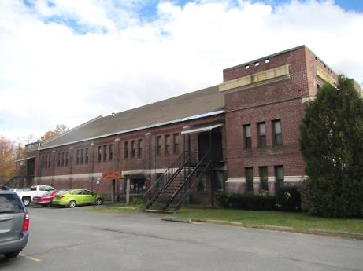
Roof edge above abandoned pistol range
Picture 9
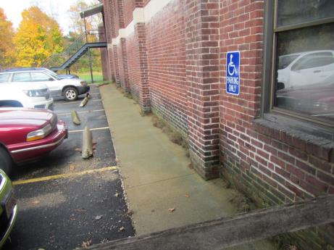
A cement apron exists below the roof that has plants growing from the wall seam
Picture 10
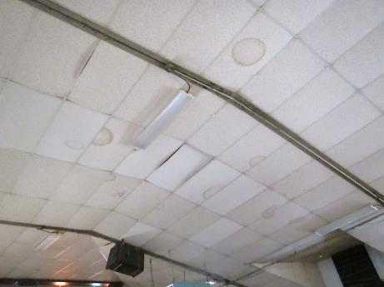
Water-damaged ceiling tiles in the Assembly Hall
Picture 11
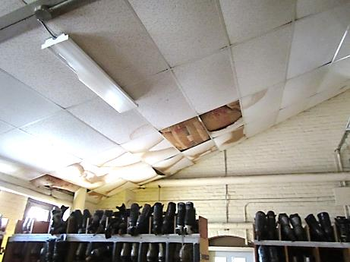
Exposed insulation above suspended ceiling in the Assembly Hall
Picture 12
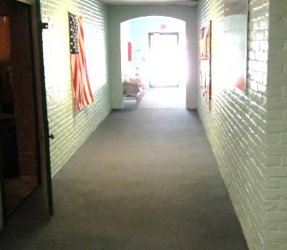
The floor at the main entrance appears to have sunken
Picture 13
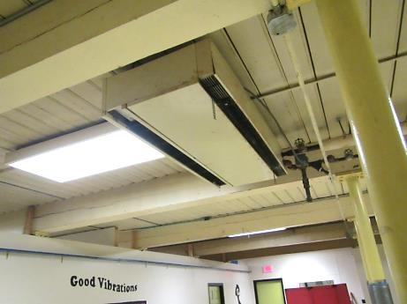
Cracked floor support beams in music room
Picture 14
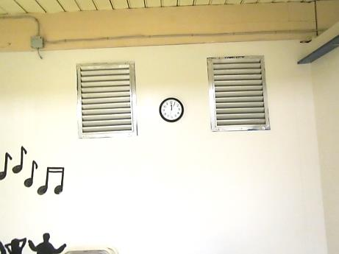
Cracked beam in music room
Picture 15
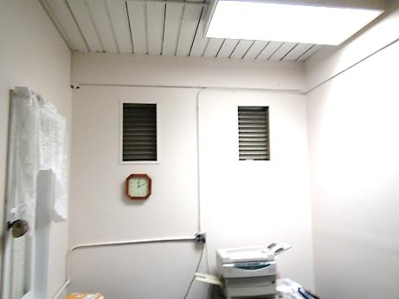
Cracked beam in office adjacent to music room
Picture 16
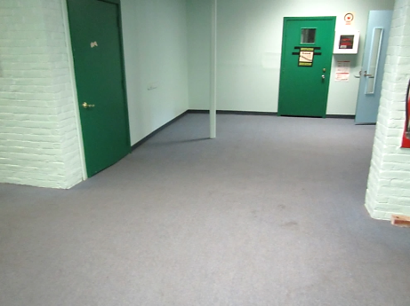
Sunken floor around support post in first floor main hallway
Picture 17
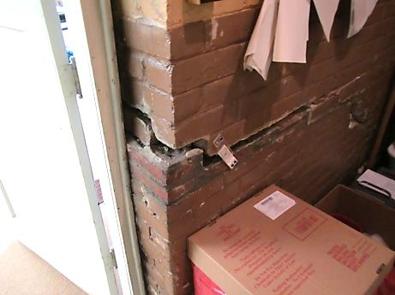
Separation of wall in storeroom adjacent to Board of Health office
Picture 18
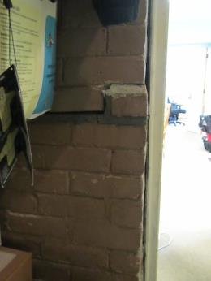
Wall crack on opposite side of door in Picture 17
Picture 19
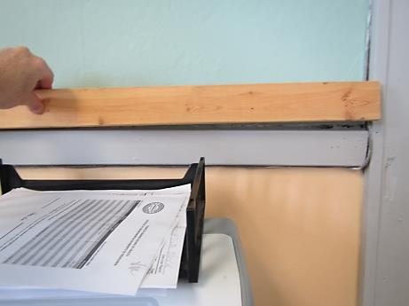
Wainscot bent by wall settling
Picture 20
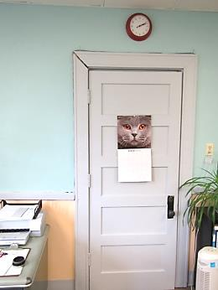
Distorted door frame
Picture 21
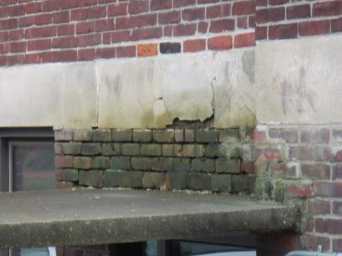
Brick, mortar and cement deterioration above main entrance roof
Picture 22
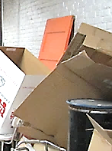
Painted door used as a control to test lead wipes
Picture 23
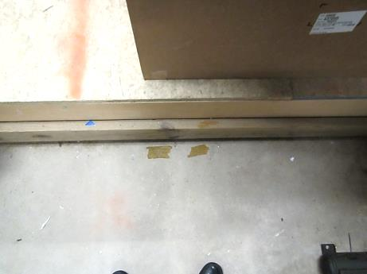
Example of floor location that tested negative for lead
Picture 24
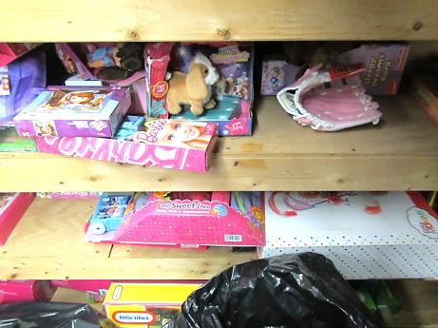
Location of shelf that tested positive for lead
Picture 25
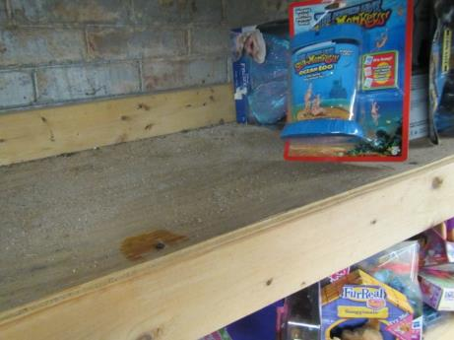
Location of shelf that tested positive for lead
Picture 26
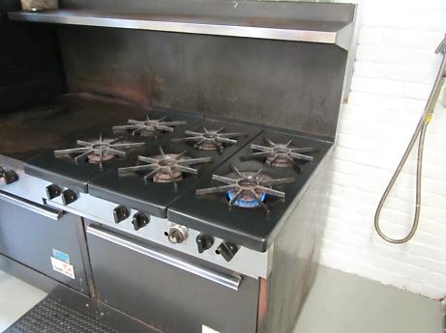
Propane-fueled gas stove
Picture 27
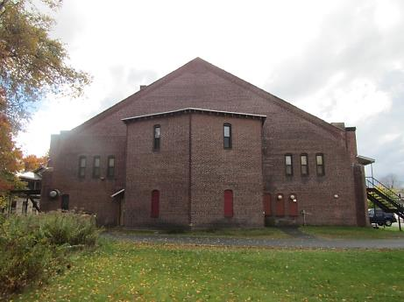
Kitchen exhaust fan

Location | Carbon  Dioxide  (ppm) | Carbon Monoxide  (ppm) | Temp  (°F) | Relative  Humidity  (%) | PM2.5  (µg/m³) | Occupants  in Room | Windows  Openable | Ventilation |  | Remarks
 |  |  |  |  |  |  |  | Supply | Exhaust
Background (Outdoors) | 401 | ND | 82 | 60 | 20 | 1
Board of Health | 647 | ND | 80 | 61 | 37 | 0 | Y | N | N | Window mounted air conditioner  Door open
Building Inspector | 532 | ND | 78 | 67 | 36 | 0 | Y | N | N
Music Room | 706 | ND | 77 | 64 | 23 | 0 | N | N | N
Hallway office by music room | 548 | ND | 77 | 66 | 25 | 0 | N | N | N
Dining room | 484 | ND | 78 | 69 | 23 | 11 | Y | N | N | Ceiling fan
Kitchen | 550 | ND | 81 | 67 | 25 | 1 | Y | N | N
Kitchen stove area | 497 | ND | 80 | 67 | 24 | 0 | Y | N | Y | Exhaust off  Gas stove
Walk in refrigerator | 522 | ND | 77 | 64 | 22 | 0 | N | N | N
Outreach | 612 | ND | 77 | 58 | 27 | 0 | Y | N | N | Window mounted air conditioner
Council on Aging | 507 | ND | 77 | 66 | 33 | 2 | Y | N | N | Window mounted air conditioner
Storeroom | 548 | ND | 77 | 66 | 19 | 0 | N | N | N
Basement | 477 | ND | 79 | 68 | 26 | 0 | N | N | N

Floor Location | Floor Temperature (ºF) | Moisture content (%) | Comment
Abandoned Pistol Range | 52-53 | 61-93 | Moisture patches on cement
Hallway of main entrance | 56-60 | 20-95 | Stained carpet
Main hallway carpeted section | 60-62 | 20-85
Main hallway painted cement area | 60-62 | 95-99
Dining room | 61-62 | 4-15
Council on the Aging | 69-72 | 8-10
Board of health | 65-67 | 4-66

Appendix A

What Can You Do in the House to Protect Children From Lead?

Temporarily Reducing Lead Paint Hazards by Cleaning
1. Wear plastic gloves to clean.
2. Pick up all chips by hand or use a damp paper towel (Window areas often have lots of paint chips)
- Seal chips and paper towels in a plastic bag and throw out.
Do not use a household vacuum or broom to clean up lead paint chips or dust!
3. Wash household surfaces
- Use TSP, a lead-specific detergent, or any all-purpose, non-abrasive cleaner.
- Scrub well for best results. (Don't scrub hard enough to remove the intact paint.)
- Clean window wells, window sills, play areas and floors at least once or twice a week.
- Keep children away when cleaning.
- Keep all cleaners safely away from children.
4. Use a spray bottle to keep dust levels down
- Use a cleaner already in a spray bottle, or put the cleaner into a spray bottle.
- If you must use a bucket, keep the wash water clean. Never put dirty paper towels into the wash water.
5. Use paper towels
- Don't use dish cloths or sponges to clean.
- Use a new paper towel to clean each area.
- Seal the used paper towels and gloves in a plastic bag and throw them out.
6. Rinse after cleaning
- Use clean water and paper towels for rinsing each area
7. Clean up properly
- Wash your hands when cleaning is done.
- Pour any wash and rinse water down the toilet, not the sink.
Important! Do not use a household vacuum or broom to clean up lead paint chips or dust. This could spread the lead dust into the air and into your vacuum cleaner or room.

This information is provided by the Childhood Lead Poisoning Prevention Program within the Department of Public Health. What Can You Do in the House to Protect Children From Lead?

