

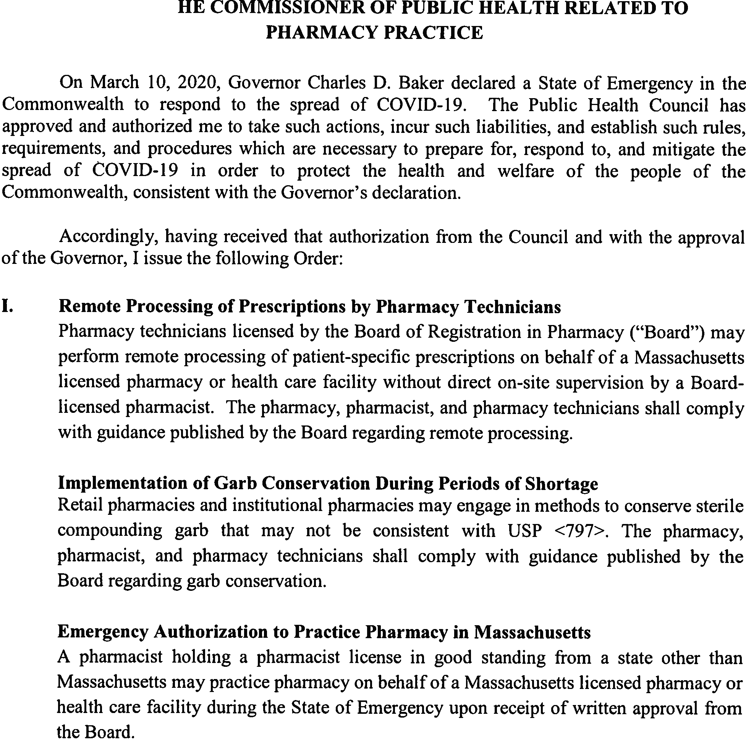

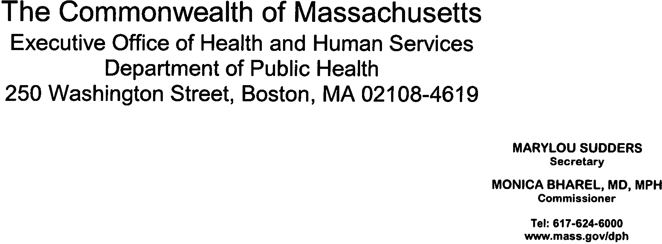









Emergency Order for Practice of Pharmacy 3.24.20 1 of 10

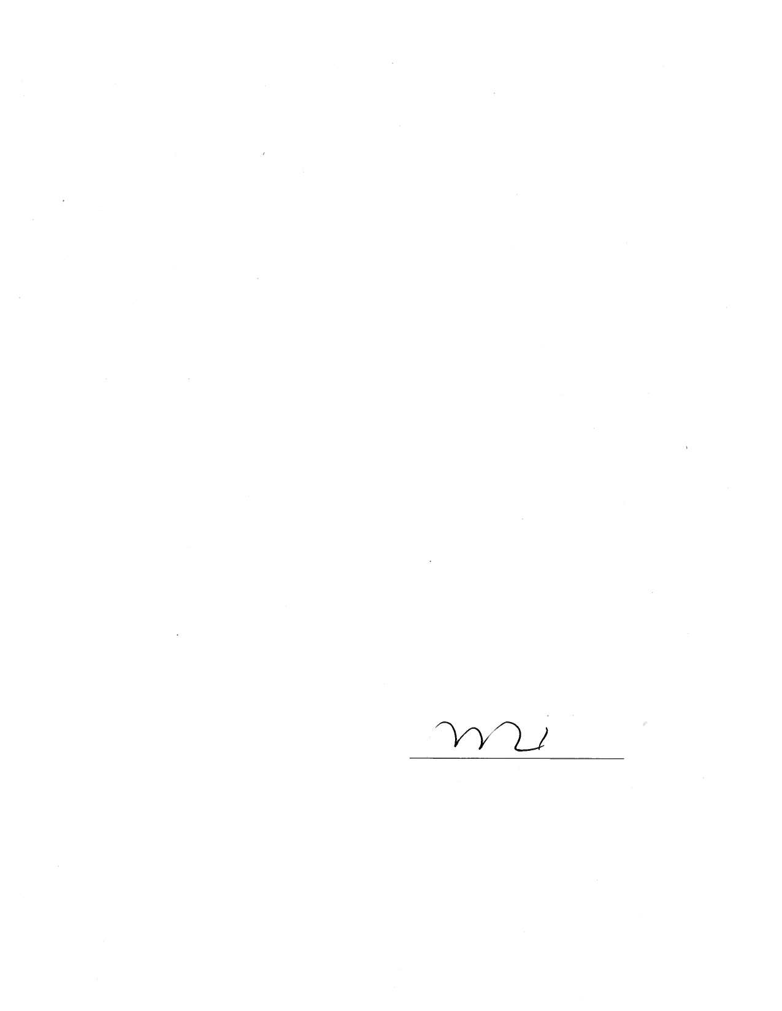

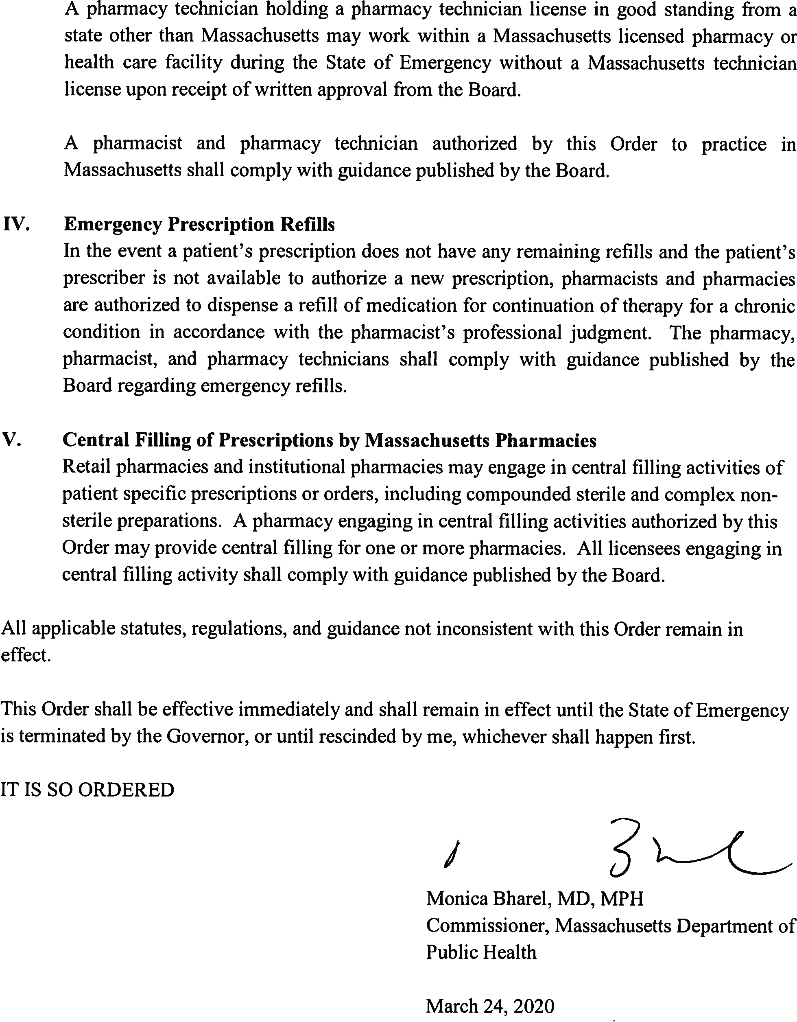

Emergency Order for Practice of Pharmacy 3.24.20 2 of 10

REMOTE PROCESSING BY PHARMACY TECHNICIANS

On March 10, 2020, Governor Charles D. Baker declared a State of Emergency in the Commonwealth to respond to the spread of COVID-19. On March 24, 2020, the Commissioner of Public Health issued an Order authorizing pharmacy technicians licensed by the Board of Registration in Pharmacy (“Board”) to perform remote processing of patient-specific prescriptions on behalf of a Massachusetts Board-licensed pharmacy without direct on-site supervision by a Board-licensed pharmacist.

Specifically, the Order authorizes pharmacy technicians to process patient-specific prescriptions outside of a Massachusetts licensed pharmacy or health care facility, provided the following requirements are satisfied:
- The pharmacy technicians are licensed by the Board.
- All prescription processing activities conducted by pharmacy technicians are reviewed and verified by a Massachusetts licensed pharmacist.
- Pharmacies must assure data security and establish controls to protect the confidentiality and integrity of Protected Health Information (PHI).
- The prescription processing activities comply with requirements set forth in Board Policy 2019-01, Shared Pharmacy Service Models Including Central Fill, Central and Remote Processing, and Telepharmacy (https://www.mass.gov/doc/policy-2019-01-shared- pharmacy-service-models-including-central-fill-central-and-remote/download).

All applicable statutes, regulations, guidance not inconsistent with the Order and this guidance remain in effect.

The Order and this guidance are effective immediately and shall remain in effect until the State of Emergency is terminated by the Governor, or the Order is rescinded by the Commissioner, whichever shall happen first.

IMPLEMENTATION OF GARB CONSERVATION DURING PERIODS OF SHORTAGE

On March 10, 2020, Governor Charles D. Baker declared a State of Emergency in the Commonwealth to respond to the spread of COVID-19. On March 24, 2020, the Commissioner of Public Health issued an Order authorizing retail pharmacies and hospital pharmacies that perform sterile compounding to implement measures to conserve protective garb.

Specifically, the Order authorizes retail pharmacies and institutional pharmacies that engage in sterile compounding to implement garb conservation measures during periods of documented shortage or potential shortage provided the following requirements are satisfied:
- The pharmacy develops and maintains a written policy that describes conservation measures to be undertaken and mitigation strategies to minimize risk of contamination.
- The pharmacy should implement USP Response to Shortages of Garb and Personal Protective Equipment (PPE) for Sterile Compounding During COVID-19 Pandemic for best practices during the shortage period: https://www.usp.org/sites/default/files/usp/document/about/public-policy/usp-covid19- garb-and-ppe.pdf
- The pharmacy should consider consulting with a microbiologist, infection control professional, or industrial hygienist for guidance on additional cleaning procedures and conducting more frequent environmental and personnel monitoring.

Beyond-Use-Dates (BUDs) should be the shortest possible to meet patient needs but may not exceed 30 hours room temperature or 9 days refrigerated.
- Garb used for non-sterile to sterile (i.e. high risk) compounding may not be reused.

Please refer to the following resources on COVID-19 for development of internal practices to facilitate appropriate response and safe practice.
- CDC’s Interim Guidance on preventing COVID-19 from spreading, which includes Strategies for Optimizing the Supply of N95 Respirators https://www.cdc.gov/coronavirus/2019-ncov/hcp/respirators-strategy/
- Healthcare Supply of Personal Protective Equipment https://www.cdc.gov/coronavirus/2019-ncov/hcp/healthcare-supply-ppe.html

- FDA’s Surgical Mask and Gown Conservation Strategies - Letter to Healthcare Providers https://www.fda.gov/medical-devices/letters-health-care-providers/surgical-mask-and- gown-conservation-strategies-letter-healthcare-providers
- NIOSH List of Antineoplastic and Other Hazardous Drugs in Healthcare Settings, 2016 https://www.cdc.gov/niosh/docs/2016-161/pdfs/2016-161.pdf
- Remediation Considerations for Handling Above Action Level Environmental Monitoring (EM) Results
https://www.mass.gov/advisory/remediation-considerations-for-handling-above-action- level-environmental-monitoring-em

All applicable statutes, regulations, guidance not inconsistent with the Order and this guidance remain in effect.

The Order and this guidance are effective immediately and shall remain in effect until the State of Emergency is terminated by the Governor, or the Order is rescinded by the Commissioner, whichever shall happen first.

CHARLES D. BAKER
Governor
KARYN E. POLITO
Lieutenant Governor

Board of Registration in Pharmacy
239 Causeway Street, Suite 500, Boston, MA 02114

Tel: 617-973-0860
Fax: 617-973-0980
TTY : 617-973-0988
.mass.gov/dph/boards/pharmacy

MARYLOU SUDDERS
Secretary
MONICA BHAREL, MD, MPH
Commissioner

EMERGENCY AUTHORIZATION FOR OUT-OF-STATE PHARMACISTS AND PHARMACY TECHNICIANS TO PRACTICE DURING THE COVID-19 STATE OF EMERGENCY

On March 10, 2020, Governor Charles D. Baker declared a State of Emergency in the Commonwealth to respond to the spread of COVID-19. On March 24, 2020, the Commissioner of Public Health issued an Order authorizing:

- A pharmacist holding a pharmacist license in good standing (without any disciplinary or non- disciplinary condition or restriction) from a state other than Massachusetts may practice in the same manner as a Massachusetts licensed pharmacist on behalf of a Massachusetts licensed pharmacy or health care facility during the COVID-19 emergency period; and

- a pharmacy technician holding a pharmacy technician license in good standing (without any disciplinary or non-disciplinary condition or restriction) from a state other than Massachusetts may work within a Massachusetts licensed pharmacy or health care facility during the COVID- 19 emergency period without a Massachusetts pharmacy technician license.

In order for a pharmacist or pharmacy technician licensed in another state to practice on behalf of a Massachusetts licensed pharmacy or health care facility, the pharmacist or pharmacy technician shall:

- submit the attached completed application to the Board;
- receive written authorization from the Board prior to engaging in practice; and
- comply with all Massachusetts laws and regulations.

The authorization to practice on behalf of a Massachusetts licensed pharmacy or health care facility in accordance with the Order and this guidance is only valid during the COVID-19 emergency period and only upon receipt of written approval from the Board.

CHARLES D. BAKER
Governor
KARYN E. POLITO
Lieutenant Governor

Bureau of Health Professions Licensure
239 Causeway Street, Suite 500, Boston, MA 02114

Tel: 617-973-0860
Fax: 617-973-0980
TTY : 617-973-0988
.mass.gov/dph/boards/pharmacy

MARYLOU SUDDERS
Secretary
MONICA BHAREL, MD, MPH
Commissioner

Application for Emergency Authorization for Out-of-State Pharmacists and Pharmacy Technicians to Practice During the COVID-19 State of Emergency

A pharmacist and pharmacy technician holding a pharmacist or pharmacy technician license in good standing from a state other than Massachusetts may practice pharmacy for a Massachusetts licensed pharmacy or health care facility during the COVID-19 emergency period, in accordance with guidance published by the Board of Registration in Pharmacy (“Board”), upon receipt of written approval from the Board to practice in Massachusetts.
Pharmacist |  | Pharmacy Technician
First Name |  | Last Name
Date of Birth [mm/dd/yyyy] |  | NABP ID#: (if applicable)
State currently practicing in: |  | License Number:
Street Address
City | State | Zip
Phone |  | Email
The pharmacy you will be assisting: |  | Location of Pharmacy

I attest that my license is in good standing with no restrictions in all jurisdictions in which I am licensed. I will abide by all Massachusetts laws and regulations. I understand this authorization is to be used only during the state of emergency that was declared by the Governor on March 10, 2020.

Signature of Applicant Date_

Print Name

Approved
Denied
Board Use Only
Date
Date
Signature of Executive Director or Designee

CHARLES D. BAKER
Governor
KARYN E. POLITO
Lieutenant Governor

239 Causeway Street, Suite 500, Boston, MA 02114

Tel: 617-973-0860
Fax: 617-973-0980
TTY : 617-973-0988
.mass.gov/dph/boards/pharmacy

MARYLOU SUDDERS
Secretary
MONICA BHAREL, MD, MPH
Commissioner



EMERGENCY PRESCRIPTION REFILLS

On March 10, 2020, Governor Charles D. Baker declared a State of Emergency in the Commonwealth to respond to the spread of COVID-19. On March 24, 2020, the Commissioner of Public Health issued an Order authorizing pharmacists and pharmacies to dispense emergency prescription refills in the event the prescriber is not available, in accordance with this policy.

Specifically, the Order authorizes pharmacies and pharmacists to dispense a refill of medication for continuation of therapy for a chronic condition when a prescription has no available refills, provided the following requirements are satisfied:
- Pharmacists must use their professional judgment to determine whether an emergency refill is necessary for patients to maintain access to prescription medication.
- The prescriber is not readily available to authorize a refill of the medication (i.e. within 72 hours).
- The maintenance medication for a chronic condition has been unchanged for at least 3 months.
- The refill prescription is reduced to writing and marked “emergency prescription.”
- The quantity is limited to a 30 day supply (or smallest available package size).
- Pharmacists will not be required to obtain a follow-up hard copy of the prescription from the patient’s provider.
- In the case of Schedule II controlled substances, an emergency supply may only be dispensed under existing DEA rules.
- The dispensing pharmacist shall notify the prescriber of the emergency dispensing within a reasonable time after such dispensing.

All applicable statutes, regulations, guidance not inconsistent with the Order and this guidance remain in effect.

The Order and this guidance are effective immediately and shall remain in effect until the State of Emergency is terminated by the Governor, or the Order is rescinded by the Commissioner, whichever shall happen first.

239 Causeway Street, Suite 500, Boston, MA 02114

Tel: 617-973-0860
Fax: 617-973-0980
TTY : 617-973-0988
.mass.gov/dph/boards/pharmacy

MARYLOU SUDDERS
Secretary
MONICA BHAREL, MD, MPH
Commissioner

CHARLES D. BAKER
Governor
KARYN E. POLITO
Lieutenant Governor

CENTRAL FILL

On March 10, 2020, Governor Charles D. Baker declared a State of Emergency in the Commonwealth to respond to the spread of COVID-19. On March 24, 2020, the Commissioner of Public Health issued an Order authorizing retail pharmacies and institutional pharmacies to serve as central fill pharmacies.

In accordance with the Order, retail pharmacies and institutional pharmacies may engage in central filling activities of patient specific prescriptions or orders, including compounded sterile and complex non-sterile preparations. A central fill pharmacy may provide central filling for one or more pharmacies.

Specifically, the Order authorizes Massachusetts retail pharmacies and institutional pharmacies to conduct central filling activities for other Massachusetts pharmacies, provided the following requirements are satisfied:
  - Pharmacies planning on serving as a central fill pharmacy must notify the Board or their licensing authority prior to engaging in the central filling of prescriptions.
  - The central fill activities comply with requirements set forth in Board Policy 2019-01, Shared Pharmacy Service Models Including Central Fill, Central and Remote Processing, and Telepharmacy (https://www.mass.gov/doc/policy-2019-01-shared-pharmacy-service- models-including-central-fill-central-and-remote/download).
  - In addition to their own patient needs, central fill pharmacies providing services for other pharmacies must have the capability to accurately and safely process and dispense the volume of prescriptions required.
  - Pharmacies must maintain data security and establish controls to protect the confidentiality and integrity of Protected Health Information (PHI).
  - Pharmacies shall comply with USP <795> and USP < 797>, as applicable.

All applicable statutes, regulations, guidance not inconsistent with the Order and this guidance remain in effect.

The Order and this guidance are effective immediately and shall remain in effect until the State of Emergency is terminated by the Governor, or the Order is rescinded by the Commissioner, whichever shall happen first.

