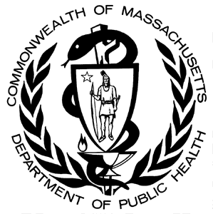
Occupational Health Surveillance Program
Massachusetts Department of Public Health

MATERIALS REQUEST FORM

Fax this form to (617) 624-5676 or e-mail it to sara.rattigan@state.ma.us.

Name: |  | Phone Number:
Company: |  | Fax Number:
Address: |  | Email address:

Please send me the following reports:
(Below is a selection of our most popular materials. All are FREE – quantities may be limited.)

General Workplace Health and Safety

Material Title Quantity

Occupational Illness and Injury Reporting Brochure ………………………………………………..

Occupational Illness and Injury Reporting Guidelines and Confidential Reporting Form ….……….

Workers’ Compensation in Massachusetts (English)………………………………………………

Portuguese………………………………………………………………………….

Spanish……………………………………………………………………………

Putting Data to Work: Occupational Health Indicators for Massachusetts ………………………

Occupational Health and Community Health Center (CHC) Patients: A Report on a Survey
Conducted at Five Massachusetts Community Health Centers ………………………………….

Lead at Work: Elevated Blood Lead Levels in Massachusetts, 1996-2001 ……………………..

Work-related Asthma

Material Title Quantity

What happens when I report a case of work-related asthma to the Massachusetts Department of
Public Health (MDPH)? Information for Health Care Providers………………………………………

SENSOR Occupational Lung Disease Bulletin (most current)...………………………………………

Fatal Work-related Injuries

Material Title Quantity

Massachusetts Fatal Injuries at Work: Annual Updates (most current)…………………..…………

Fatal Work-related Injuries among Brazilians in Massachusetts, 1999-2007 (English) ………….…..

Portuguese ………..…………………………………………………………………...

City Laborer Dies after Falling Off a Moving Refuse Collection Truck (English) ………..…………

Portuguese…...…………………………………………………..…………………….

Spanish…………..……………………………………………………………………..

Confined Space: Open-top tractor trailers loaded with loose material have the potential to engulf
and suffocate workers (English) ………….……………………………………………………………

Forklift Operator Crushed between Forklift Cage and Mast (English) …………..……………………

Portuguese…………....…………………………………………………………………

Spanish………….....…………………………………………………………………….

Carbon Monoxide Poisoning …………. ………………………………………………………………

Needlesticks and Other Sharps Injuries

Material Title Quantity

Sharps Injuries among Hospital Workers in Massachusetts, 2002-2009 Summary ……………………

Sharps Injuries among Medical Trainees, 2002-2009 Summary ………………………………………

Sharps Injuries in the Operating Room, 2004 ...………….…………………………………………….

Many more materials are available online from the Occupational Health Surveillance Program.

