INDOOR AIR QUALITY ASSESSMENT

Ordway Building
Amesbury Senior Center
9 School Street
Amesbury, Massachusetts

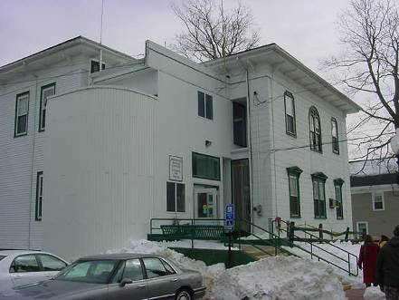

Prepared by:
Massachusetts Department of Public Health
Center for Environmental Health
Emergency Response/Indoor Air Quality Program
April 2007

Background/Introduction
At the request of Sharon White, Health Agent for the town of Amesbury, the Massachusetts Department of Public Health (MDPH), Center for Environmental Health (CEH) provided assistance and consultation regarding indoor air quality concerns at the Ordway Building (OB) located at 9 School Street, Amesbury, Massachusetts. On February 20, 2007, a visit was made to the OB to conduct an indoor air quality assessment by Cory Holmes, an Environmental Analyst in CEH’s Emergency Response/Indoor Air Quality (ER/IAQ) Program. Mr. Holmes was accompanied by Ms. Pamela Brown, (Director of the Amesbury Council on Aging), and Ms. White during the assessment. The assessment was prompted by concerns of potential mold growth on the second floor as well as general indoor air quality concerns in the building.
The OB is a two-story, wood-framed building (with basement) constructed in the early 1900s as a school. The building has undergone interior renovations over the years and currently houses the Amesbury Senior Center (ASC). The basement houses the Amesbury Emergency Operations Center (EOC) as well as an unfinished crawlspace that is used for storage. The first floor contains the ASC. At the time of the assessment, the second floor was unoccupied, with the exception of an office that is utilized by Ms. Brown and a computer room used by the ASC. Windows are openable throughout the building.
Due to previous IAQ concerns, the town of Amesbury hired Smith & Wessel Associates, Inc. (SWA), an environmental consulting firm to perform a mold assessment in selected areas at the OB. These areas included the stairwell, community development and elderly care areas. The stairwell in particular, was reported to have a history of chronic water penetration/damage. The SWA report recommended that mold-contaminated building materials be removed and replaced and that remediation be conducted using isolation methods outlined in the US Environmental Protection Agency’s document “Mold Remediation in Schools and Commercial Buildings” (SWA, 2005). At the time of the CEH assessment remediation had been completed, which included removal/replacement of mold-contaminated materials; and the installation of new windows in the stairwell and re-siding of portions of the exterior of the building to prevent water penetration (Picture 1).

Methods
In addition to taking various IAQ tests, CEH staff performed a visual inspection of building materials for water damage and/or microbial growth. Moisture content of porous building materials (e.g., carpeting, gypsum wallboard (GW), wood) was measured with Delmhorst, BD-2000 Model, Moisture Detector with a Delmhorst Standard Probe. Air tests for carbon dioxide, temperature and relative humidity were taken with the TSI, Q-TRAK™ IAQ Monitor, Model 8551.

Results
The ASC has a staff of 4 and can be visited by up to 80 individuals daily. The tests were taken during normal operations. Test results appear in Table 1.

Discussion
Ventilation
It can be seen from Table 1 that carbon dioxide levels were above 800 parts per million (ppm) in three of eight areas surveyed at the time of the assessment, indicating poor air exchange in these areas. However, it is important to note that several areas were unoccupied or sparsely populated, which can greatly reduce carbon dioxide levels. Carbon dioxide levels would be expected to be higher with increased occupancy. The building is not equipped with a modern mechanical ventilation system but relies on openable windows for air circulation. All windows in occupied areas were shut during the assessment; therefore the introduction of fresh outside air was minimal.
The Massachusetts Building Code requires that each room have a minimum ventilation rate of 20 cubic feet per minute (cfm) per occupant of fresh outside air or openable windows (SBBRS, 1997; BOCA, 1993). The ventilation must be on at all times that the room is occupied. Providing adequate fresh air ventilation with open windows and maintaining the temperature in the comfort range during the cold weather season is impractical. Mechanical ventilation is usually required to provide adequate fresh air ventilation.
Carbon dioxide is not a problem in and of itself. It is used as an indicator of the adequacy of the fresh air ventilation. As carbon dioxide levels rise, it indicates that the ventilating system is malfunctioning or the design occupancy of the room is being exceeded. When this happens, a buildup of common indoor air pollutants can occur, leading to discomfort or health complaints. The Occupational Safety and Health Administration (OSHA) standard for carbon dioxide is 5,000 parts per million parts of air (ppm). Workers may be exposed to this level for 40 hours/week, based on a time-weighted average (OSHA, 1997).
The MDPH uses a guideline of 800 ppm for publicly occupied buildings. (A guideline of 600 ppm or less is preferred in schools due to the fact that the majority of occupants are young and considered to be a more sensitive population in the evaluation of environmental health status). Inadequate ventilation and/or elevated temperatures are major causes of complaints such as respiratory, eye, nose and throat irritation, lethargy and headaches. For more information concerning carbon dioxide, please see Appendix A.
Temperature readings in occupied areas ranged from 65º F to 70 º F, which were below or at the lower end of the MDPH recommended comfort guidelines the day of the assessment. The MDPH recommends that indoor air temperatures be maintained in a range of 70 º F to 78 º F in order to provide for the comfort of building occupants. In many cases concerning indoor air quality, fluctuations of temperature in occupied spaces are typically experienced, even in a building with an adequate fresh air supply.
The relative humidity measured in occupied areas ranged from 18 to 27 percent, which was below the MDPH recommended comfort range the day of the assessment. The MDPH recommends a comfort range of 40 to 60 percent for indoor air relative humidity. Relative humidity levels in the building would be expected to drop during the winter months due to heating. The sensation of dryness and irritation is common in a low relative humidity environment. Low relative humidity is a very common problem during the heating season in the northeast part of the United States.

Microbial/Moisture Concerns
As mentioned, one of the primary concerns prompting the request for an IAQ assessment was related to potential mold growth in unoccupied areas on the second floor. For building materials to support mold growth, a source of water exposure is necessary. To determine moisture content, CEH staff conducted testing of porous building materials in occupied areas. Materials with increased moisture content over normal concentrations may indicate the possible presence of mold growth. All materials tested were found to have low (i.e., normal) moisture content and appeared to be free of visible mold colonization at the time of the assessment (Table 1).
It is important to note that moisture content of materials measured is a real-time measurement of the conditions present in the building at the time of the assessment. Repeated water damage to porous building materials can result in microbial growth. The US Environmental Protection Agency (US EPA) and the American Conference of Governmental Industrial Hygienists (ACGIH) recommend that porous materials be dried with fans and heating within 24 to 48 hours of becoming wet (US EPA, 2001; ACGIH, 1989). If not dried within this time frame, mold growth may occur. Once mold has colonized porous materials, they are difficult to clean and should be removed.
Although no visible mold growth was observed on the second floor, several potential sources of moisture were observed. Most notably, water stained gypsum wallboard (GW) in the men’s restroom. The ceiling of the men’s room is constructed of GW, which was visibly water damaged, most likely from roof (or possibly plumbing) leaks in the attic (Picture 2).
Another potential source of moisture was an open window observed in the former Recreation Director’s office. It was reported that staff from this area were relocated to the building directly adjacent to the OB. To maintain communications, phone and other cables are fed through the window across the lawn and into the second floor window of the building next door (Picture 3). Although this configuration appears to be temporary, the windows cannot be shut completely which can provide a source for drafts, moisture and pest entry.
Water damaged boxes were observed stored on the floor in a second floor closet (Picture 4). These boxes and the materials stored therein should be inspected and discarded if moldy.
Water damaged ceiling tiles were observed in the EOC. Water-damaged ceiling tiles can provide a source for mold growth and should be replaced after a water leak is discovered and repaired. Moisture measurements of the tiles during the assessment were low (i.e., normal), which indicate they are likely from a previous plumbing leak.
Visible mold growth was observed on porous materials stored in the basement crawlspace adjacent to the EOC (Pictures 5 and 6). The crawlspace is unfinished/unconditioned and is susceptible to elevated moisture conditions (e.g., >70%) during spring/summer months. Therefore is not an ideal space to store materials that are susceptible to mold growth such as paper or cardboard. Missing/damaged mortar around brick was observed in this area from which light could be seen penetrating (Picture 7). Breaches in the building envelope such as this can allow for the introduction of uncontrolled moisture into the crawlspace.
MDPH staff examined the outside perimeter of the building and identified several potential issues that could provide a source of water penetration into the building, these included:
- Damaged/leaking gutters and downspouts (Picture 8),
- Damaged foundation masonry (Picture 9),
- Spaces around plywood plugs that are inserted in place of windows (Picture 10),
- Missing flashing/cladding (Picture 11), and
- Snow drifts against the exterior door (Picture 12), which can also inhibit emergency egress.
The aforementioned conditions represent potential water penetration sources. Over time, these conditions can undermine the integrity of the building envelope and provide a means of water entry into the building via capillary action through foundation concrete and masonry (Lstiburek & Brennan, 2001). In addition, some of these breaches may also provide a means of entry for pests/rodents into the building.
Water damaged wooden floors were observed in the recreation room, which reportedly occurred due to a previous leak. Moisture measurements were low/normal. The water damaged section of the floor was physically damaged, bowed and gave way when stepped upon. Although, this water damage does not pose a health issue it does pose a safety issue, particularly due to the age of occupants in the building.
Window-mounted air conditioners (ACs) were observed in several areas. These units are normally equipped with filters, which should be cleaned or changed as per manufacturer’s instructions to avoid the build-up and re-aerosolization of dirt, dust and particulate matter. Several of the units were missing filters and the cooling fins were occluded with dust and debris, which can provide a mold growth media when moistened.

Other IAQ Evaluations
Several other conditions that can affect indoor air quality were noted during the assessment. Mechanical exhaust vents in restrooms on both the first and second floors were not operating at the time of the assessment. Exhaust ventilation is necessary in restrooms to remove moisture and to prevent restroom odors from penetrating into adjacent areas. In addition restrooms had automatic air freshener dispersal units (Picture 13). These products contain chemicals that can be irritating to the eyes, nose and throat of sensitive individuals. Furthermore, air fresheners do not remove materials causing odors, but rather mask odors that may be present in the area.
Exposed fiberglass insulation was observed around pipes in the ASC store room (Picture 14) and in the attic. Exposure to fiberglass can serve as a skin and respiratory irritant. In the case of the pipes they should be re-wrapped (Picture 15). To avoid exposure to fiberglass and other accumulated dust and particulates in the attic, the access hatch should be replaced. Open utility holes, missing outlet covers and spaces along floors were observed in several areas throughout the building (Pictures 16 through 18). These breaches can serve as a means for odors, dusts and particulates to migrate between rooms and floors.

Conclusions/Recommendations
In view of the findings at the time of the visit, the following recommendations are made to improve indoor air quality:
- Refrain from storing porous materials in the crawlspace.
- Inspect and discard any water damaged/mold colonized materials in the crawlspace as well as in the second floor stairwell storage closet. Disinfect any non-porous surfaces of microbial growth with a mild detergent or antimicrobial, wipe clean surfaces with soap and water after disinfection.
- Utilize dehumidifiers in below grade areas to reduce relative humidity as needed. Ensure dehumidifiers are cleaned and maintained as per the manufacture’s instruction to prevent microbial growth.
- Work with a roofing contractor to identify/isolate and repair roof leaks damaging ceilings in the second floor men’s restroom. Once leaks are repaired, remove and replace water damaged GW.
- Ensure leaks are repaired and remove/replace water-damaged ceiling tiles in the EOC. Examine the area above and around these areas for mold growth. Disinfect areas of water leaks with an appropriate antimicrobial or mild detergent.
- Ensure exterior doors are free from snow drifts to prevent water damage and to provide egress in the event of an emergency.
- Install filter media in portable air conditioners and clean cooling fins prior to use. Disinfect with an appropriate antimicrobial if necessary. If filtration media cannot be acquired consider replacing AC units.
- Replace water damaged subfloor in recreation room to avoid a tripping/safety hazard.
- Seal utility holes, spaces around floors and replace missing outlet covers to eliminate paths of odor/particulate migration from wall/floor cavities into occupied areas.
- Re-wrap exposed fiberglass insulation around pipes in the ASC storeroom.
- Replace attic access hatch.
- Use windows as designed to provide air exchange. Care should be taken to ensure windows are properly closed at night and on weekends to avoid the freezing of pipes and potential flooding.
- Restore exhaust ventilation in restrooms to remove odors and moisture, make repairs as necessary.
- For buildings in New England, periods of low relative humidity during the winter are often unavoidable. Therefore, scrupulous cleaning practices should be adopted to minimize common indoor air contaminants whose irritant effects can be enhanced when the relative humidity is low. To control for dusts, a high efficiency particulate arrestance (HEPA) filter equipped vacuum cleaner in conjunction with wet wiping of all surfaces is recommended. Drinking water during the day can help ease some symptoms associated with a dry environment (e.g. throat and sinus irritations).
- Make any needed repairs to building envelope (e.g., repointing brick foundation) to prevent water infiltration and subsequent water damage.
- Seal around windows and plywood plugs, as shown in Picture 10, to eliminate drafts/moisture/pest entry.
- As a temporary measure to prevent water penetration/pest entry, seal space from open window in former recreation office with duct tape.
- Repair/replace missing/damaged gutters and downspouts to collect and drain water away from the building.
- Repair/replace missing flashing/cladding shown in Picture 11.
- Refrain from using strongly scented materials (e.g., air fresheners).
- Consult “Mold Remediation in Schools and Commercial Buildings” published by the US EPA (US EPA, 2001) for further information on mold and/or mold clean up. Copies of this document are available from the US EPA: http://www.epa.gov/iaq/molds/mold_remediation.html.
- Refer to the resource manual and other related indoor air quality documents for further building-wide evaluations and advice on maintaining public buildings. These documents are available on the MDPH’s website: http://mass.gov/dph/indoor_air.

References

ACGIH. 1998. American Conference of Governmental Industrial Hygienists. Industrial Ventilation A manual of Recommended Practice. 23rd Edition.

BOCA. 1993. The BOCA National Mechanical Code/1993. 8th ed. Building Officials and Code Administrators International, Inc., Country Club Hill, IL. Section M-308.1.1.

Lstiburek, J. & Brennan, T. 2001. Read This Before You Design, Build or Renovate. Building Science Corporation, Westford, MA. U.S. Department of Housing and Urban

OSHA. 1997. Limits for Air Contaminants. Occupational Safety and Health Administration. Code of Federal Regulations. 29 C.F.R 1910.1000 Table Z-1-A.

SBBRS. 1997. Mechanical Ventilation. State Board of Building Regulations and Standards. Code of Massachusetts Regulations. 780 CMR 1209.0

SWA. 2005. Smith & Wessel Associates, Inc., Mold Assessment, 9 School Street, Amesbury, MA. Dated November 18, 2005.
US EPA. 2001. “Mold Remediation in Schools and Commercial Buildings”. Office of Air and Radiation, Indoor Environments Division, Washington, DC. EPA 402-K-01-001. March 2001. Available at: http://www.epa.gov/iaq/molds/mold_remediation.html
Picture 1

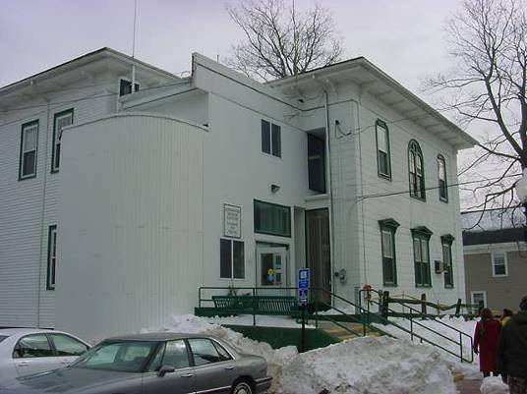

Front of Ordway Building Showing new Windows and Siding (Front Left) Stairwell

Picture 2

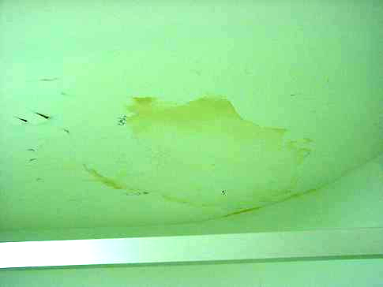

Water Damaged Gypsum Wallboard Ceiling and Peeling Paint in Second Floor Men’s Room

Picture 3

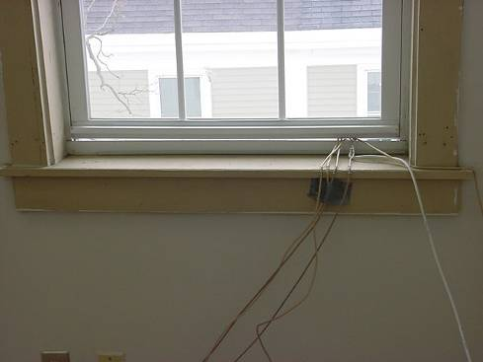

Wires/Cables Fed out Window in Former Recreation Office over to Adjacent Building

Picture 4
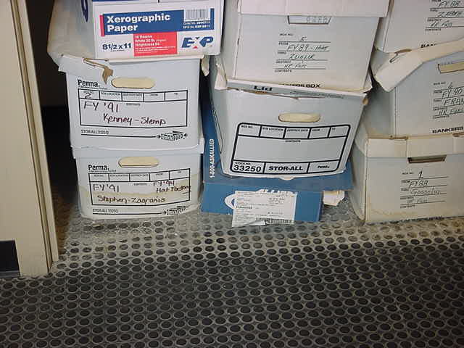

Water Damaged Boxes in Second Floor Stairwell Storage Closet
Picture 5

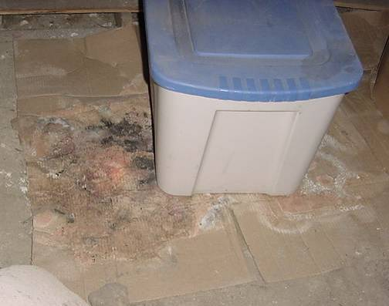

Mold Colonized Cardboard (as Indicated by Dark Stains) in Unfinished Crawlspace

Picture 6

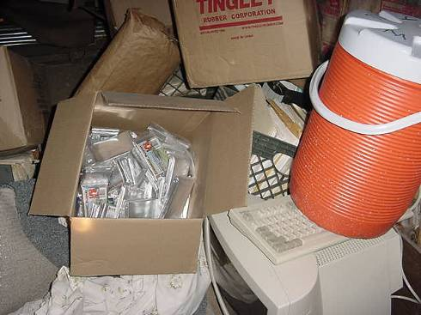

Cardboard Boxes, Paper Bags and Pieces of Carpeting Stored in the Unfinished Crawlspace
Picture 7

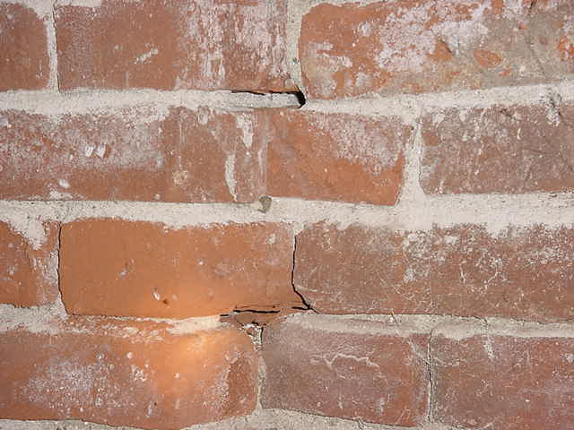

Missing/Damaged Mortar around Bricks through Which Light Could be Seen Penetrating, Picture Taken from Interior of Unfinished Crawlspace

Picture 8

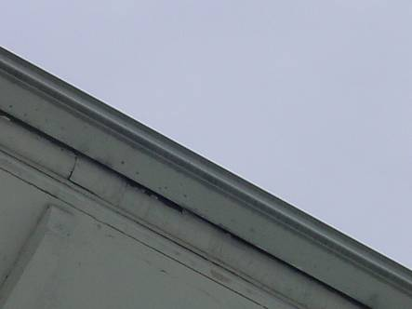

Water Dripping From Breaches on Underside of Gutter
Picture 9

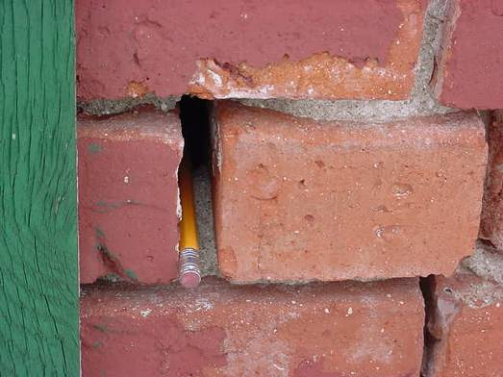

Missing/Damaged Mortar around Exterior Brick, Pencil Inserted by CEH Staff to Show Depth

Picture 10

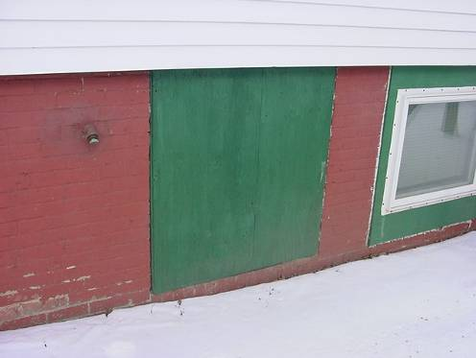

Spaces around Plywood Plugs Inserted in Windows
Picture 11

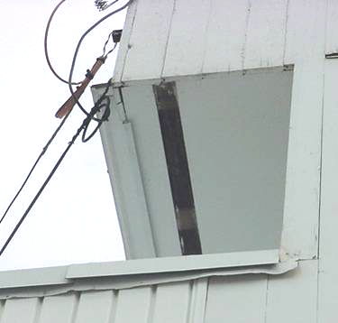

Missing Flashing/Cladding Exposing the Underside of the Building Exterior

Picture 12

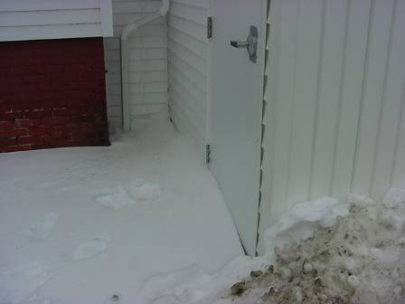

Snow Drift against Exterior Door
Picture 13

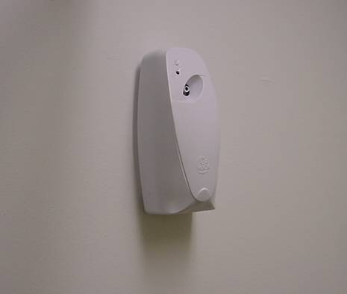

Automatic Air Freshener Dispersal Unit in Restroom

Picture 14

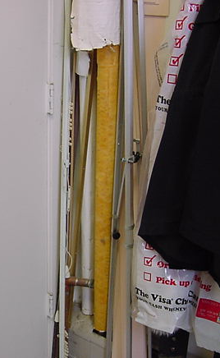

Exposed Fiberglass Pipe Insulation in ASC Storage Room
Picture 15

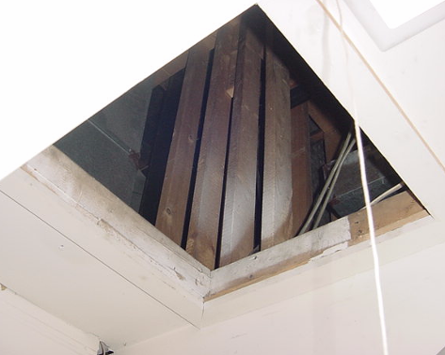

Open Access Hatch to Attic

Picture 16

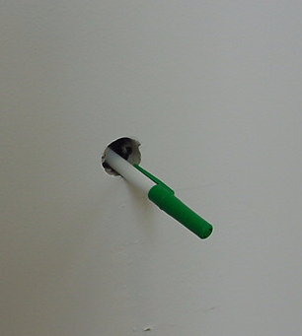

Open Hole in Wall in Second Floor Office, Pen Inserted by CEH Staff to Show Depth
Picture 17

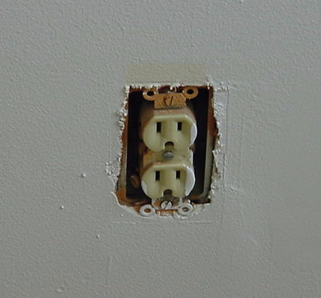

Missing Outlet Cover on Second Floor

Picture 18

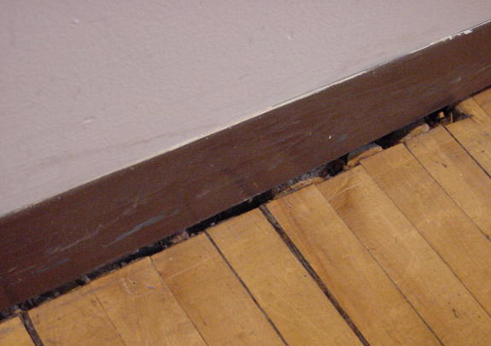

Open Spaces between Floor and Wall (Second Floor)
Location | Carbon  Dioxide  (*ppm) | Temp  (°F) | Relative  Humidity  (%) | Occupants  in Room | Windows  Openable | Ventilation |  | Remarks
 |  |  |  |  |  | Supply | Exhaust | Remarks
Outside  (Background) | 423 | 40 | 20 |  |  |  |  | Cold, SW winds 5-10 mph
Director Council on Aging Office | 905 | 69 | 21 | 3 | Y | N | N
Ladies 2nd Floor Restroom |  |  |  |  | N | N | Y | Exhaust not operating, automatic air freshener dispersal system
Hallway |  |  |  |  |  |  |  | Spaces along floor/wall
Custodial Closet |  |  |  |  | N | N | Y | Water damaged ceiling-low moisture
Men’s Room |  |  |  |  | N | N | Y | Exhaust not operating, automatic air freshener dispersal system, water damaged ceiling-low moisture
MRC | 741 | 67 | 19 | 0 | Y | N | N | Low moisture measurements wood/carpet
Former Recreation Director’s Office | 730 | 68 | 18 | 0 | Y | N | N | Window open to feed cables to adjacent building-cant shut, missing outlet covers, open utility holes/spaces along floor/wall, low moisture measurements wood/carpet
Former Community Development Office | 718 | 67 | 18 | 0 | Y | N | N | AC, spaces along floor/exterior door, Water damaged floor-former pipe leak, low moisture measurements wood/carpet
Community Development & Recreation Storage Closet | 637 | 65 | 23 | 1 | N | N | Y | Water damaged boxes stored on floor
ASC Storeroom |  |  |  |  |  |  |  | Exposed fiberglass insulation around pipes, boxes on tile floor
Lower Level Men’s Room |  |  |  |  | N | N | Y | Exhaust not operating, water damaged wall plaster-low moisture
Lower Level Ladies’ Room |  |  |  |  | N | N | Y | Exhaust not operating
Health Office | 769 | 69 | 27 | 0 | Y | N | N | Radiator reportedly not functioning
Thrift Shop | 1604 | 69 | 27 | 20 | Y | N | N | Accumulated items-dust, no filter on AC-coils occluded with dust/debris
Recreation Room | 1467 | 70 | 26 | 20 | Y | N | N | Water damaged floor-low moisture, loose-safety/tripping hazard
EOC | 757 | 66 | 25 | 2 | N | N | N | Water damaged plaster/ceiling tiles-low/normal moisture measurements
Restroom |  |  |  |  | N | N | Y | Exhaust vent not functioning
Crawlspace |  |  |  |  |  |  |  | Mold colonized porous materials (cardboard/paper), missing/damaged mortar around brick-light penetration

