Information Session for Organizations Interested in Becoming Certified Application Counselors (CACs)
Executive Office of Health and Human Services
March 20, 2023

Slide 2

The Certified Application Counselor (CAC) Program
- In Massachusetts, the CAC program is a joint program administered by MassHealth and supported by the Massachusetts Health Connector
- CACs help people:
  - Apply for insurance benefits
  - Enroll in health plans
  - Maintain health insurance coverage
- CACs provide optional assistance to individuals who seek out their help
  - Individuals do not need a CAC to apply for or receive benefits
- Being a CAC is a volunteer position
  - CACs are not employees of MassHealth
  - No one is paid for becoming a CAC or performing the responsibilities of a CAC

Slide 3

Becoming a CAC
An organization must first partner with MassHealth and the Massachusetts Health Connector
Current CAC designated organizations include but are not limited to:
- Hospitals
- Community Health Centers
- Nonprofits or Community- Based Organizations

Then, the organization can designate or select individuals who work or volunteer to become CACs
- Not all employees or volunteers need to become CACs
- However, at least one person from the organization must go through training and become certified
Being a CAC requires certification and comes with certain responsibilities
- To become certified, CACs must complete a self-paced, online training and an annual refresher
- CACs are employed by their organization, but receive and need to maintain training and certification from MassHealth and the Health Connector

Slide 4

Benefits and Responsibility of Becoming a CAC or CAC Organization
Responsibilities
- Work or volunteer for a CAC organization that has partnered with MassHealth and the Massachusetts Health Connector
- Complete initial CAC training, maintain CAC status, as well as yearly recertification
- Be willing and able to not turn away any individual who comes to them seeking assistance, including individuals who are not previous clients but have sought assistance

Benefits
- Once a CAC organization, you can designate anyone else in your org go become a CAC
- You will be prepared to help individuals complete an application or renewal
- You will have access to certain MassHealth and Health Connector systems to be able to see the status of applications and renewals

Slide 5

Responsibilities of CACs
CACs DO:
- Provide information about the full range of health care coverage options and programs offered by MassHealth and the Health Connector
- Help individuals complete and submit applications or renewals
- Work with individuals to provide required documentation when applying for or renewing coverage
- Interact with MassHealth and the Health Connector on the status of applications and renewals
- Help to facilitate enrollment into health care programs

CACs DO NOT:
- Make decisions about whether individuals are eligible for any public health insurance program
- Assist with private health insurance
- Get paid by MassHealth for their work as CACs
- Charge for services they provide as a CAC

Slide 6

How People Find CACs
Individuals can find a Certified Assister close to them by using the Find Local Help tool at mahealthconnector.org/
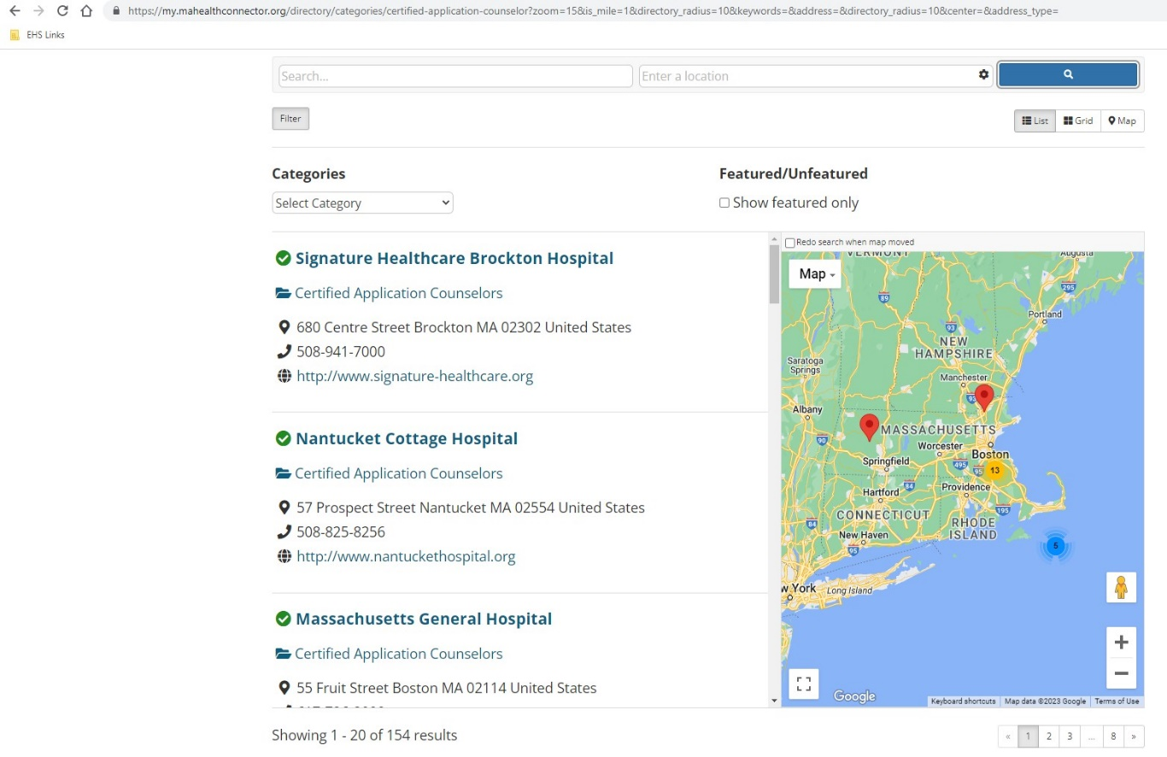

Side 7

Questions?
If you are interested in having your organization join the CAC Program, please email mailto:mahealthconnectortraining@massmail.state.ma.us

Health plans and health insurance companies cannot become CAC organizations

