The Massachusetts Office for Refugees and Immigrants

ANNUAL REPORT 2018
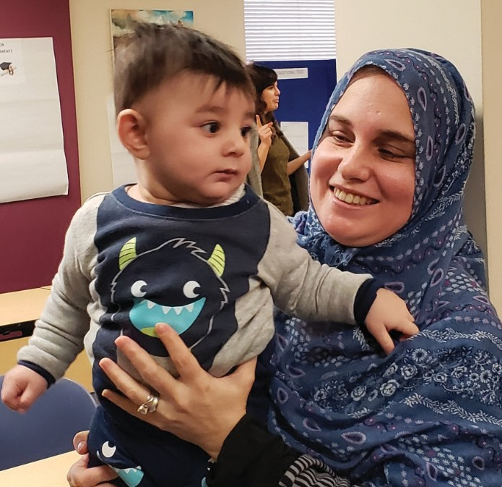

CHARLES D. BAKER Governor
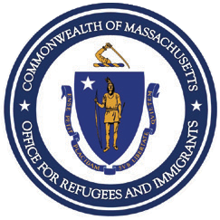KARYN POLITO Lieutenant Governor
MARYLOU SUDDERS Secretary of Health & Human Services
MARY TRUONG Executive Director

Cover Photo: Refugee mom and child participated in ORI’s Town Hall Meeting in Lowell

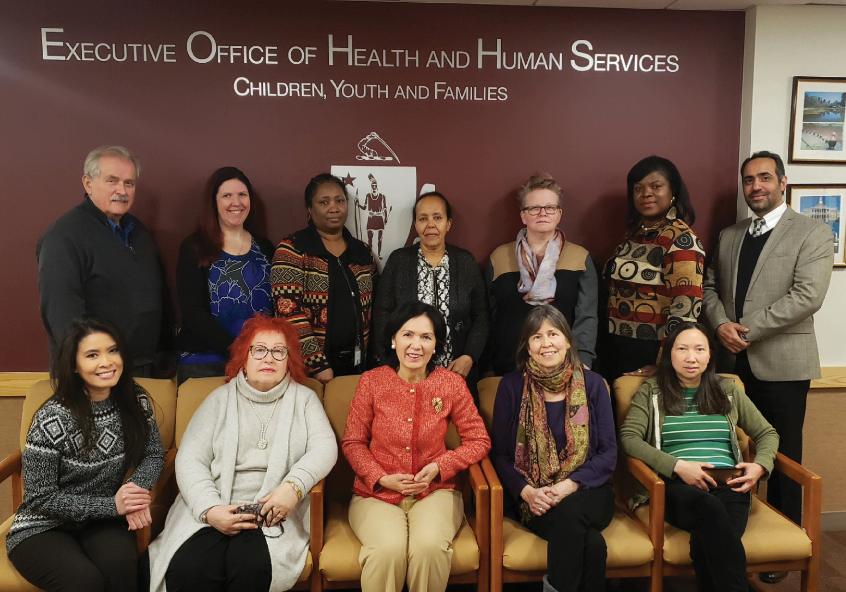

Annual Report 2018

OUR MISSION.

Promote the full participation of refugees and immigrants as self-sufficient individuals and families in the economic, social, and civic life of the Commonwealth.

ABOUT ORI

The Massachusetts Office for Refugees and Immigrants (ORI) administers programs that provide direct services to clients through a network of community partners including sister agencies, resettlement agencies, faith-based and ethnically grounded organizations, all of which cooperate to meet the needs of our culturally and linguistically diverse newcomer populations.

WELCOME FROM
GOVERNOR CHARLIE D. BAKER
“

The Baker-Polito Administration values the immigrant community’s
role in making Massachusetts a vibrant and competitive commonwealth. Massachusetts has long benefited from the significant contributions that persons who come to the United States from other countries make to our economy and our communities.

CONTENTS

MESSAGE FROM THE EXECUTIVE DIRECTOR 6
EXECUTIVE SUMMARY 8
REFUGEE POPULATION DEMOGRAPHICS 10
EMPLOYMENT SERVICES 12
EMPLOYMENT SERVICES (CONT.) 14
FINANCIAL LITERACY FOR NEWCOMERS 16
CHILDREN AND YOUTH SERVICES 18
COMMUNITY AND ELDERS SERVICES 20
HEALTH SERVICES 22
CITIZENSHIP SERVICES 24
TOWN HALL MEETINGS 26
SUCCESS STORIES 28
COMMUNITY PARTNERSHIP 30
FINANCIALS 32
ACKNOWLEDGMENT 34

MESSAGE FRO EXECUTIVE DIR
Dear Friends,
Over the past year, much attention has been paid worldwide to refugees and immigrants. Sadly, also, in many places, hostility has been expressed towards them. Immigration policies have generated bitter controversy, in Asia and Europe as well as in United States. Meanwhile, millions of individuals across the globe are fleeing war, persecution, poverty, and famine. In this crisis, Massachusetts has reaffirmed its commitment to serve as a source of hope,
6 welcoming those seeking refuge with open arms, and ensuring, by offering a wide range of services, that newcomers feel safe, valued, and supported as they integrate into new communities. In Federal Fiscal year
2018 (FFY2018), the generous people of our Commonwealth happily welcomed 783 individuals. In comparison with FFY2017 though, the number of arrivals in Massachusetts has dropped by 60% as a result of lowering the national refugee admission ceiling to 45,000. Nevertheless, in FFY2018 ORI has served more than 6,500 refugees and immigrants across all federal, state and private-funded programs. We at ORI believe this welcoming spirit and
the efficacy of our programs may set an important example for others who seek to keep our nation a land of liberty and opportunity.

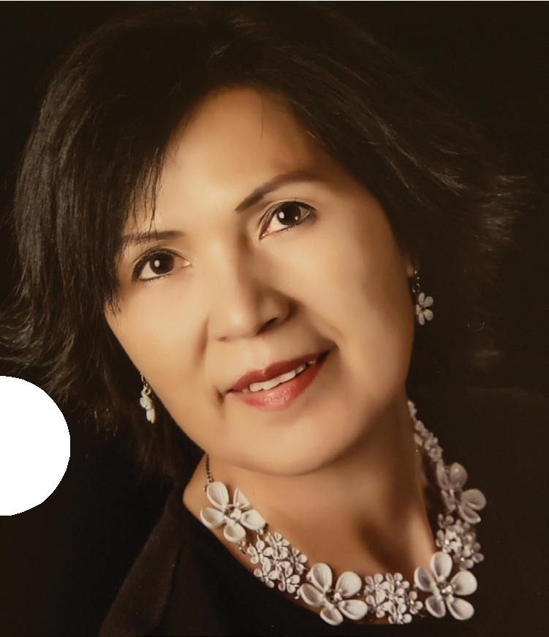M THE ECTOR.

As the number of newcomers decreases, ORI continues to provide essential core services that focus on employment, English language skills, and, above all, self-sufficiency. Training in financial literacy, for example, can prevent disaster for persons unfamiliar with our banking system and credit practices.
Citizenship services are crucial to promoting inclusion, and, in
a period with fewer newcomers, we can intensify our efforts with legal residents now eligible to naturalize. ORI is determined to persevere in our mission, working to diversify our outreach to
our newcomers. We are eager also to foster awareness of the 7
significant contributions immigrants and refugees have made, throughout our history, to our state and our nation.
Although we anticipate a further reduction in new arrivals in FFY2019, we will continue our mission to serve vulnerable populations newly residing in the Commonwealth, providing access to services such as healthcare and education. As we meet new challenges, I would like to extend my heartfelt thanks to our service providers, community supporters, and ORI staff members for their hard work and continued support of the MA Refugee Resettlement Program. Your dedication and constant advocacy on behalf of refugees and immigrants not only creates a better Massachusetts for each and every citizen, but sets a national example of compassion and respect for human dignity.

Mary Truong
Executive Director

EXECUTIVE SU

Over the last year, ORI worked diligently to expand and strengthen its partnerships with service providers and stakeholders to ensure providing high quality
and locally accessible services to its refugee and immigrant populations. In brief:

- More than 45 workshops have been delivered in 3 regions of the state to equip more than 220 participants with
knowledge necessary for them to take control of their finances.

- One thousand eight hundred and ten (1,810) Massachusetts’ lawful permanent residents enrolled in ORI Citizenship for
8 New Americans Program.

- Over 1,190 refugees participated in various employment programs. Of those, more than 760 obtained employment, with hourly wages from $11.00 to $13.24 per hour.

- ORI successfully assisted 149 unaccompanied minors into appropriate housing and care.

Youth Adjustment Services helped 111 young newcomers
through their transition into living in Massachusetts communities.

- More than 170 refugee and immigrant elders received ORI’s services to refugee elders.

MMARY.

  - Refugee Community Services provided 665 refugees with assistance to access and understand mainstream service systems and local resources.

  - ORI’s health promotion services reached out to over 590 individuals and helped them with their medical needs.
9
  - More than 600 newly-arrived refugees and immigrants received early medical screening services with more than 99% making successful transition to primary care.

  - ORI Refugee School impact program served 722 young people and 337 parents around the state to ensure better academic achievement for children.

  - ORI visited refugees and immigrants in their home towns and cities to learn about their struggle and success. More than 180 individuals participated.

REFUGEE POPU DEMOGRAPHIC

In FFY2018, Massachusetts welcomed individuals from more than 49 countries. The largest populations came from The Democratic Republic of the Congo, Haiti, Afghanistan, Ukraine, and El Salvador. The following infographics represent our newcomers’ nationalities, age distribution, and resettlement locations in the
last year.

NEW ENROLLEES
BY AGE DISTRIBUTION
10
63%
25%
11%

1%

NEW ENROLLEES

18 through 64 years

5 through 17 years Newborn through 4 years 65+ years
“ I came to the United States because I was running from a civil
war in Congo. When I got here, I was wondering how I was going to survive in this new environment, and International Institute of New England (IINE),
an ORI’s service provider, helped me feel like I was not alone. They found me my first job, and then I told them I want to advance my

BY IMMIGRATION STATUSES
Overseas Refugees
15%
62%
15%
7%
1%
No Connection “Free” 21%
Moved to MA “Secondary Migrant” 2%
Tied to the Community “U.S. Tie” 39%

Cuban or Haitian Entrant Asylee
Special Immigrant Visa Holder (Iraq or Afghan)

Certified Victim of Trafficking
career and they told me about
a Skills Training program for careers in hotels, hospitals and banks. I took the class for
2 months and now I’m working at the Renaissance Boston Waterfront hotel and I’m very grateful. I don’t know what I would do without IINE.
- Uwezo, an enrollee from Democratic Republic of the Con-

LATION S.
NEW ENROLLEES BY COUNTRY OF ORIGIN

Afghanistan 9.32%

11
Nepal
2.68%
Uganda
3.70%
El Salvador
7.79%
Ukraine 9.07% Bhutan 5.24%
Nepal 2.68%
El Salvador 7.79%
Uganda 3.70%
Haiti 15.71%

DR Congo 19.41% Other Countries 27.08%

RESETTLEMENT REGIONS BY PERCENTAGE (%)

Western Massachusetts:
Agawam, Amherst, Chicopee, Greenfield, Holyoke, Northampton, Pittsfield, Springfield, W. Springfield, Westfield

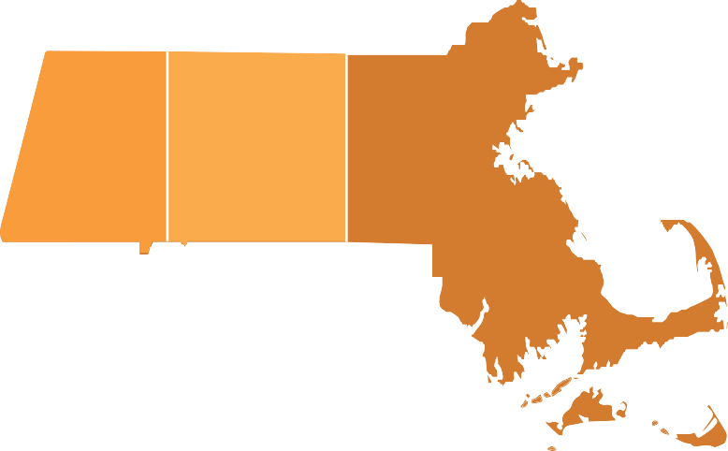Eastern Massachusetts:
30%
15%
55%
Merrimack Valley:
Lowell, Lawrence
Greater Boston:
Boston, Brockton, Cambridge, Chelsea, Everett, Frammingham, Lynn, Malden, Revere, Salem

Central Massachusetts:
Worcester, Fitchburg, Leominster

CASH ASSISTANCE TERMINATIONS & REDUCTIONS

EMPLOYMENT OUTCOMES

73%

27%
65% 26%

9%

Cash Assistance Terminations Cash Assistance Reductions
Refugees Obtaining 1st Employment

Refugees Receiving Pre-employment English Training

Refugees Obtaining Upgrades

12

ACCESSED VOCATIONAL SKILLS TRAININGS

Driver’s Education Training 87
Customer Service 78
Health Sciences/Elder Care 62
Computer for Office Use 29
Hospitality 26
Banking Industry Training 14
Food Service Training 13
Medical Interpretation 4
0 20 40 60 80 100

The Massachusetts Office for Refugees and Immigrants

EMPLOYMENT SERVICES.

Employment services help all employable individuals obtain their first job, retain employment, and identify career laddering opportunities. Bilingual
and bicultural staff provides intensive counseling and mentoring to support economic independence and reduce welfare
dependence of refugees and other eligible populations.
Services offered include: Integrated English for Employment, résumé creation, interview preparation and coaching, computer literacy, online job applications, and, once employed, first job
assistance, post- employment follow-up, retention assistance, suggestions about upgrades, career laddering, career path opportunities, trainings, and networking.
ORI’s employment partners maintain strong
connections with employers to provide cultural competency supports
during the hiring and

1133

REFUGEE EMPLOYMENT BY INDUSTRY
training processes, as well as the months following employment.

Annual Report 22018
Food Service & Food Distributor
24%
Manufacturing Industry
18%
Retailing
13%
Health Care Industry
9%
Hospitality Industry
9%
Banking & Financial Services
6%
Commercial & Distribution Services
6%
Security Services
4%
Biotechnology & Life Sciences
4%
Green Services Industry
2%
Media & Entertainment Industry
2%
Marketing & Sales
2%
IT Services & Technology
1%

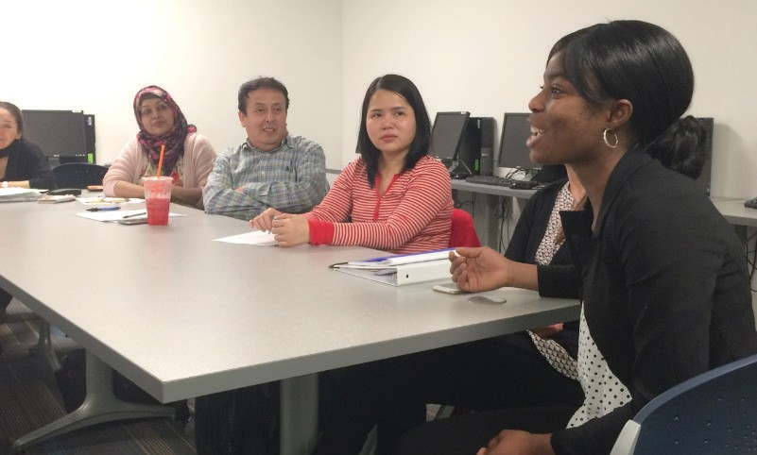

14 INTEGRATED EMPLOYMENT SERVICES

Photo: A job training session provided by ORI’s service

TEAMWorks! a 2-year program was created by ORI and the Refugee Employment Services partner in Lynn. This highly successful integrated program incorporated two essential components:
  - Using English in daily community activities, and
  - Additional Cognitive and Behavioral supports.

Services included: (1) Industry specific skills training in Hospitality and Food Preparation; (2) Removing Barriers to employment through Driver’s Education, Computer Skills and Customer Skills trainings, and providing individualized case management; (3) Creating Life
Skills groups to address emerging integration issues;
- Providing housing Supports for shared living;
- Offering Team Building activities including sports and community field trips; finally, (6) Building a strong Community by creating a solid Social Support Structure.
ORI regrets that FFY18 marked the final year of services due to changes in funding.

EMPLOYMENT
(CONT.)SERVICES.

VOCATIONAL SKILLS TRAINING

Vocational Skills Training (VST) courses are specific classes offered to refugee learners to train for a particular job, career or industry. VST is designed to assure that employment services meet local market demands and take advantage of job opportunities. ORI, whenever possible, conducts VSTs in partnership with employers.
Skills Trainings over the past year have included:
  - Hospitality Industry
  - Food Service 15
  - Home Health Aide (HHA) and Certified Nursing Assistant
  - Banking Industry
  - Customer Service
  - Driver’s Education (including CDL)
  - Medical Interpretation
  - Medical Billing & Coding

“ My employment counselor stuck by my side and together we didn’t lose hope. We spent a lot of time together practicing for
interviews and after three job interviews I was finally hired as a paraprofessional. Even after I got my job she continues to look after me and check in about how my kids are doing.
— Sohair, single mother of three from Su-

FINANCIAL LIT FOR NEWCOME

The Financial Literacy for Newcomers Program (FLN) supports refugees, immigrants, and some Puerto Rican evacuees by working in close cooperation with financial institutions, government agencies, community-based organizations and other stakeholders. The FLN targets the specific needs of newcomers as
they learn how to manage their personal finances. The program explains American credit and banking systems in ways that
16 can be readily grasped. The information presented is culturally and linguistically
appropriate, thorough and practical, covering the basics of banking, budgeting, credit scores and credit reports, borrowing basics, and buying a home.
In 2018, the FLN program met three main objectives: (1) Increasing access for refugees and immigrants to a portfolio of financial products and services;
- Augmenting the availability of culturally and linguistically appropriate teaching tools and resources; and
- Strengthening partnerships between the state, financial institutions, and service providers to further support refugee populations. The financial education
workshop series were conducted over
a period of two months, with a graduation ceremony at the end. Participants, who attended all of the classes and completed the program requirements, received
a one-time $50 incentive for their participation. Participants filled out a pre- and post-program surveys, and workshop surveys, to assess the program’s overall impact. Overall, both participants and service providers rated the program highly.
In 2018, ORI surpassed its goal for this year by providing financial education training to 220 plus participants.
Forty-five workshops were conducted throughout Massachusetts’ 3 regions.

Top: FLN graduation ceremony in Lynn

Bottom: Newcomers in a FLN session

ERACY RS.

to do to save my money. I see my expenses are very high and I have to reduce them.
“ This class is very good. You really opened my eyes and now I understand what I have
— Christina, refugee from Democrat- ic

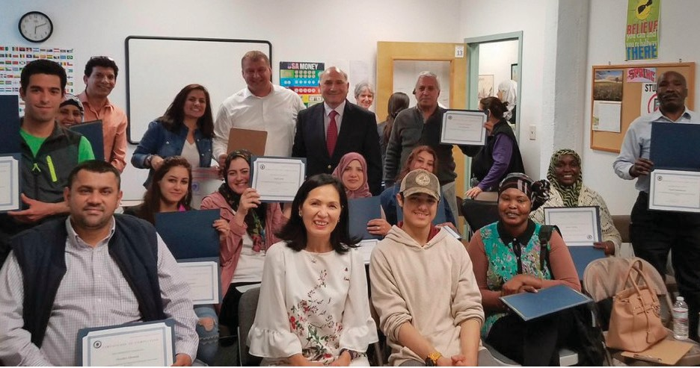
17

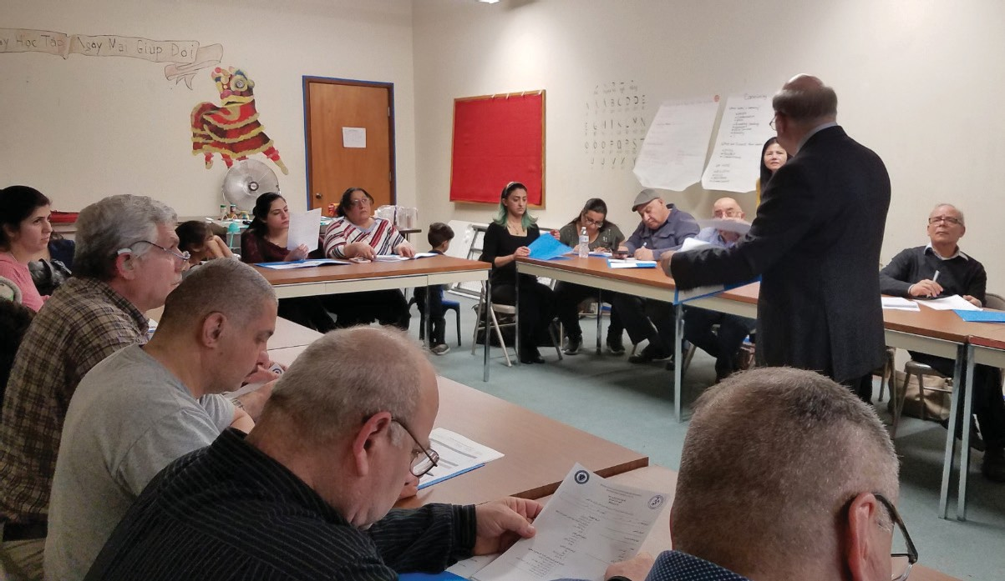

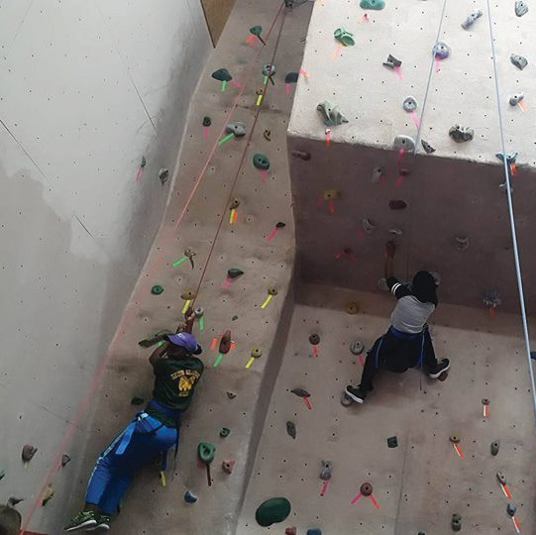
YOUTH ADJUSTMENT SERVICES

Youth Adjustment Services (YAS) is dedicated to helping refugee youth
find community and autonomy, facilitating integration and also developing skills for independent living. The program provides young immigrants and refugees with career services, short term job training and internship opportunities,
life skills coaching,
18 counseling on higher education opportunities and also individual social adjustment case
management. In FFY 2018, YAS was able to help 111 young newcomers

transition to life in Massachusetts and begin to feel themselves, fully and freely, members of their communities.

CHIL

REFUGEE SCHOOL IMPACT PROGRAM

Top: Youth in activity

Bottom: A soccer session organized by ORI’s service

The Refugee School Impact Program (RSI) provides individualized services for each refugee child entering the public school system. Service providers work with their families to foster understanding of elementary and secondary education in the United States so that parents can encourage academic achievement and social integration. In FFY 2018, RSI has successfully reached 722 young people and 337 parents around the state.

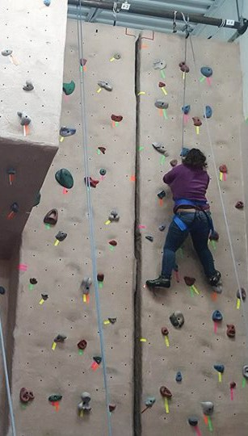
UNACCOMPANIED REFUGEE MINORS PROGRAM
In partnership with the Department of Children and Families, ORI’s Unaccompanied Refugee Minors Program (URMP) helps 149 children and adolescent refugees.
Without parents or guardians, these minors need support to adjust to new caregivers, communities, and schools.
Their emotional and behavioral health is often at risk. Children and adolescents are placed in a range of environments, from licensed foster homes to group homes, residential treatment centers, independent living homes, or therapeutic foster care. This year, URMP nurtured 149 refugee minors with health, housing, education, community engagement, and other forms
of support.

19

DREN & YOUTH
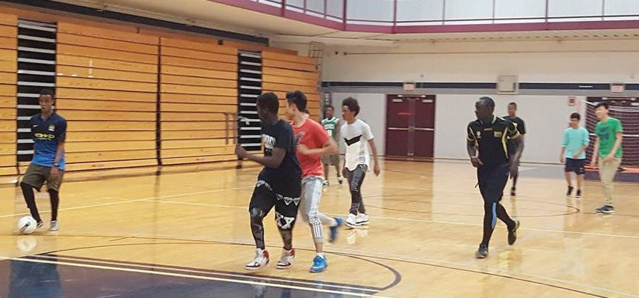
SERVICES.

COMMUNITY & SERVICES.

REFUGEE COMMUNITY SERVICES

Refugee Community Services (RCS) introduces refugee populations to the diverse range of social services available in Massachusetts, and helps them understand and access state and local resources. These include family support to promote economic self-sufficiency, help with housing issues, fuel assistance, educational supports, and daycare for children, as well as referrals to mental health, medical, and legal services. In 2018, RCS directly supported 665 refugees.
20
Providers use ethnic TV, radio, newspapers, and local events to reach out to refugee populations and help them as they adjust to their new communities.

PROGRAM TO ENHANCE ELDER REFUGEE SERVICES

ORI connects refugee elders to mainstream senior citizen services and also to intergenerational programs, while helping them navigates systems that can be linguistically challenging. In FFY 2018, Program to Enhance Elder Refugee Services (PEERS) served 172 refugee elders.

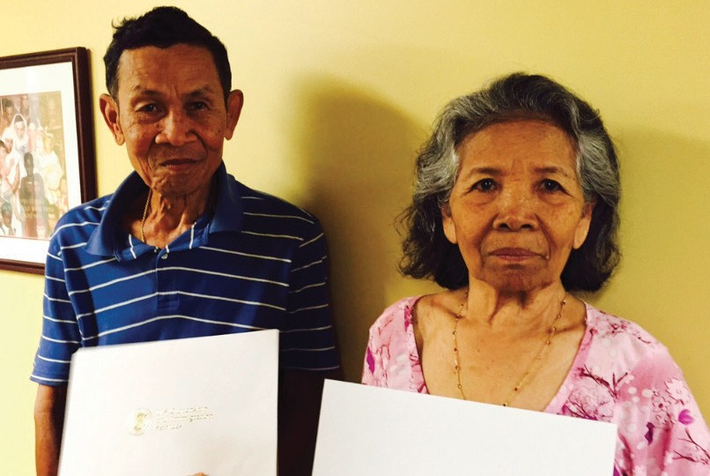
ELDERS

21

“I am a refugee from Congo. I arrived in the United States with many health issues and no knowledge of English, which is a
tremendous challenge to my ability to adjust and socialize with my peers. The PEERS program was very important to help me transition smoothly into Massachusetts. The program provided me with health education, coaching, navigation, and necessary support that help me to understand the American system as I
am adjusting to my new life.

Photo: Elders receiving naturalization certificates

— Lezimbere, a refugee from Democratic Republic of the Congo

22

Photo: Medical professionals operating a surgery

HEALTH SERVICES.

REFUGEE HEALTH ASSESSMENT SERVICES

Through partnership with the Massachusetts Department of Public Health, ORI makes health assessment services available to all newly-arrived refugees and immigrants.
The Refugee Health Assessment Program (RHAP) facilitates follow-up care for refugee and immigrant patients either through primary or specialty care. In 2018, 810 health assessments were conducted with more than 99% successful
transition to primary care. 23

REFUGEE HEALTH PROMOTION

ORI’s Refugee Health Promotion program provides ongoing individual healthcare access assistance to the newest refugee arrivals and preventive health information to refugee communities. It also works to heighten cultural competence within mainstream agencies. In 2018, 591 refugees received
direct support in accessing health and mental health services. In addition, 63 health forums or classes were held on a variety of issues of concern to newcomers. One hundred and twenty
(120) non-ORI service providers received orientation about culture and customs of refugee populations to better understand how they would present as patients and how they would regard healers and health professionals.

CITIZENSHIP SERVICES.

ORI’s Citizenship for New Americans Program (CNAP) enables low-income, lawful permanent residents in Massachusetts to become naturalized citizens of the United States. This year, 1,810 individuals enrolled in CNAP.

CITIZENSHIP SERVICES
24

5,000
4,000
3,000
2,000
1,000
Clients naturalized Naturalization exams passed
Naturalization applications filled Clients enrolled per year

SFY13 SFY14 SFY15 SFY16 SFY17 SFY18

“ The CNAP program at the Merrimack Valley Immigrant & Education Center was a godsend to me when I applied to
become a U.S. citizen. They helped me complete the application, prepare for the interview and overcome the translation barrier.
They made my Dreams Come True!

— Maria, from the Dominican Repub-

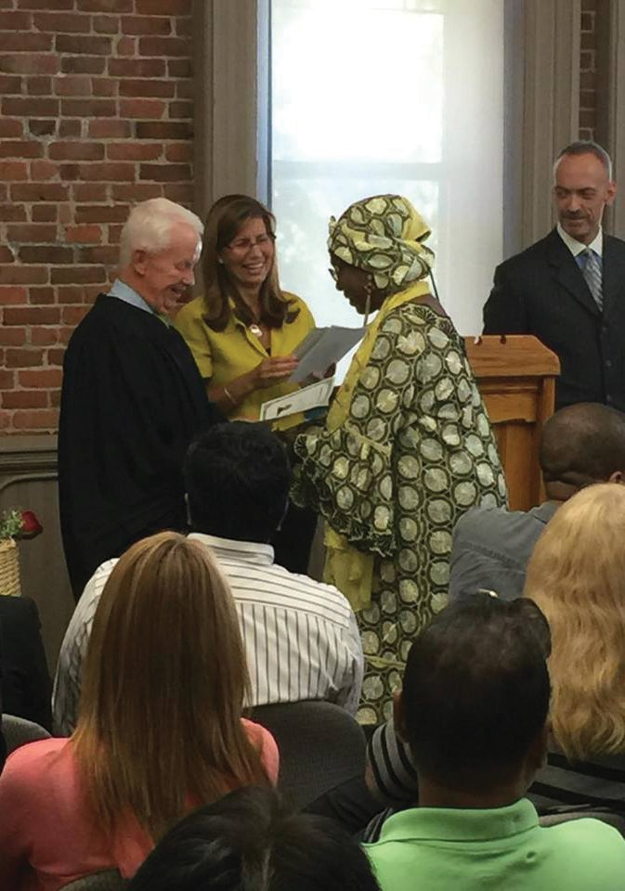

25

Photo: Former refugee receiving naturalization certificate

TOWN HALL M

ORI’s third annual statewide refugee town hall meetings in 2018 brought together more than 180 refugees and immigrants in 4 regions – Lowell, Lynn, West Springfield, and Worcester. Participants came from Afghanistan, Bhutan, Brazil, Central African Republic, Chad, China, Democratic Republic of Congo, El Salvador, Ethiopia, Guatemala, Haiti, Honduras, Iraq, Nepal, Rwanda, Somalia, Southern Sudan,
Sri Lanka, Sudan, Syria, Venezuela, and Vietnam. Live interpretation was provided during all those meetings.

All participants expressed the eagerness to integrate into their new communities
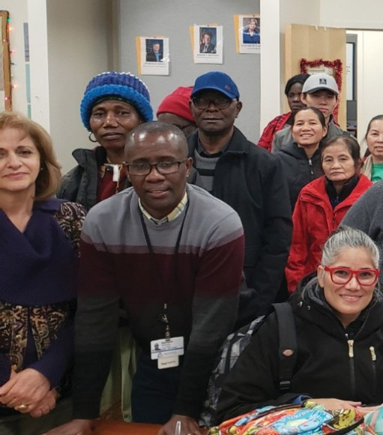
26 and spoke of the obstacles they were facing as well as the opportunities they sought. The discussions were frank and open, and ORI anticipates these exchanges will produce better services
and better outcomes for the challenging process of resettlement.

Topics discussed included housing, education, employment, healthcare, public transportation, civil rights, naturalization, and family reunification. This year’s town hall meetings featured a representative from Massachusetts
General Hospital. Dr. Bosson spoke about the opioid crisis and drug abuse and suggested ways parents might counsel their children about these dangers.
Officials from the United States Citizenship and Immigration Services (USCIS) answered many questions about immigration law and procedures, naturalization and family reunification.

Representatives from Massachusetts Department of Transportation (MassDOT/MBTA) addressed participants’ questions about services and scheduling. Additionally, MassDOT/MBTA manager from the Office of Civil Rights
and Diversity was able to answer questions also about tenants’ rights in Massachusetts.

EETINGS.
ORI concluded the Town Hall meetings by distributing donated items to participants and wanted to thank CONVERSE, Interfuture, Fragomen and individual donor for their generosity.

ORI wanted to thank the ongoing partnership from service providers – Ascentria Care Alliance, International Institute of New England and the New American Association of Massachusetts, for co-hosting these meetings.

27
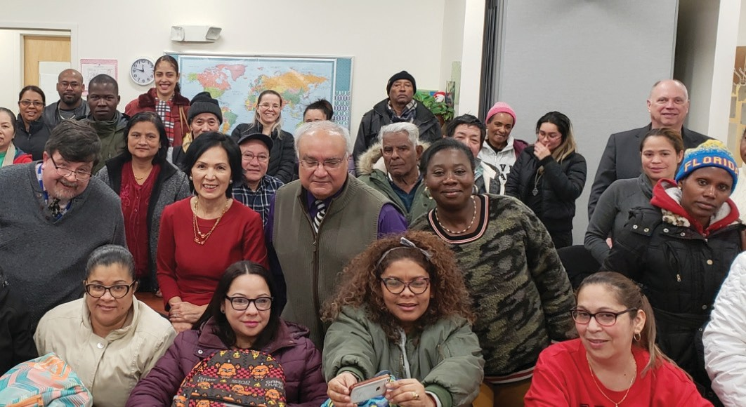
Photo: Refugee Town Hall Meeting in Worcester

SUCCESS STORIES.

28

NETHGINE CHARLES

In Haiti, Nethgine worked as a salesperson, re-selling goods from Santo Domingo to her community. Shortly after her arrivals to Boston in October 2017 as Haitian Entrant with her 13 year old son, she enrolled in ORI Employment Support Services Program (ESSP) at Jewish Vocational Services (JVS) to advance her English and vocational skills, even before having obtained her work permit which
was in process. At JVS, Nethgine took advantage of their Hospitality Training Program which included classroom instruction and hands-on training at an employer partner, the Intercontinental Hotel. Upon obtaining her work permit, she was already prepared to enter the job market and quickly found employment working as a Room Attendant at the Omni Parker Hotel earning $21.50/hour.

ABDI

“Abdi” arrived in Lynn in 2014 from Somalia with his mother and siblings. He spoke no English, and often seemed angry. He sometimes had conflicts with students and staff members at the New American Center (NAC), and struggled with both behavior and academics at
school. ORI Programs; Youth Adjustment Services and Refugee School Impact Program worked closely with Abdi, his school guidance counselor, his teachers, and his mother. Positive, trusting relationships developed between Abdi and programs staff. He started to attend the NAC after school program daily for
help with his homework and to work on his English. Eventually, he felt safe and accepted, and was better able to control his anger. He attended the summer youth program at the NAC and worked hard in the classes. He still sometimes struggles to control his emotions, but
now he has insights into his emotions and strategies to deal with them. This year, Abdi graduated from Middle School and will be volunteering at the New American Program’s summer elementary program, working with younger students as a helper and role model.

PIERRE PANTALEON 29
Pierre, a native of Haiti, arrived in Boston in 2018. Shortly after arrival, he volunteered at a food bank and enrolled in ORI Employment Program at JVS. Pierre participated in JVS’ Hospitality Training program which included both classroom instruction and practical train- ing in a partner hotel. Upon graduation, he was offered a job at his first-choice hotel, the Fairmont Copley Plaza Hotel!
He accepted the full-time, benefited position with a wage of $19.57/hr and is expecting an increase to $20.57 after 6 months of employment.

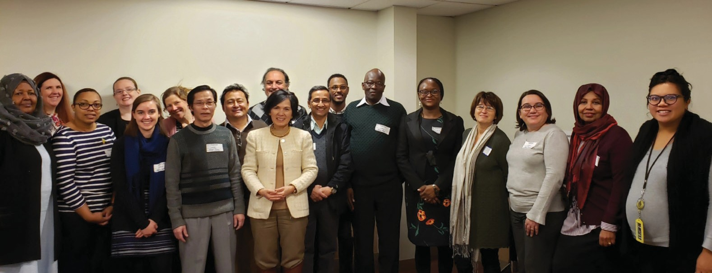
30 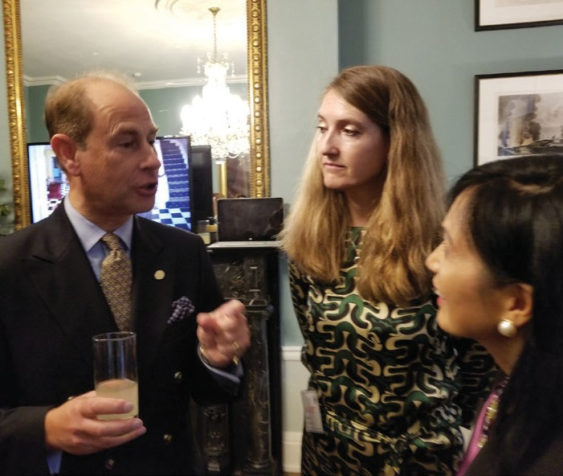 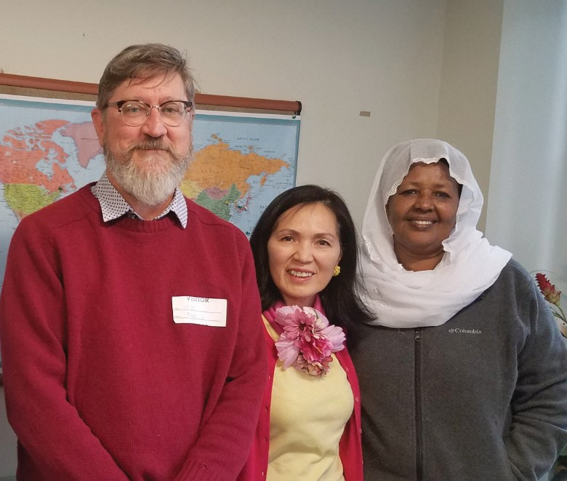 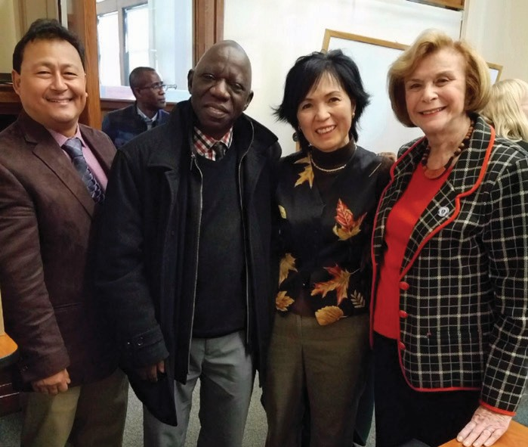

COMMUNITY PARTNERSHIP.
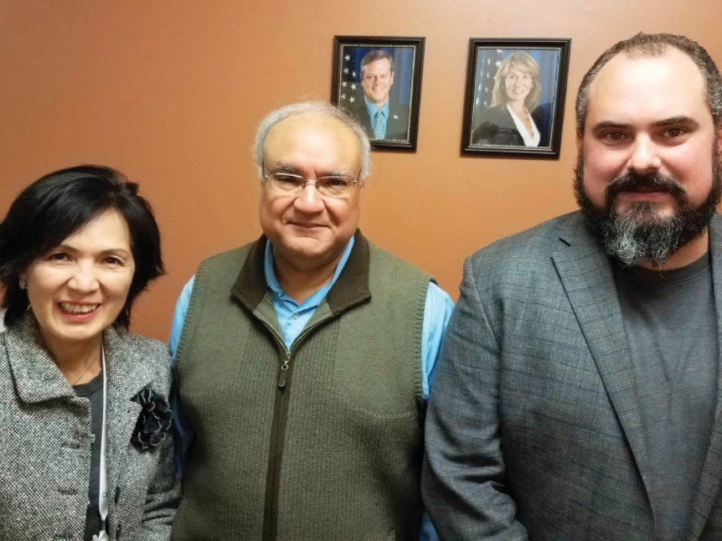
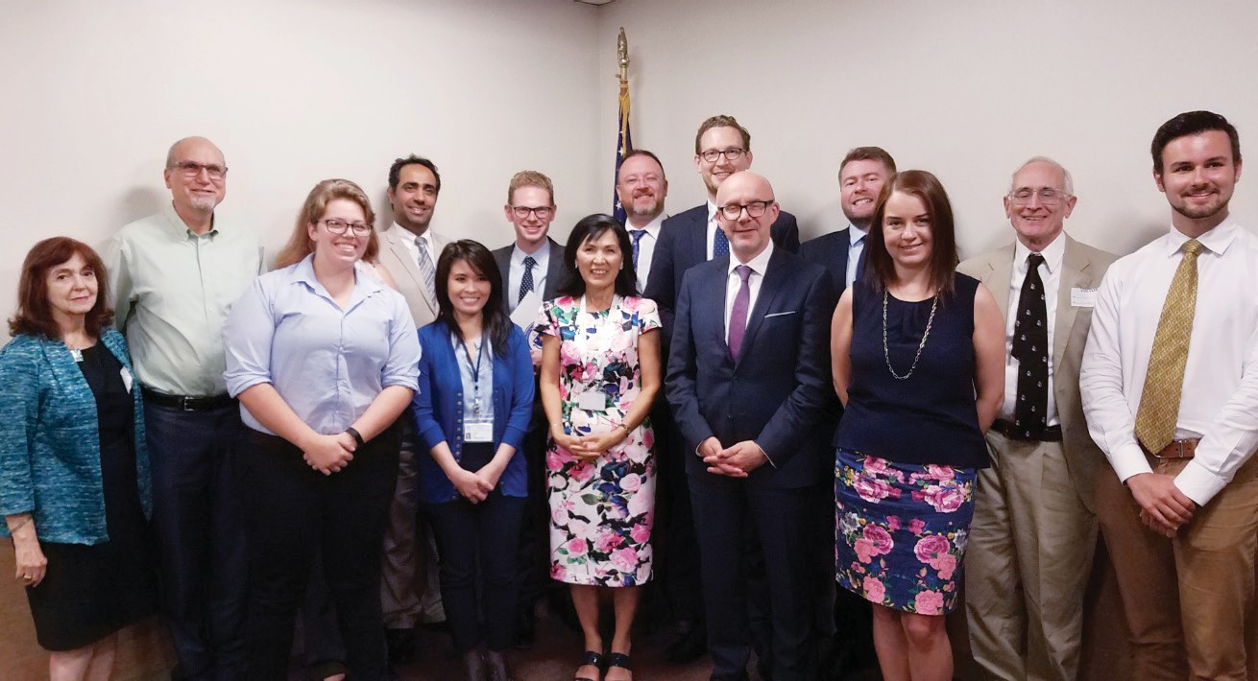

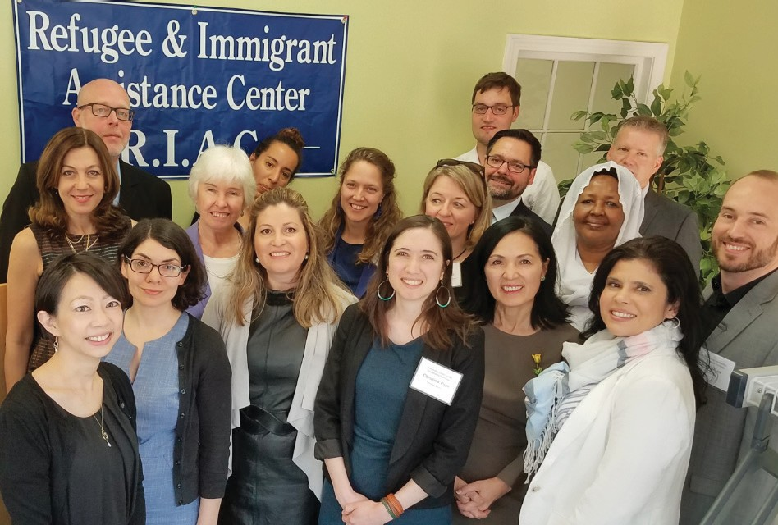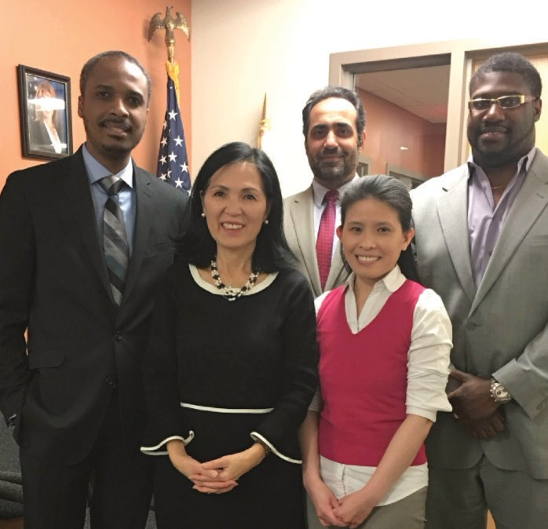

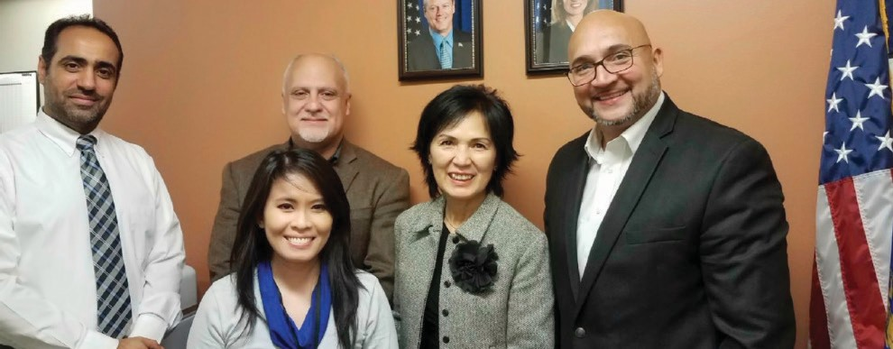
31

To ensure a successful integration for refugees and immigrants into their new communities, ORI continued its tireless efforts to strengthen existing partnership and create new ones.
Below are pictures for some of partners ORI met during this year.

Second row from left: Prince Edward of England, UK Consul General Harriet Cross and E.D. Truong; Australian Fellow; Senator Harriette L. Chandler,
E.D. Truong and Partners; Latin American Business Organization representatives

First row from left: ORI Annual Meeting with Service Providers; German Delegation; Haitian Chamber of Commerce representatives.
Bottom from left: E.D. Truong with MassDot representatives; Meeting with members of the United Kingdom Parliament.

FINANCIALS.

ORI is 91% federally funded through the U.S. Department of Health and Human Services’ Office of Refugee Resettlement (ORR).
In addition, 8% is state funding to support citizenship and employment services for refugees and immigrants living in the Commonwealth. ORI also received 1% of its total from private funding to support its Financial Literacy for Newcomers Program.
In FFY2018, the ORI overall budget was $16.25M, with $14.7M funded through federal grants, $1.4M from state dollars, and
$143,000 through private donors.

ORI continues to seek out additional public-private partnerships to sustain and enhance its mission, to strengthen collaborations with key stakeholders, and to further empower refugees
32 and immigrants as they successfully integrate into their new communities.
ORI is grateful to all partners and key stakeholders who
whole-heartedly supported its programs. ORI sincerely welcomes all who would like to help by contributing monetary and/or in-kind support to make 2019 an even more successful year for both newcomers and the Commonwealth. If interested, please call us at (617) 727-7888 or send us an email to mary.truong@state.ma.us.

FUNDING PERCENTAGE

Federal State Private
90.95%
8.05%
1%

33

FUNDING TO REFUGEE SERVICES BY CATEGORY

61.05%

13.88%

7.71%
5.79%
3.55%
2.03%
Unaccompanied Minors
Employment Related Services Health Assessment
Cash Assistance Case Management
Social Adjustment Services

ACKNOWLEDGMENT.

ORI would like to thank the following partners in support of our work.

Charles Baker Governor
Karyn Polito Lieutenant Governor
Marylou Sudders Secretary of Health and Human Services

Governor’s Advisory Council on Refugees and Immigrants • Office of Refugee Resettlement • Executive Office of Elder Affairs • MA Commission for the Blind
34 MA Department of Children and Families • MA Department of Public Health MA Department of Transitional Assistance • MA Department of Youth Services
MassHealth • Interns, volunteers and supporters Service Providers • United States Citizenship and Immigration Services • Generation Fund • CONVERSE
Fragomen LLP • Interfuture • Private donors

Special thanks to:
Mr. Jeff Goldman Esq. for his generous help in producing this report
Andy Doan, graphic designer

CONTACT US

Massachusetts Ofﬁce for Refugees and Immigrants
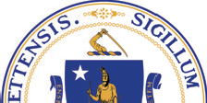600 Washington Street, 4th Floor
Boston, MA 02111

For more information, or to download this report, please visit:
617.727.7888 | www.mass.gov/ORI

