20
21

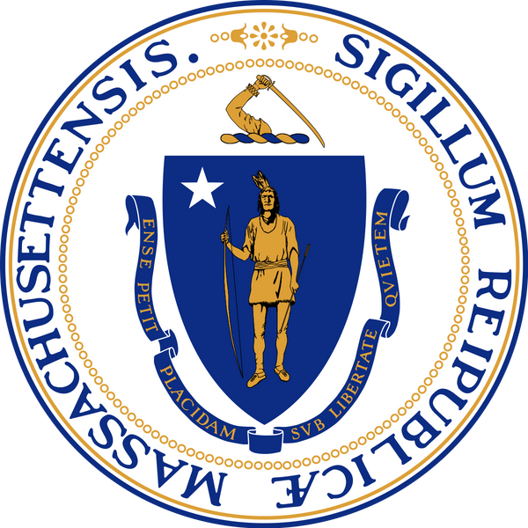
T H E M A S S A C H U S E T T S
O F F I C E F O R R E F U G E E S A N D I M M I G R A N T S

FINANCIAL
LITERACY FOR NEWCOMERS REPORT

MESSAGE FROM THE EXECUTIVE DIRECTOR

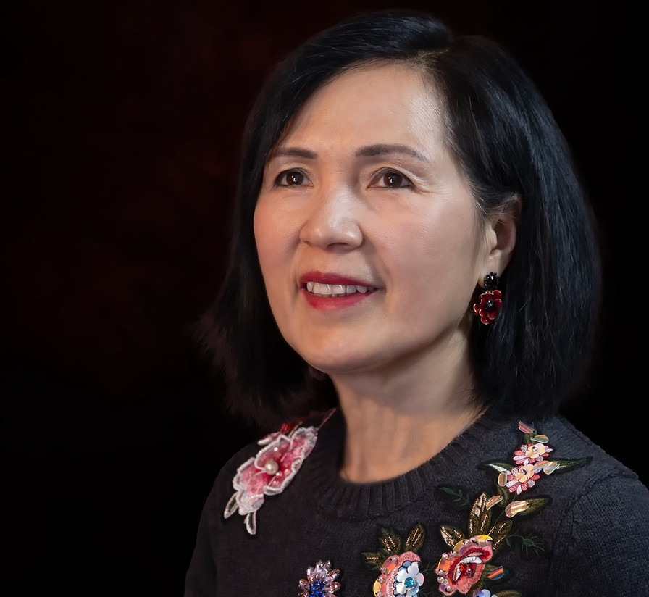

FLN participants inspired us with their resilience and resourcefulness in the face of overwhelming odds.
The Covid-19 pandemic has forever changed our lives in innumerable ways. Thousands have lost loved ones, their livelihoods, or both. Lockdowns and social distancing have moved services online, challenging the momentum and progress gained from decades of assisting refugees and immigrants in Massachusetts. In the midst of it all, refugees and immigrants, always among the state’s most vulnerable, are struggling to adapt, often without technological skills, tools and family/community supports. Their road to self- sufficiency has seemingly never been more challenging.

In State Fiscal Year 2021, the Massachusetts Office for Refugees and Immigrants (ORI) strove to meet the challenge of this new reality with a modified version of its highly successful Financial Literacy for Newcomers (FLN) program. Financial literacy is essential to economic self-sufficiency and long-term financial success for all Massachusetts residents. Financial literacy training has never been more important to refugees and immigrants who are learning to manage their personal finances in a new homeland without the benefit of basic financial knowledge or experience with the American financial system. ORI’s FLN program offers a linguistically and culturally appropriate introduction to basic concepts and tools of the American financial system, tailored specifically to the needs of newcomers. Delivered in a practical and user-friendly format, FLN financial workshops cover the basics of banking, budgeting, credit scores, credit reports and buying a home.

Strengthening our partnerships with community organizations, financial institutions and government agencies, MORI adapted its FLN curriculum to an accessible and inclusive online workshop format, ensuring that refugees and immigrants would continue to have access to financial education and tools so important to their success. In SFY21, FLN participants inspired us with their resilience and resourcefulness in the face of overwhelming odds. Despite the pandemic, ORI partnered with 11 community organizations to serve over 1,000 participants in online FLN workshops across the Commonwealth.

ORI is grateful for the ongoing support from donors, legislators, public officials, and community partners for helping us grow our FLN program. With your support, we will continue to enable those most affected by the crisis to rebuild their livelihoods and participate in the American Financial System—laying the groundwork for their new lives in Massachusetts. We thank you for your continued partnership and invite you to review the highlights of another successful year summarized in our SFY 2021 Financial Literacy for Newcomers (FLN) report.

Mary Truong

Financial Literacy for Newcomers — Annual Report 2021

DEMOGRAPHICS
Data of Financial Literacy for Newcomers Program participants

Country of Origin Language Marital Status

Ukraine 9.7%

Guana 5.6%

Iraq 6.8%

Bhutan 10.4%
Syria 3.9%

Other 33.1%

Dominican Republic

Nepali 14.2%

Russian 4.6%
French 3.6%
Ukrainian 6.3%

English 6.5%

Other 11.7%

Spanish 17.7%

Divorced 8%

Single 27%

Married 61%

Haiti 23.8%
6.7%

Arabic 12.6%

Haitian Creole 22.8%
Widowed 4%

Immigration Status
Income
Housing Situation

US Citizen 14%

Immigrant 14%
Undisclosed 8%

Refugee 16%

Asylee 14%

$30,000 - $50,000 10%

$15,000 - $30,000 25%

$50,000 + 5%

Live with Family 24%

Below $15,000 60%

Unhoused 3%
Own 9%

Rent 64%

Permanent Resident 34%
Work Status

Household Size

Ethinicity

Unemployed 51%
Retired 8%

60
Part time 19%

Full time
22% 40

20

Middle Eastern 12.9%

Caucasian 7.9%
Other 4%

Latino 39.6%

0
1 2 3 4 5 6+

30
COUNTRIES OF ORIGIN

African American 35.6%

14
SPOKEN LANGUAGES

Financial Literacy for Newcomers — Annual Report 2021

MEASURING
PROGRESS

Each year, The Massachusetts Office for Refugees and Immigrants helps hundreds of FLN participants accomplish the workshop series across Massachusetts. This year, we’ve been deeply grateful for the number of FLN participants who have attended the classes. In the State Fiscal Year of 2021, 453 refugees and immigrants individuals attended 23 workshops series (92 workshops).

93%
OF FLN PARTICIPANTS GRADUATED

MEETING GRADUATION GOALS (DATA BASED ON SURVEYS FILLED OUT BY FLN PARTICIPANTS)

83% felt confident about visiting a bank to open an account
85% felt confident that they know the amount of a down payment needed for buying a house
82% that they know how to use a bank debit card.

96% said the instructors were helpful or very helpful.

90% felt confident that they understand what a home equity loan is
100% said they would recommend FLN to others.

88% felt confident that they know what is a good credit score is and what is a bad credit score
99% said the education materials were helpful or very helpful.

91% felt confident that they know how to reduce their spending

LOOKING FORWARD

Both online and through our in-person workshops, the FLN program empowers participants to make smart financial decision and improve their odd's of success in the American Financial System. In the State Fiscal Year of 2021, we reached more individuals than ever amidst a pandemic crisis. But where do you go from here? We’ve learned a lot from our experience so far, and we have many more ideas. We aim to improve FLN’s services.

— Increase our impact
We will combine our research and data-driven evidence with contextual knowledge to deliver the highest quality Financial Literacy Program and add new topics including Borrowing Basics or Starting a Business, to our workshop series.

— Expand our scale
We will increase the number of people we reach with our workshop series by adding new FLN partners. We will use our resources and expertise to empower and strengthen local community-based organizations.

— New languages
To help expand the program to new audiences, we want to include new languages and translation to our workshop series and materials supplied during classes.

GRADUATIONS

Over this year, we have worked closely with community-based organizations to promote financial literacy across MA and to advance a more just and equitable society. Here, we highlight a few pictures of our FLN graduation ceremony.

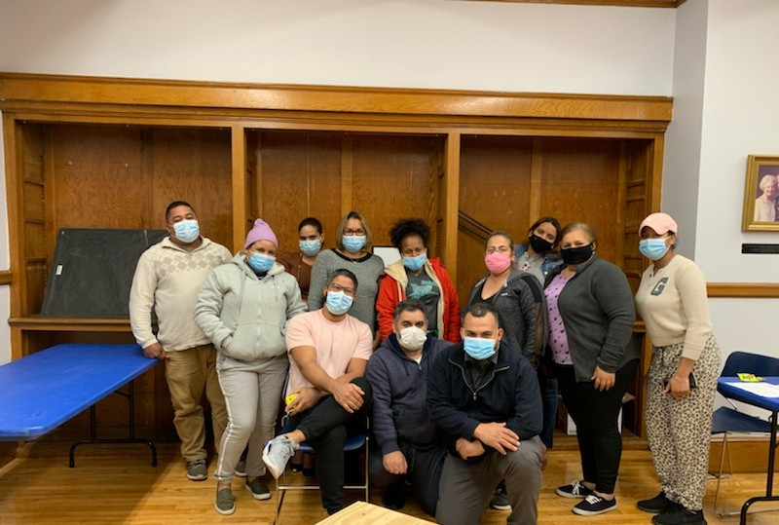
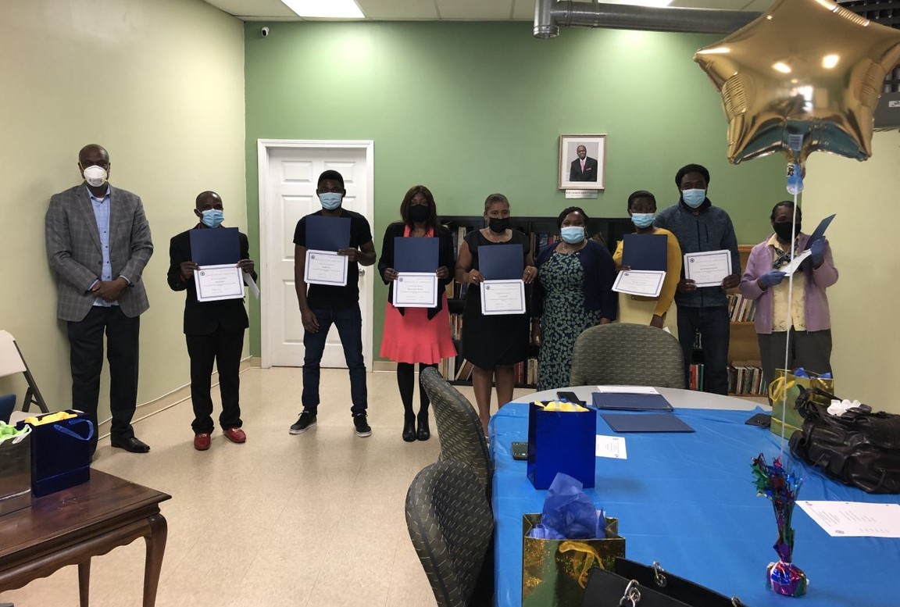

GRADUATION CEREMONIES

Ascentria West Springfield Ascentria Worcester
FLN PARTNERS
Association of Haitian Women Inc. Angels-Net Foundation
New American Association of Massachusetts Lawrence Family Development Inc.
Quincy College
Community Uplift Program Inc. The Literacy Center Inc.
Community Economic Development Center Mount Olive Community Center

Financial Literacy for Newcomers — Annual Report 2021

ACKNOWLEDGEMENTS

We’d like to thank the following funders and supporters: The Generations Fund and First Republic Bank.
We are also grateful for the support of the Legislature, Governor Baker & Lt. Governor Polito, and Secretary Sudders.
Volunteer Trainers: MassHousing, American Consumer, Credit Counseling, Citizens Bank, People's United Bank, Webster Bank, Boston Private, and Eastern Bank
Annual Report Design: F. Leandro Freire
We are also grateful to ORI staff and our partner organizations who have helped to make FLN a success.
We wish to recognize the participation of: Mary Truong, ORI Executive Director Falah Hashem, ORI Chief of Staff
F. Leandro Freire, FLN Program Coordinator

We thank you for your continued support in our efforts to contribute to our mission.

Contact

The Massachusetts Office for Refugees and Immigrants
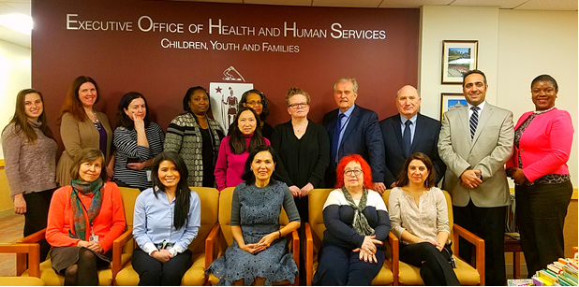
600 Washington St.
4th Floor, Boston, MA 02111
www.mass.gov/ori
T: 617-727-7888
TTY: 617-727-8147

Financial Literacy for Newcomers — Annual Report 2021

