MASSACHUSETTS OFFICE FOR REFUGEES AND IMMIGRANTS

ANNUAL REPORT 2017

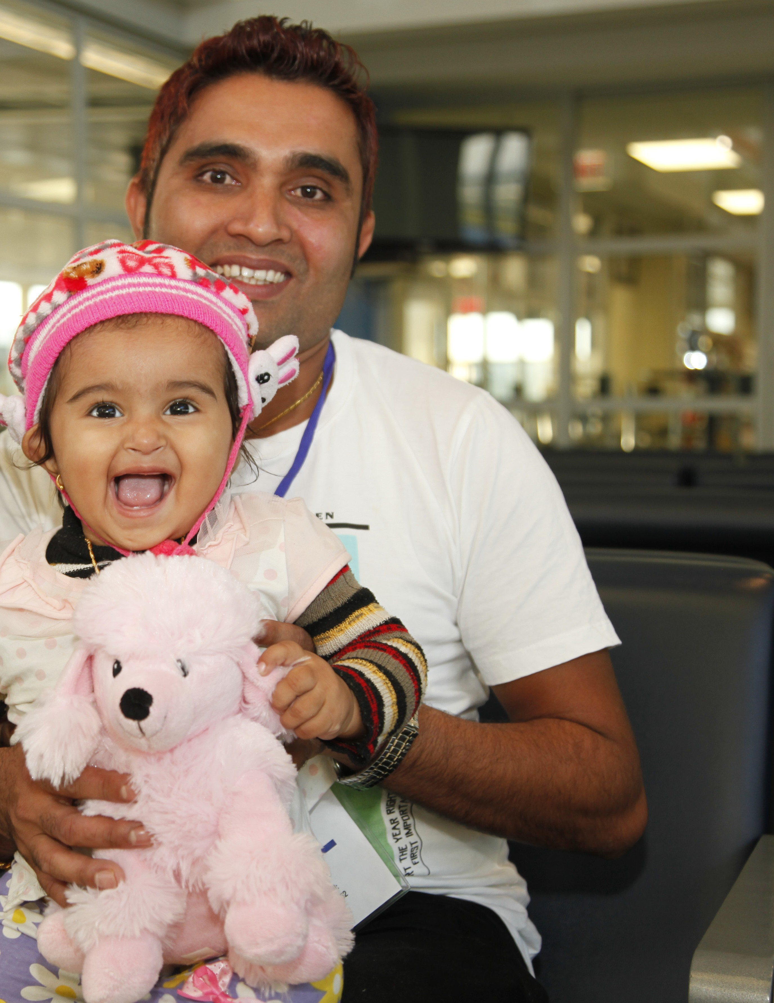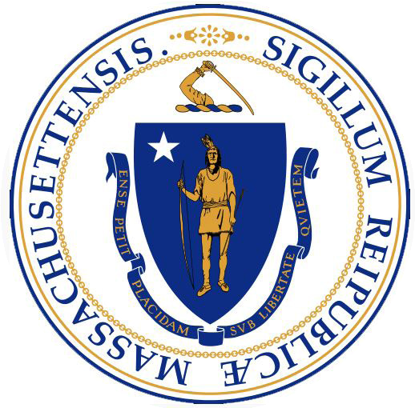Charles D. Baker
Governor

Karyn Polito
Lieutenant Governor

Marylou Sudders
Secretary of Health and Human Services

Mary Truong
Executive Director

The mission of ORI is to support the effective resettlement of refugees and immigrants in the state; promote full participation of refugees and immigrants in the economic, civic, social and cultural life of the Commonwealth; and foster a public environment that recognizes and supports the ethnic and cultural diversity of the state.
Cover Photo: Newly arrived refugee family from Bhutan, courtesy of Catholic Charities of Worcester County (CCW)

the future is bright.”
“
CONTENTS

MESSAGE FROM THE EXECUTIVE DIRECTOR ……………………………………. 7
EXECUTIVE SUMMARY ……………………………………. 8
REFUGEE POPULATION DEMOGRAPHICS ……………………………………. 10
CATHOLIC CHARITIES OF WORCESTER COUNTY ……………………………………. 12
MOHAMMAD AND HAJMEENA’S JOURNEY TO THE UNITED STATES ……..... 13
EMPLOYMENT SERVICES ……………………………………. 14
EMPLOYMENT SUCCESS STORIES ……………………………………. 15
MICRO-ENTERPRISE ……………………………………. 16
MASSREAP SUCCESS STORIES ……………………………………. 17
CHILDREN & YOUTH ……………………………………. 17
URMP SUCCESS STORY ……………………………………. 18
ELDER SERVICES ……………………………………. 19
HEALTH PROMOTION ……………………………………. 19
CITIZENSHIP SERVICES ……………………………………. 20
FINANCIAL LITERACY FOR NEWCOMERS ……………………………………. 21
REFUGEE HEALTH ASSESSMENT PROGRAM ……………………………………. 21
TOWN HALL MEETINGS ……………………………………. 22
INTERNATIONAL DIPLOMATS ……………………………………. 23
FINANCIALS ……………………………………. 24
AKNOWLEDGEMENTS ……………………………………. 27

MESSAGE FROM THE EXECUTIVE DIRECTOR
“

Massachusetts

of hope and
Dear Friends,

Over the last several years, the world has seen many individuals and families displaced by poverty, war, famine, and violence. In these bleak moments, Massachusetts acts as a source of hope and welcomes those seeking refuge by offering an array of services and a path to new life. In Federal Fiscal Year 2017 (FFY17), the honorable people of Massachusetts welcomed 1,993 refugees into their communities.

As the number of newcomers decreases, the Massachusetts Office for Refugees and Immigrants (ORI) continues to provide core services which focus on employment, English language skills, and, above all, self-sufficiency. ORI anticipates a challenge ahead as a result of limited resources. However,, this challenge comes with the opportunity for us to reflect on and reevaluate our programs as well as diversify our partnerships. Here are a few of the ways we have used that opportunity:
acts as a source

We recently launched Financial Literacy for Newcomers (FLN), a program that allows immigrants and refugees to understand the American banking system. The need for this program was overwhelming, as it is impossible to be self-sufficient without the ability to make informed financial decisions. ORI received more than
welcomes those seeking refuge by offering an array of services and a pathway to new life.”
$250,000 in funding to implement this multi-year program through a historic public-private partnership.

In spite of the reduction in the number of newly arrived refugees and immigrants, ORI has continued to provide the same high level of service to its constituents to ensure positive employment outcomes. In 2017, over 1,050 individuals were hired with an average hourly wage of $12.10, above the state minimum wage.

The Massachusetts Refugee Enterprise Achievement Program (MassREAP) encourages refugees to develop home and community based small businesses. This year, MassREAP soared to new heights by creating or retaining 119 jobs solely from refugee-owned businesses. Community providers have also held small group workshops and given technical assistance to 432 refugees who had expressed interest in growing or opening a business.

Although we anticipate a further reduction in new arrivals in FFY18, we will continue our mission to serve the world’s most vulnerable populations by providing programs to help individuals access everything from healthcare to education. As we meet new challenges, I would like to extend my sincerest thanks to our service providers, community supporters, and ORI staff members for their hard work and continued support of the MA Refugee Resettlement Program. Your dedication and constant advocacy on behalf of refugees and immigrants creates a better Massachusetts for each and every citizen.

Mary Truong Executive Director

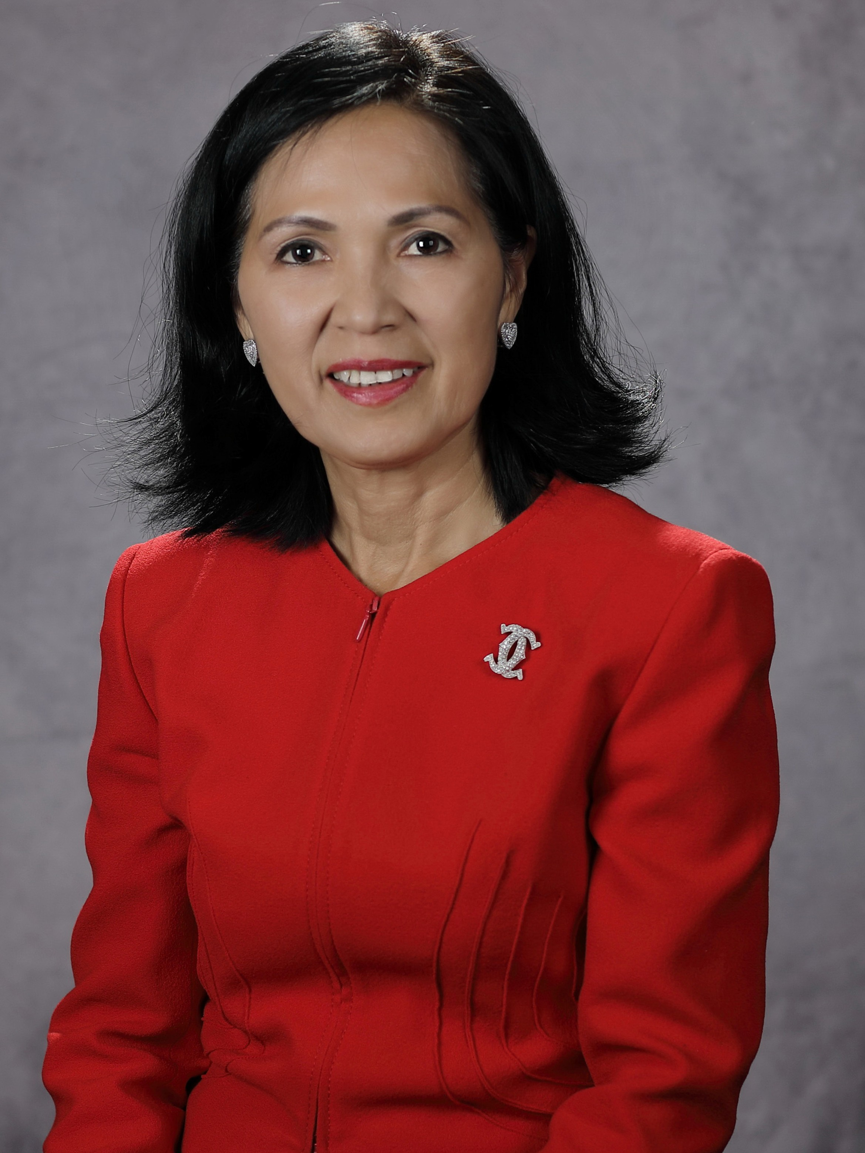

6 Massachusetts Office for Refugees and Immigrants 7

EXECUTIVE SUMMARY

In FFY 2017, more than 1,990 refugees and immigrants were welcomed to Massachusetts. Building on policies that emphasize both compassion and sustainability, the Massachusetts Office for Refugees and Immigrants (ORI) in turn bolstered its commitment to the state’s longstanding values of providing safe haven to people fleeing desperate and dangerous conditions and to our own ethnic and cultural diversity.
Over the course of the previous year, ORI strengthened its partnerships with service providers and stakeholders to ensure our capacity to successfully integrate refugees and other immigrants into their communities by fostering their trust and delivering high-quality services. We are pleased to report that we were able to provide the necessary funding and guidance to allow our newcomers to flourish. In our 2017 annual report, ORI will present highlights on the population of immigrants and refugees we welcomed, the services our strategic partners provided newcomers and the agency’s notable accomplishments during the previous federal fiscal year, from October 1, 2016 to September 30, 2017.
The populations eligible for ORI’s services include: refugees, asylees,
Cuban and Haitian entrants, victims of a severe form
of trafficking who have received certification or an eligibility letter from the Administration of Children and Families, certain Amerasians from Vietnam who are admitted into the U.S. as immigrants, and Iraqis and Afghans with Special Immigrant Visas. Throughout this report the term “refugee” is used to refer to all of the categorically eligible groups identified above.

MISSION HIGHLIGHTS IN FFY 2017

ARRIVALS
The Commonwealth welcomed 1,993 people from Iraq, Haiti, Somalia and the
Democratic Republic of Congo, among over 40 countries.

CITIZENSHIP
The Office funds a network of community-based organizations that provide English language and civics classes, application assistance, interview preparation and additional support services to individuals and families eligible for citizenship. This year, ORI worked with 17 providers throughout Massachusetts to assist approximately 2,500 individuals seeking help navigating the complex, time-consuming and often intimidating naturalization process. In 2017, the Citizenship for New Americans Program (CNAP) helped 1,273 applicants file citizenship applications. Of that number, 605 applicants took the citizenship exam and 399 passed it. Furthermore, at least 464
applicants became U.S. citizens.

EDUCATION
ORI works with trusted community-based organizations and school districts, licensed foster care providers and group homes to help elementary, middle and high school students thrive at their schools. Through our collaboration with sister agencies, including the Department of Elementary and Secondary Education and the Department of Children and Families, we assist parents and foster parents support their children’s education. Education programs served over 750 young people by providing tutoring, English language classes, liaisons to parents and cultural and recreational activities during the
previous federal fiscal year.

8 Massachusetts Office for Refugees and Immigrants

In FY 2017,

more than
“
1,990

refugees and immigrants were welcomed to
Massachusetts.”

REFUGEE SENIORS
Elderly refugees face unique hurdles when they arrive in a new culture, including language barriers and transportation access to and from appointments. Recognizing the critical role elders play within their families, and the importance of keeping multi-generational families intact, ORI focuses on connecting elders with mainstream senior citizen services and helping them navigate these service systems, while providing access to intergenerational activities and interpretation and translation services.
Through collaborative efforts, our office served over 250 refugee elders during this federal fiscal year with case management services, assistance with the naturalization process, housing applications and other service referrals.

EMPLOYMENT
One of ORI’s top priorities is workforce development—helping newly arrived populations overcome their barriers to employment with the final goal of achieving self-sufficiency. ORI-funded employment services include skills assessments and vocational skills trainings; English for Employment classes; orientation to the work place; résumé assistance and job interview practice; job placement and retention; job upgrades; career laddering and, additional long-term supports.

After completion of trainings, employable individuals are well-prepared to seek jobs as bank tellers, certified nurse assistants, machine operators, kitchen staff/chefs and hospitality workers, among others.
During FFY 2017, over 1,450 refugees participated in various employment programs. Of those, more than 1,050 obtained employment. For these individuals, hourly wages ranged from the minimum wage to upwards of
$15.00 to even $24.00 an hour.

HEALTH PROMOTION
In FFY 2017, ORI Refugee Health Promotion providers helped over 1,000 refugees enroll in health insurance programs and navigate health and behavioral health systems. Service providers made over 40 home visits to assist clients with specific concerns related to their home environment, their health or a disability. Regional providers put on 77 workshops throughout the state focusing on such preventive health topics as nutrition, chronic diseases such as diabetes and high blood pressure, fire safety, flu prevention, home
and personal hygiene and behavioral health education.

HEALTH ASSESSMENT
As part of initial resettlement, refugees must be screened for communicable diseases and other health problems within 90 days of their entry into the U.S. Refugee Health Assessment services (RHAP). Screenings are provided through an Interagency Service Agreement between the Massachusetts Office for Refugees and Immigrants (ORI) and the Massachusetts Department of Public Health (DPH) and offer linguistically and culturally appropriate health assessment services, including including immunizations and referrals to primary care. During FFY 2017, 1,847 of health assessment visits were conducted at seven community health centers and two hospital clinics throughout the state. Ninety-five percent were successfully transitioned to primary care.
MICRO-ENTERPRISE
ORI provides refugees residing in the Greater Boston, Greater Worces-ter and Greater Springfield areas of the state with an array of services through the Massachusetts Refugee Enterprise Achievement Program
(MassREAP) which offers income-producing strategies to refugees who are unemployed or under-employed. For example, we help individuals develop small-scale and home-based businesses, as well as traditional business ventures. These services are available to refugees who want to start a new business or need help sustaining or expanding an existing enterprise. Services include basic business training and credit-building workshops; ongoing one- on-one pre- and post-loan technical assistance; low-interest micro loans; and assistance in obtaining community and commercial loans that are not typically available to lower-income borrowers with few assets.

REFUGEE TOWN HALL MEETINGS
The Office co-hosted a series of five Refugee Town Hall meetings throughout the state of Massachusetts, in collaboration with refugee resettlement agencies to welcome recently-arrived refugees, and to learn how we could better address the unique concerns of newly resettled individuals and families.
The meetings were held in Boston, Lowell, Worcester, Springfield and Westfield. More than 180 refugees attended from various from countries including Afghanistan, Belarus, Bhutan, Burundi, Democratic Republic of Congo, Dominican Republic, El Salvador, Haiti, Iraq, Moldova, Russia, Syria, and Ukraine.

UNACCOMPANIED MINORS
ORI works collaboratively with the Department of Children and Families (DCF) to administer the Unaccompanied Refugee Minors Program. These young people face unique emotional, educational and
vocational challenges as they arrive in the U.S. without a parent. The Unaccompanied Refugee Minors Program helps youth develop independent living skills related to school acclimation, job training, financial literacy and behavioral health so that they develop into productive, healthy and self-reliant adults. In 2017, ORI served 189 children in culturally and linguistically appropriate and licensed foster homes and other licensed care settings that met their specific needs.

FINANCIAL LITERACY FOR NEWCOMERS
ORI recognizes that a hallmark of self-sufficiency is the capacity to make informed financial decisions. Newcomer populations often face unique obstacles achieving financial proficiency, due to language barriers, different financial customs in their countries of origin and the complexity of the American banking system. During FFY 2017, ORI raised more than $250,000 to fund two separate projects. Through partnership with the Generation Fund, ORI will implement a multi-year project in four regions of the state. Additionally, People’s United Bank partnered with ORI to implement a smaller project in Worcester in December 2017 and implemented a second seminar in January 2018.

FFINANCIAL PLANNING FOR FFY 2017 WITH YOUR HELP
Overall budget in FFY17 was $19.5M. During this year, ORI will continue to seek out additional public-private partnerships to sustain and enhance our mission, to strengthen our collaboration with stakeholders to bridge gaps in services and further empower refugees and immigrants to successfully integrate into their new communities. There are a number of meaningful ways that you – our public, private and non-profit partners – can further help refugees and immigrants, and we hope that you will become a critical source of support.
Here are some of the opportunities:

- you may provide monetary assistance to our providers who work directly with newcomers;
- help ensure safe, accessible housing to refugee tenants looking to make Massachusetts their home; and
- support hardworking refugees and immigrants in their desire to become self-sufficient by hiring them.

We are profoundly grateful to all of our partners and key stakeholders who helped support and make this year a great success. We heartily welcome all of you who would like to join these efforts to make 2018 a banner year for our newcomers and the state.

9

REFUGEE POPULATION DEMOGRAPHICS
“
Each year, Massachusetts welcomes
individuals from more than 40 countries.”

Countries of Origin in FFY 2017
24%
29%
6%
7%
12%
7%
7%
8%
Each year, Massachusetts welcomes individuals from more than 40 countries. Recently, the largest refugee populations have come from Iraq, Haiti, Somalia, and Congo DR. During federal fiscal year 2017, 1,219 new refugees and 774 new individuals with other qualifying immigration statuses were served by ORI.

The age groups of newly arriving populations served under the Massachusetts Refugee Resettlement Program has stayed relatively consistent with previous years. Most refugees (over 66% are between the ages of 18-64. Nine percent (9% are 4 years old or younger, 23% are between the ages of 5 and 17, and 2% are 65 years or older.

The balance of resettlement between regions in Massachusetts changes slightly with approximately 61% of new arrivals resettling in Eastern MA, 17% in Central MA, and 22% in Western MA. Predominant cities include Boston (18%, Lowell (8%, Lynn (5%,

Haiti : 29%
Bhutan : 8%
Other : 24% DR Congo : 7%
Iraq : 12%
Syria : 7%
Springfield (8%, West Springfield (6%, Westfield (5%, and Worcester (17%, with other Massachusetts cities also receiving newly arriving individuals (33%. A city’s percentage of statewide

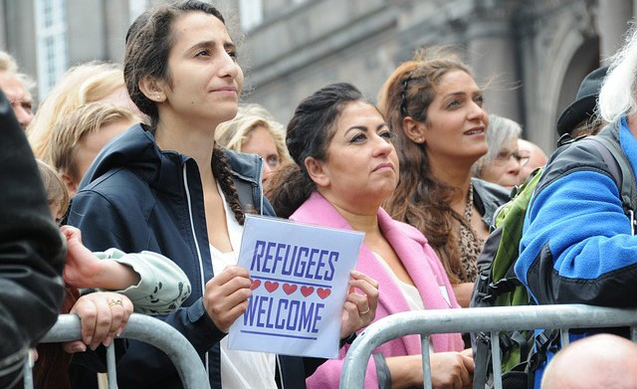
Somalia : 7% Ukraine : 6%
resettlement adjusts slightly each year.

Refugee Age Distribution in FFY 2017
Resettlement Locations in FFY 2017

9%
2%
23%
66%
22%
17%
61%
61% to Eastern Massachusetts 17% to Central Massachusetts
22% to Western Massachusetts

65+ years : 2%
18-64 years : 66%
5-17 years : 23%
0-4 years : 9%

CATHOLIC CHARITIES
OF WORCESTER COUNTY
Refugee resettlement can be challenging but helps many people who need to leave their country due to violence or war or ethnic conflicts. Catholic Charities Diocese of Worcester started its Refugee
Resettlement Program in 1975. Catholic Charities has resettled diverse populations from the different parts of the world in Worcester. Catholic Charities of Worcester County’s staff are the first to meet refugees at the airport, often late at night, they find them affordable housing, provide furniture and other household needs, connect them with English as a Second Language (ESL classes, connect them to job training and

MOHAMMAD AND HAJMEENA’S JOURNEY TO
THE UNITED STATES
In November of 2016, Mohammad and Hajmeena came to Massachusetts from Afghanistan with their two young children. They arrived in Boston ready to begin a new life in the United States but soon found themselves overwhelmed as they
attempted to navigate new social, cultural, and linguistic barriers to success. Despite these difficulties, Mohammad and Hajmeena were grateful for the opportunity to live in a safe place that offered more opportunities for success than they had in their home country. They committed themselves to taking advantage of the resources available to them in Boston, including the resources offered by the Office for Refugees and Immigrants.

jobs, enroll the children in school, connect them with health assessment appointments and help them obtain public benefits such as SNAP (Food Stamp), TAFDC (Cash Benefit), Health Insurance, Social Security etc.

In addition, Catholic Charities has a number of other programs that provide helpful supplemental resources to their refugee clients. Catholic charities site hosts an Emergency Assistance Program (which includes a food pantry that they often use to help their clients. This program also includes emergency stabilization services that can provide assistance in paying or obtaining reduced rates on utility bills, rent, prescriptions, and assistance with other basic needs. Catholic Charities’ Worcester site also provides immigration services and a free citizenship classes that assist immigrants with applications, civics education, and immigration counseling. These numerous programs enable them to provide a variety
of supplemental assistance to their refugee population, so that refugees may work towards their future aspirations of self-sufficiency and citizenship. Catholic Charities also provides cultural orientation to refugees’ new home in America and to the local community they are living in. Despite challenging issues like finding affordable housing, permanent jobs, transportation to numerous health appointments, the tireless effort of different stakeholders and hard work of Catholic Charities’ employees to decrease their clients’ barriers, eventually they are able to have a better life.

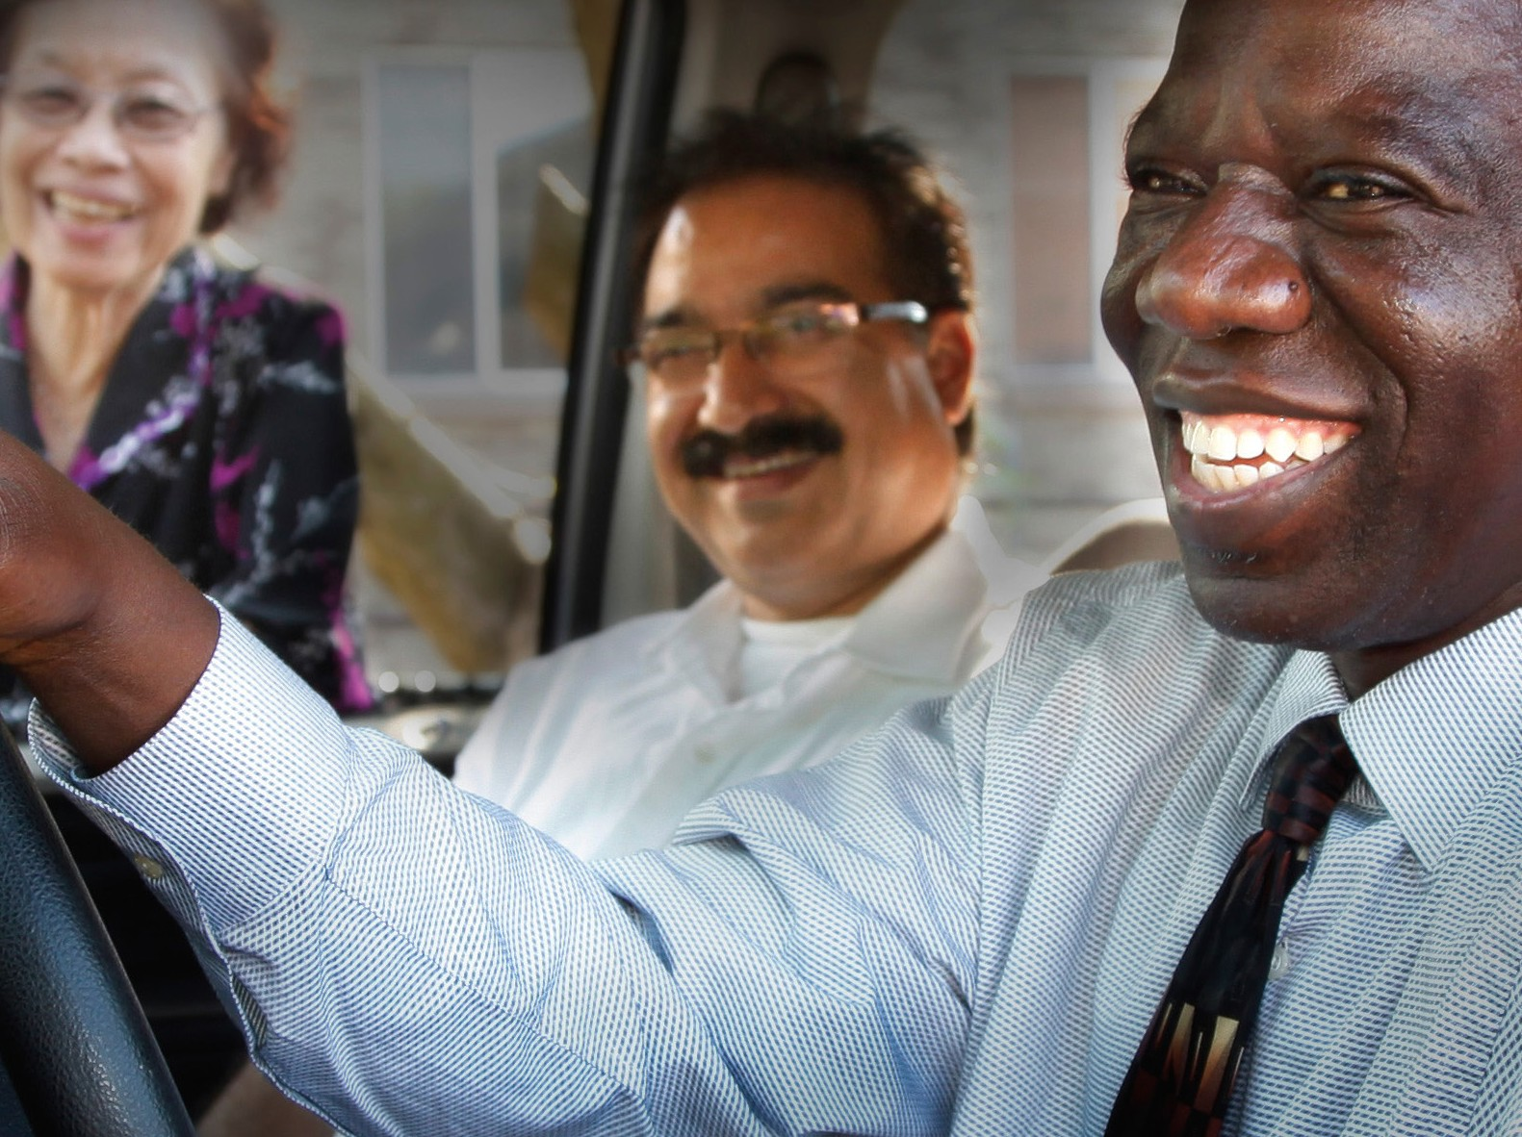
“more than years...”
40
Resources and support provided by the ORI were instrumental in helping Mohammad and Hajmeena adjust to their new home and become independent and productive members of the community. Soon after arriving, Mohammad made use of ORI employment services as he began the process of building financial and social stability.

Because Mohammad was lucky enough to be proficient in English, he was able to find a job within six weeks of coming to Boston. Just three months later, Mohammad had already advanced to a job as a shift supervisor with better pay and benefits at Logan Airport working in catering. He quickly developed a reputation as a dedicated and reliable worker and within seven months was promoted to a supervisory position.

With the help of the ORI and the Department of Transitional Assistance, Mohammad and Hajmeena were able to become self-sufficient soon after they arrived in the United States. Mohammad’s new career and his quick advancement at work allowed them to provide for their family’s needs. After only two months, Mohammad and Hajmeena no longer needed the benefits provided by the Department of Transitional Assistance, and their earning and spending boosted the economy of their local community.

While Mohammad pursued employment to provide financial stability for the family, Hajmeena and his children took their own steps to become successful in Massachusetts and the United States. Their children have begun kindergarten and first grade in the Boston Public Schools. During their school’s kindergarten kick-off event, they were personally welcomed to the school system by Boston Mayor Marty Walsh.

Hajmeena recently enrolled at a local community college where she is studying Advanced English. This past fall, she took an intensive ESL course to prepare her for success in her upcoming courses to pursue her business management degree.

In addition to caring for her children, studying for her classes, and adjusting to cultural differences in the United States, Hajmeena has also begun volunteering with recently arrived refugee families. She is currently helping a new Afghani family navigate the city of
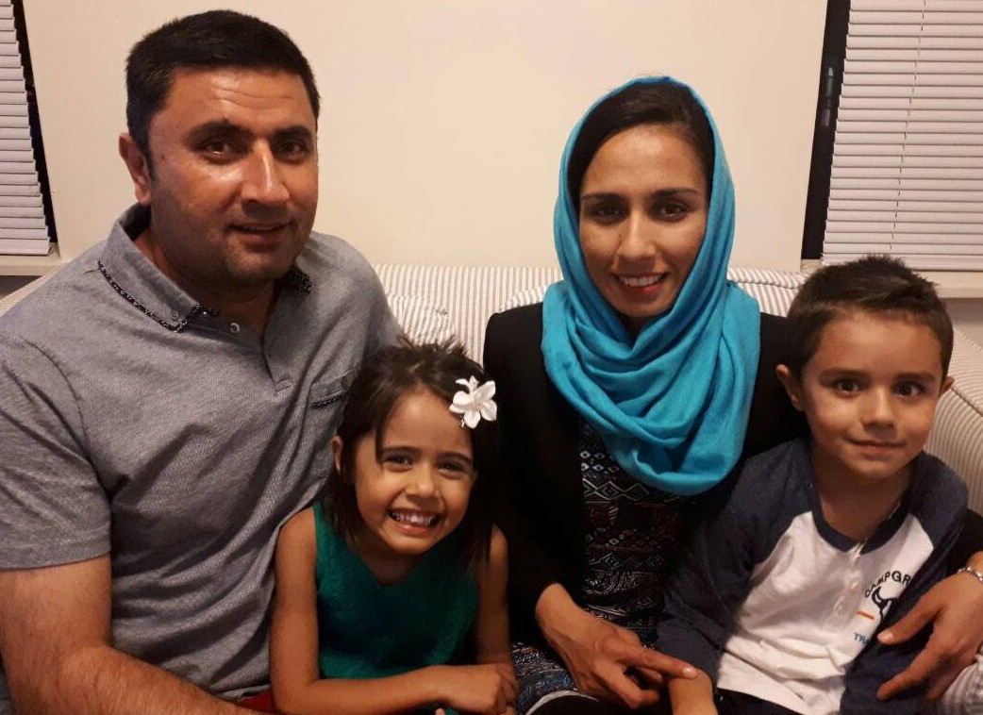
Boston. Basic tasks, such as learning to use public transportation and navigating supermarkets can be confusing for new residents, and Hajmeena has taken the time to share what she has learned from her own experiences with these new arrivals.

Mohammad and Hajmeena are excellent examples of the ways refugees give back to their new communities in the United States. With dedication, commitment and motivation, Mohammad and Hajmeena have become self-sufficient and are able to provide for their family. Their work and spending boost the local economy and their presence adds to the cultural diversity that Boston holds dear. This family has embraced the challenges of life in the United States and is working as hard as possible to overcome these challenges, become productive members of the community, and provide future opportunities for their children.

EMPLOYMENT SERVICES

Through both federal and state funding, employment services provide integrated assistance to new arrivals. Services include intensive case management, English language instruction, vocational skills development and training, job placement, and employment readiness and retention supports.

FISCAL YEAR 2017 ACCOMPLISHMENTS

Refugees Obtained Employment

72%

72% of our active employment caseload obtained employment.
RODINALD
Rodinald arrived to the USA in August 2016. In Haiti, Rodinald earned his Bachelor’s Degree in Economic Science and worked as a Social Worker following the hurricane in Haiti. Through refugee employment services provided at Jewish Vocational Service (JVS). he received job readiness vocational English classes, one-on-one job coaching, and participated in the Food Service Training
program, which is an 8-week training partnership between JVS and the Boston Long Wharf Marriot Hotel. Rodinald worked with kitchen staff to learn food preparation, cleaning and sanitizing and following recipes. He studied ServSafe Food Handler material and passed his certification exam in January.

In addition to the Food Service Training program, Rodinald also participated in the Boston Children’s Hospital Training Program, where he trained in environmental services and food service for 4 weeks. He worked with instructors to learn hospital vocabulary, safety protocol, and security procedures as well as performed the hands-on 7-step cleaning process. Newly ServSafe Certified, Rodinald secured a full-time job with AirServ, a food service company at Boston Logan Airport, where he makes $15 an hour with benefits.

EMPLOYMENT SUCCESS STORIES

Rodinald is doing very well in his position and is happy to continue his strong work ethic with a new opportunity in the US.

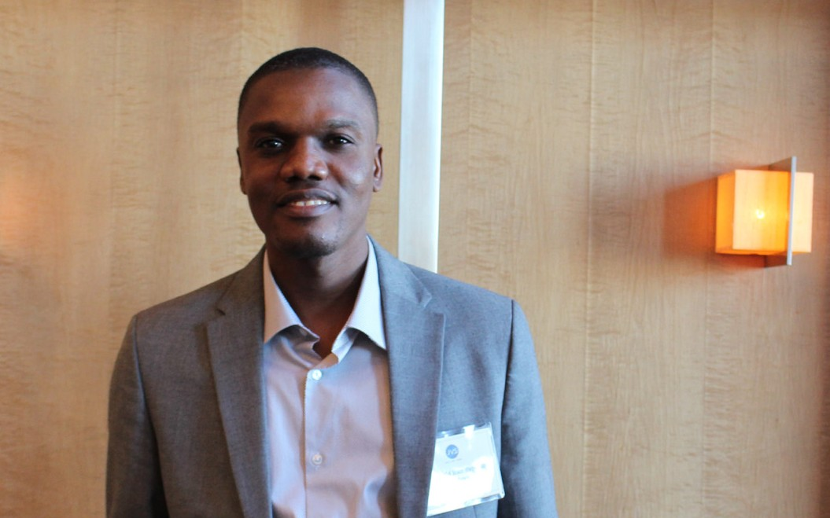

Cash Assistance Termination

69%

Cash Assistance Benefits terminated due to employment remains at 69%.

Employment Retention

87%

Job retention among employment program participants is at 87% for 2017. This percentage shows a steady trend over the last three years.

Obtained Driver’s Permit
“
The average
hourly wage
for first time jobs is well over $12.00 per hour.”

Over 117 refugee clients enrolled in employment services received financial assistance to access Skills Trainings including Driver’s Education Instruction.

79%

Accessed Training in

37%
Health & Finance Industries

37% accessed trainings in the Hospitality, Health and the Financial Industries and obtained their respective certifications and/or licenses.

IMAN
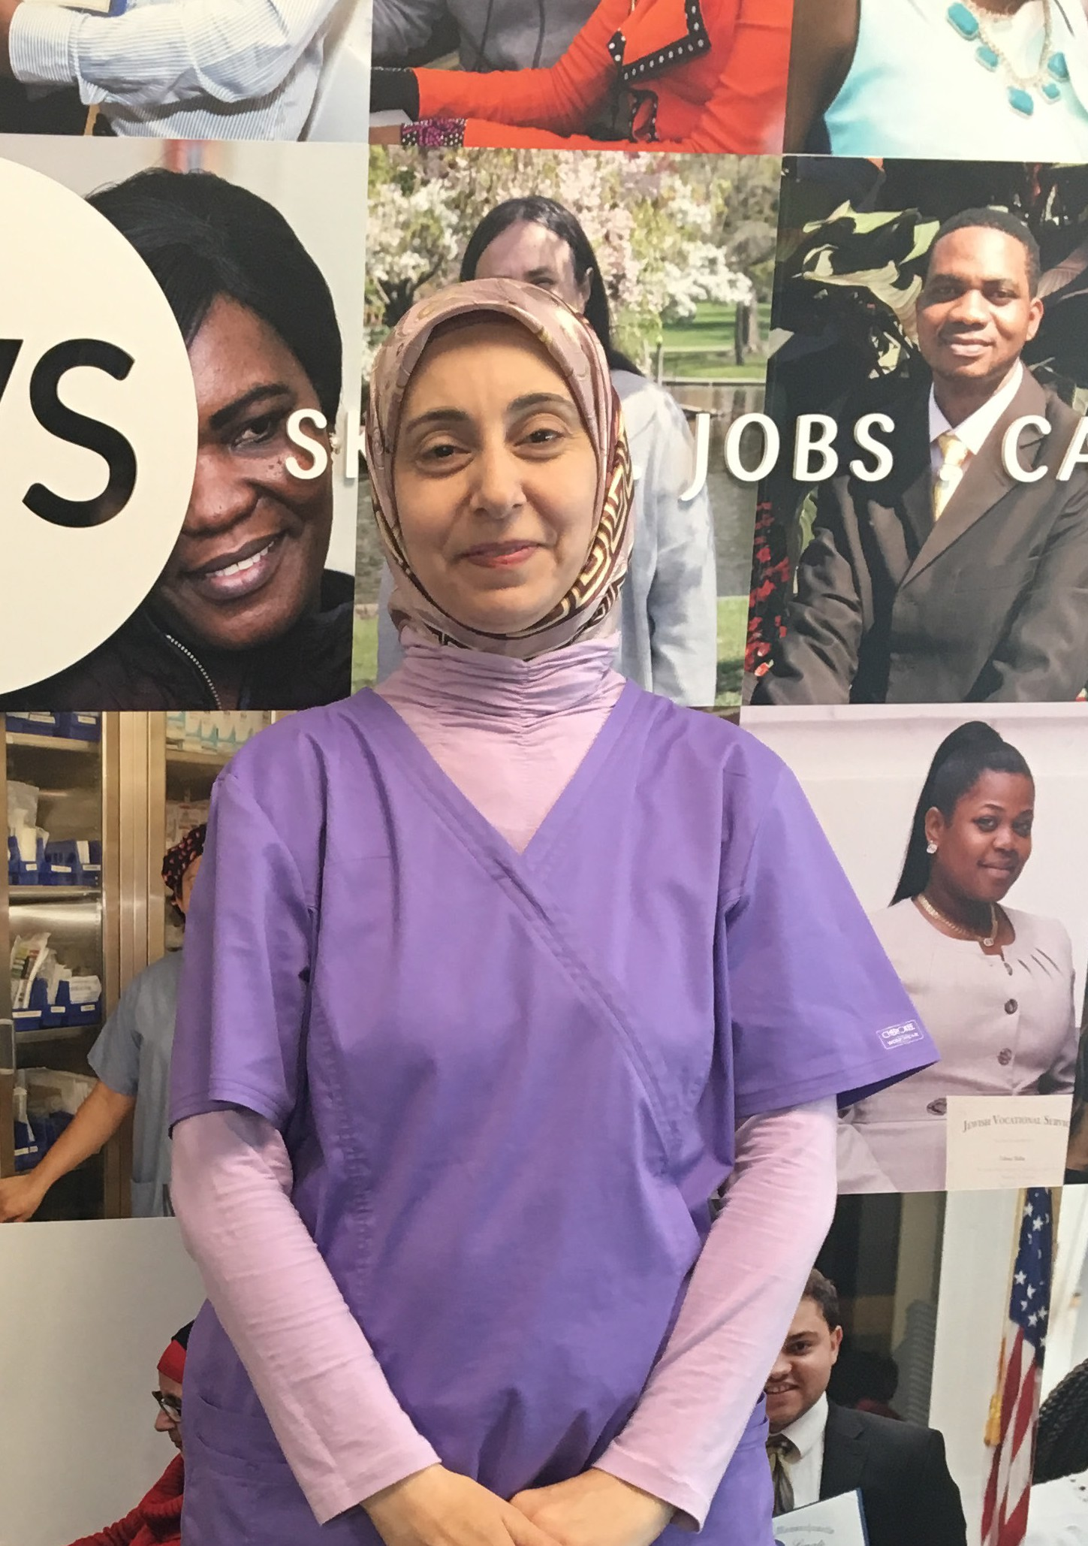
Iman moved to the U.S. with her 3 children to join her husband in October 2016. Upon arrival, she enrolled in Refugee Employment Services at the Jewish Vocational Service (JVS).
Iman attended Vocational English as a Second Language (VESOL) classes while her children were in school and worked closely with JVS staff to secure after school programs for her children so that she could focus on the job readiness program. Through hard work, Iman improved her English and applied for work in the medical field, based on her experience as a doctor in Syria. Her coach supported her assisting with cover letters, online applications, assessments, interview practice and follow- up communication.

Iman applied for the Spaulding Certified Nursing Assistant program at JVS and was accepted after two rounds of interviews. Upon completion of the eight week training program, she was hired at Spaulding Hospital in Cambridge as a full-time CNA making $14/hr. She is excelling in her role and loves being back in a hospital.

To further achieve self-sufficiency, Iman worked with a financial coach to develop a budget, and enrolled in a program that helped her pass a driving test and receive a Massachusetts license.

MICRO-ENTERPRISE

MassREAP
The Massachusetts Refugee Enterprise Achievement Program (MassREAP offers
an alternative income-producing strategy for refugees by helping them to develop either small-scale, home-based businesses, or traditional brick and mortar business ventures in the community. MassREAP provides refugees access to low-interest loans, credit-building activities and business-related technical assistance. In addition to assisting with new business start-ups, MassREAP contributes to the stabilization and strengthening/expansion of existing refugee enterprises.

PROGRAM STAKEHOLDERS & SUSTAINABILITY
MassREAP collaborates with direct service providers like the Jewish Vocational Service (JVS and Ascentria Care Alliance (ACA in Massachusetts to help refugees and immigrants start and advance their micro-enterprise through low-interest loans.
Refugees are the direct program beneficiaries.

MassREAP partners are exploring ways to take the program to the next level of success, such as by applying to the Small Business Administration (SBA) Microloan Program for loans and operational funds to promote long-term program sustainability. MassREAP program beneficiaries are empowered to become successful leaders and entrepreneurs. Many beneficiaries become job creators, an indication of sustainability for both their business as well as the MassREAP program. This is the last year of ORI’s funding for this program.

FFY 2017 ACCOMPLISHMENTS
FY17 was a very strong year for MassREAP. The number of small business loans attained by refugees increased by 34% from 47 loans in FY16 to 63 loans attained in FY17. A total of 119 jobs were created or retained by MassREAP-assisted businesses; 79 were new jobs, and 40 were existing jobs retained due to MassREAP program assistance to refugee owned businesses (most jobs held by refugees).

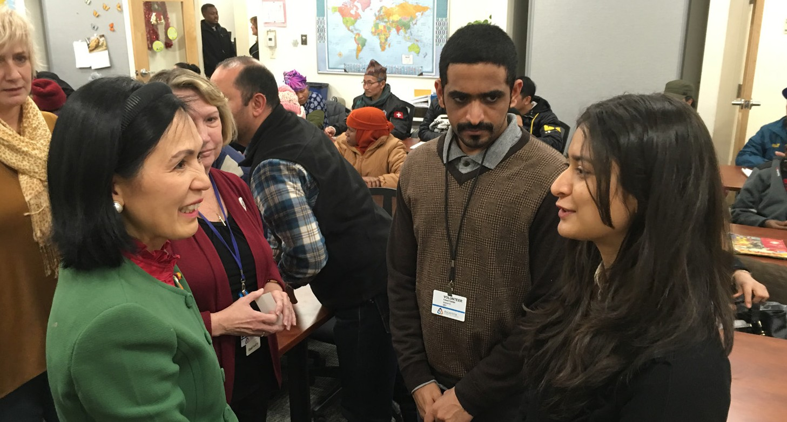
MassREAP staff based in Boston, Worcester and Westfield provided pre-loan technical assistance, post-loan, follow-up one-on-one and small group technical assistance through workshops and presentations to as many as 432 refugees who expressed an interest in starting or growing a business.

MassREAP SUCCESS STORIES

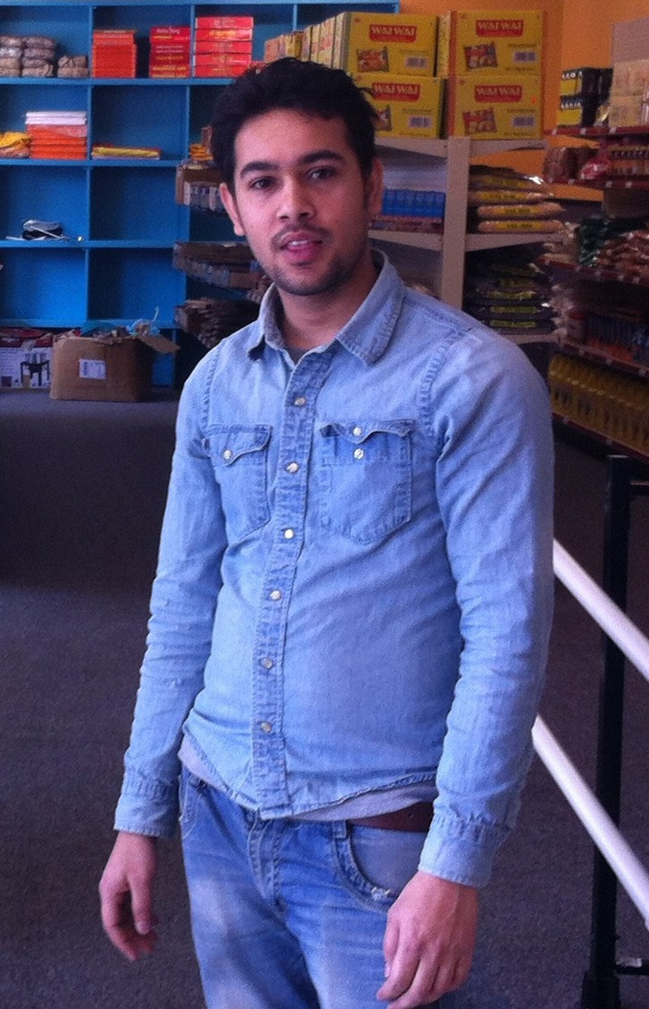
GOVINDA
Govinda was born in Bhutan and grew up in a refugee camp in Nepal where he attended elementary and high school. He later studied physics as a college student outside of the camp. He comes from a family with an entrepreneurial spirit. His family started a Money Transfer and Computer Institute, located outside of the camp, to teach computer skills and to be a Western Union/Moneygram transfer location.

Govinda, began the journey to create his own small business just three years after being resettled in Western Massachusetts. The Microenterprise Development Program made possible through Ascentria Care Alliance provided technical assistance, workshops, and one-on-one counseling and coaching to help him prepare his business plan. With a micro loan from the MassREAP program and with financial assistance from family members, he opened his store five months later.

Global Super Market offers a variety of ethnic foods and spices, health needs, candies, soda, handmade Nepalese clothing, religious books, decorative flowers, and other items. “We are doing better than our business plan”, Govinda stated recently. “Many of our current customers were customers in our store in Nepal, so we have a good foundation to build on.” When asked about their greatest challenge, Govinda stated that “meeting city requirements took much effort. However, if you work hard in the USA, you can succeed. I plan to work very hard to make a positive contribution to West Springfield and my community members. ”
“
Last year, the
RSI program
successfully
reached 794 young people and 409 parents around the state.”

CHILDREN & YOUTH
ORI has strategic statewide oversight of two programs for refugee youth and young adults: the Unaccompanied Refugee Minors (URM), and Refugee School Impact (RSI). URM and RSI both exist on a national level, and aim to increase opportunities for minors to reach their potential as newcomers to the U.S.. The URM was developed in the 1980s to address the needs of thousands of children from Southeast Asia without a parent or guardian to care for them. In Massachusetts, the program was initiated in 1996 and is a collaborative effort between ORI and the Massachusetts Department of Children and Families.

THE UNACCOMPANIED REFUGEE MINORS (URM)
Refugee and immigrant youth have unique obstacles upon arrival. They often arrive in the country of resettlement, fleeing dire circumstances in their nation of origin, without an adult family member. The program was able to reach, engage, house and protect 189 minors during 2017. Through a network of caretakers, the URM program helps youth develop appropriate skills to enter adulthood and to ultimately achieve social self-sufficiency. Children are placed according to their individual needs, ranging from licensed foster homes, to group homes, residential treatment centers, independent living programs, or therapeutic foster care.

THE REFUGEE SCHOOL IMPACT (RSI)
RSI addresses the impact of refugee children on local public school districts by identifying and addressing gaps in services to this population, an activity conducted in partnership between refugee service providers and local school districts. The program provides services relative to the needs of refugee children and their families in terms of their educational experiences, and supports local public school districts in fostering high academic and social success among refugee youth. Last year, the RSI program successfully reached 794 young people and 409 parents around the state.

URMP SUCCESS STORY

While most of those in the Massachusetts Unaccompanied Minors Program have come through UN channels from overseas refugee camps, the Office for Refugee Resettlements is mandated to care for others fleeing political or social unrest by crossing the US - Mexico border with no adult caretaker. Their lives speak of a resiliency and strength that form the basis for great things. Two of these youth are excelling with the support of the URM Program and loving foster family.

Agustín and Edgar grew up in villages in different parts of Guatemala. Both attended school up to the sixth grade, when their families could no longer afford to send them. As children, they worked long hours, Agustín in construction, and Edgar shining and fixing shoes and working on a plantain and coffee farm. Occasionally, they found time to attend weekly Catholic mass, and play soccer with friends.

Throughout Agustín’s childhood, he increasingly faced threats from the Mara Salvatrucha, or MS-13 gang. In 2013, Agustín made the decision, with the support of his mother, to flee the country. He traveled with a group of guides and migrants through Guatemala and Mexico to the US border, and eventually crossed into McCalley, TX. Agustín and the group were then abandoned in the desert by their guides, with no food and water. After three days, he was apprehended by immigration officials and placed in a youth shelter in Texas. He was eventually transferred to the Unaccompanied Refugee Minors Program in Massachusetts for long-term foster care.

Like Agustín, Edgar worked hard. By age 14, he was living with cousins in an area of town called La Rata (The Rat) which was known for criminal activity. After gang members shot the landlord’s son and demanded money for ‘protection’, Edgar fled Guatemala for the US. He traveled by bus and on top of La Bestia (the beast) trains, until he reached the US-Mexico
border. He witnessed extensive gang violence and horrific injuries to migrants falling from trains. Crossing the border, he traveled through the desert with little food and water. Edgar

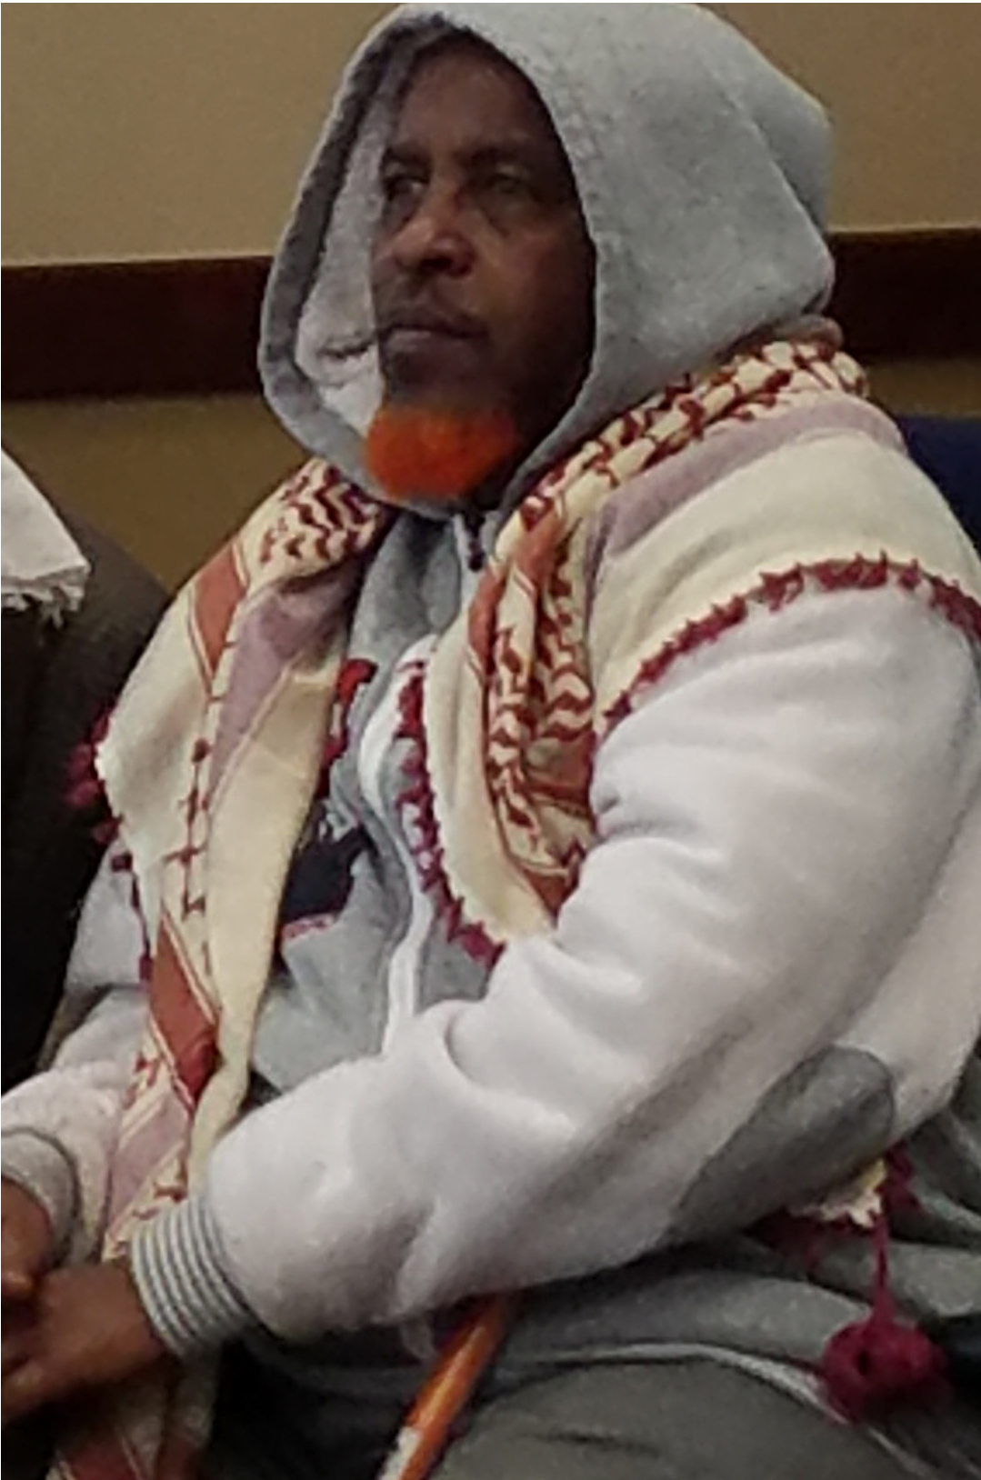

HEALTH PROMOTION
REFUGEE ELDER SERVICES

Refugee elders serve a valuable role both within the family and within our shared communities. However, with migration and acculturation, the status of the elder in a refugee family can change remarkably. ORI has implemented the Program to Enhance Elder Refugee Services (PEERS) as a means to strengthen relationships between refugee elders and refugee organizations and measurably reduce disparities faced by older individuals within a new environment. Services are designed to meet the specific needs of refugee elders, such as providing ethnic food in Meals on Wheels programs, organizing social support groups, or sponsoring health education workshops and activities.

In SFY17, ORI reached more than 257 refugee elders and their families which includes:

- 213 elders who received case management services;
- 121 homebound elders who received home visits
- 85 elders who were assisted with citizenship supports; and
- 18 elders who participated in volunteer, employment, and leadership positions, and accessed computer instruction.

was eventually apprehended by immigration officials while entering Houston, TX, placed in a shelter for unaccompanied youth, and transferred to long-term foster care with Agustín. Both Agustín and Edgar developed an amazing, supportive relationship with their foster family, flourishing in their care and with each other’s support.

Today, after 3 years in Worcester High School, Agustín and Edgar are freshmen at Boston College where they are fully involved in their academics and campus life. Agustín states that: “Attending Boston College is a dream that is becoming a reality for me. My dream is that in four years I will be walking the stage with
a degree in management and leadership… I believe that with this degree I will be able to create small businesses back in my community and give them that hope that they are seeking for”.

As for Edgar, in his 2017 essay “From the Campo to the Campus” (Campo is the Spanish word for countryside), he writes about his life’s journey and the opportunities he has had, through hard work and perseverance, to better himself and his goals to support his family and community in Guatemala. Edgar aspires to become a motivational speaker and to work in law enforcement. Whatever they do, their stories and lives thus far have no doubt built strength and resilience that will take them far.
ORI has oversight and coordination of the Massachusetts Refugee Health
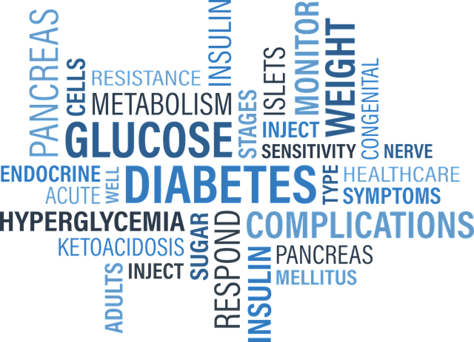
Promotion Program (MRHPP). The core objectives of the program include:

- Health and Behavioral Health Literacy: Ensuring that all newly-arrived refugees receive education and appropriate follow-up care for health conditions.

- Health Equity and a Reduction of Gaps in Accessing Health Services: Ensuring that refugees have full access to health and behavioral health services.

- Access to Health Care (including Health Insurance): Provide supports and coordination to ensure that all refugees can access health insurance coverage.

- Coordination and Capacity Building: Enhancing state and local level coordination of health promotion, preventive health and behavioral health services for refugees, and maximize federal, state and local resources, refugee social service providers and health care providers.

In SFY17, a total of 1,046 refugees were supported in enrolling in individual health assistance. The program delivered 469 home visits to clients most in need. Culturally and linguistically appropriate workshops were delivered to clients in prevention-based workshops covering a wide range of topics including: suicide and domestic violence prevention, nutrition habits, behavioral health needs, fire safety, effective parenting in a new culture, and navigating health care coverage in the United States.

CITIZENSHIP SERVICES
Becoming a citizen of the United States through naturalization can be a complex process for many. It requires English language proficiency, basic knowledge of U.S. history and civics, accurate completion of the citizenship application form and a successful interview with a United States Customs and Immigration Services (USCIS) official. ORI funds a network of community- based organizations to provide English language and civics classes, application assistance, interview preparation and additional support services to aspiring applicants around the state via the Citizenship for New Americans Program, or CNAP.

The purpose of CNAP is to enable low-income, lawful permanent residents in MA to become naturalized citizens of the U.S. Citizenship bestows upon foreign-born individuals the right to participate fully in civic and economic life in the U.S.

During this program year (July 1, 2016 – June 30, 2017), CNAP participants had a variety of successes that include:

- 1,273 participants received application assistance to begin their paths to becoming citizens.

- Nearly 470 participants became citizens in the last year.

FINANCIAL LITERACY FOR NEWCOMERS

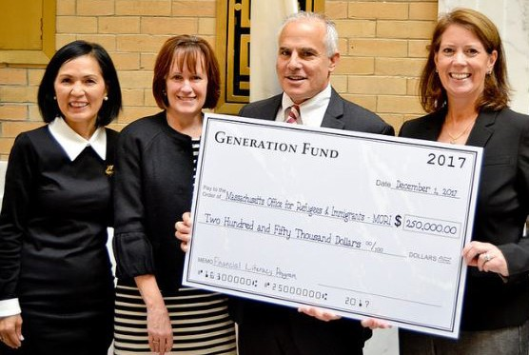
A true hallmark of self-sufficiency is the capacity to make informed financial decisions, yet new arrivals often face unique obstacles with regard to achieving financial proficiency. Some of the obstacles include language and literacy barriers, different financial customs, and a complex American banking system.

To address these obstacles and capitalize on the merits and strengths newcomers bring with them, ORI has designed and implemented the Financial Literacy for Newcomers (FLN) program. The FLN program aims to build stronger bonds between refugee communities and existing financial institutions and develop educational initiatives that target the specific needs of newcomers. Specific objectives include:

- Orientation of refugees and immigrants to financial institutions’ portfolio of services.
- Development and delivery of culturally and linguistically appropriate financial information with a focus on basic personal finance, budgeting, avoiding scams, sending money to the home country (a.k.a. remittances), investing and retirement planning.

- Enhanced collaboration and partnership between public and private partners to support local refugee and immigrant communities in understanding the importance of financial literacy.

FLN is supported by a multiyear funding through the Generation Fund and one time grant from People’s United Bank. ORI’s overall goal is to develop and deliver culturally competent financial education literature, tools, and resources to approximately 1,000 new arrivals over the course of the next three years.

Nearly
“
470

participants became citizens in the last year.”

REFUGEE HEALTH ASSESSMENT
Health and well-being are fundamental to successful refugee resettlement and integration. All refugees are eligible for medical services, including the initial medical screening, which is provided within 90 days of entry into the U.S. In Massachusetts, the medical screening services are coordinated by the Massachusetts Department of Public Health (MDPH) in partnership with ORI, and operationalized as the Refugee Health Assessment Program (RHAP).

The RHAP design uses a public health framework to remove barriers that may prevent newly arrived refugees from accessing early medical diagnosis and treatment services. Because RHAP is the refugee’s first point of contact with the U.S. healthcare system, RHAP sites strive to offer a welcoming environment and provide support in navigating the health system.

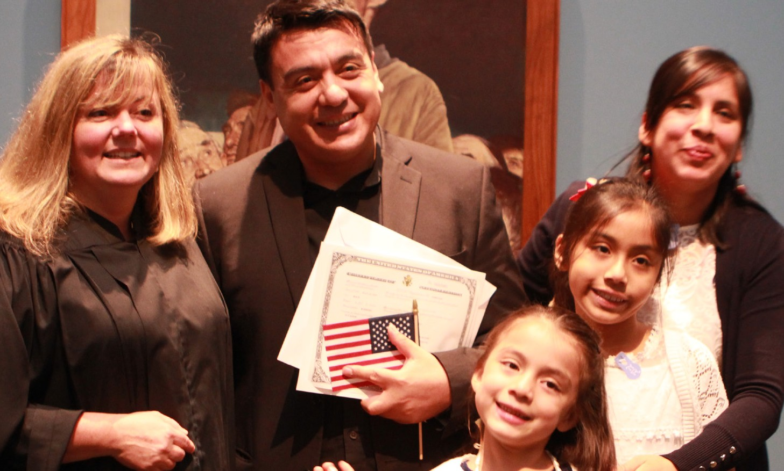
20 Massachusetts Office for Refugees and Immigrants
In Massachusetts, there are nine RHAP sites (seven community health centers and two hospital-based clinics) in five geographic centers where there is active refugee resettlement. These sites have extensive experience and expertise in refugee health and are key partners for MDPH and ORI in supporting refugee resettlement. In FFY 2017, 1,847 refugees received RHAP services.

RHAP is tailored to refugee experiences and needs. Through RHAP, providers review migration histories, overseas medical documents including vaccination records, and provide a thorough assessment that includes screening for infectious and non-infectious conditions of public health concern, and provision of immunizations. RHAP also facilitates follow-up of conditions identified during either the overseas medical examination or RHAP that may adversely affect resettlement of refugees.

Refugee children benefit from RHAP – almost half of those who receive RHAP services are children. RHAP facilitates school entry by completing the school physical and immunization requirements so children can quickly begin their education and integration into the classroom.

A key RHAP activity is linking refugees with primary care services, either at the RHAP site or another provider of their choice. The RHAP record provides important information for their primary care provider. MDPH continues follow-up of refugees for whom tuberculosis evaluation and treatment is recommended.

21

TOWN HALL MEETINGS
In December of 2017, ORI Executive Director Truong led the first series of statewide Refugee Town Meetings to discuss areas of concern for newcomers, which were held in partnership with ORI’s refugee resettlement agencies, the Attorney General’s Fair Labor Division, and other partners, including the United States Citizenship and Immigration Services (USCIS). The Town Hall Meetings took place in Essex, Hampden, Middlesex, Suffolk, and Worcester counties, with more than 180 refugee newcomers participating. Individuals
came from Afghanistan, Belarus, Bhutan, Burma, Cameroon, Cuba, Nepal, Iraq, Iran, Pakistan, Somalia and Syria, among other countries. All participants were united in their desire to make America their home. Newcomers, supported by the linguistic capabilities of their interpreters of Arabic, French, Nepali, Russian and other languages, spoke aptly of obstacles as well as opportunities that come with the resettlement process. The following represents the outcomes of these conversations organized by subject matter:

HOUSING
The cost of living in Massachusetts is among the highest in the nation, and for many, the short-term time specific benefits they
obtain create a struggle to paying rent. Many refugees must simultaneously learn English in order to obtain employment and reduce reliance upon assistance. This is time consuming, and as noted below, accessibility to English as a second language classes is limited.

ACCESS TO HEALTHCARE
Most newcomers, responding to questions with regard to medical care and access to care, indicated that they were able to have prompt
access to an appointment upon arrival to the United States, and communicated being very impressed with the comprehensive level of care they were able to receive.

ENGLISH LANGUAGE ACQUISITION
Newcomers shared the obstacles in learning English, indicating a need for more classes, as well as classes that better fit work schedules
and specific English learning needs (for example, classes with emphasis on casual conversation). There was a simple desire to be immersed and become fluent in order to more rapidly find employment.

PUBLIC SAFETY
Newcomers communicated a feeling of safety in their particular communities. Many recognized their regions were diverse and
welcoming. Refugees were provided the number for the Attorney General’s Hotline as a means to prevent, report and reduce hate crimes in the Commonwealth.

EMPLOYMENT
Refugee newcomers present at each of the Town Hall meetings indicated a profound need to be able to maintain employment and
advance professionally in their fields of choice. Some expressed their challenges in becoming gainfully employed due to language barriers and having transportation obstacles, while many refugees already obtained jobs leading to solid family self-sufficiency.

The Town Hall meetings provide a unique and inclusive approach to highlighting specific concerns and to working towards long-term, sustainable solutions. In with the spirit of the season, ORI was able to present gifts to the town meeting participants. These gifts were provided by generous donation from Fragomen LLP and included warm weather goods, backpacks, school supplies, and other items.

Massachusetts’s welcoming message to refugees and immigrants was heard internationally in 2017 by delegates who came from many countries to learn from ORI about resettlement process in the state and the battery of services available to the newcomers. These pictures capture some of the delegates’ visits to ORI:

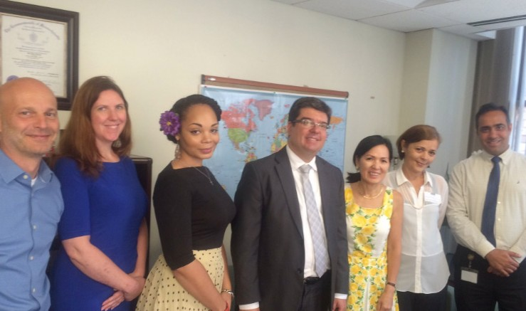
Brazilian Consul General
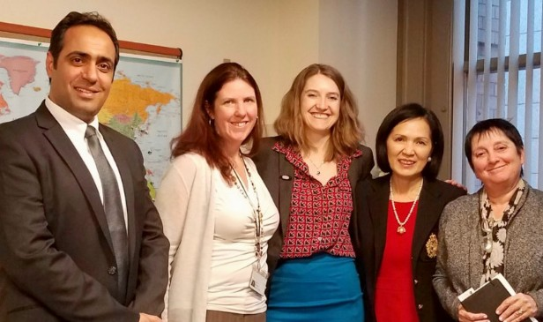
British Consul General
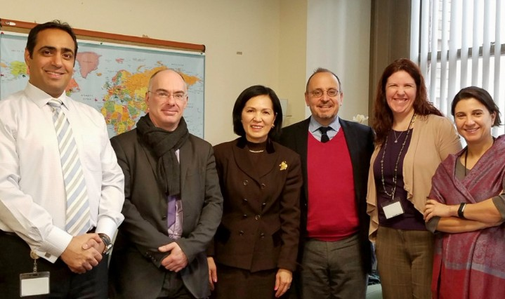
French Consul General

INTERNATIONAL DIPLOMATS

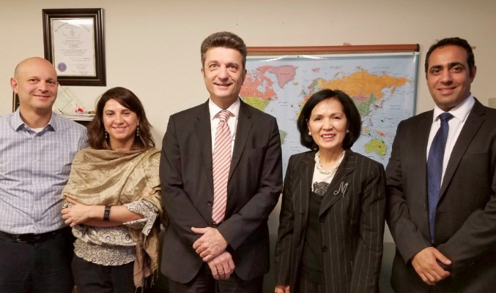
German Consul General

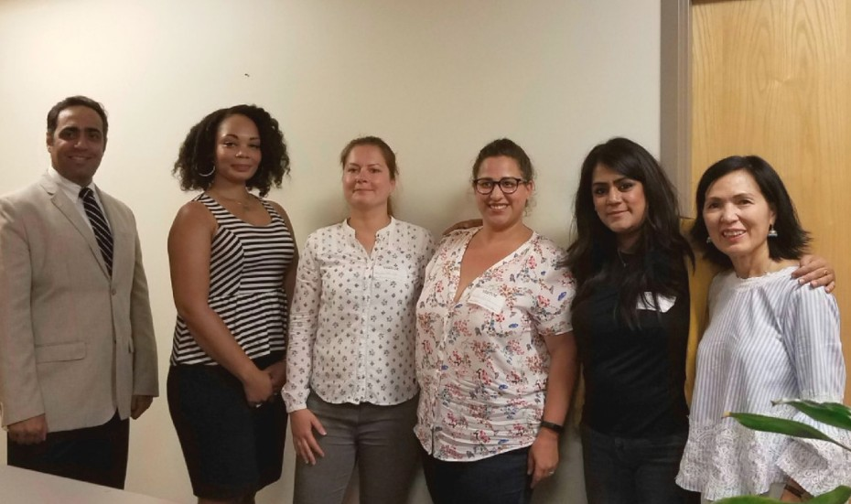
Switzerland Delegation
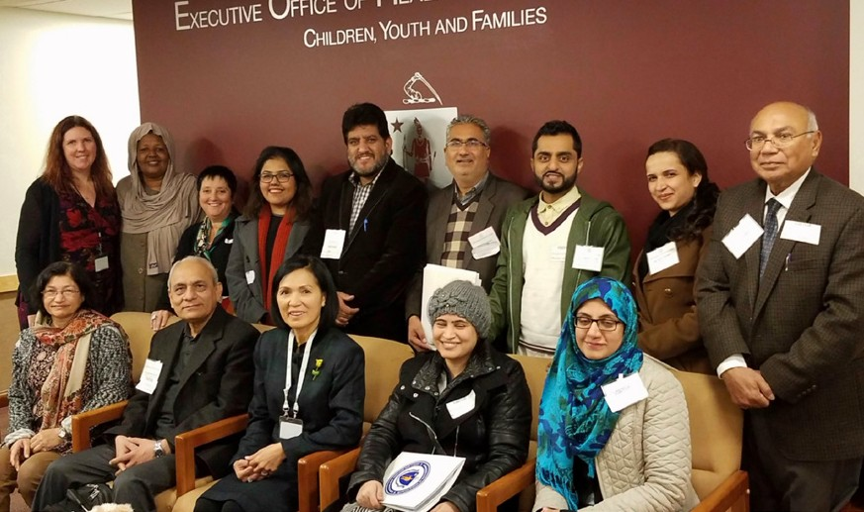
India and Pakistan Delegations
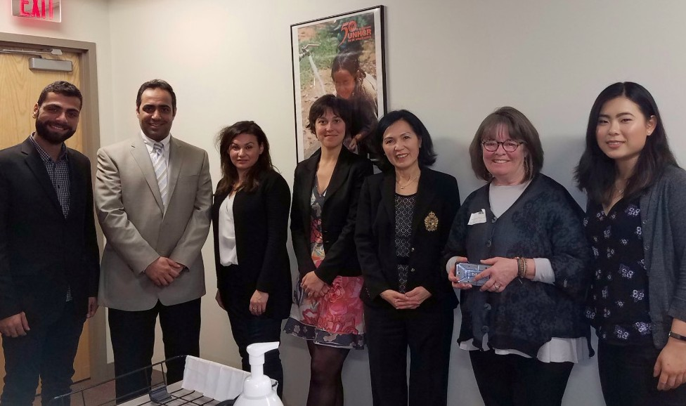
Italy Delegation

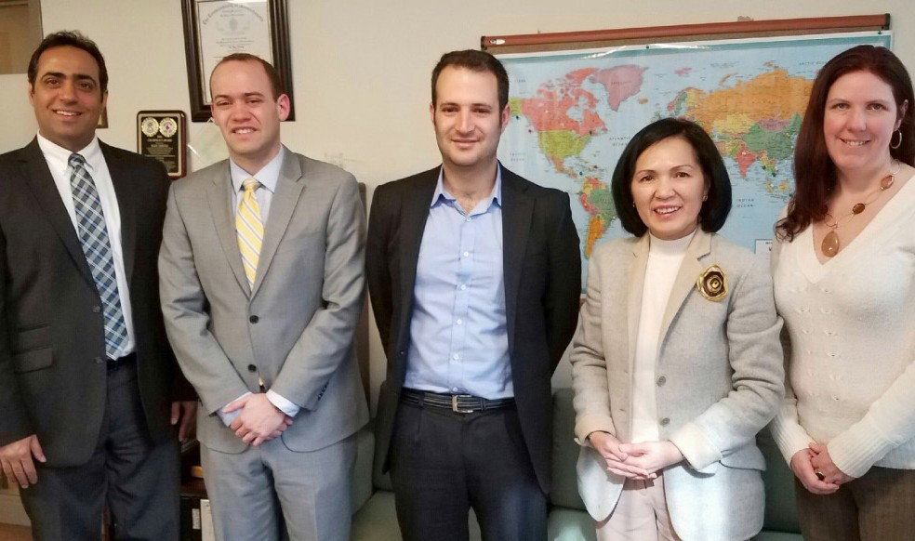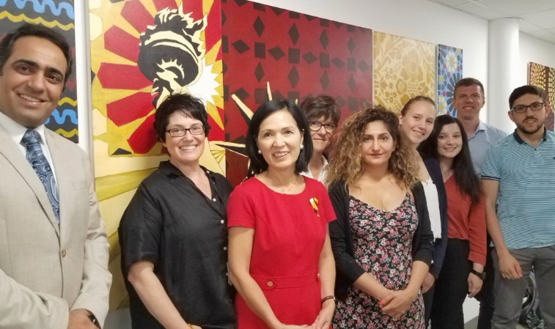

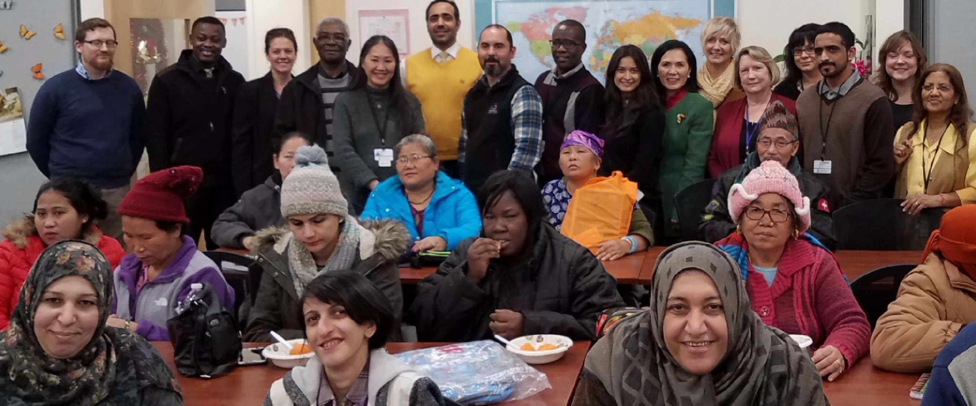
22 Massachusetts Office for Refugees and Immigrants
Israel Delegation
Sweden Delegation 23

FINANCIALS
ORI is primarily funded through the federal Office of Refugee Resettlement, which supports services for refugees. ORI also receives state funding to support citizenship and employment services to refugees and immigrants residing in the Commonwealth.

During federal fiscal year 2017 (FFY17), ORI administered 11 programs that provided direct services to clients through a network of refugee resettlement agencies (including faith-based organizations), and ethnic community- based organizations, that all have the capacity to serve the culturally and linguistically diverse needs of newcomer populations. In FFY17, the ORI overall budget was $19.5 M, with $18.1M funded from federal grants and $1.4M from state dollars. State funding includes $0.4 M of appropriation to administer CNAP and $1 M through an ISA with the Massachusetts Department of Transitional Assistance (DTA) to administer the Employment Support Services Program (ESSP).

ORI continues to seek out additional public-private partnerships to sustain and enhance our mission, to strengthen our collaborations with stakeholders, and to further empower refugees and immigrants to successfully integrate with their new communities.

ORI is grateful to all of our partners and key stakeholders who supported the programming that was such a success over the previous year. We heartily welcome all who would like to join these efforts to make 2018 a banner year for both our newcomers and our Commonwealth.

Refugee Services by Category in FFY 2017

School Impact Program : 2.16% Health Promotion : .75%
44.44%
1.46%
5.28%
10.32%
15.48%
14.28%
6.24% 2.49%
Elder Services : .57% Citizenship Services : 1.81%

Unaccompanied Minor: 44.44% Employment Services : 15.48%
Other : 5.28%
Social Adjustment Services : 2.49%

Case Management : 6.24% Cash Assistance : 14.28%
“Let’s make
2018
a banner year
for both our newcomers and our Commonwealth.”
Health Assessment : 10.32% Microenterprise : 1.46%

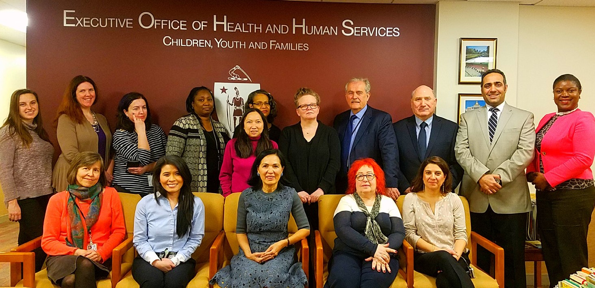
“
Thank You!
Gracias. Merci. Mahadsanid.”

ORI WOULD LIKE TO THANK THE FOLLOWING PARTNERS IN SUPPORT OF OUR WORK

Governor Charles Baker Lieutenant Governor Karyn Polito
Executive Office of Health and Human Services Secretary Marylou Sudders Governor’s Advisory Council on Refugees and Immigrants
Office of Refugee Resettlement

Generation Fund People’s United Bank
Executive Office of Elder Affairs MA Commission for the Blind
MA Department of Children and Families MA Department of Public Health
MA Department of Transitional Assistance MA Department of Youth Services MassHealth
Interns, volunteers and supporters Service Providers
United States Citizenship and Immigration Services Fragomen LLP
Karhu CEO, Huub Valkenburg

Additional thanks to burke+design for their help in producing this report. ( www.burkeplus.com )

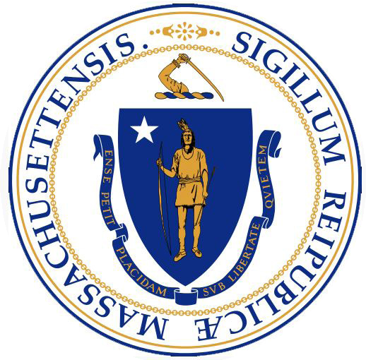

CONTACT US
Massachusetts Office for Refugees and Immigrants 600 Washington Street, 4th Floor
Boston 02111
T: 617-727-7888

For more information, or to download this report, please visit:
www.mass.gov/ORI

