ORRF Advisory Council Presentation

Opioid Recovery & Remediation Fund Advisory Council
Monday, December 11, 2023
10:30 AM – 12:00 PM
Zoom

Welcome & Approval of Approval of 09/27/23 Meeting Minutes
AGO Opioid Settlement Updates
Sandra Wolitzky
Chief, Health Care Division
Office of the Attorney General

2023 Payments to ORRF
Settlement | 2023 ORRF Payments
Distributors | $13.8M
Mallinckrodt | $7.1M
AGO Medicaid Fraud Settlements | $785k
McKinsey | $566k
J&J | $471k
Total | $22.7M
© 2023 Massachusetts Attorney General’s Office

Total Payments So Far and Estimated 18-Year Totals
To Whom: | Settlements Funds Already Paid (as of December 2023) | Estimated Total Settlement Funds to Be Paid Over 18 Years
To ORRF | $105,527,022 | $607,029,155
To Municipalities | $51,031,535 | $379,263,142
Note: The estimated totals are updated from the June 2023 projections to reflect implementation expenses for the Teva, Allergan, Walmart, Walgreens, and CVS settlements and the impact of the Mallinckrodt second bankruptcy.
© 2023 Massachusetts Attorney General’s Office

Municipal Abatement Updates
The three images displayed are logos of the following:

Logo 1. Bureau of Substance Addiction Services (BSAS)
BSAS operates under the auspices of the Executive Office of Health and Human Services and sits at the Department of Public Health. Its mission is to support accessible, effective, and culturally responsive prevention, intervention, treatment, harm reduction, and recovery support principles, programs and practices.​

Logo 2. Care Massachusetts -The Opioid Abatement Partnership (Care Mass)
Care Mass was developed to oversee the opioid abatement work and is guided by the commitment to utilize abatement funds in ways that supplements and strengthens existing prevention, harm reduction, treatment, and recovery resources, and centers the voices of those most impacted by the opioid epidemic.

Logo 3. John Snow Institute (JSI)
JSI is the organization contracted by BSAS to oversee the implementation of the Care MA initiative, which includes providing support to help municipalities participating in the State Subdivision Agreement that are receiving opioid abatement funding.
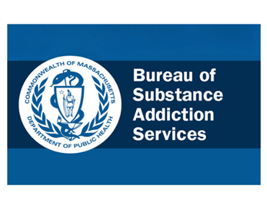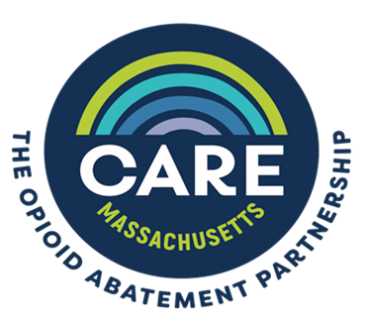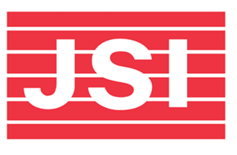
Background:
BSAS contracted the John Snow Institute (JSI) to provide support to municipalities in their efforts to invest opioid settlement funds to effectively address the opioid crisis.
CARE Massachusetts: The Opioid Abatement Partnership is guided by the commitment to utilize abatement funds in a way that supplements and strengthens existing prevention, harm reduction, treatment, and recovery resources, while ensuring that the voices of those most impacted by the opioid epidemic are involved in the decision-making process.

Typical Municipal Abatement Payment Schedule
FY23 (July 1, 2022 - June 30, 2023)
July 15, 2022 ⁻ Distributor Payment Year One
Sept. 30, 2022 Distributor Payment Year Two
Nov. 2, 2022 Distributor Payment Year Three

Exemplar Municipal Expenditures Reporting Dashboard
Municipal Dashboard Link
The image displayed below is the homepage of the municipal dashboard. The homepage contains a map of Massachusetts that is color-coded. There are four colors on the color-code key. The orange box represents municipalities required to submit an annual expenditure report, the purple box represents municipalities not required but submitted an annual expenditure report. The blue box represents municipalities not required and did not submit an annual expenditure report. The gray box represents municipalities that did not participate in the FY23 State Subdivision Agreement and did not receive opioid abatement funding in FY23. A dropdown menu is located to the right of the map that allows end users to view individual municipal expenditure reports by typing in the name of the municipality in the search engine. Directly below the dropdown menu is a black box that displays the counties that participated in the State Subdivision Agreement.

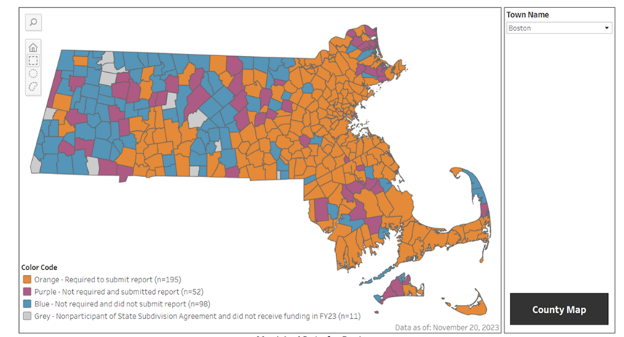

Key Themes Raised by Advisory Council in Meetings to Date
Equity: Need to focus on populations disproportionately impacted
Data Collection & Analysis: Need for improved data collection, analysis, and reporting on SUD trends
Supporting Families: Need to focus on supporting and strengthening families
Service Expansion/Enhancement: Need to expand/enhance services across continuum gap
Workforce: Need to strengthen and rebuild workforce
Social Determinants of Health: Need to focus on upstream factors, including housing and poverty
Awareness: Need to decrease stigma and increase understanding of treatment opportunities

Advisory Council Recommended Priorities
The table below displays the results of a survey taken by the ORRF Advisory Council that asked members to rank priority areas they think the ORRF should focus on first. The priority areas are listed in Column A Rows 3 through 8. Columns B through H list how respondents ranked each priority area from 1^{s} to 6^{th.} Not Applicable is listed in Column I for those that did not provide a ranking. Finally, the Column weighted totals for each priority area are listed in Column J.

Priority Area Survey Results – ORRF Advisory Council
Priority Area | How Many Ranked 1st | How Many Ranked 2nd | How Many Ranked 3rd | How Many Ranked 4th | How Many Ranked 5th | How Many Ranked 6th | NA/Not Ranked | Weighted Total
Equity | 8 | 2 | 2 | 1 | 1 | 0 | 2 | 71
Service Expansion/ Enhancement | 3 | 4 | 1 | 4 | 2 | 1 | 1 | 59
Workforce | 4 | 0 | 3 | 3 | 1 | 3 | 2 | 50
Supporting Families | 1 | 4 | 1 | 1 | 7 | 2 | 0 | 49
Social Determinant | 0 | 2 | 3 | 4 | 2 | 3 | 2 | 41
Data Collection and Analysis | 0 | 3 | 4 | 1 | 0 | 4 | 4 | 38
Awareness | 0 | 1 | 1 | 1 | 2 | 3 | 8 | 19
Other | 0 | 0 | 1 | 0 | 1 | 1 | 13 | 7
Weighting Key: Ranking 1st = 6 points; Ranking 2nd = 5 points; Ranking 3rd = 4 points; Ranking 4th = 3 points; Ranking 5th = 2 points; Ranking 6th = 1 point; NA/Not Ranked = 0 points

Proposed Implementation of Priorities
Based on the ORRF Strategic Framework and Advisory Council (AC) recommendations, combined with data on unmet needs and current activities in the Commonwealth, our goal is to focus on 4 of the 5 following priority areas via ORRF funding, and to advance a focus on Workforce (ranked 3rd by the AC) via the Behavioral Health Trust Fund. Social Determinants investments, and an Equity lens, will be woven throughout these priority areas.
Priority Area | New Funding Commitment
Equity (ranked 1st) | $10M ORRF
Service Expansion/Enhancement (2nd) | $18M ORRF
Workforce (3rd) | $15M BHTF
Supporting Families (4th) | $3.5M ORRF
Data Collection & Analysis (6th) | $2.0M ORRF

Equity (Ranked 1) Community-Driven Equity Framework
CAB’s
Engagement Meetings
Research
Community Dialogue
Other input mechanisms
Capacity Building
Funding
Amounts
Awardees
Structure
Policy
Training & TA
Practice Guidance
Improve Health Outcomes
Increase Equity
New Organizations Funded

Community-Driven Activities at BSAS
HRIA - Capacity-Building and Grantmaking for BIPOC-led/serving community organizations (CBOs, FBOs, TIPSOs)
UMass Boston CANALA Institutes - Understanding the Substance-Related Needs of Massachusetts' Communities of Color
Black and Latino Men’s Re-Entry - Funds six community-based service providers to offer care coordination and recovery support to Black and Latino men at high risk of post-incarceration overdose in five communities: Boston, Lawrence, Lynn, Worcester, and Springfield
Consumer Advisory Boards (CAB) - Currently have two CABs: Harm Reduction Advisory Committee and BIPOC grantmaking and capacity building
Two pilot CABs in development: Transgender & Gender Expansive (TGE) CAB and Frontline Provider CAB
Future CABs for consideration
Compensated consultants with topic-specific lived and/or professional expertise
Participation in bureau operations where appropriate

Proposed New Equity Investments
Proposal:
$10m (annually) in Trust Fund dollars to support gaps and needs identified by population and topic-specific community advisory boards including:
$6.5m (annually) in Trust Fund dollars to expand Black and Latino Men’s Re-Entry and fund new Recovery-Based Re-Entry Services for Women.
$3m (annually) in Trust Fund dollars to expand BIPOC grantmaking and capacity building, known as Redefining Community Wellness through HRiA.
$500K (annually) in Trust Fund dollars to support the School of Re-Entry to ensure the programming being offered is comprehensive and reflective of evidence-based practices.

Service Expansion and Enhancement (Ranked 2)
Background: The ongoing opioid and polysubstance use crises underscore the need to invest in low barrier models of access to medication for addiction treatment, including bridge clinics and addiction consult services, especially through an equity lens. Additionally co-occurring stimulant use disorder highlights the need to invest in evidence practices such as contingency management.
Proposal:
$16m (annually) in Trust Fund dollars to fund 15 Hospital-based SUD programs in highest need communities facing greatest disparities to increase access to substance use disorder services and continuity of care in the community.
$2m (annually) in Trust Fund dollars to strengthen investments in contingency management, particularly in light of limitations in federal funding.

Workforce (Ranked 3)
Proposal:
The Executive Office of Health & Human Services administers a Behavioral Health Trust Fund, which we propose to leverage to expand upstream investments in recruitment and retention strategies and to promote a well-trained SUD workforce, especially through an equity lens.
These OUD/SUD investments are envisioned as part of a comprehensive portfolio of Behavioral Health workforce investments being developed by EOHHS in partnership with expert/stakeholder input and the Governor’s Workforce Skills Cabinet.
We welcome your recommendations for specific areas of SUD workforce investment. As Chair of the ORRF Advisory Council, Secretary Walsh would present these SUD-related workforce proposals as they are developed to this Advisory Council for feedback and awareness.

Supporting Families (Ranked 4)
Background: The effects of substance use disorder are felt by the whole family. Culturally specific evidence-based and evidence-informed models exist to support these families. However, additional support including both funding and training is needed to pilot, implement, and evaluate these models within specific communities and populations, especially through an equity lens.
Proposal:
$3m (annually) in Trust Fund dollars to fund high-need communities to implement and evaluate community-driven and culturally specific evidence-based and evidence-informed models* for families impacted by SUD.
$500K (annually) in Trust Fund dollars to fund grief support for family members who have lost a loved one to overdose.
*EBPs may include culturally specific EBPs such as Familias Unidas (Latinx), Strong African American Families (Black/African American) and Family Spirit (Native/Indigenous), as well as Group Peer Support and other evidence-informed strategies such as grandparents raising grandchildren, etc.

Data Collection & Analysis (Ranked 6)
Background:
To increase transparency and promote shared access to data, BSAS recently launched a new dashboard to share data from BSAS-licensed or funded programs. BSAS is currently exploring possibilities to expand and enhance this dashboard, including potentially adding other datasets from across government such as mortality, hospitalization, and ED syndromic surveillance data, as well as creating more localized community profiles. These and other enhancements would create the necessary foundation for effectively measuring and reporting on KPIs related to ORRF strategies.
Proposal:
$2m (annually) in Trust Fund dollars to expand and enhance the Commonwealth’s substance use dashboard to include additional datasets, community profiles, and tracking of ORRF KPIs.

Summary of New Investments

Priority Area | Proposed Annual Investment from ORRF FY25-29
Equity | $10.0 million
Service Expansion/Enhancement | $18.0 million
Supporting Families | $3.5 million
Data Collection & Analysis | $2.0 million
Total | $33.5 million

Upcoming Meetings in 2024
Wednesday March 6, 2024
11am–12:30pm (Zoom)
- Updates on current initiatives, including Community/Municipal Grants Program
- Strategies to make OUD data more accessible
Additional Meeting Dates in 2024
Thursday June 13 @ 10:30 am
Tuesday September 10 @ 12:30 pm
Tuesday December 3 @ 11 am

100% Compliance for Required Municipal Reporting for FY23
The chart below is a clustered column chart that illustrates the submission rate for municipalities required to submit a report and municipalities not required to submit a report. The submission rate for the 195 municipalities required to submit was 100% and the submission rate for the 138 municipalities not required to submit was 38%.
Required to report pursuant to AGO State-Subdivision Agreement

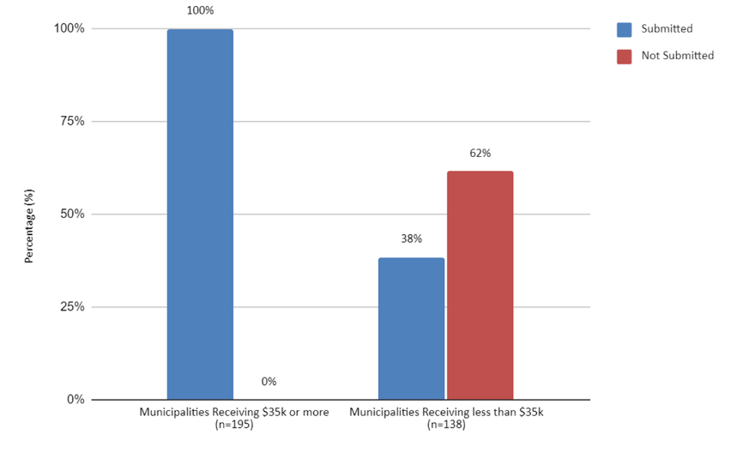

Required to report pursuant to AGO State-Subdivision Agreement
Not required to report pursuant to AGO State-Subdivision Agreement

Municipal Abatement Funds Received and Expended in FY23
The chart below is a clustered column chart comparing the $42,159,703.26 opioid abatement funds that were distributed to municipalities compared to the $1,893,026,69 of opioid abatement funds that were expended by municipalities.

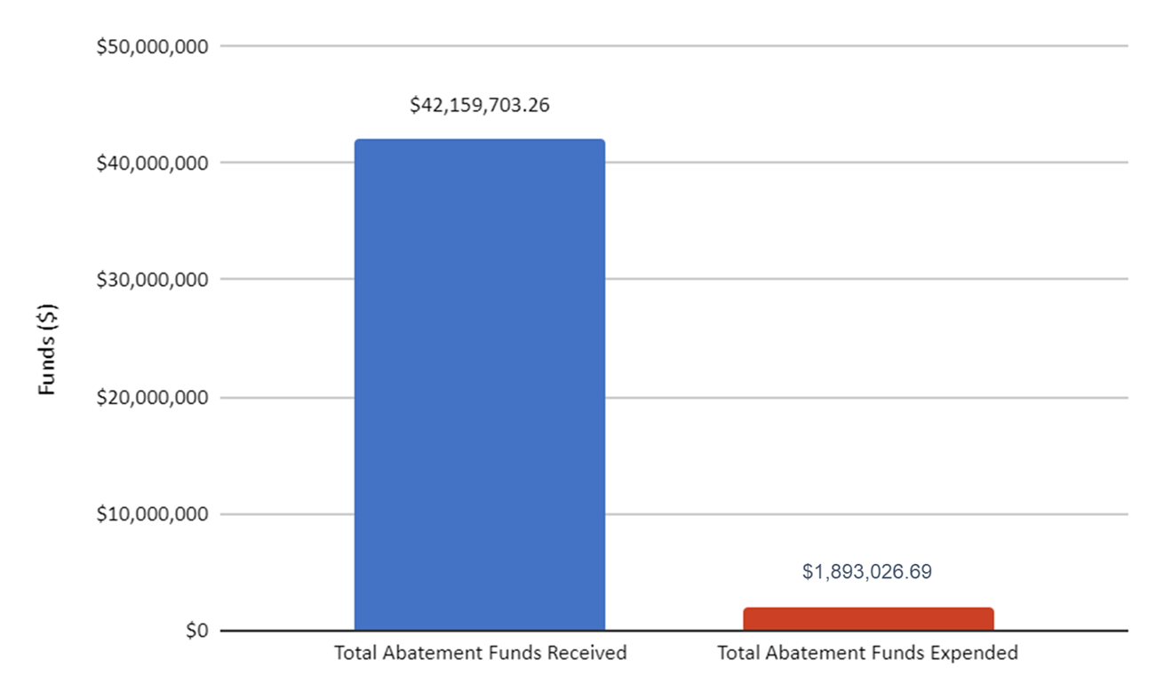

Total FY23 Municipal Expenditures by Category
The chart displayed below is a pie chart that reflects the total amounts expended per category reported by municipalities. Specifically:
Administrative Costs = $511,028.39
Family Support = $15,277.30
Other Services = $445,964.06
Opioid Prevention = $176,460.56
Harm Reduction = $359,213.11
Connection to Care = $118,761.40
Criminal Justice Support = $63,859.39
OUD Treatment = $67,989.37
Treatment & Recovery = $134,473.11

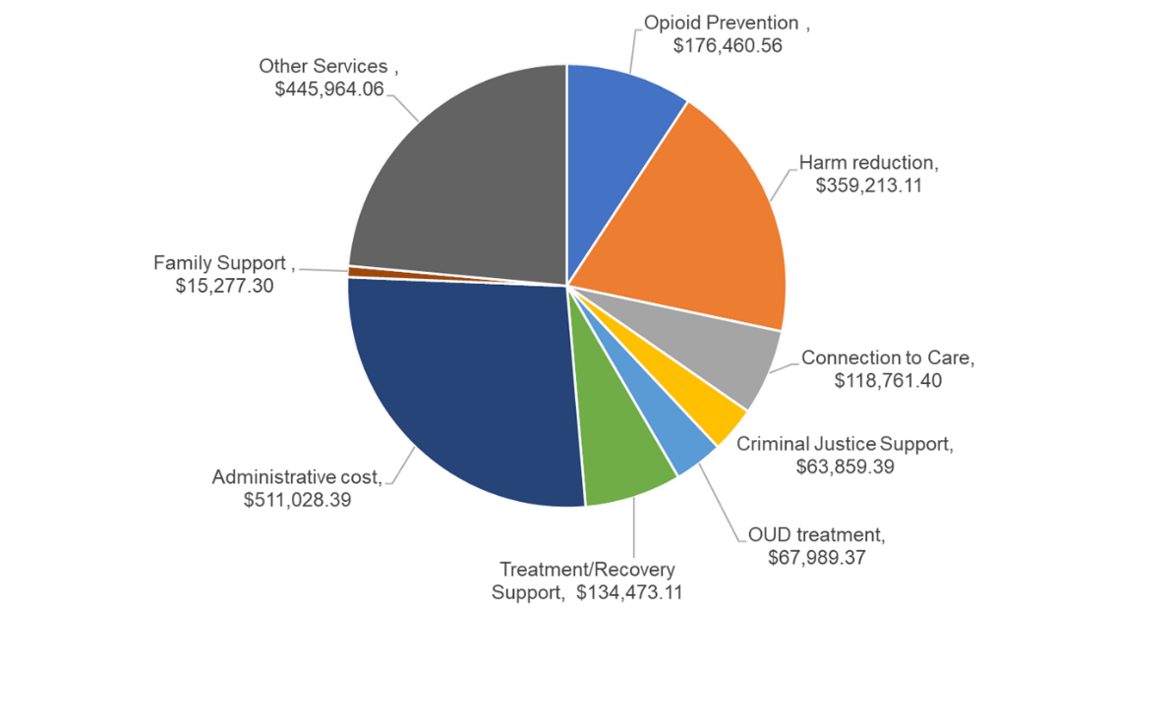
* Examples of "Other Services" reported by municipalities: Community Engagement/Community Needs Assessment; Crisis Response Teams; Legal Services; First Responders Capacity Building; Job Trainings/Mental Health First Aid Trainings; Coordinated Care; Youth Support; Transportation

Municipal Engagement/Technical Assistance Forums
The chart below is a clustered column chart that compares the number of people that attended to the number of people registered to attend the Regional Forums hosted in September of 2023 held for each of the five regions. The totals are as follows:
Southeast Region Attended = 33 Registered = 52
Central Region Attended = 35 Registered = 45
Metrowest Region Attended = 48 Registered = 68
Western Region Attended = 47 Registered = 61
Northeast Region Attended = 48 Registered = 85
All Regions Attended = 211 Registered = 311

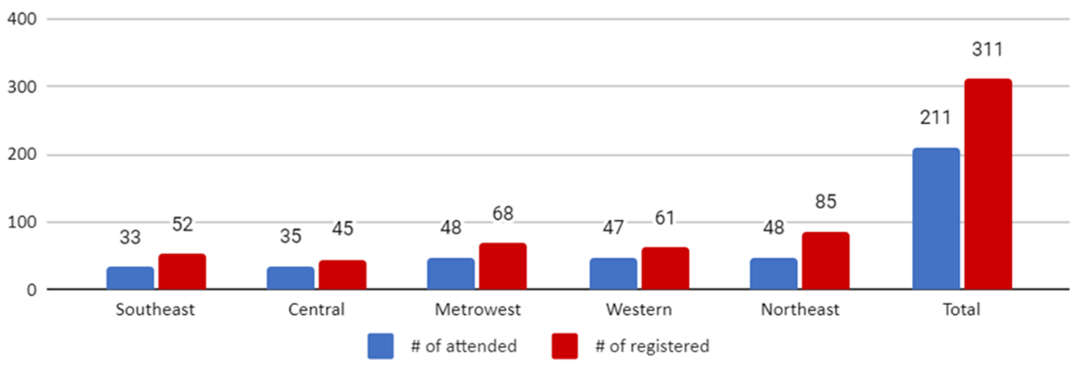

Municipal Engagement/Technical Assistance Office Hours
The chart below is a clustered column chart that displays the number of registrants that participated in the Office Hour Webinars offered by Care Mass. Specifically,
Number of attendees at the October 26th Office Hour Webinar = 33
Number of attendees at the November 9th Office Hour Webinar = 12

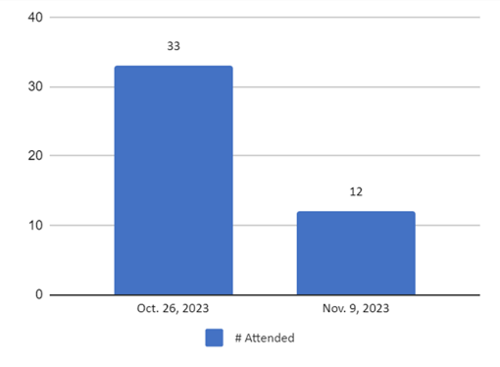

Municipal Technical Assistance Requests by Category
The chart below is a clustered bar chart that depicts the total number of technical assistance requests received by category. The totals are as follows:
Evaluation and Reporting = 1
Program Monitoring = 8
Opportunities to collaborate with other cities/towns = 8
Community engagement = 13
Annual reporting = 7
Community needs assessment and planning = 14
Opioid use abatement strategies = 15
Other = 3
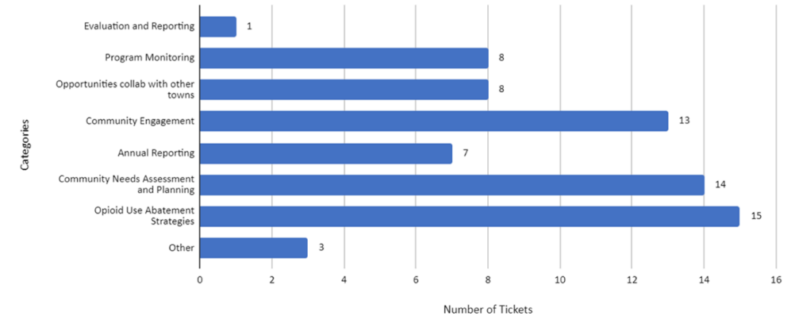

BSAS Community Profiles Dashboard
The image below is an exemplar of the BSAS Community Profiles Dashboard that integrates substance addiction indicators and offers a unified view of substance misuse data in the state. The dashboard covers all 351 cities/towns and 14 counties in Massachusetts. All of the data is passed through a data-suppression engine with datasets from across 6 separate systems to allow for richer and more meaningful analysis. Communities are able to download the data or access it programmatically through an API for additional analysis.
- Visit Data on Enrollments in Substance Addiction Services | Mass.gov and select “Community Profile” (no login is needed
- Select your Massachusetts community (1 of the 351 cities/towns or 14 counties)
- A set of curated substance misuse and treatment metrics & visuals for your community is displayed. Data can be downloaded for further analysis or offline use

