ORRF Advisory Council Presentation

Opioid Recovery & Remediation Fund Advisory Council


Executive Office of Health & Human Services
Wednesday, March 6, 2024

Today’s Agenda
SmartArt: Two-level Icon Circle List with Six Icons

Icon 1. Meeting

Text: Welcome to New Council Members


Icon 2. Stopwatch

Text: Approval of 12/11/23 Meeting Minutes


Icon 3. Megaphone

Text: Important Announcements


Icon 4. Eye

Text: ORRF Mission, Vision, & Principles


Icon 5: Checkmark Sign

Text: Updates on Strategic Priorities


Icon 6: Bar Graph

Text: Initiative Spotlight: BSAS Data Dashboard
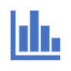

Welcome to New Council Members

Thank you to Jennifer Almonte & Kate Lena for your service!

A warm welcome to our new members:

Candice McClory - Opioid Prevention Specialist, City of Lynn
Born and raised in Lynn, MA, Ms. McClory’s work over the last 15 years has been in the public health field, working with diverse populations to address the opioid crisis and its impacts on individuals and communities. Her core competencies include public health, harm reduction, overdose prevention, and education relating to HIV, HCV, and other STIs. She is passionate about helping people who use drugs and their families access care and resources, and reducing the stigma and barriers they face.

Vaira Harik, Assistant County Administrator, Barnstable County Commissioner’s Office
Prior to becoming the Assistant County Administrator at the Barnstable County Commissioner’s Office, Ms. Harik was the Deputy Director and Senior Project Manager for Barnstable County’s Department of Health and Human Services where she convened public, private, and non-profit agencies and partners to address regional health and social problems in the areas of substance misuse, aging and disability, childcare accessibility, and health equity, with a focus on policy and systems change. Ms. Harik received her master's degree in health policy and management from Harvard University.

Vote on 12/11/23 Meeting Minutes

Important Announcements
SmartArt: One-level Icon Vertical Circle List with Three Icons

Icon 1. Dollar Sign

Text: Vendor selected for Community Grant-Making RFR


Icon 2. Meeting

Text: Massachusetts Municipal Opioid Abatement Conference scheduled for March 19th and 20th Link for conference registration: https://www.caremass.org/mmoac2024


Icon 3. Bar Graph

Text: Updated Municipal Expenditure Dashboard

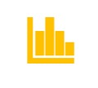

Link for municipal dashboard: https://www.caremass.org/ma-opioid-abatement-municipality-data

Vote on 12/11/23 Meeting Minutes

ORRF Mission & Vision
SmartArt: One-level Basic Bending Process

Link for ORRF Strategic Framework: https://www.mass.gov/doc/orrf-advisory-council-meeting-presentation-12622/download

Mission*: The purpose of the Opioid Recovery and Remediation Trust Fund (Fund) is to mitigate the effects of the opioid epidemic on individuals and families, particularly in historically underserved communities, which have experienced a disproportionately high rate of opioid related overdose deaths.
Vision*: The Fund will finance activities across the full continuum of prevention, harm reduction, treatment, services and supports for an individual’s recovery from opioid addiction and in support of their loved ones.

ORRF Guiding Principles
SmartArt: Two-level Linear Seven-Block Process Numbered

Link for ORRF Strategic Framework: https://www.mass.gov/doc/orrf-advisory-council-meeting-presentation-12622/download

Block: 01
Focus on historically underserved populations suffering from and/or impacted by opioid use disorder

Block: 02
Incorporate health equity and community engagement principles into each funded program

Block: 03
Prioritize localized, community-focused efforts where possible

Block: 04
Drive funding decisions based on current data and evidence-based research

Block: 05
Focus on sustainability concepts for funded efforts from the beginning

Block: 06
Prioritize innovative and nontraditional solutions

Block: 07
Fund solutions and programs that do not have alternative funding sources

Timeline of Council Activities
SmartArt: Two-level Accent Process for Four-Year Timeline

Year: 2021
- Reviewed scope of crisis and existing landscape of services
- Approved preliminary recommendations
- Developed a set of principles to guide future expenditures

Year: 2022
- Reviewed progress toward implementation of recommended initiatives
- Refined principles to guide future expenditures
- Completed ORRF Strategic Framework to guide future activities

Year: 2023
- Reviewed continuing investments in ongoing initiatives
- Approved grant program to support community-based and municipal initiatives, leveraging the ORRF Strategic Framework
- Identified additional spending priorities for FY2024+

Year: 2024 (Proposed)
- Begin implementation of spending priorities for FY2024+
- Expand opportunities for ongoing community engagement
- Solidify consistent reporting structure using KPIs, as emphasized in ORRF Strategic Framework

Overview of Strategic Priorities & Initiatives
SmartArt: Two-level Vertical Five-Bracket List

Bracket 01: Equity
- Redefining Community Wellness – NEW IN FY2024
- BIPOC and Women’s Re-Entry – NEW IN FY2024
- School of Re-Entry – NEW IN FY2024

Bracket 02: Service Expansion/Enhancement
- Harm Reduction Expansion
- Access to MOUD
- Hospital-Based SUD Services – NEW IN FY2024

Bracket 03: Workforce Development
- Student Loan Forgiveness

Bracket 04: Supporting Families
- Expanding Access to Culturally Responsive Evidence-Based Practices for Families – NEW IN FY2024
- Grief Support – NEW IN FY2024

Bracket 05: Social Determinants of Health
- Low Threshold Housing and Housing Support

Bracket 06: Data Collection & Analysis
- BSAS Dashboard Expansion

Updates on Ongoing Initiatives
SmartArt: Two-level Vertical Box List

Box 01: Workforce
- MA-Repay: Initial round of funding resulted in 395 substance use treatment providers receiving loan repayment awards totaling $12,642,872
- Launching second round with remaining funds (~$2M) to capture any workers who may have joined the workforce after January 2023

Box 02: Access to MOUD
- 5 programs funded across the state to add mobile components and/or medication units in areas of high need
- OTP Desert Study will inform future funding opportunities

Box 03: Housing & Housing Supports
- 585 unique individuals sheltered across 7 Low-Threshold Sites
- 200 of these individuals placed in permanent housing through a housing navigation program (n=194) or were housed through reunification with friends or family

Box 04: Harm Reduction Expansion
- Funds 7 vendors to expand access to harm reduction services for underserved individuals including, but not limited to, Black, Indigenous, and People of Color (BIPOC)

Box 05: Emergency Fund
- Allocating up to $1.6M in approved emergency funds to maintain housing capacity

Updates on New Initiatives
SmartArt: Two-level Vertical Box List

Box 01: Equity
- Planning to re-open Black and Latino Men's Re-Entry RFR to add 1-2 sites in areas of high need.
- Planning to release Women's Re-Entry in Spring 2024 to provide enhanced community-based supports for people who identify as women pre- and post- release from incarceration as well as for those under community supervision.
- Announced $2.9 million in grants to support BIPOC-led and primarily serving organizations to address substance use and/or social determinants impacting substance use through Redefining Community Wellness program

Box 02: Service Expansion/Enhancement
- Posted notice of intent to award funding to 16 hospital systems through Hospital-based SUD RFR
- Funded hospitals will establish or expand existing addiction consult services and/or bridge clinics co- or closely located to the hospital, to increase access to care and strengthen linkages to ongoing care
- Began meeting with hospitals to review contract expectations including plans for data collection and evaluation
- Goal is to have contracts in place by 4/2024

Box 03: Supporting Families
- Plan to release an RFR in Spring 2024 to fund existing evidence-based and evidence-informed models that support families
- $3M will provide funds needed to pilot, implement, and evaluate these models that focus on priority populations and are equity-driven

Box 04: Data Collection/Analysis
- Spotlight Presentation: BSAS Dashboard Expansion

Initiative Spotlight: Community Profile Dashboard
Screenshot of BSAS Community Profile Dashboard and Data on BSAS Enrollments

The image below is an exemplar of the BSAS Community Profile Dashboard that integrates substance addiction indicators and offers a unified view of substance misuse data in the state. The dashboard covers all 351 cities/towns and 14 counties in Massachusetts. All of the data is passed through a data-suppression engine with datasets from across 6 separate systems to allow for richer and more meaningful analysis. Communities are able to download the data or access it programmatically through an API for additional analysis.

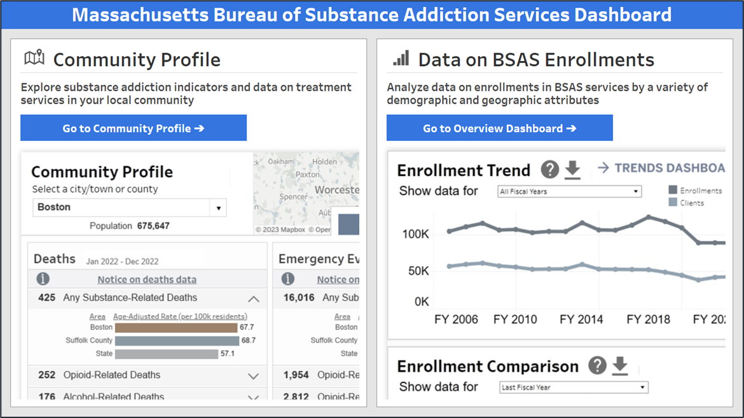

The Challenge
SmartArt: One-level Icon Vertical Circle List with Four Icons

There are several barriers to accessing substance misuse and treatment data today that can hinder communities in data-driven decision-making:

Icon 1. Data Systems

Text: Data is scattered across several different systems
A user must visit multiple webpages/reports to access relevant data



Icon 2. Data Sources

Text: Each dataset has its own reporting methods
This can often lead to significant variations in measures when comparing data across data sources due to differences in reporting methods



Icon 3. Data Sets

Text: Data may be unavailable at the community level
Data is often unavailable at the community level (city/town or county), as this level of disaggregated reporting requires complex data suppression rules


Icon 4. Data Silos

Text: Data are often siloed to their own reporting system
Existing dashboards and reports are often limited in the data they can report, due to legal or data sharing agreements needed to access different data


The Opportunity: Unified Community Profile
SmartArt: Two-level Icon Circle List with Four Icons

The Community Profile integrates substance addiction indicators into a single dashboard, offering the first unified view of substance misuse data in the state.

Icon 1. Data Systems

Text: Unites datasets across 6 separate systems, allowing for richer and more meaningful analysis

Icon 2. Data Indicators

Text: Provides a set of curated indicators for 3 major categories: substance-related deaths, emergency events, and substance addiction services
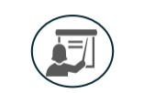

Icon 3. Data Sets

Text: Comprehensively covers all 351 cities/towns and 14 counties in Massachusetts, with all data passing through a data-suppression engine


Icon 4. Download Sign

Text: Data can be downloaded for additional analysis



Example of Case Uses
SmartArt: Three-level Grouped List with Five Icons

Icon 1. Three Users

Text: General Public
Explore both high-level summaries and deep dive details on substance-related deaths, emergency events, and substance addiction services in your local community

Icon 2. First Aid Kit

Text: Community Health Stakeholders
Select your location of interest to see substance use and services metrics that can be used to inform addiction treatment services planning and conduct needs assessments

Icon 3. Reports

Text: Internal EOHHS Stakeholders
Reference the dashboard when generating reports that are used for internal meetings to understand substance misuse data at the community level

Icon 4. Magnifying Glass

Text: Academic Researchers
Download specific community data for further analysis (in tools like Excel, R or Python) or query it programmatically using the dashboard’s API

Icon 5. Newspaper

Text: Media
Screenshot dashboard visualizations when creating news articles that discuss substance misuse issues in Massachusetts

Key Features
SmartArt: Two-level Icon Vertical Circle List with Six Icons

Icon 1. Data Filters

Text: Data on BSAS Enrollments
The BSAS Enrollments page captures information on enrollment in BSAS services broken out by geography, fiscal years, and demographic characteristics. There are over 3 million possible combinations of these filters.



Icon 2. Line Graph

Text: Community Profile
The Community Profile view provides specific city, town, and county level snapshots of substance-related deaths, emergency events, and services

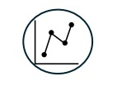

Icon 3. Lock

Text: Individual Privacy Protections
All data passes through a custom designed data-suppression engine to minimize any risk of individual disclosure.


Icon 4. Download Sign

Text: Data Downloadable for Offline Users
can download the data powering the visualizations they create through the dashboard or through an API.
Icon 5. Checkmark Sign
Text: Best Practices in Accessibility
The dashboard has been designed to follow best practices in state and federal accessibility guidelines.

Icon 6. Open Book
Text: Data Dictionary
A comprehensive data dictionary for all terms defines key concepts used throughout the dashboard.


How It Works
Screenshot of The City of Boston's Community Profile page
- Visit Data on Enrollments in Substance Addiction Services | Mass.gov and select “Community Profile” (no login is needed)
- Select your Massachusetts community (one of the 351 cities/towns or 14 counties)
- A set of curated substance use/ treatment metrics and visuals for your community is displayed. Data can be downloaded for further analysis or offline use.
The image below is an exemplar of the City of Boston’s BSAS Community Profile page. The dashboard covers all 351 cities/towns and 14 counties in Massachusetts. Data is passed through a data-suppression engine with datasets from across 6 systems to allow for richer and more meaningful analysis. Communities are able to download the data or access it programmatically through an API for additional analysis.

Overview Page
Screenshot of the City of Boston’s Community Profile page with bar graph of stimulant-related deaths
The Community Profile Overview page displays a curated set of overview metrics that convey substance addiction impact and services within a community. These metrics are organized into three categories:
  - Substance-Related Deaths
  - Emergency Events
  - Substance Addiction Services
- Users can expand the metrics to display bar graph comparisons to the state rate and, if a city/town is selected, the county rate.
- Users can hover over each metric to display a 5-year trend and the percent change since the prior year.

Detail Tabs
SmartArt: Two-level Title Picture Lineup with Three Photos

Photo 01: City of Boston’s Community Profile Death Tab

Text: Deaths
Using the top-level filter, users can multi-select which substance(s) the visuals will reflect.
- The Number of Deaths Trend displays a 5-year trend of SUD-related deaths.
- The Age-Adjusted Death Rate Trend displays a 5-year trend of the selected community rate compared to the state and (if applicable) its county.
- The Age-Adjusted Death Rate Distribution compares this rate to the distribution of city/town or county rates in the most recent year.

Photo 02: City of Boston’s Community Profile Emergency Visits Tab

Text: Emergency Visits
Using the top-level filter, users can multi-select which substance(s) the visuals will reflect.
- The Number of ED Visits trend displays a 5-year trend of ED visits.
- The Age-Adjusted ED Visit Rate Trend displays a 5-year trend of the selected community rate compared to the state and (if applicable) its county.
- The Age-Adjusted ED Visit Rate Distribution compares this rate to the distribution of city/town or county rates in the most recent year

Photo 03: City of Boston’s Community Profile Substance Addiction Services Tab

Text: Substance Addiction Services
Using the top-level filter, users can select which service visualizations to view.
- The Locations of Naloxone Kits Distributed and Locations of Fentanyl Test Strips Distributed views display maps of naloxone kits and fentanyl test strips distributed in each city/town or county.
- The Locations of BSAS Providers That Rendered Services view displays a map visualizing where BSAS clients travel to receive services from BSAS providers, along with bar graphs showing number of providers and clients by service category.

Dashboard Demo

Screenshot the Community Profile Dashboard on Overview Tab

Link for Community Profile Dashboard: Data on Enrollments in Substance Addiction Services | Mass.gov

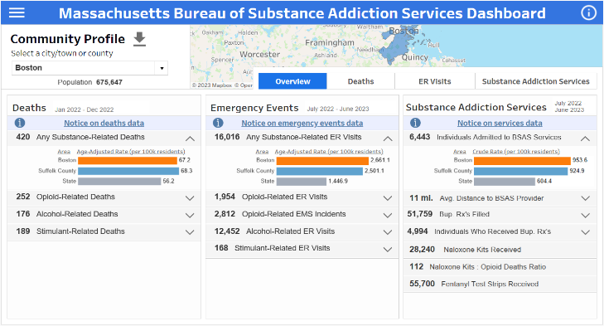

Questions & Answers
Hermik Babakhanlou-Chase
Director of BSAS’s Office of Statistics and Evaluation
Email: hermik.babakhanlou-chase@mass.gov

Upcoming Council Meetings
- Thursday, June 13, 2024 from 10:30 am – 12:00 pm
- Tuesday, September 10, 2024 from12:30 – 2:00 pm
- Tuesday, December 3, 2024 from 11:00 am – 12:30 pm

