# ORRF Advisory Council Presentation

Opioid Recovery & Remediation Fund Advisory Council

State Seal
Commonwealth of MA State Seal

Executive Office of Health & Human Services

March 12, 2025

The ORRF Team

SmartArt: Bending Picture Caption List with Eight Pictures

Picture 1

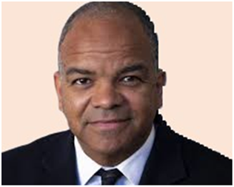

Text: Kiame Mahaniah (EHS)

Undersecretary for Health

Picture 2

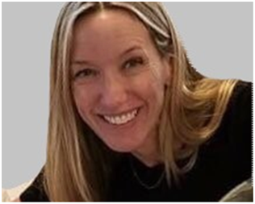

Text: Deirdre Calvert (BSAS)

BSAS Director

Picture 3

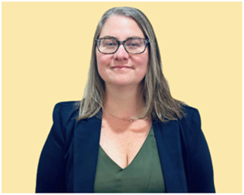

Nicole Schmitt (BSAS)

Director of Strategy & Innovation

Picture 4

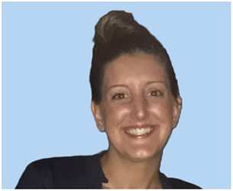

Julia Newhall (BSAS)

Director of Opioid Abatement Strategy & Implementation

Picture 5

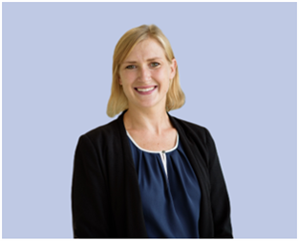

Casey Leon (BSAS)

Epidemiologist

Picture 6

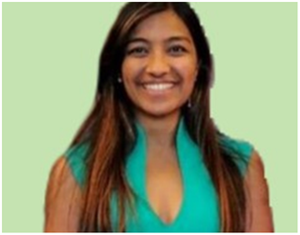

Millie Bhatia (EHS)

Health Policy Manager

Picture 7

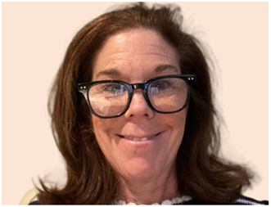

Susan Weiss (BSAS)

Executive Assistant

Picture 8



Leanne Burke (EHS)

Executive Assistant

Today’s Agenda

SmartArt: Two-level Icon Circle List with Five Icons

Icon 1. Stopwatch

Text: Approval of 12/06/24 Meeting Minutes



Icon 2. Law Scale

Text: Update from MA Attorney General’s Office



### Icon 3. Megaphone

### Text: Important Announcements



### Icon 3. Eye

### Text: ORRF Mission & Vision



### Icon 4: Checkmark Sign

### Text: Strategic Updates



### Icon 5: Bar Graph

### Text: Spotlight: Black & Latino Men’s Re-Entry Program

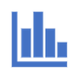

Vote on 12/04/24 Meeting Minutes

Opioid Settlement Updates

Gregory Hardy, Assistant Attorney General, Health Care Division, Office of the Attorney GeneralState Seal of the Commonwealth of MA Office Of The Attorney General


2025 Payments To ORRF So Far

|  |  |
| --- | --- |
| **Company/Settlement** | **Amount** |
| **Distributors** | **$14,421,163.15** |
| **Endo International** | **$7,573,945.41** |
| **Allergan** | **$4,306,673.37** |
| **Teva** | **$4,255,341.27** |
| **CVS** | **$3,802,257.79** |
| **Johnson & Johnson** | **$437,701.17** |
| **AGO Medicaid Fraud Settlements** | **$188,000.00** |
| **Walgreens** | **$69,440.52** |
| **Total** | **$35,054,523.68** |

Upcoming Payments to ORRF

|  |  |  |  |  |
| --- | --- | --- | --- | --- |
| **Company** | **Payment Year** | **Payment Type** | **Amount** | **Approximate Date** |
| **Walgreens** | Year 3 | Abatement | $3,625,187.77 | 3/31/2025 |
| Additional Restitution | $69,440.51 |
| **Total** | **$3,694,628.28** | | | |

Total Payments so Far & Estimated 18-Year Total

|  |  |  |
| --- | --- | --- |
| **Recipient** | **Settlement Funds Already Paid**  **(as of March 12, 2025)** | **Estimated Total Settlement Funds to Be Paid Over 18 Years** |
| **ORRF** | $215,076,878.88 | $617,728,353.77 |
| **Municipalities** | $112,317,956.99 | $338,245,457.39 |

Important Announcements

SmartArt: Alternating Picture Blocks

Icon 1. Piggy Bank

Text: Emergency Funds

Icon 2. Building

Text: Legislative Briefing

Icon 3. Microphone

Text: Regional Listening Sessions

Icon 4. Projector with Graph

Text: Municipal Dashboard

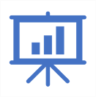

Regional Listening Sessions

Text: Northeast Listening Session, Wednesday March 19th, 2025, 1:30 PM – 5:30 PM, Lynn City Hall Auditorium

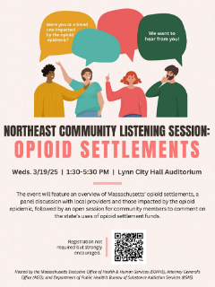

Municipal Dashboard

Opioid Abatement Municipal Dashboard

Map of Massachusetts that is color coded according to reporting requirement status

Reporting Requirements

Annual payment ≥$35,000

All municipalities encouraged to submit report

Reporting Elements

Funds Expended

Shared Commitments

Assessment & Planning

Populations Served

Strategy Implementation

The chart below is a clustered column chart displaying the total amount of opioid abatement funds municipalities received in FY24 and the total amount of opioid abatement funds municipalities expended in FY24. The first column shows that municipalities received $83,093,961.59 in FY24, and the second column displays that municipalities expended $4,689,237.09 in FY24.

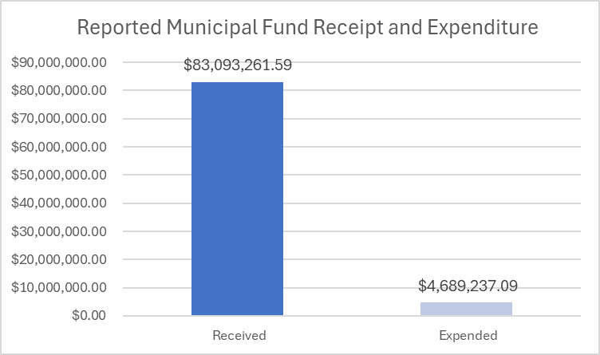

Preliminary Data | FY24 Municipal Expenditure Report

The chart below is a clustered column chart with two columns across nine spending category. The first column shows the total dollars spent per category, which is the combined spending of all municipalities. The second column shows the percentage of municipalities that expended funds in each category. Total dollars spent and total rate of spending per category are as follows:

* Administrative Costs - $1,030,280.54, 34%
* Connections to Care - $729,754.52, 43%
* Treatment & Recovery Support - $689,823.23, 46%
* Harm Reduction - $642,920.50, 56%
* Opioid Use Disorder Treatment - $556,708.19, 30%
* Opioid Use Prevention - $500,451.62, 43%
* Othe Costs - $242,493.62, 18%
* Address Needs of Justice-Involved Individuals - $196,147.29, 13%
* Support Pregnant or Parenting People & Families - $100,658.16, 11%

Expenditures ($) by Category

% of Municipalities with Expenditures in Each Category

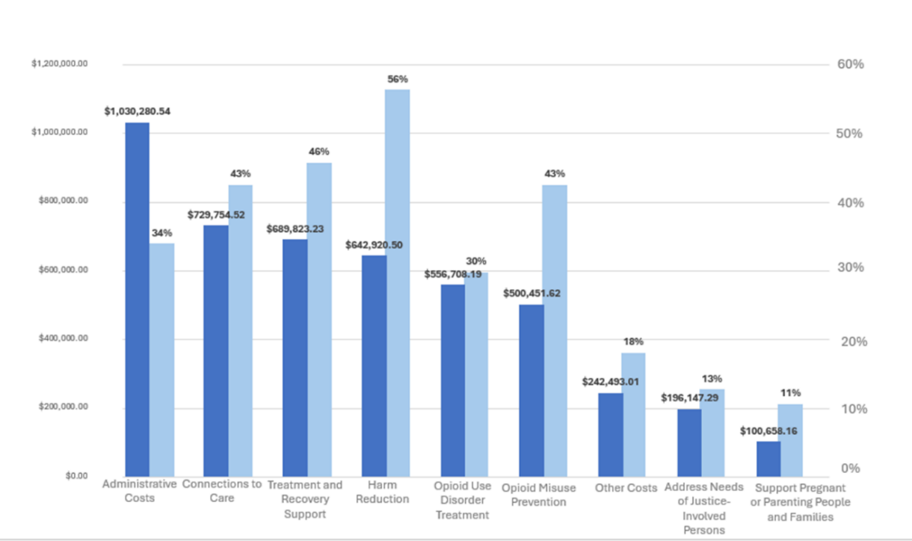

ORRF Mission & Vision

SmartArt: Converging Arrows

Link for ORRF Strategic Framework: <https://www.mass.gov/doc/orrf-advisory-council-meeting-presentation-12622/download>

***Mission*:*** Mitigate the effects of the opioid epidemic on individuals and families, particularly in historically underserved communities that have experienced disproportionately high rates of opioid related overdose deaths

***Vision*:*** Fund activities across the full continuum of prevention, harm reduction, treatment, services to support individual’s recovery from opioid addiction and in support of their loved ones

ORRF Guiding Principles

SmartArt: Two-level Basic Process with Seven Processes

Link for ORRF Strategic Framework: <https://www.mass.gov/doc/orrf-advisory-council-meeting-presentation-12622/download>

### Process: 01

Focus on historically underserved populations suffering from and/or impacted by opioid use disorder

### Process: 02

Incorporate health equity and community engagement principles into each funded program

### Process: 03

Prioritize localized, community-focused efforts where possible

### Process: 04

Drive funding decisions based on current data and evidence-based research

### Process: 05

Focus on sustainability concepts for funded efforts from the beginning

### Process: 06

Prioritize innovative and nontraditional solutions

### Process: 07

Fund solutions and programs that do not have alternative funding sources

Timeline of Council Activities

SmartArt: Two-level Accent Process for Five-Year Timeline

Year: 2021

* Monitored progress of implementation of recommended initiatives
* Assessed scope of crisis and existing landscape of services
* Approved preliminary recommendations
* Developed a set of principles to guide future expenditures

### Year: 2022

* Monitored progress of implementation of recommended initiatives
* Refined principles to shape future expenditures
* Completed ORRF Strategic Framework to guide future activities

Year: 2023

* Provided continuous feedback of ongoing investments
* Approved grant-making initiative to support CBO and municipalities
* Hired director
* Developed five-year budget plan

Year: 2024

* Implemented Mosaic Grant-Making Program
* Hosted inaugural municipal opioid abatement conference
* Launched Community Profiles Dashboard
* Hired ORRF epidemiologist

Year: 2025

* Hosting regional listening sessions
* Finalizing KPIs based on strategic priorities and initiatives
* Standardizing data collection and analysis of all ORRF-funded activities
* Launching ORRF Dashboard that will include financial and programmatic data

Annual ORRF Funding Commitments by Strategic Priority

**Annual Funds Received:** FY23 $62.76 million, FY24 $92.6 million, FY25 $27.22 million

**Annual Funds Committed:** FY23 $27.93 million, FY24 $23.63 million, FY25 $59.4 million

**Equity**

FY24 $4.38 million:

* $750K: Redefining Community Wellness Grantmaking
* $1.5M: Mosaic Grantmaking
* $2.13M: BIPOC Re-Entry Program

FY25 $16 million:

* $500K: School of Re-Entry
* $3M: Redefining Community Wellness Grantmaking
* $6M: Mosaic Grantmaking
* $6.5M: BIPOC Re-Entry Program

**Service Expansion & Enhancement**

FY23 $6.5 million

* $3.1M: Access to MOUD
* $3.4M: Harm Reduction

FY24 $10.5 million

* $3.1M: Access to MOUD
* $3.4M: Harm Reduction
* $4M: Hospital-based SUD programs

FY25 $27.5 million

* $2M: Contingency mgmt. initiatives
* $3M: Mobile addiction services
* $3.1M: Access to MOUD
* $3.4M: Harm Reduction
* $16M: Hospital-based SUD programs

**Workforce**

FY23 & FY24 $15 Million Total

Two rounds of SUD Provider Loan Repayment Initiative ($13M + $2M)

**Family Supports**

FY24 $500,000

* $500K: Grief support to individuals and families that have lost someone due to SUD

FY25 3.5 million

* $500K: Grief support programming
* $3M: Community innovations for families

**Social Detriments of Health**

FY23 $6 million

* $6.0M: Low Threshold Housing

FY24 $6.65 million

* $6.65M: Low Threshold Housing

FY25 $9.3 million

* $1.5M: Access to Recovery Program
* $7.8M: Low Threshold Housing

**Data Collection & Analysis**

FY23 $432.700

* $432.7K: KPMG support strategic planning & data collection

FY24 $500,000

* $500K: Deployed new SUD Community Dashboard

FY25 $2 million

* $2M: Increase data transparency, finalize ORRF key performance indicators for ORRF Dashboard

**Municipal Capacity- Building Support**

FY24 $1.1 million

* $1.1M: Municipal TTA

FY25 $1.1 million

* $1.1M: Municipal TTA

Overview of Strategic Priorities & Initiatives

SmartArt: Two-level Vertical Five-Bracket List

### Bracket 01: Equity

* Redefining Community Wellness
* BIPOC and Women’s Re-Entry
* School of Re-Entry

### Bracket 02: Service Expansion/Enhancement

* Harm Reduction Expansion
* Access to MOUD
* Hospital-Based SUD Services

Bracket 03: Workforce Development

* Student Loan Forgiveness

### Bracket 04: Supporting Families

* Expanding Access to Evidence-Based Practices for Families
* Grief Support

### Bracket 05: Social Determinants of Health

* Low Threshold Housing and Housing Support
* Community “Mosaic” Grant Program

### Bracket 06: Data Collection & Analysis

* BSAS Dashboard Expansion
* ORRF KPIs & Expenditure Dashboard

Initiatives Updates

SmartArt: Vertical Two-Level Six-Box List

### Box 01: Equity

* School of Reentry The program has expanded its scope of work to ensure that evidence-based, trauma-informed and culturally responsive care is accessible to all incarcerated individuals with SUD.

Box 02: Service Expansion/Enhancement

* Mobile Addiction Services Brandeis University completed evaluation that revealed fidelity in program implementation. Expanded to two new program sites located in Brockton and Lowell.
* Access to MOUD Awards in process to fund existing opioid treatment programs (OTPs) and office-based addiction treatments (OBATs) to enhance services and increase access to medications for OUD and stimulant use disorder. Continuing to fund programs statewide that provide low barrier, low threshold clinical care (including buprenorphine) and harm reduction services to individuals who are at high risk for overdose and other medical complications associated with substance use, with 16,497 encounters reported in FY24.Box 03: Workforce Development

Box 03: Workforce

* Grief Support After Death by Overdose (SADOD) supporting harm reduction workforce by providing peer grief and trauma resources to address the high incidence of loss within this industry.

Box 04: Supporting Families

* Grief SupportSADOD supporting families statewide through virtual and in-person grief support (e.g., peer support meetings, 1:1 peer allyship, trainings to build community capacity in processing substance-related deaths).

Box 05: Social Determinants of Health

* Mosaic GrantmakingCo-hosted a Design Lab with RIZE focused on service ecosystem and how it supports families impacted by SUD and collected 125 surveys to identify strengths and gaps that will be used to prioritize focus areas based upon existing needs.

Box 06: Data Collection & Assessment

* BSAS Community Profiles DashboardSuccessfully implemented bi-annual data update, including data from 9 administrative sources to provide current SUD-related deaths, hospitalizations, and treatment services.

Initiative Spotlight

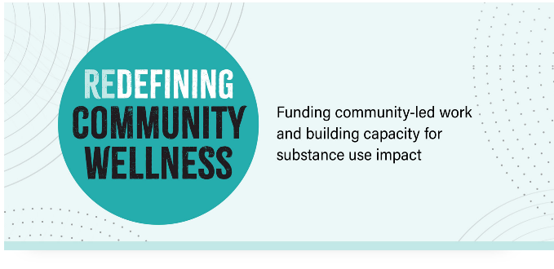

Text Box 1

Andi Macone

Director, BSAS Office of Community

Health & Equity (OCHE)

[andrea.macone@mass.gov](mailto:andrea.macone@mass.gov)​

Background

Text Box 1

Communities of color have inadequate access to culturally responsive substance use programming and are disproportionately affected by policies that do not consider their needs.

In response to this challenge and the lack of diverse representation among currently funded grantees, the Redefining Community Wellness Grants Program intentionally centers BIPOC voices throughout the grantmaking and capacity building process.

About

Text Box 1

Redefining Community Wellness is administered and managed by Health Resources in Action (HRiA), a non-profit public health organization that helps people live healthier lives and create healthy communities through prevention, health promotion, policy, and research.

In addition to providing financial support through grants, HRiA provides funded organizations with capacity building trainings, technical assistance, and individualized support, and facilitates a learning community. Capacity building services are intended to help funded organizations deliver effective programs and increase readiness for future state funding.

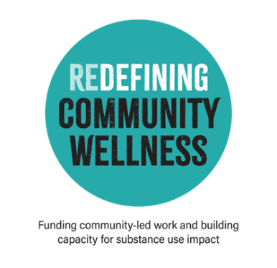

Goals

Text Box 1

* To support BIPOC-led organizations in redefining community wellness to address the negative impacts of substance use in their communities through a wide range of programming that helps improve health, wellness, and quality of life for community members; and
* To provide capacity building that improves organizations’ ability to apply for future funding, which ultimately helps increase BIPOC representation in receiving grants beyond this program

Timeline

SmartArt: Two-level Basic Timeline

***July 2022***: Project Start

***Oct 2022:*** BAC Started

***Feb 2023:*** Input from KPI

***June 2023:*** CAB Launched

***Sep 2023:*** GrantRFP Launched

***Oct 2023:*** Pre-Grant Capacity Building Provided

***Nov 2023:*** Grant App Due

***Jan 2024:*** Grants Dispersed

Community-Led Process

Smart Chart: Vertical Picture List

Icon 1. Lightbulb Above People

Text: Community Key Informants (CKI)

* HRiA/BAC engaged a dozen representatives of BIPOC-led community organizations or individual BIPOC representatives with experience in the substance use field and/or lived experience to inform the development of the CAB, and obtain initial insights on the development of this grantmaking initiative



Icon 2. Post-It Notes with Thumbtack

Text: BSAS Advisory Committee (BAC)

* Comprised of BSAS staff with the goal for them to share their personal and professional lived experiences and perspectives to inform key components like the CAB and grantmaking initiative ​



### Icon 3. Four People Standing Side by Side

### Text: Community Advisory Board (CAB)

* The 100% BIPOC CAB launched in summer of 2023 and led the decision-making process for designing the grant application. This included developing a criteria and selection process, serving on the review team, and identifying opportunities to build capacity offered to grant applicants and grantees ​



Approved Use of Funds

Text Box

Funding supports activities that include a wide range of programming to address SUD directly or indirectly by focusing on social determinants of health

Proposed activities serve the priority populations and address one or more of the following areas: ​

* Overdose prevention, intervention, and post-intervention ​
* Addressing barriers to accessing services ​
* Addressing housing, food insecurity and other basic needs through resource navigation ​
* Strengthening belonging and relationships in communities through education and support services​

Eligibility

Text Box

Massachusetts-based non-profit 501(c)3 organizations or groups with a 501(c)3 fiscal sponsor that are BIPOC-led and that primarily serve BIPOC communities including community-based organizations, faith-based organizations, and Tribal, Indigenous people serving organizations. Organizations that are currently funded by BSAS are not eligible.​

Capacity Building For Applicants

Text Box 1

**Funding Information Session**

Questions & Answers | 10/05/23 9:30 AM – 11 AM

**SUD & Social Determinants of Health 101**

How to Frame your Proposed Work Workshop

Questions & Answers | 10/18/23 10 AM – 11 AM

Text Box 1

**Grant Writing Workshop**

Questions & Answers | 10/26/23 12 PM – 1 PM

**Drop-In Office Hour Session**

Questions & Answers | 11/17/23 12 PM – 1 PM

Round One Grant Interviews

Text Box 1

Total # of Applications Received: 98​

Total # of Awards (Based on Available Funding): 20​

Total Amount Awarded: $2.9M​

* Amount per Grantee: Up to $145,000​

Timeline: March 2024 – June 2025​

* Planning Phase: March 2024 – June 2024​
* Implementation Phase: July 2024 – June 2025

Photo of Julio Meran, Merrimack Valley Dream Center


Text Box 2

Julio Meran, Merrimack Valley Dream Center

Round One Grantees

Text Box

* African Cultural Services, Inc. ​
* B FREE Wellness ​
* Black Behavioral Health Network, Inc. ​
* Calvary Pentecostal Church ​
* Cambodian Mutual Assistance Association of Greater Lowell (CMAA) ​
* Chastity’s Consulting & Talent Group ​
* Choice Recovery Coaching, Inc. ​
* Dwelling House of Hope, Inc. ​
* Follow My Steps Foundation, Inc. ​
* Future Hope Apprenticeship and Recovery Program
* Latin American Health Alliance of Central Massachusetts ​
* Mandela Yoga Project, Inc. ​
* Merrimack Valley Dream Center, Inc. ​
* Mother Woman d/b/a Women of Color Health Equity Collective ​
* Save Souls, Inc. ​
* Sueños Basketball ​
* Talbot Avenue Church of Christ ​
* Transformational Prison Project ​
* Urban Impact Initiative Massachusetts ​
* Vietnamese American Civic Association, Inc.

Evaluation

Text Box

PROCESS

* Grantmaking Process
* Grant Implementation & Sustainability

OUTCOMES

* Grantee KPIs
* Program KPIs

PRIMARY DATA SOURCES

* Grantee Reports
* Surveys
* Qualitative Interviews & Focus Groups with Grantees and Key Partners
* Storytelling

Questions & Answers

Text Box

Email - [OpioidRecoveryandRemediationFund@mass.gov](mailto:OpioidRecoveryandRemediationFund@mass.gov)

Icon - Envelope with Inward Arrow



Picture – A Group of People Standing Together

Photo - A group of people standing together


2025 Meeting Schedule

Quarter, Date, Format, & Initiative Spotlight

Q1

Wed. 03/12/25

Virtual (Zoom)

Black and Latino Men's Re-Entry

Q2

Wed. 06/11/25

Virtual (Zoom)

Hospital-Based SUD Services

Q3

Wed. 09/10/25

Hybrid (Southeast Region)

ORRF Dashboard

Q4

Wed. 12/10/25

Virtual (Zoom)

Municipal Training & Tech. Assistance