# ORRF Advisory Council Presentation

Opioid Recovery & Remediation Fund Advisory Council

State Seal
Commonwealth of MA State Seal

Executive Office of Health & Human Services

June 13, 2024

Today’s Agenda

SmartArt: Two-level Icon Circle List with Six Icons

Icon 1. Meeting

Text: Welcome to New Council Member

Meeting 


Icon 2. Stopwatch

Text: Approval of - 03/06/24 Meeting Minutes



### Icon 3. Megaphone

### Text: Important Announcements



### Icon 4. Eye

### Text: ORRF Mission, Vision, & Principles



### Icon 5: Checkmark Sign

### Text: Updates on Strategic Priorities



### Icon 6: Bar Graph

### Text: Initiative Spotlight: Low-Threshold Housing



Welcome to New Council Members

### Thank you, Jennifer Tracey, for your service!

### A warm welcome to our new member:

Michele Clark, Deputy Commissioner of Programs & Services, Boston Public Health Commission (BPHC)

Michele Clark, DrPH, MPH brings 25 years of experience leading federal, state, and local public health projects across a range of areas including substance use, HIV, and reproductive health access. In her current role at BPHC, she works closely with the Recovery Services, Homeless Services, and Infectious Disease Bureaus. Dr. Clark served as a Senior Consultant at John Snow Institute (JSI) where she led evaluation, capacity building, and quality improvement projects, including HIV workforce training, HIV and OUD systems coordination, and an evaluation of the Massachusetts DPH BSAS-funded opioid urgent care centers.

## Vote on 03/06/24 Meeting Minutes

Important Announcements

SmartArt: One-level Icon Vertical Circle List with Three Icons

Icon 1. Dollar Sign

Text: Mosaic Grantmaking Program



Link for Mosaic Grantmaking Program: <https://www.rizema.org/mosaic-opioid-recovery-partnership/>

Icon 2. Circles with Arrows

Text: Municipal Opioid Abatement Funds



### Icon 3. Law Scale

### Text: Updates from Attorney General’s Office

### Law Scale

### Link for municipal dashboard: <https://www.caremass.org/ma-opioid-abatement-municipality-data>

Opioid Settlement Updates

Sandra Wolitzky Chief, Health Care Division Office of the Attorney General

State Seal
Commonwealth of MA Office Of The Attorney General State Seal


2024 Payments To ORRF So Far

|  |  |
| --- | --- |
| **Company/Settlement** | **Amount** |
| **Walmart** | $37,353,052.98 |
| **Walgreens** | $9,196,433.09 |
| **Publicis Health** | $7,901,266.05 |
| **Distributors** | $6,347,634.12 |
| **CVS** | $4,752,378.17 |
| **Allergan** | $4,267,697.69 |
| **Teva** | $3,851,173.65 |
| **McKinsey** | $565,928.24 |
| **AGO Medicaid Fraud Settlements** | $250,000.00 |
| **Total** | **$74,485,563.99** |

© 2024 Massachusetts Attorney General’s Office

Upcoming Payments To ORRF

|  |  |  |  |
| --- | --- | --- | --- |
| **Company** | **Payment Year** | **Amount** | **Approximate Date** |
| **J&J** | Year 3 | $437,701.17 | 6/16/2024 |
| **CVS** | Year 2 | $3,802,257.79 | 6/30/2024 |
| **Distributors** | Year 4 | $14,421,604.00 | 7/15/2024 |
| **Allergan** | Year 2 | $4,306,673.37 | 7/15/2024 |
| **Teva** | Year 2 | $4,255,341.27 | 7/15/2024 |
| **Total** | **$27,223,577.60** | | |

© 2024 Massachusetts Attorney General’s Office

Total Payments So Far and Estimated 18-Year Total

|  |  |  |
| --- | --- | --- |
|  | **Settlements Funds Already Paid**  **(as of June 5, 2024)** | **Estimated Total Settlement Funds to Be Paid Over 18 Years** |
| **To ORRF** | $180,022,356.20 | $610,154,408.36 |
| **To Municipalities** | $93,223,953.87 | $377,540,923.10 |

Notes: The estimated total settlement funds expected to be paid to the ORRF have been updated to reflect the prepayment in 2024 of a portion of the Distributor payments due in 2027.

© 2024 Massachusetts Attorney General’s Office

ORRF Mission & Vision

SmartArt: One-level Basic Bending Process

Link for ORRF Strategic Framework: <https://www.mass.gov/doc/orrf-advisory-council-meeting-presentation-12622/download>

***Mission*:*** The purpose of the Opioid Recovery and Remediation Trust Fund (Fund) is to mitigate the effects of the opioid epidemic on individuals and families, particularly in historically underserved communities, which have experienced a disproportionately high rate of opioid related overdose deaths.

***Vision*:*** The Fund will finance activities across the full continuum of prevention, harm reduction, treatment, services and supports for an individual’s recovery from opioid addiction and in support of their loved ones.

ORRF Guiding Principles

SmartArt: Two-level Linear Seven-Block Process Numbered

Link for ORRF Strategic Framework: <https://www.mass.gov/doc/orrf-advisory-council-meeting-presentation-12622/download>

### Block: 01

Focus on historically underserved populations suffering from and/or impacted by opioid use disorder

### Block: 02

Incorporate health equity and community engagement principles into each funded program

### Block: 03

Prioritize localized, community-focused efforts where possible

### Block: 04

Drive funding decisions based on current data and evidence-based research

### Block: 05

Focus on sustainability concepts for funded efforts from the beginning

### Block: 06

Prioritize innovative and nontraditional solutions

### Block: 07

Fund solutions and programs that do not have alternative funding sources

Timeline of Council Activities

SmartArt: Two-level Accent Process for Four-Year Timeline

### Year: 2021

* Reviewed scope of crisis and existing landscape of services
* Approved preliminary recommendations
* Developed a set of principles to guide future expenditures

### Year: 2022

* Reviewed progress toward implementation of recommended initiatives
* Refined principles to guide future expenditures
* Completed ORRF Strategic Framework to guide future activities

### Year: 2023

* Reviewed continuing investments in ongoing initiatives
* Approved grant program to support community-based and municipal initiatives, leveraging the ORRF Strategic Framework
* Identified additional spending priorities for FY2024+

### Year: 2024

* Implementing FY2024+ strategic priorities
* Planning series of regional listening sessions to enhance community engagement
* Developing ORRF KPIs and Expenditure Dashboard

Overview of Strategic Priorities & Initiatives

SmartArt: Two-level Vertical Five-Bracket List

### Bracket 01: Equity

* Redefining Community Wellness – *NEW IN FY2024*
* BIPOC and Women’s Re-Entry – *NEW IN FY2024*
* School of Re-Entry – *NEW IN FY2024*

### Bracket 02: Service Expansion/Enhancement

* Harm Reduction Expansion
* Access to MOUD
* Hospital-Based SUD Services – *NEW IN FY2024*

Bracket 03: Workforce Development

* Student Loan Forgiveness

### Bracket 04: Supporting Families

* Expanding Access to Culturally Responsive Evidence-Based Practices for Families – *NEW IN FY2024*
* Grief Support – *NEW IN FY2024*

### Bracket 05: Social Determinants of Health

* Low Threshold Housing and Housing Support

### Bracket 06: Data Collection & Analysis

* BSAS Dashboard Expansion
* ORRF KPIs & Expenditure Dashboard – NEW IN 2024

Initiatives Updates

SmartArt: Basic Block Two-Level List

### Box 01: Equity

* Launched capacity building webinars for Redefining Community Wellness grantees
* Reopening Black and Latino Men’s Reentry RFR w/additional sites in FY25
* Women’s Reentry RFR reviewed by Trans & Gender Expansive CAB for inclusive language

Box 02: Service Expansion/Enhancement

* 12 of 15 hospital-based SUD services contracts in place
* Working with hospitals to set up billing and data collection processes as they begin to increase staffing to expand access to SUD services Goal

Box 03: Workforce Development

* MA-Repay second round slated for late summer 2024 ($2M), directed toward any workers who joined the workforce after January 2023
* First of two disbursements will be processed in late summer 2024, the one-year mark since service obligations began

Box 04: Supporting Families

* Working with RIZE Massachusetts on a planning process to engage family members impacted by overdose to help design an RFP specifically for this population

Box 05: Social Determinants of Health

* Mosaic program first round of grants released
* Second round will be municipal matching grants, scheduled to be released in Fall 2024

Box 06: Data Collection & Assessment

* Per Council feedback, engaging with CHIA to obtain data from All-Payer Claims Database to get a more complete picture of SUD services
* Hired a dedicated ORRF epidemiologist anticipated to start in late summer 2024

Initiative Spotlight: Low-Threshold Housing

Icon 1. House and Landscape



Housing & Homeless Services Unit (HHSU)

SmartArt: One-level Icon Vertical Circle List with Three Icons

Icon 1. Compass

Text: HHSU’s Mission



Icon 2. Circle with Overlapping Arrows

Text: Evolution & Intersection with SUD



### Icon 3. Target Audience

### Text: Target Population



Housing Models

SmartArt: Two-level Table

### Box 01: Housing First

### Box 02: TEA Model

Box 03: Housing Stability Support Program

Box 04: Recovery Housing

BSAS Housing & Homeless Services Continuum

Screenshot of BSAS’s Housing and Homeless Services Continuum

The image below illustrates the housing and homeless service programs that BSAS funds across the substance use disorder (SUD) continuum of care

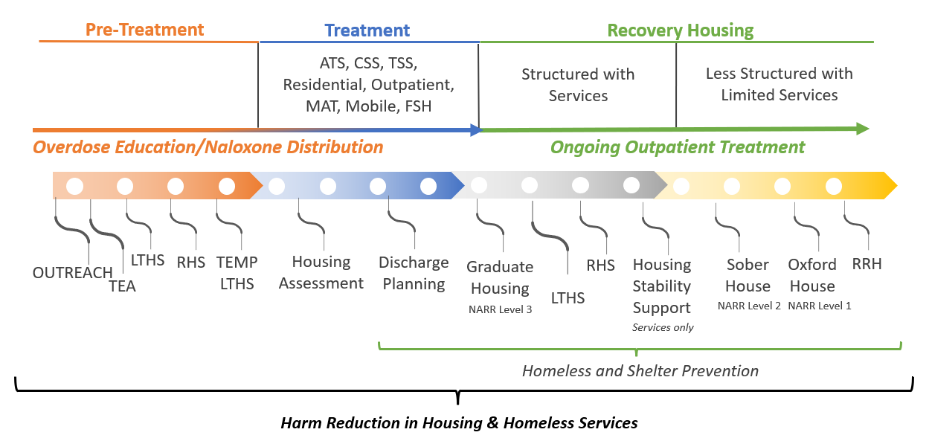

HHSU Programs Supported by ORRF

Screenshot of HHSU’s catchment areas and the locations of programs that are supported by ORRF

The image below is a screenshot that illustrates the catchment areas of ORRF-supported programs and where they are located throughout MA

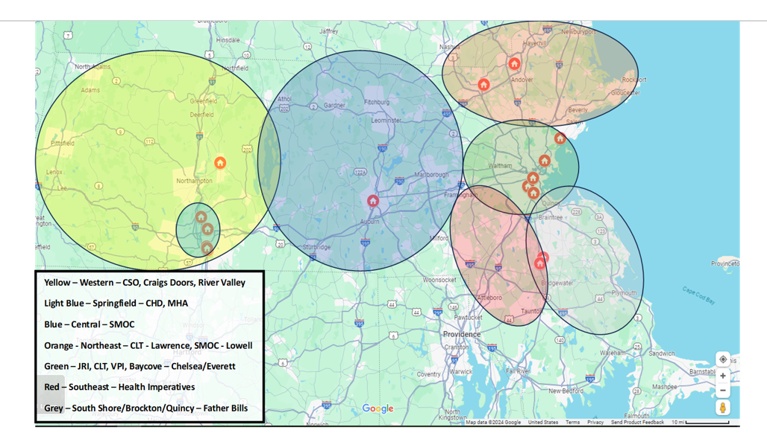

HHSU Programs Supported by ORRF

The table below contains information about the Housing and Homeless Services Unit’s Low-Threshold Housing programs that are supported by ORRF, including contracted vendors, catchments areas and program locations, housing model, number of BSAS contracts, number of individuals who have been housed, and number of individual that have served since the start date of the contract.

|  |  |  |  |  |  |
| --- | --- | --- | --- | --- | --- |
| **LOW-THRESHOLD HOUSING & SERVICES**  **VENDOR LIST** | **CITY/REGION LEASED UNITS CATCHMENT AREA** | **MODEL** | **CONTRACTED FY24** | **# CURRENTLY HOUSED** | **TOTAL SERVED FROM CONTRACT START** |
| Bay Cove Human Services | Chelsea / Everett | Permanent | 39 | 39 | 41 |
| Center for Human Development | Holyoke / Springfield | Permanent | 45 | 51 | 58 |
| Clinical & Support Options | Springfield | Permanent | 100 | 100 | 118 |
| Commonwealth Land Trust | Boston | Permanent | 78 | 70 | 65 |
| Commonwealth Land Trust | Lawrence | Permanent | 20 | 20 | 24 |
| Craig's Doors | Amherst | Permanent | 15 | 16 | 16 |
| Eliot Community Human Services | Lynn | Permanent | 47 | 48 | 56 |
| Father Bill's and MainSpring | Quincy / Brockton / Plymouth | Permanent | 28 | 34 | 40 |
| Health Imperatives | Brockton | Permanent | 10 | 11 | 11 |
| Justice Resource Institute | Boston | Permanent | 34 | 24 | 30 |
| Mental Health Associates | Springfield | Permanent | 30 | 20 | 20 |
| River Valley Counseling Center | Holyoke | Permanent | 20 | 18 | 19 |
| South Middlesex Opportunity Council/  Lowell Transitional Ctr | Lowell | Permanent | 20 | 20 | 27 |
| South Middlesex Opportunity Council/Open Pantry | Springfield | Permanent | 20 | 20 | 29 |
| South Middlesex Opportunity Council | Worcester | Permanent | 2 | In Development | |
| Victory Programs | Boston | Permanent | 39 | In Development | |
| Center for Human Development | Holyoke / Springfield | Temporary | 25 | In Development | |
| Pine Street Inn | Boston | Temporary | 32 | 33 | 68 |
| South Middlesex Opportunity Council | Leominster | Temporary | 26 | In Development | |
| Square Medical | Quincy / Brockton | Temporary | 33 | 28 | 11 |
|  |  | **TOTALS** | **663** | **552** | **633** |

Questions & Answers

Jennifer Halstrom

Director of BSAS’s Housing & Homeless Services Unit (HHSU)

Email: [jennifer.halstrom@mass.gov](mailto:jennifer.halstrom@mass.gov)

Upcoming Council Meetings

Date, Time, and Location

Tuesday, September 10, 2024 – 12:30 – 2:00 PM – In person TBD

Tuesday, December 3, 2024 – 11:00 AM – 12:30 PM – Virtual (Zoom)