# ORRF Advisory Council Presentation

Opioid Recovery & Remediation Fund Advisory Council

State Seal
Commonwealth of MA State Seal

Executive Office of Health & Human Services

September 10, 2024

Today’s Agenda

SmartArt: Two-level Icon Circle List with Five Icons

Icon 1. Stopwatch

Text: Approval of - 06/13/24 Meeting Minutes



### Icon 2. Megaphone

### Text: Important Announcements



### Icon 3. Eye

### Text: ORRF Mission, Vision, & Principles



### Icon 4: Checkmark Sign

### Text: Updates on Strategic Priorities



### Icon 5: Bar Graph

### Text: Initiative Spotlight: Mosaic Grant Program



## Vote on 03/06/24 Meeting Minutes

Important Announcements

SmartArt: One-level Icon Vertical Circle List with Three Icons

Icon 1. Dollar Sign

Text: Annual Expenditure Report (FY24)



Icon 2. Circles with Arrows

Text: Massachusetts Municipal Opioid Abatement Report



### Icon 3. Report

### Text: Annual ORRF Report (FY24)

### Report

ORRF Mission & Vision

SmartArt: One-level Basic Bending Process

Link for ORRF Strategic Framework: <https://www.mass.gov/doc/orrf-advisory-council-meeting-presentation-12622/download>

***Mission*:*** The purpose of the Opioid Recovery and Remediation Trust Fund (Fund) is to mitigate the effects of the opioid epidemic on individuals and families, particularly in historically underserved communities, which have experienced a disproportionately high rate of opioid related overdose deaths.

***Vision*:*** The Fund will finance activities across the full continuum of prevention, harm reduction, treatment, services and supports for an individual’s recovery from opioid addiction and in support of their loved ones.

ORRF Guiding Principles

SmartArt: Two-level Linear Seven-Block Process Numbered

Link for ORRF Strategic Framework: <https://www.mass.gov/doc/orrf-advisory-council-meeting-presentation-12622/download>

### Block: 01

Focus on historically underserved populations suffering from and/or impacted by opioid use disorder

### Block: 02

Incorporate health equity and community engagement principles into each funded program

### Block: 03

Prioritize localized, community-focused efforts where possible

### Block: 04

Drive funding decisions based on current data and evidence-based research

### Block: 05

Focus on sustainability concepts for funded efforts from the beginning

### Block: 06

Prioritize innovative and nontraditional solutions

### Block: 07

Fund solutions and programs that do not have alternative funding sources

Timeline of Council Activities

SmartArt: Two-level Accent Process for Four-Year Timeline

### Year: 2021

* Reviewed scope of crisis and existing landscape of services
* Approved preliminary recommendations
* Developed a set of principles to guide future expenditures

### Year: 2022

* Reviewed progress toward implementation of recommended initiatives
* Refined principles to guide future expenditures
* Completed ORRF Strategic Framework to guide future activities

### Year: 2023

* Reviewed continuing investments in ongoing initiatives
* Approved grant program to support community-based and municipal initiatives, leveraging the ORRF Strategic Framework
* Identified additional spending priorities for FY2024+

### Year: 2024

* Implementing FY2024+ strategic priorities
* Planning series of regional listening sessions to enhance community engagement
* Developing ORRF KPIs and Expenditure Dashboard

Overview of Strategic Priorities & Initiatives

SmartArt: Two-level Vertical Five-Bracket List

### Bracket 01: Equity

* Redefining Community Wellness
* BIPOC and Women’s Re-Entry
* School of Re-Entry

### Bracket 02: Service Expansion/Enhancement

* Harm Reduction Expansion
* Access to MOUD
* Hospital-Based SUD Services

Bracket 03: Workforce Development

* Student Loan Forgiveness

### Bracket 04: Supporting Families

* Expanding Access to Evidence-Based Practices for Families
* Grief Support

### Bracket 05: Social Determinants of Health

* Low Threshold Housing and Housing Support
* Community “Mosaic” Grant Program

### Bracket 06: Data Collection & Analysis

* BSAS Dashboard Expansion
* ORRF KPIs & Expenditure Dashboard

Initiatives Updates

SmartArt: Vertical Six-Bullet List

### Box 01: Equity

* Completed three-year evaluation for Black and Latino Men’s Re-entry program with the intention of updating program based on findings before reopening procurement
* Final stages of posting Women’s Re-entry RFR and awaiting approval to go live on Commbuys

Box 02: Service Expansion/Enhancement

* Hospital-based SUD programs are in the process of establishing data collection systems and have begun serving patients. BSAS procured clinical and fiscal TTA to support hospitals in delivering EB and PP for the maximization of third-party reimbursement
* Released joint application w/ SOR to fund existing OTPs to enhance services and increase access to medications for OUD and stimulant use disorder for underserved and/or high need populations based on available data and promising practices. Awardees to be announced in late September

Box 03: Workforce Development

* As part of MA-Repay, loan repayment awards were offered to SUD professionals across the Commonwealth. Round one awarded all eligible applicants with $2M remaining to support a second round for professionals hired after the first application closed on 1/30/2023. The second round opened on 8/28/2024 and is scheduled to close on 9/25/2024. Award notifications will be sent directly to applicants in Spring 2025

Box 04: Supporting Families

* Co-hosting Design Lab with RIZE aimed at assessing the ecosystem of family supports in MA, identifying strengths and gaps, and prioritizing areas of need
* Contracted with SADOD to provide resources, information, and assistance to individuals and families who have lost a loved one due to drugs/alcohol

Box 05: Social Determinants of Health

* Low threshold housing has served 640 individuals; 585 have been sheltered across seven sites, 200 of whom have been placed in permanent housing through a housing navigation program or have been housed through reunification with friends or family

Box 06: Data Collection & Assessment

* Added new features and functionality to the SUD Community Profiles Dashboard, including: the Overview tab now features a statewide view along with several new metrics; the Deaths tab has been redesigned to allow detailed analysis of deaths by race/ethnicity, age, and gender; a new Data to Action tab offers communities recommendations on how to apply the data found in the dashboard
* Initiative Spotlight:

ORRF Revenue and Expenditures

**Funds Received:** for Fiscal Year (FY22) $12.97 million, FY23 $62.76 million, FY24 $92.6 million, FY25 $27.22 million

**Funds Committed/Expended:** FY22 $9.25 million, FY23 $27.93 million, FY24 $23.84 million, FY25 $55.10 million

**Annual Commitments by Strategic Priority**

**Equity:** FY24 $4.38 million, FY25 $16 million

**Service Expansion & Enhancement:** FY22 $6.5 million, FY23 $6.5 million, FY24 $10.5 million, FY25 $24.5 million

**Workforce:** $15 million for both FY24 & FY25

**Family Supports:** FY24 $500,000, FY25 3.5 million

**Social Detriments of Health:** FY22 $2 million, FY23 $6 million, FY24 $6.85 million, FY25 $8 million

**Data Collection & Analysis:** FY22 $750,000, FY23 $432.700, FY24 $500,000, FY25 $2 million

**Municipal Capacity- Building Support:** FY24 $1.1 million, FY25 $1.1 million

Initiative Spotlight

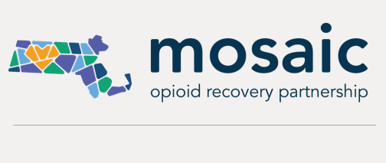

Welcome

Text Box 1

In this presentation, we will review the Mosaic Opioid Recovery Partnership’s

Community-based Opioid Response Efforts (CORE) grant program and introduce the next rounds of efforts.

Text Box 2

Agenda:

* Overview
* How we got here
* Review process
* Grantees
* Technical assistance & evaluation
* Coming up
* Q & A

Mosaic Opioid Recovery Partnership

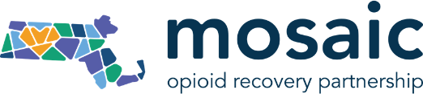

Text Box

The goal of the Mosaic Opioid Recovery Partnership is to create a pathway of access to apply for funds for both municipalities and community-based organizations, particularly those based in communities that are historically underserved and have experienced a disproportionately high rate of opioid-related overdose deaths.



Funded by MA Department of Public Health, Bureau of Substance Addiction Services and Powered by RIZE

Guiding Principles

Graphic that includes four colorful squares grouped together, and each square containing one of the four guiding principles. 
First square - Center the voiced of people with lived and living experience 
Second square - Ensure efforts are informed by commitments to equity, inclusion, and compassion
Third square - Work to reduce stigma
Fourth square - Advocate for approached that support people in understanding and achieving their own goals regarding harm reduction, treatment, and recovery


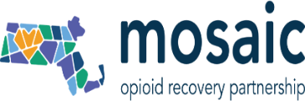

Mosaic Website Memory Wall

Screenshot of Mosaic Memory Wall that states “Remembering Those We’ve Lost” “Mosaic is grounded in hope, optimism, and opportunity. It is also grounded in the recognition that the settlement funding results from the loss of life and devastation our communities have experienced because of the opioid overdose crisis. In every action we take and every decision we make, we carry the memories of those who have been affected, ensuring their stories guide our work”.

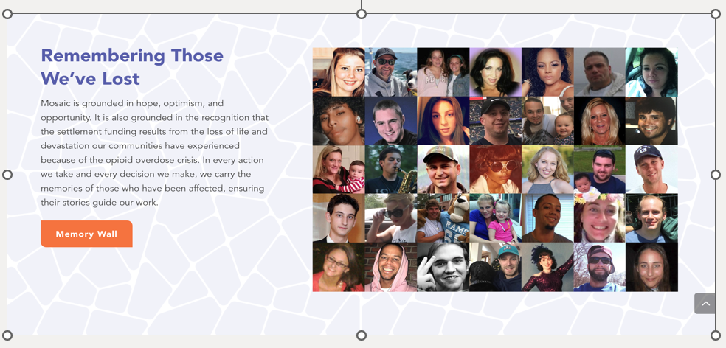

$15 million in grants across three rounds

Text Box

Round One: Community-based Opioid Response Efforts (CORE)

Timeline: August 2024-2027

RIZE awarded $3,750,000 to 18 organizations through CORE

Round Two: Matching Municipal Grants

Timeline: Application to be posted 9/23/24 with awards January 2025

$1,250,000 one-year funding for three years (2025, 2026, 2027): total $3,750,000

Round Three: Population-based or Program-specific Opioid Response Efforts

Timeline: Application to be posted in early 2025

$2,500,000 three-year grants 2025-2027: total $7,500,000

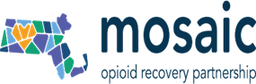

Round 1: Community-based Opioid Response Efforts (CORE)

Text Box

The primary goal of CORE, Mosaic’s first round of grantmaking, is to help organizations deepen their impact, bring their work to scale, and build a strong and sustainable infrastructure to meet the needs of the populations they serve.

CORE guidelines

Text Box

* $3,750,000 over three years
* The three-year grants range from $16,000 to $150,000 annually, depending on the organization’s size and budget
* The grants will provide general operating support with a focus on:
  + stabilizing operations
  + addressing urgent and emerging issues
  + building capacity to deliver services
  + investing in organizational infrastructure
  + Focus groups with PWLLE
  + Together in Recovery Advisory Committee, HEALing Communities Study CAB

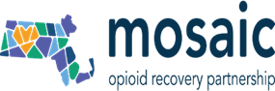

CORE application process

Text Box

* Simple online form
  + Available in English and Spanish
  + 8 questions designed to capture
    - the mission and core activities of the applicant
    - how the applicant operationalizes equity, access, and inclusion
    - the organization’s goals and how CORE funding would help achieve them
* Webinar: 64 attendees
* Office hours (3 one-hour virtual sessions): 39 organizations attended

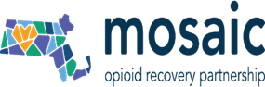

CORE applicant pool

Text Box

* 97 applications submitted
* Relatively evenly distributed on the size of operating budgets
* Nearly half of the applicant organizations work in recovery support services, followed by prevention, harm reduction, treatment, and trauma/grief/family supports
  + Applicants serve priority populations:
  + 91% reach PWLLE
  + 74% reach BIPOC communities
  + 73% reach people experiencing housing insecurity

Pie Chart

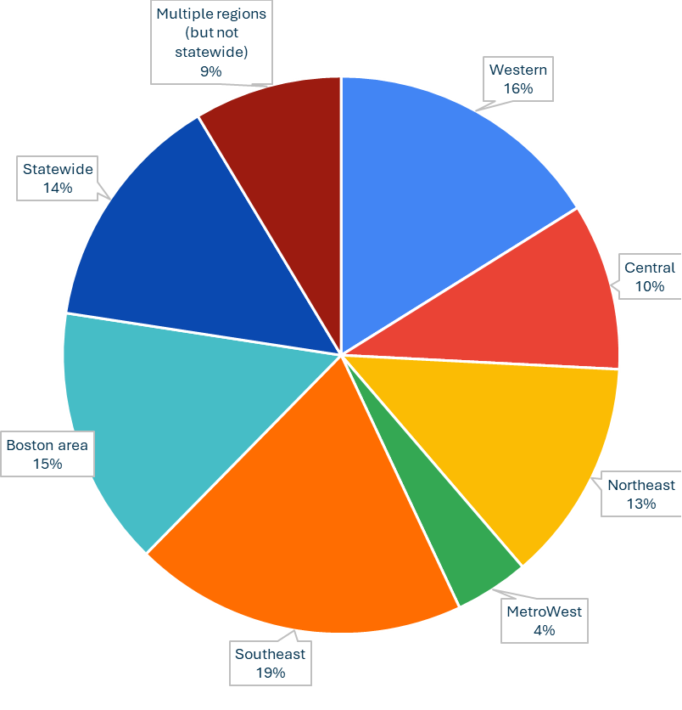

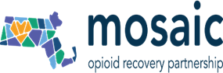

CORE applicants survey results

Text Box

* 97% of respondents found the application process “somewhat” or “very” easy
* 89% “strongly” or “somewhat” agreed that the application process empowered small community organizations to apply
* 85% of applicants “strongly” or “somewhat” agreed that they felt confident that organizations/groups like theirs would be evaluated fairly for this program

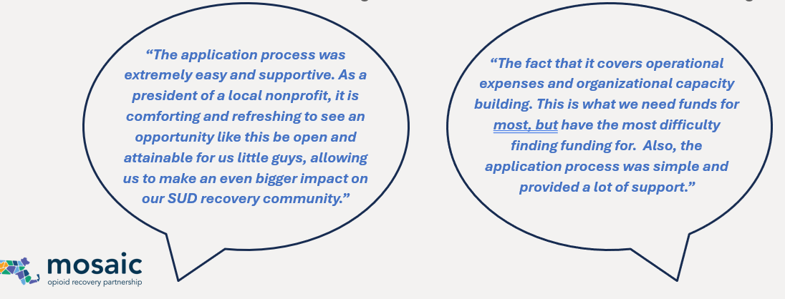

CORE community review

Text Box

* 11 teams * 3 reviewers
* Each team included PWLLE, family members, subject matter, and equity and inclusion experts
  + 81% PWLLE (self or family member)
  + 73% subject matter expertise
  + 54% understood health equity principles
  + 54% previous experience reviewing grants
* Reviewers found RIZE resources helpful
  + 1:1 discussions with the RIZE team
  + Virtual Mosaic CORE grant reviewer training
  + Mosaic-bias one-pager
  + Recognizing bias video

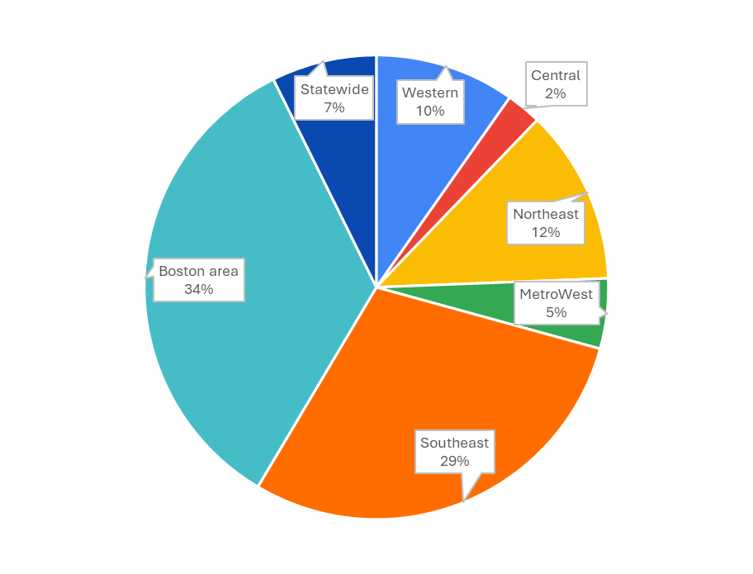

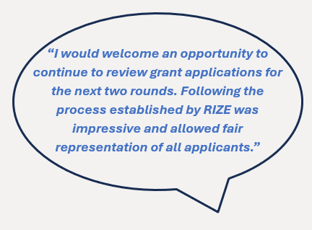

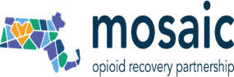  
CORE scoring process

Text Box

* Scores for each application = average of the 3 community reviews
* Additional review process focused on county-level need was applied to all applications: opioid overdose burden underserved communities
* Applicants were then grouped by continuum of care category and the top 50% were moved forward as finalists
* RIZE then reviewed each application for equitable distribution by:
  + geography
  + organizational size
  + continuum of care category

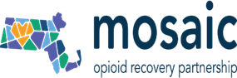

CORE grantee demographics

Text Box

* Awardees are relatively evenly distributed along the continuum of care
* Almost every county in the Commonwealth represented
* 72% of awardees have operating budgets below $1 million
* CORE grants could have a positive impact on health equity
  + 89% reach BIPOC communities
  + 83% reach PWLLE
  + 67% reach people experiencing housing insecurity

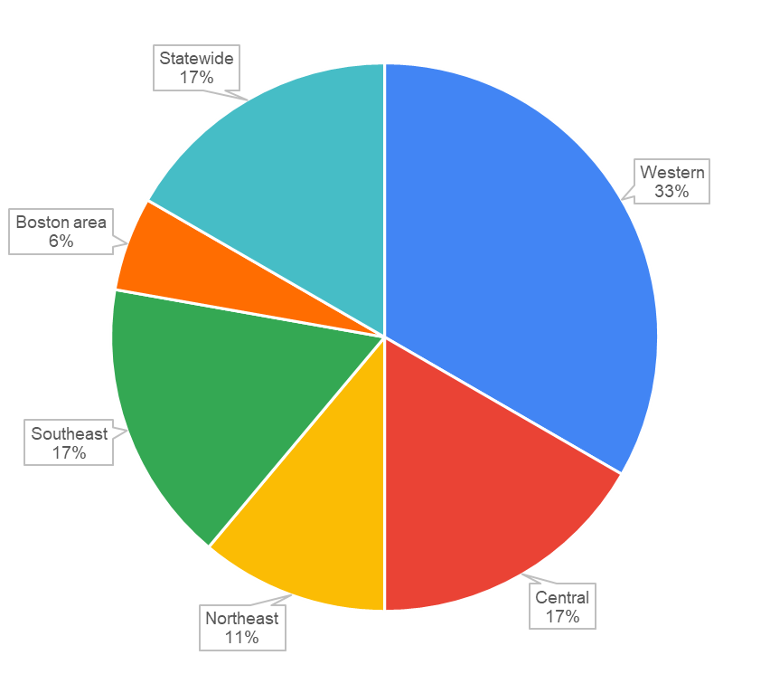

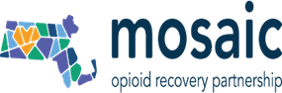

CORE grantees

Table listing the organizations funded by the CORE grants, the amount awarded, county where the organization is located, and their continuum of care area

|  |  |  |  |
| --- | --- | --- | --- |
| Organization | Recommended Amount (3 year) | County | Care Continuum |
| Access Hope | $255,000.00 | Barnstable | Harm Reduction |
| AIDS Project Worcester | $400,000.00 | Worcester | Prevention |
| Black Behavioral Health Network | $50,000.00 | Hampden | Connections to Care |
| Camp Happy Place | $65,000.00 | Berkshire | Trauma, Grief, and Family Supports |
| Centro De Ayuda Y Esperanza Latina | $135,000.00 | Bristol | Prevention |
| Choice Recovery Coaching Inc. | $222,500.00 | Hampden | Recovery Supports |
| Extreme Kid, Inc. | $100,000.00 | Hampden | Prevention |
| Fishing Partnership Health Plan (DBA: Fishing Partnership Support Services) | $450,000.00 | Bristol | Connections to Care |
| Hilltown Youth Recovery Theater | $100,000.00 | Franklin | Connections to Care |
| HRH413 | $115,000.00 | Hampshire | Harm Reduction |
| Safe Exit Initiative | $380,000.00 | Worcester | Harm Reduction |
| South Shore Peer Recovery | $222,500.00 | Plymouth | Recovery Supports |
| The Commission on the Status of Grandparents Raising Grandchildren of Massachusetts | $275,000.00 | Suffolk | Trauma, Grief, and Family Supports |
| The Psychological Center | $150,000.00 | Essex | Connections to Care |
| The Sun Will Rise | $150,000.00 | Norfolk | Trauma, Grief, and Family Supports |
| Torch Light Recovery | $222,500.00 | Suffolk | Recovery Supports |
| Troubled Waters Inc. d/b/a Bridge Club of Greater Lowell | $332,500.00 | Middlesex | Recovery Supports |
| Uhai for Health Inc | $125,000.00 | Worcester | Prevention |

Evaluation plan

Text Box

* The evaluation plan includes guiding questions and approaches for evaluating
  + the grantmaking process
  + grant implementation
  + outcomes over the course of the program
* It aligns with the ORRF strategic plan and draws on best practices from equitable evaluation and trust-based philanthropy
* The primary data sources for the evaluation will be:
  + annual grantee reports
  + surveys for grantees and other stakeholders
  + qualitative interviews and focus groups with grantees and other stakeholders
  + participant observation

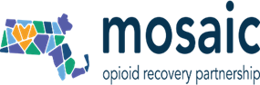

Training and technical assistance

Text Box

* Technical assistance (TA) is available to Mosaic CORE grantees, through multiple methods, to support capacity building:

1) Opt-in Mosaic Coaching

2) Grantee Webinars and Learning Communities

* Bootcamp for executive directors (leadership development, budgeting)
* Network building
* Stigma and bias

3) On-demand TA Requests

* Creating a strategic or business plan
* Evaluation and data management
* Marketing and communications
* Promoting equity in service access and delivery

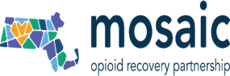

Round Two Municipal Matching Grants

Text Box

* The program will **match municipal opioid settlement funds** in cities and towns that are 1) using best practices to end the overdose crisis, 2) utilizing Care Mass resources, 3) conducting community outreach and needs assessments, and 4) collaborating with others.
* Projects and initiatives should be developed with input from public health experts, municipal leaders, families affected by the crisis, and people with lived and living experience.
* Proposed projects must align with the [Massachusetts State Sub-Division Agreement for Statewide Opioid Settlements](https://www.mass.gov/doc/march-4-2022-ma-subdivision-agreement/download) and advance non-punitive, health-centered approaches to substance use disorder-related harms and challenges.

Round Two Municipal Matching Grants

Text Box

* RIZE will award $1,250,000 in one-year grants for 2025, with two additional grant rounds in 2026 and 2027, totaling a $3.75 million ORRF investment to municipalities across the Commonwealth.

Screenshot of table containing municipal matching grant timeline, including the applications released, webinar, application due, notifications, and grantees announced.

Local media highlights grantees

One oval speech bubble containing quote that was highlighted in the media about the CORE grant

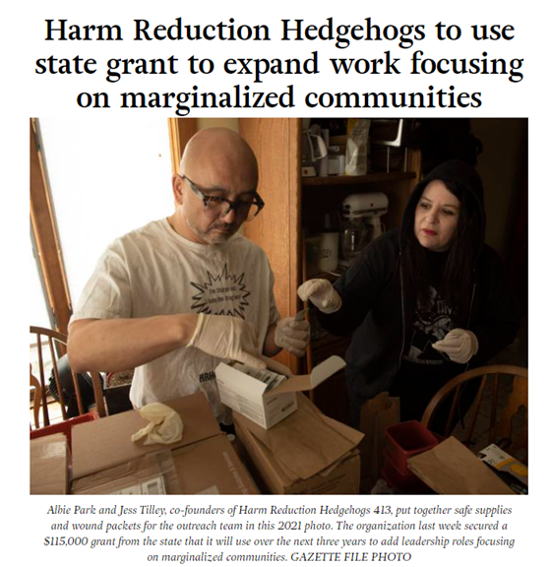

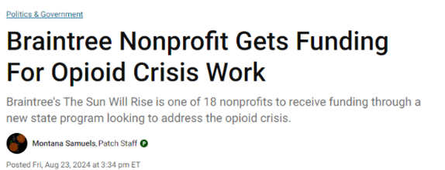

Kim Powers, E.D. & Founder of Access Hope

The Enterprise Mashpee, 8/29/24

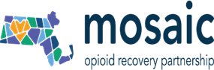

Thank you

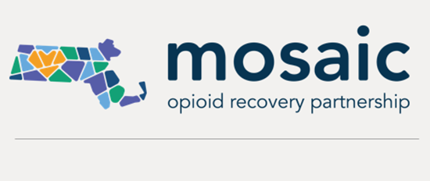

Text Box

mosaic.rizema.org

Questions & Answers

Text Box

EMAIL - [OpioidRecoveryandRemediationFund@mass.gov](mailto:OpioidRecoveryandRemediationFund@mass.gov)

Next Meeting

