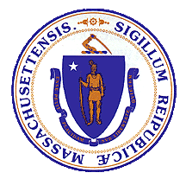
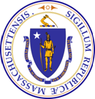

Opioid Recovery & Remediation Fund Advisory Council

Wednesday, September 27, 2023
12:30 – 2:00pm
In person at Worcester City Hall with Zoom option
1

Today's Agenda

- Welcome

- Approval of 8/2/2023 Meeting Minutes

- Recap of Strategic Themes/Ideas from Advisory Council

- Overview of Existing Initiatives and Potential Opportunities by
Theme

- Recommend Systems Change Priorities

- Upcoming Topics & Proposed Meetings in 2024

Today's Agenda

- Welcome

- Approval of 8/2/2023 Meeting Minutes

- Recap of Strategic Themes/Ideas from Advisory Council

- Overview of Existing Initiatives and Potential Opportunities by Theme

- Recommend Systems Change Priorities

- Upcoming Topics & Proposed Meetings in 2024

Today's Agenda

- Welcome

- Approval of 8/2/2023 Meeting Minutes

- Recap of Strategic Themes/Ideas from Advisory Council

- Overview of Existing Initiatives and Potential Opportunities by Theme

- Recommend Systems Change Priorities

- Upcoming Topics & Proposed Meetings in 2024

Key Themes & Ideas from Meetings to Date

- Equity: Need to focus on populations disproportionately impacted
- Data Collection & Analysis: Need for improved data collection, analysis, and reporting on SUD trends
- Supporting Families: Need to focus on supporting and
strengthening families
- Service Expansion/Enhancement: Need to expand/enhance
services across continuum gap
- Workforce: Need to strengthen and rebuild workforce
- Social Determinants of Health: Need to focus on upstream
factors, including housing and poverty
- Awareness: Need to decrease stigma and increase understanding
of treatment opportunities 5

Today's Agenda

  - Welcome

  - Approval of 8/2/2023 Meeting Minutes

  - Recap of Strategic Themes/Ideas from Advisory Council

  - Overview of Existing Initiatives and Potential Opportunities by Theme

  - Recommend Systems Change Priorities

  - Upcoming Topics & Proposed Meetings in 2024

Equity

Existing Activities:
    - BIPOC grantmaking and capacity building
    - Black and Latino Re- Entry
    - Development of and collaboration with population- and topic- specific Community Advisory Boards

Examples of Potential Opportunities for ORRF:
- Expand BIPOC grantmaking and capacity building
- Scale Black and Latino Re-Entry programs
- Funding to support gaps and needs identified by population and topic- specific community advisory boards
- Establish SMART goal related to equity

Existing Activities:
Data Collection & Analysis
  - BSAS Dashboard
  - Municipal ORRF TTA

Potential ORRF Activities:
  - Dashboard expansion and enhancement
  - Scale and enhance municipal ORRF dashboard/ visualization at a statewide level
  - Other ideas?

Existing Activities:
Supporting Families
- Moms Do Care
- First Steps Together
- National Center on Substance Abuse and Child Welfare's 2023 Policy Acade my and in-depth technical assistance
- Proposed dual reporting legislation
- Grandparents Raising Grandchildren

Potential ORRF Activities:
- Increased support for Plan of Safe Care (POSC) Implementation
- Funding to support dual
reporting implementation
- Funding to support implementation of evidence- based and evidence-informed practices for families
- Expand work of Grandparents Raising Grandchildren Commission

Existing Activities:
Services Expansion/Enhancement
  - Hospital-based SUD services
  - Mobile addiction services
  - Stimulant Treatment
and Recovery teams
  - MAT Enhanced

Potential ORRF Activities:
  - Expand funding for hospital- based addiction consult teams and bridge clinics to expand reach and promote community follow-up
  - Scale mobile addiction services statewide
  - Strengthen investments in contingency management, especially in light
of limitations of federal funding

Existing Activities:
Workforce
  - Loan repayment
  - Paid internship
initiatives

Potential ORRF Activities:
  - Explore innovative tuition support, paid training, and other workforce opportunities, with a focus on underrepresented communities
  - Other ideas?

Existing Activities:
Social Determinants of Health
  - Housing and related supports, including low- threshold housing
  - Access to recovery
  - Transportation pilot

Potential ORRF Activities:
- Strengthen investments in social determinants of health
interventions, including scaling existing initiatives
- Other ideas?

Existing Activities:
Awareness
  - State Without StigMA
  - HelpLine Advertising
  - Night Life campaign

Potential ORRF Activities:
  - Update and re-release State Without StigMA or similar campaign
  - Continue to promote and enhance HelpLine services and/or Night Life campaign
  - Other ideas?

Today's Agenda

- Welcome

- Approval of 8/2/2023 Meeting Minutes

- Recap of Strategic Themes/Ideas from Advisory Council

- Overview of Existing Initiatives and Potential Opportunities by Theme

- Recommend Systems Change Priorities

- Upcoming Topics & Proposed Meetings in 2024

Recommend Systems Change Priorities

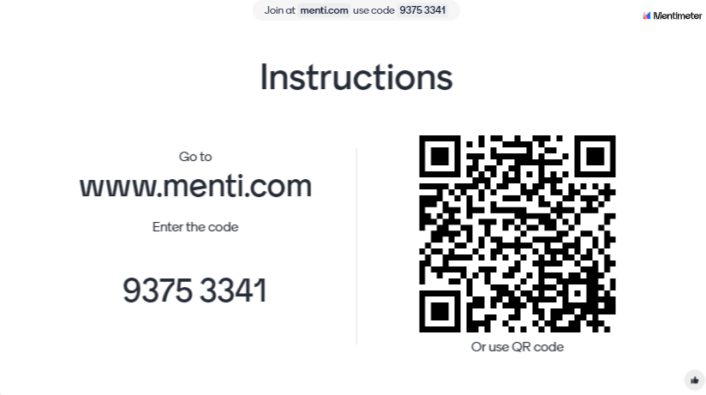

Today's Agenda

- Welcome

- Approval of 8/2/2023 Meeting Minutes

- Recap of Strategic Themes/Ideas from Advisory Council

- Overview of Existing Initiatives and Potential Opportunities by Theme

- Recommend Systems Change Priorities

- Upcoming Topics & Proposed Meetings in 2024

Upcoming Topics and Proposed Meetings in 2024

Monday December 11, 2023 10:30am–12:00pm (Zoom)
Proposed Meeting
Dates in 2024

Wednesday March 6
@ 11 am

Thursday June 13
@ 10:30 am

Tuesday September 10 @ 12:30 pm

Tuesday December 3
@ 11 am
  - Review ORRF municipal reporting structure/ progress
  - Insights from data for ORRF municipal matching grants
  - Strategies to make OUD data more accessible

